3GPP TSG-SA3 Meeting #102-e S3-210220r05

e-meeting, 18th - 29th January 2021 Revision of S3-20xxxx

Source: Alibaba Group

Title: New solution on UE onboarding for SNPN with the interaction between PS and DCS

Document for: Approval
Agenda Item: 5.12

1 Decision/action requested
This document proposes a new solution: UE onboarding for SNPN with the interaction between PS and DCS to the TR 33.857. SA3 is kindly requested to approve this document.

2 References
[1] 3GPP TR 21.905: "Vocabulary for 3GPP Specifications".
[2] 3GPP TS 33.501: "Security architecture and procedures for 5G System"
[3] 3GPP TR 23.700-07: "Study on enhanced support of non-public networks (Release 17)"
[4] 3GPP TS 23.501: "System Architecture for the 5G System"

3 Rationale
For the onboarding and the provisioning of credentials aspects in the TR 23.700-07. An further study regarding the security aspect of the interaction between PS and DCS need to be conducted.
This contribution proposes new solutions on UE onboarding and provisioning for SNPN with the interaction between PS and DCS.

4 Detailed proposal
*** BEGIN OF CHANGE ***

6.Y Solution #Y: UE onboarding for SNPN with the interaction between PS and DCS

6.Y.1 Introduction
This solution addresses Key Issue #2 “Provisioning of Credentials” and Key Issue #4 “Securing initial access for UE onboarding between UE and SNPN”.
The assumption of this solution is that
1. The UE has been provisioned with default UE credentials from DCS;
2. The UDM is configured with a mapping of the Universal UE ID with the PS address.
3. The Universal UE ID is the UE permanent ID which is unique for every single UE. The Universal UE ID can be SUCI or other kinds of UE ID that can uniquely differentiate a UE.

6.Y.2 Solution details

6.Y.2.1 Procedure
A mechanism of UE onboarding and provisioning for SNPN with the interaction between PS and DCS is described in the Figure 6.Y.2.1-1. The main idea of this mechanism is that the UE firstly registers with the O-SNPN with restricted access and then performs authentication with DCS via User Plane. After the success of authentication with DCS, the PS provisions the SNPN credential to the UDM and UE, respectively.
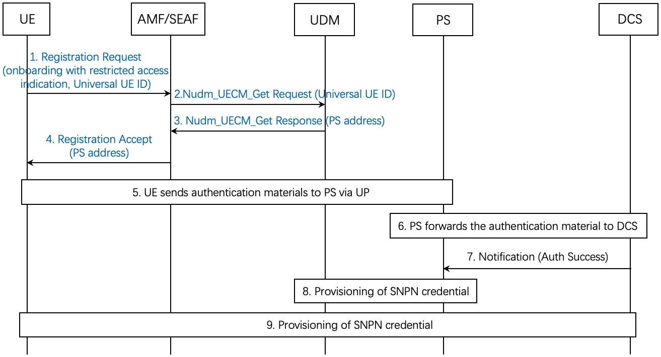
Figure: 6.Y.2.1-1: UE onboarding and provisioning for SNPN with the interaction between PS and DCS(authentication via UP)
1. The UE sends Registration Request to AMF. The Registration Request includes a “Onboarding with restricted access” indication and a Universal UE ID.
2. The AMF sends Nudm_UECM_Get Request with the Universal UE ID to UDM.
Editor’s Note: The privacy protection and format of the Universal UE ID is FFS.
3. Upon the receipt of the Nudm_UECM_Get Request, the UDM sends Nudm_UECM_Get response with the PS address to AMF.
4. Upon the receipt of the Nudm_UECM_Get Response from the UDM, the AMF sends Registration accept, containing PS address, to UE.
5. The UE sends authentication materials (i.e. signing material and default credential ID) to PS via UP once it obtains the restricted access.
6. The PS identifies the DCS address via UE Universal ID and forwards the authentication material to the DCS.
7. The DCS authenticate the UE through verifying the authentication material. If the vertication successes, the DCS sends a notification including the Authentication Success to PS.
8. The PS provisions the UDM with SNPN credential. The detailed provisioning method is out of the scope of SA3.
9. The PS provisions the UE with SNPN credential. The detailed provisioning method is out of the scope of SA3.

6.Y.2.2 Procedure
A mechanism of UE onboarding and provisioning for SNPN with the interaction between PS and DCS is described in the Figure 6.Y.2.2-1. The main idea of this mechanism is that the UE performs primary authentication. After the success of primary authentication, the PS provisions the SNPN credential to the UDM and UE, respectively.
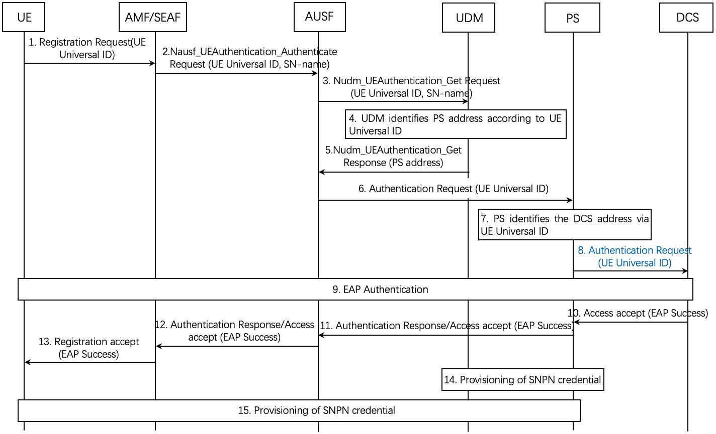
Figure: 6.Y.2.2-1: UE onboarding and provisioning for SNPN with the interaction between PS and DCS (primary authentication)
1. The UE sends a Registration Request to the AMF. The registration Request includes the UE Universal ID.
2. The AMF sends Nausf_UEAuthentication_Authentication Request, containing UE Universal ID and SN-Name, to the AUSF.
3. The AUSF sends Nudm_UEAuthentication_Get Request, containing UE Universal ID and SN-Name, to the UDM.
4. The UDM identifies PS address according to UE Univeral ID.
5. The UDM sends Nudm_UEAuthentication_Get Response, containing PS address, to the AUSF.
6. The AUSF executes the Primary Authentication by sending EAP request, containing UE Universal ID, to the PS.
7. The PS identifies the DCS address via UE identity ID.
8. The PS forwards the Authentication Request, containing UE Unviersal ID, to the DCS.
9. The UE and DCS conducts EAP authentication.
10. If the authentication successes, the DCS sends an Access accept containing EAP success to the PS.
11. The PS sends an Authentication Response/Access accept to the AUSF.
12. The AUSF sends Authentication Response/Access accept to the AMF.
13. The AMF sends Registration accept to the UE.
14. The PS provisions the UDM with SNPN credential. The detailed provisioning method is out of the scope of SA3.
15. The PS provisions the UE with SNPN credential. The detailed provisioning method is out of the scope of SA3.

6.Y.3 System impact
Editor’s Note: Each solution should clearly list which entities need new functionality and what functionality they need for the provided solution to work.

6.Y.4 Evaluation
Editor’s Note: Each solution should motivate how the potential security requirements of the key issues being addressed are fulfilled.
*** END OF CHANGE ***

