3GPP TSG-SA WG6 Meeting #32 S6-191617
Roma, Italy 8th – 12th July 2019 (revision of S6-191305, S6-191417, S6-191531, S6-191592, S6-191611)
CR-Form-v11.2
CHANGE REQUEST
 | 23.280 | CR | 0210 | rev | 5 | Current version: | 16.3.0
For HELP on using this form: comprehensive instructions can be found at
http://www.3gpp.org/Change-Requests.

Proposed change affects: | UICC apps |  | ME | X | Radio Access Network |  | Core Network | X

Title: | Corrections to the emergency alert procedures
Source to WG: | at&t
Source to TSG: | S6
Work item code: | enh2MCPTT |  |  |  |  |  |  | Date: |  | 2019-06-22
Category: | F |  |  |  |  |  |  | Release: |  | Rel-16
 | Use one of the following categories:  F (correction)  A (mirror corresponding to a change in an earlier release)  B (addition of feature),  C (functional modification of feature)  D (editorial modification)  Detailed explanations of the above categories can  be found in 3GPP TR 21.900. |  |  |  |  |  |  |  | Use one of the following releases:  Rel-8 (Release 8)  Rel-9 (Release 9)  Rel-10 (Release 10)  Rel-11 (Release 11)  Rel-12 (Release 12)  Rel-13 (Release 13)  Rel-14 (Release 14)  Rel-15 (Release 15)  Rel-16 (Release 16)
Reason for change: |  | The existing MC service emergency alert procedures are not totally correct and also missing location based emergency alert procedures.
Summary of change: |  | - Fixing the existing procedures in 10.10.1.2 and 10.10.2.2 to clarify where the emergency alert request and cancel will be sent.  - Add new procedures to cover the location based emergency alert procedures.  - Add the missing information flows.
Consequences if not approved: |  | Incorrect guidance will be given to stage 3 development.
Clauses affected: |  | 10.10.1.2, 10.10.1.2.1, 10.10.1.2.2, 10.10.1.2.3 (new),10.10.2.2, 10.10.2.2.1, 10.10.2.2.2, 10.1.2.x1 (new), 10.1.2.x2 (new), 10.1.2.x3 (new), 10.1.2.x4 (new), 10.1.2.x5 (new), 10.1.2.x6 (new), 10.1.2.x7 (new)
 |  | Y | N
Other specs |  |  | X | Other core specifications |  |  | TS/TR ... CR ...
affected: |  |  | X | Test specifications |  |  | TS/TR ... CR ...
(show related CRs) |  |  | X | O&M Specifications |  |  | TS/TR ... CR ...
Other comments:

* * * First Change * * * *

10.10.1.2 MC service emergency alert

10.10.1.2.1 MC service emergency alert initiation
The procedure focuses on the case where an MC service client is initiating an MC service emergency alert unicast signalling for communicating the alert with the affiliated MC service group members of that MC service group. An MC service client in the MC service emergency state gains elevated access privilege for all of the MC service user's mission critical applications. This procedure will place the MC service client in the MC service emergency state if the MC service client is not already in that state.
Procedures in figure 10.10.1.2.1-1 are the signalling control plane procedures for the MC service client initiating an MC service emergency alert with an MC service group i.e., MC service users on MC service client 1, MC service client 2 and MC service client 3 belong to the same MC service group which is defined on group management server.
NOTE 1: For simplicity, a single MC service server is shown in place of a user home MC service server and a group hosting MC service server.
Pre-conditions:
- The MC service group to be used for emergency communications by MC service client 1 is previously defined on the group management server and MC service client 2 and MC service client 3 are affiliated to that MC service group.
NOTE 2: Alternatively, the client could have been provisioned for emergency behaviour on the currently selected group.
2. All members of the MC service group belong to the same MC system.
3. The initiating MC service client 1 is affiliated with one or more MC service groups.

4. The initiating MC service client 1 may not have carried out an explicit affiliation procedure with the MC service group designated as the MC service emergency group.
5. Optionally, MCPTT client 1 may use an activated functional alias for the group communication.
6. The MCPTT server may have subscribed to the MCPTT functional alias controlling server within the MC system for functional alias activation/de-activation updates.

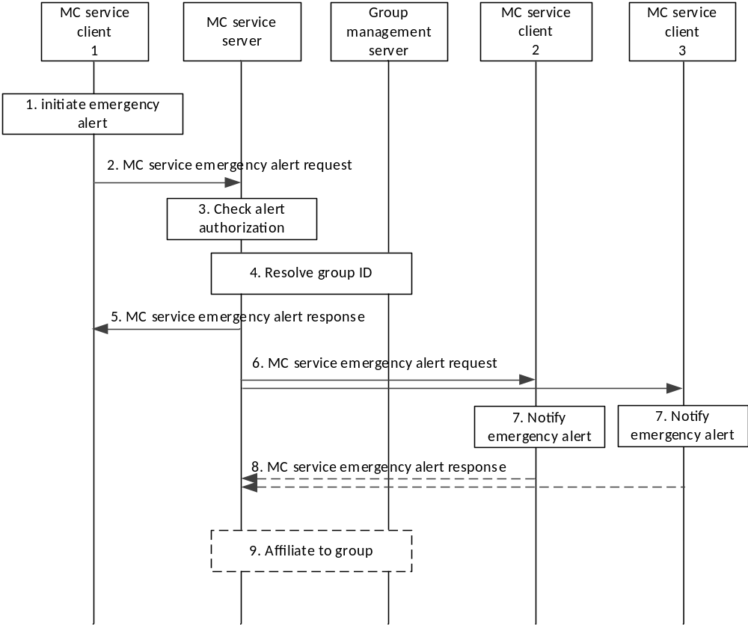

Figure 10.10.1.2.1-1 MC service emergency alert
1. The MC service user at the MC service client 1 initiates an MC service emergency alert. MC service client 1 sets its MC service emergency state. The MC service user at MC service client 1 may select a functional alias used for the call. The MC service emergency state is retained by the MC service client 1 until explicitly cancelled.
2. MC service client 1 requests the MC service server to send an MC service emergency alert request to the MC service group designated as the MC service emergency group.
3. MC service server checks whether the MC service user of MC service client 1 is authorized for initiation of MC service emergency alerts for the indicated MC service group. The MC service server checks whether the provided functional alias, if present, can be used and has been activated for the user.
4. MC service server resolves the MC service group ID to determine the members of that MC service group and their affiliation status, based on the information from group management server.
5. The MC service server sends the MC service emergency alert response to the MC service user 1 to confirm the MC service emergency alert request. MC service group calls made by the MC service client 1 will be sent as emergency calls until the emergency state on the MC service client 1 is cancelled.
6. The MC service server sends an MC service emergency alert request towards the MC service clients of each of those affiliated MC service group members. The MC service emergency alert request message shall contain the following information: Location, MC service ID and MC service group ID (i.e., MC service user's selected MC service group or dedicated MC service emergency group, as per user profile configuration) and the MC service user's mission critical organization name. If in step 2, the MC service client 1 does not include the location information in the MC service emergency alert request to the MC service server, the MC service server acquires the location information of the MC service user at the MC service client 1 from the location management server. If the location information is included in step 2, then the MC service server uses the location information from MC service client 1.
7. MC service users are notified of the MC service emergency alert. The functional alias of the group call initiating MC service user may be displayed.
8. The receiving MC service clients send the MC service emergency alert response to the MC service server to acknowledge the MC service emergency alert.
9. The MC service server implicitly affiliates the client to the emergency group if the client is not already affiliated.
NOTE 3: Sending the emergency alert without making a request to also start an emergency call does not put the group into the in-progress emergency state.
NOTE 4: Sending the emergency alert does not put the other UEs in the group into an emergency state.
NOTE 5: The MC service client 1 need not initiate a group call. For example, the MC service client can be configured to only allow alerts or the MC service user can choose not to make an MC service emergency group call.
NOTE 6: It is configured whether MC service client 1 automatically triggers a subsequent MC service emergency group call.
Editor's note: How emergency alert is synchronized between MC services is FFS.

10.10.1.2.2 MC service emergency alert cancel
The procedure focuses on the case where an MC service client has initiated an MC service emergency alert and entered the emergency state, and wishes to cancel the alert, informing the MC service server and other group members of this cancellation. By doing so, the MC service client may also request the cancellation of the in-progress emergency state of the group.
Procedures in figure 10.10.1.2.2-1 are the signalling control plane procedures for the MC service client cancelling an MC service emergency alert with an MC service group i.e., MC service users on MC service client 1, MC service client 2 and MC service client 3 belong to the same MC service group which is defined on MC service group management server.
NOTE 1: For simplicity, a single MC service server is shown in place of a user home MC service server and a group hosting MC service server.
Pre-conditions:
1. The MC service client 1 had previously successfully initiated an MC service emergency alert.
2. The MC service client 1 is still in the emergency state.
3. The initiating MC service client 1 has affiliated with the MC service group designated as the MC service emergency group.

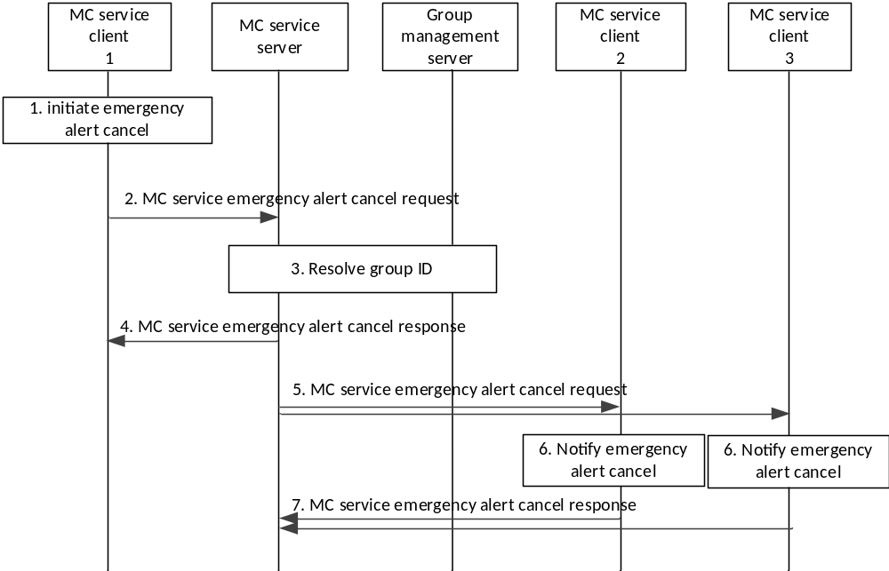
Figure 10.10.1.2.2-1 MC service emergency alert cancel
1. The MC service user at the MC service client 1 initiates an MC service emergency alert cancel.
NOTE 2: The MC service emergency alert cancel request carries an indication to also request that the in-progress emergency is to be cancelled. The MC service server can accept or deny the request to cancel the in-progress emergency state of the group as a whole, separately from accepting or denying the request to cancel the emergency alert at MC service client 1. Additionally, an authorized user can cancel either or both the in-progress emergency state of the group and the initiator's MC service emergency alert.
2. MC service client 1 requests the MC service server to send an MC service emergency alert cancel to the MC service group to which MC service client 1 had previously sent the emergency alert.
3. MC service server resolves the MC service group ID to determine the members of that MC service group and their affiliation status, based on the information from group management server.
4. The MC service server sends the MC service emergency alert cancel response to the MC service client 1 to confirm the MC service emergency alert cancel request. MC service client 1 resets its emergency state.
5. The MC service server sends an MC service emergency alert cancel request towards the MC service clients of each of those affiliated MC service group members.
6. MC service users are notified of the MC service emergency alert cancellation of MC service client 1.
7. For a unicast MC service emergency alert cancel, the receiving MC service clients send the MC service emergency alert cancel response to the MC service server to acknowledge the MC service emergency alert cancel. For a multicast MC service emergency alert cancel, these acknowledgements are not sent unless the MC service clients have been configured to do so.

10.10.1.2.3 Entering MC service emergency alert area
Editor's Note: MC service emergency alert triggered by MC service client locally which stores the pre-defined area is another possible solution. How to define this procedure and how to combine the two solutions is FFS.
The procedure focuses on the case where an MC service emergency alert to be triggered when an MC service UE moves into a pre-defined area. This procedure will place the MC service client in the MC service emergency state if the MC service client is not already in that state.
Procedures in figure 10.10.1.2.3-1 are the signalling control plane procedures for the MC service server triggering an MC service emergency alert with an MC service group i.e., MC service users on MC service client 1, MC service client 2 and MC service client 3 belong to the same MC service group which is defined on MC service group management server. This procedure will place the MC service client in the MC service emergency state if the MC service client is not already in that state.
NOTE: For simplicity, a single MC service server is shown in place of a user home MC service server and a group hosting MC service server.
Pre-conditions:
1. The MC service group is previously defined on the group management server with MC service client 2 and MC service client 3 affiliated to that MC service group.
2. All members of the MC service group belong to the same MC service system.
3. An area in which the MC service client should send emergency alert is pre-defined in MC service server.
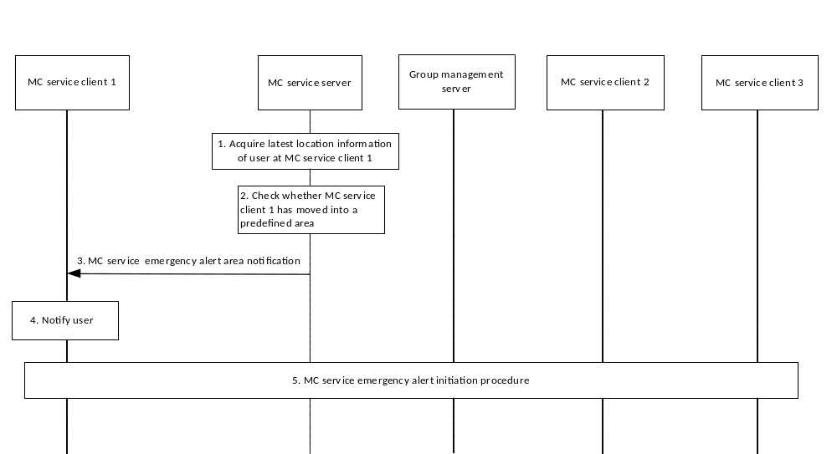
Figure 10.10.1.2.3-1 Entering MC service emergency alert area

1. MC service server acquires the latest location information of user at MC service client 1 from location management server as described in 10.9.3.6.
2. MC service server checks whether MC service client 1 has moved into a pre-defined area.
3. If so, MC service server sends an MC service emergency alert area notification to MC service client 1 to notify that it has moved into the area in potential danger.
4. MC service client 1 notifies the MC service user about the MC service emergency alert area.
5. MC service client 1 initiates MC service emergency alert procedure as described in 10.10.1.2.1.

10.10.1.2.4 Leaving MC service emergency alert area
This procedure focuses on the case where a notification is sent when an MC service UE moves out of a pre-defined area. This procedure will notify the MC service client that it is now out of the pre-defined emergency alert area. It is up to the MC service user at that MC service client to determine if the emergency state is to be cleared or not.
Procedures in figure 10.10.1.2.4-1 are the signalling control plane procedures for the MC service server sends an MC service emergency alert area notification. It is optional if the MC service user wants to initiate the MC service emergency alert cancel procedure to inform the members in the MC service group that its emergency condition is over.
NOTE 1: For simplicity, a single MC service server is shown in place of a user home MC service server and a group hosting MC service server.
Pre-conditions:
1. The MC service group is previously defined on the group management server with MC service client 2 and MCPTT client 3 affiliated to that MC service group. This MC service group has been pre-defined for communicating the emergency alert in the user profile.
2. All members of the MC service group belong to the same MC service system.
3. An area in which the emergency alert for the MC service client should remain active is pre-defined in MC service server.
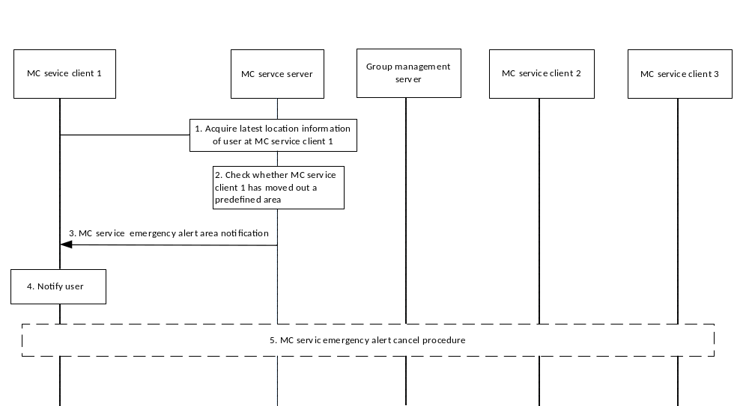
Figure 10.10.1.2.4-1 Leaving MC service emergency alert area
1. MC service server acquires the latest location information of user at MC service client 1 from location management server as described in subclause 10.9.3.6.
2. MC service server checks whether MC service client 1 has moved out a pre-defined area.
3. If so, MC service server sends an MC service emergency alert area notification to MC service client 1 to notify that it has moved out of the area in potential danger.
4. MC service client 1 notifies the MC service user about the MC service emergency alert area cancel. It is up to the MC service user at the MC service client 1 to determine if the emergency state is clear.
5. Optionally, the MC service user of MC service client 1 initiates MC service emergency alert cancel procedure as described in 10.10.1.2.2.
NOTE 2: It is up to the MC service user to clear the local emergency state on the client after the MC service UE has moved out of the emergency alert area, the MC service server cannot clear the client's local emergency state.

* * * Second Change * * * *

10.1.2.x1 MC service emergency alert request
Table 10.1.2.x1-1 describes the information flow MC service emergency alert request from the MC service client to the MC service server.
Table 10.1.2.x1-1 MC service emergency alert request information elements
Information Element | Status | Description
MC service ID | M | The identity of the alerting party
Functional alias | O | The functional alias of the alerting party
MC service group ID | M | The MC service group ID with which the alert is associated
Location | O | The alerting MC service client's location

Table 10.1.2.x1-2 describes the information flow MC service emergency alert request from the MC service server to the MC service client.
Table 10.1.2.x1-2 MC service emergency alert request information elements
Information Element | Status | Description
MC service ID | M | The identity of the alerting party
Functional alias | O | The functional alias of the alerting party
MC service group ID | M | The MC service group ID with which the alert is associated
Organization name | M | The alerting MC service user's mission critical organization name
Location | O | The alerting MC service client's location

10.1.2.x2 MC service emergency alert response
Table 10.1.2.x2-1 describes the information flow MC service emergency alert response from the MC service client to the MC service server and from the MC service server to the MC service client.
Table 10.1.2.x2-1 MC service emergency alert response information elements
Information Element | Status | Description
MC service ID | M | The identity of the alerting party
MC service group ID | M | The MC service group ID with which the alert is associated

10.1.2.x3 MC service emergency alert cancel request
Table 10.1.2.x3-1 describes the information flow MC service emergency alert cancel request from the MC service client to the MC service server and from the MC service server to the MC service client.
Table 10.1.2.x3-1 MC service emergency alert cancel request information elements
Information Element | Status | Description
MC service ID | M | MC service user identity of the cancelling party
MC service ID (NOTE) | O | MC service user identity whose emergency alert is to be cancelled
MC service group ID | M | The MC service group ID with which the alert is associated
Group's in-progress emergency state cancel request | O | Requests cancellation of the in-progress emergency state of the group
NOTE: This information shall be present if the message is requesting cancellation of another MC service user's alert. If not present, then the alert of the MC service ID of the cancelling party is being cancelled

10.1.2.x4 MC service emergency alert cancel response
Table 10.1.2.x4-1 describes the information flow MC service emergency alert cancel response from the MC service client to the MC service server and from the MC service server to the MC service client.
Table 10.1.2.x4-1 MC service emergency alert cancel response information elements
Information Element | Status | Description
MC service ID | M | The identity of the cancelling party
MC service group ID | M | The MC service group ID with which the alert is associated

10.1.2.x5 MC service emergency alert area notification
Table 10.1.2.x5-1 describes the information flow MC service emergency alert area notification from the MC service server to the MC service client.
Table 10.1.2.x5-1 MC service emergency alert area notification information elements
Information Element | Status | Description
MC service ID | M | MC service user identity of the party to be notified
Emergency Alert Area Indicator | M | An indicator that the MC service user is in an Emergency Alert Area or out of an Emergency Alert Area.

NOTE: Normally, the pre-defined area that triggers the emergency alert and the pre-defined area that triggers the out of MC service alert area notification is not the same.

10.1.2.x6 MC service emergency alert announcement
Table 10.1.2.x6-1 describes the information flow for the MC service emergency alert announcement from the MC service client to the other MC service clients.
Table 10.1.2.x6-1: MC service emergency alert announcement information elements
Information Element | Status | Description
MC service ID | M | The identity of the alerting MC service user
MC service group ID | M | The MC service group ID with which the alert is associated
Location | O | The alerting client's location, if known
Organization name | M | The alerting user's mission critical organization name

10.1.2.x7 MC service emergency alert cancel announcement
Table 10.1.2.x7-1 describes the information flow for the MC service emergency alert cancel announcement from the MC service client to other MC service clients.
Table 10.1.2.x7-1: MC service emergency alert cancel announcement information elements
Information Element | Status | Description
MC service ID | M | The identity of the cancelling MC service user
MC service group ID | M | The MC service group ID with which the alert is associated

* * * Third Change * * * *

10.10.2.2 MC service emergency alert

10.10.2.2.1 Emergency alert initiation
Figure 10.10.2.2.1-1 describes procedures for the MC service client initiating an MC service emergency alert with an MC service group.
This procedure will place the MC service client in the MC service emergency state if the MC service client is not already in that state.
Pre-conditions:
1. The initiating MC service client 1 has been provisioned with an MC service group designated as the MC service emergency group.
NOTE 1: Alternatively, MC service client 1 could have been provisioned for emergency behaviour on the currently selected group.
2. Information for ProSe direct communications corresponding to the MC service group and its mapping to ProSe Layer-2 Group ID are pre-configured in MC service client 1.
3. MC service clients 2 and 3 belong to and are ready for off-network communications on the MC service group.

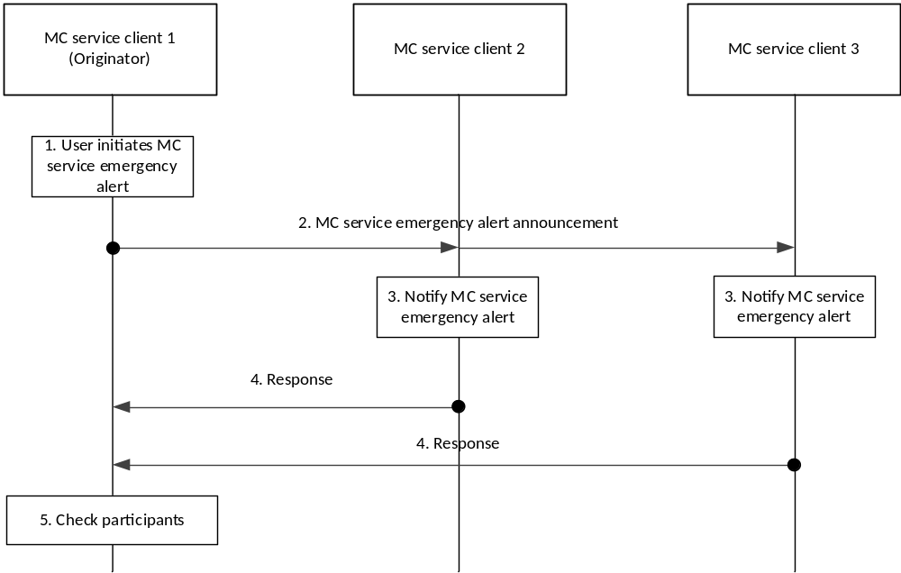
Figure 10.10.2.2.1-1: Emergency alert initiation
1. MC service client 1 sets its MC service emergency state. This MC service emergency state is retained by the MC service client until explicitly cancelled. Once MC service client1 is in the MC service emergency state, any communications initiated by MC service client 1, group or private, shall be initiated as emergency communications and shall receive priority treatment.
2. MC service client 1 sends an MC service emergency alert announcement to the other participants on the MC service emergency group. The MC service emergency alert announcement is sent periodically so that late joining MC service group members are notified.

NOTE 2: Sending the emergency alert without making a request to also start an MC service emergency communication does not put the group into the in-progress emergency state.
3. MC service users are notified of the MC service emergency state of the originating MC service user.
4. The MC service clients upon receiving the emergency alert announcement message acknowledge the MC service emergency alert to the originating MC service client.
NOTE 3: The MC service client 1 needs not initiate a group communication. For example, the MC service client can be configured to only allow alerts or the MC service user can choose not to make an MC service emergency group communication.
NOTE 4: MC service clients need to respond only to the first emergency alert announcement message that is received.
NOTE 5: It is configured if MC service client 1 will automatically trigger a subsequent MC service emergency group call.
5. The originating MC service client 1 checks the responses and may inform the MC service user of the MC service group members whose MC service clients responded.

10.10.2.2.2 Emergency alert cancel
An MC service client has initiated an MC service emergency alert, has entered the MC service emergency state and wishes to cancel the alert, informing the other MC service group members of the cancellation. As part of this process, the MC service client may also request the cancellation of the in-progress emergency state in the group if authorized to do so.
Procedures in figure 10.10.2.2.2-1 describe procedures for the MC service client cancelling an MC service emergency alert.
Pre-conditions:
1. The MC service client 1 has successfully initiated an MC service emergency alert and is in the MC service emergency state.
2. Information for ProSe direct communications corresponding to the MC service group and its mapping to ProSe Layer-2 Group ID are pre-configured in MC service client 1.
3. The initiating MC service client 1 and MC service clients 2 and 3 are still in off-network contact via the MC service group provisioned to MC service client 1 as for the MC service emergency group.

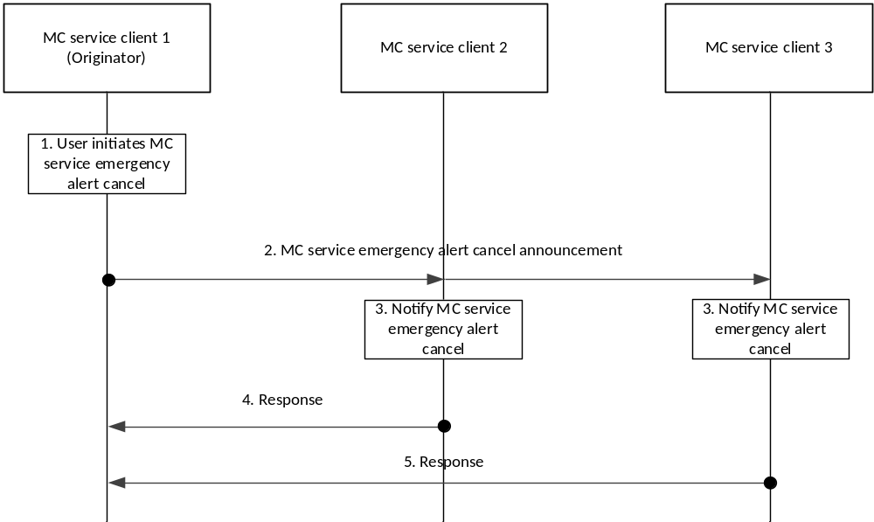
Figure 10.10.2.2.2-1 Emergency alert cancel
1. The user at the MC service client 1 initiates an MC service emergency alert cancel.
2. MC service client 1 sends an MC service emergency alert cancel announcement to the MC service group to which MC service client 1 had previously sent the emergency alert announcement message.
3. MC service users are notified of the MC service emergency alert cancellation by MC service client 1.
4. The receiving MC service clients acknowledge the MC service emergency alert cancel to the originating MC service client.
NOTE: MC service clients that track the MC service emergency alerts of other MC service users, e.g. clients that fail to receive subsequent periodic MC service emergency alert announcements after a configured timeout can consider the alert to be cancelled.

