3GPP TSG-SA WG6 Meeting #49-bis-e S6-222004
e-meeting, 22nd June – 1st July 2022 (revision of S6-221927)

Title: LS on Clarification of Edge Node Sharing
Response to:
Release: Release-18
Work Item: FS_eEDGEAPP

Source: 3GPP SA6
To: GSMA OPG
Cc: 3GPP SA2, 3GPP SA

Contact person: Yanmei Yang
yangyanmei@huawei.com

Send any reply LS to: 3GPP Liaisons Coordinator, mailto:3GPPLiaison@etsi.org

Attachments: None

1 Overall description
SA6 has specified edge enabling architecture (EDGEAPP) in 3GPP TS 23.558 in Rel.17. During Rel.18, eEDGEAPP study has captured Key Issue #22 (clause 4.22) in 3GPP TR 23.700-98 v1.0.1. This Key Issue is based on GSMA OPG requirements for Edge Node Sharing.

In Edge Node Sharing context, there are two separate actors or business entities defined by SA6 – PLMN operator and Edge Computing Service Provider (ECSP). It is possible that PLMN Operator and ECSP are same organization. For Edge Node Sharing aspects, SA6 mainly refer the clauses 3.3.5, 3.5.4.3.3, Annex A.2.1 and Annex A.2.2 specified in GSMA OPG Operator Platform Telco Edge Requirements (v2.0) – GSMA.OPG.02.

Please note, the SA6 discussion and the questions in this LS assume that the scenarios described are non-roaming.

Clause A.2.1 in GSMA.OPG.02 captures OP to 3GPP EDGEAPP mapping:
The illustration in Figure 19 of GSMA.OPG.02 shows Edge Enabler Server (EES) and Edge Configuration Server (ECS) are considered to be a part of Operator Platform. Edge Application Server(s) and Edge Enabler Server(s) are shown to utilize the Edge Node.

Clause A.2.2 shows EDGE-9 interface as E/WBI (not shown in Figure 19).

Considering the above, SA6 would like to ask GSMA OPG for further clarification as the following:

GSMA OPG.02, clause 3.3.5 Edge Node Sharing mentions:
“Two operators may decide to share edge nodes to maximise their edge presence. Using the figure below as an example, the mobile network of both operators covers the whole country. However, Partner A deploys edge sites in the country's North Region and operator B in the South Region. In this case, Operator B might deploy an application on Partner A's edge node while providing connectivity to the end-user over their own radio network”.

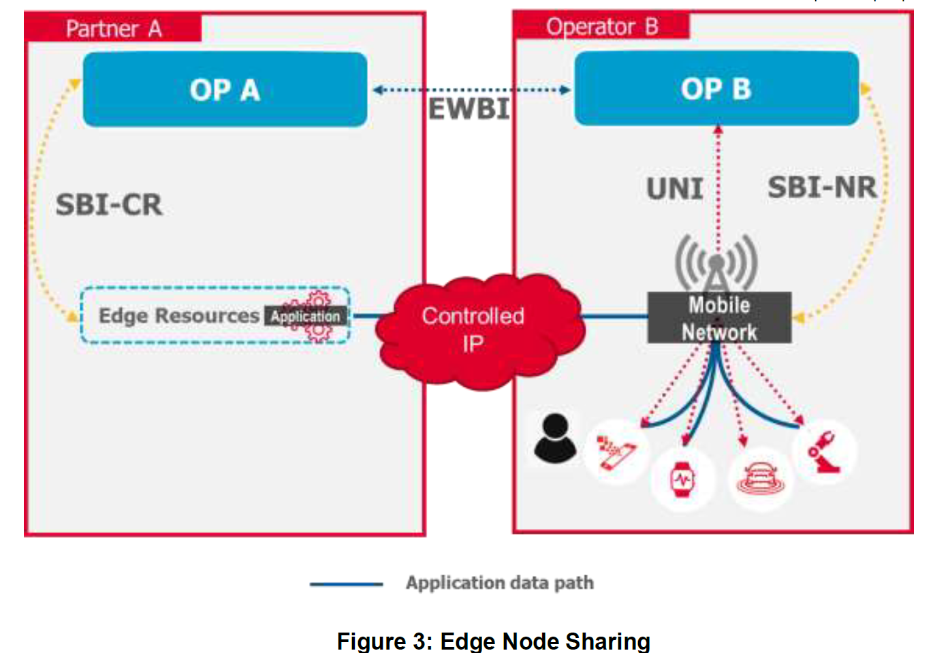
“Figure 3 above shows an end-user who is a subscriber of Operator B's OP services and is currently connected to Operator B's network in the country's north. Edge node sharing enables this end-user to access the Edge Cloud service, even though Operator B does not have their own edge resources in this Region; the Operator B Edge Cloud service is hosted on Partner A's edge node.”.

In this context, the following aspects require further clarifications:

Q1: Would GSMA OPG confirm the SA6 understanding that when the UE is located in the North Region, it is served by operator B’s PLMN when consuming an application on Partner A's edge node deployed in the North region?

Q2: Would GSMA OPG please provide the definition of and explain the relationship between edge node, edge sites and edge resources?

Q3: When UE further moves into the South Region, SA6 assumes that if the application is also deployed on Operator B’s edge node in the South Region, the UE can be served by the local application in Operator B’s edge node in the South Region. Would GSMA OPG please confirm the SA6 assumption?

Q4: When UE is served by Operator B’s mobile network in North region and its User Client (UC) is trying to discover edge application, is the UC aware of the Partner OP? Further, is there a requirement that the User Client be provided information (other than Application Endpoint exposure towards UC(s) via the UNI) about OP A by OP B? And if so, for what purpose?

NOTE: User Client (UC) as defined by GSMA OP is equivalent to Edge Enabler Client (EEC) as defined by 3GPP SA6.

Q5: Figure 3 shows that the UNI request is towards OP B, however, can a UNI request for availing OP services be sent directly towards OP A of Partner A in edge node sharing case?

Q6: Is GSMA considering an EES deployed in OP A (as depicted in figure 19 of GSMA OP.02) as also part of a shared edge node offered by Partner A (to Operator B) in clause 3.3.5 edge node sharing case?

Q7: Regarding the GSMA OPG figure 3, please clarify in which region OP B is deployed.
Considering this clarification, is it required that Operator B deploys an EES in OP B of the North region to obtain application services from the Partner A's shared edge node? Or is it required that Operator B deploys an EES in OP B of the South region to obtain services from the Partner A's shared edge node?

Q8: If EES (part of OP B) is deployed in Edge Node, then can EES be used to access services of Partner OP A also deployed in an Edge Node?

In addition, reading the following text from clause 3.5.4.3.3 in GSMA OPG requirement:

"Edge node sharing is a scenario wherein an OP, when serving the UNI requests originating from (its own) UCs, decides to provide the application from the Edge nodes of a partner OP (where the application is available). Like the scenario discussed in section 3.3.5, this decision may be due to the Operator's policy controls, specific Application Provider restrictions, due to constraints originating from the federation agreement between the Operators and others. An E/WBI service is required to support the publishing of application and Availability Zone information to enable specific applications to be served from a Leading OP’s Edge Cloud in the following scenarios:
• In a roaming scenario where local breakout (i.e. data plane access to Edge Cloud resources in visited network) is not available, the applications need to be served from the Home OP for consumption by roaming UCs;
• In a non-roaming scenario where an OP needs to allow its own UCs, the consumption of applications published by a Partner OP served from that partner’s Edge Cloud."

Q9: It is SA6 understanding that the Application Client in the UE consumes application services on the network and that the UC does not consume application services on the network. Is this understanding aligned with GSMA understanding? If not, would GSMA please clarify in which use cases the UC would consume application services?

Q10: Clarification is required on the following service consumption for edge node sharing scenarios:
- Is it possible that OP B will set certain limitation to allow only application clients serviced by its own UC(s) to consume the application deployed in its partner OP A?
- Can the application deployed by OP B in the partner OP A be consumed by application clients serviced by UCs from OP A?
- Can application clients serviced by UCs of OP B consume only application deployed by OP B in OP A?
- Can application clients serviced by UCs of OP B consume application services from OP A?

In SA6 context, Edge Computing Service Provider (which can be mapped to Operator Platform provider) can be a PLMN operator or a 3rd party (e.g. Hyper-scaler).

Q11: Taking into account GSMA OPG.02, Annex C.2, does GSMA have any position on whether it is possible that the OP is a 3rd party in figure 3 in clause 3.3.5 of GSMA OPG.02 for the Edge Node Sharing case?

In clause 3.5.4.3.1, following information is specified:
3.5.4.3.1 Application Onboarding Management Service
An OP shall use the Application Onboarding Management Service over E/WBI to onboard applications towards another OP.
The onboarding service shall include the following:
• Transfer application images (container per section 3.6 or VMs per section 3.7) and Application Provider criteria towards a partner OP. The procedure may also request the launch of application instance(s) in partner OP edge clouds as a follow-up action after onboarding.
• Transfer of other application-specific files, e.g. application manifest, specifying the workload information like mobility strategy, QoE and privacy policies, also other optional characteristics indicating the application's needs (flavours, latency, prioritization, reservation)
• Publishing of application information to support the Edge Node Sharing scenario (as described in Section 3.5.4.3.3)."

In clause 3.5.4.3.3, supported information for E/WBI is specified:
“The E/WBI service shall support the following information:
• Publish Application, including application metadata information (including information about the policies controlling application distribution restrictions)
• Availability Zones;
• Unpublish application; to cancel the availability of published application(s)
• Get a list of Applications; for an OP to retrieve the list of published application instances with specific criteria (e.g. edge location, availability zone, etc.)
• Get Application instance information; for an OP to retrieve the application instance information in the “Edge application profile” as part of the Common Data Model in section 3.4.2. Then, the OP serving the subscriber can use that information for sharing connection parameters with the UC (e.g. application IP address or access token).”

Also, from Annex A.2.2:
“3GPP SA6 defines the EDGE-9 interface for the Operator Platforms to communicate with each other, as defined for E/WBI.”.

In Release 17, the SA6 perspective is that EDGE-9 maps to E/WBI, and SA6 is also studying in Release 18 a new EDGE-10 interface between ECSs to fulfill OP requirement. To understand the realization of this mapping, the following questions require GSMA OPG feedback:

Q12: Is the publishing of application information part of the application onboarding management service or is it a subsequent triggered event upon instantiation of the application?

Q13: Are all the information specified in clause 3.5.4.3.3 part of Application onboarding management service? If not, what operations are related to the information not associated with the application onboarding management service?

SA6 requests GSMA OPG to provide response to the above questions.

2 Actions
To GSMA OPG
ACTION: SA6 requests GSMA OPG to provide response to the questions in order to progress the work in SA6 for edge node sharing.

3 Dates of next TSG SA WG 6 meetings
SA6#50-e 22nd August – 31st August 2022 online meeting
SA6#51-e 10th October – 19th October 2022 online meeting

