3GPP TSG-SA WG6 Meeting #49-bis-e S6-221927
e-meeting, 22nd June – 1st July 2022 (revision of S6-221755)

Title: LS on Clarification of Edge Node Sharing
Response to:
Release: Release-18
Work Item: FS_eEDGEAPP

Source: 3GPP SA6
To: GSMA OPG
Cc: 3GPP SA2

Contact person: Yanmei Yang
yangyanmei@huawei.com

Send any reply LS to: 3GPP Liaisons Coordinator, mailto:3GPPLiaison@etsi.org

Attachments:

1 Overall description
Currently, SA6 captured Key Issue #22 (clause 4.22) in 3GPP TR 23.700-98 v1.0.1. The Key Issue was originated from GSMA OPG requirement for Edge Node Sharing.
It is to be noted that in SA6, in Edge Node Sharing context, we have two separate entities – PLMN operator and Edge Computing Service Provider (ECSP). It is possible that PLMN Operator and ECSP are same provider.
Also, during the discussion, SA6 mainly referred to clause 3.3.5, 3.5.4.3.3, Annex A.2.1 and Annex A.2.2 of GSMA OPG Operator Platform Telco Edge Requirements (v2.0).

SA6 would like to ask GSMA OPG for further clarification as the following:

GSMA OPG.02, clause 3.3.5 Edge Node Sharing mentions:
“Two operators may decide to share edge nodes to maximise their edge presence. Using the figure below as an example, the mobile network of both operators covers the whole country. However, Partner A deploys edge sites in the country's North Region and operator B in the South Region. In this case, Operator B might deploy an application on Partner A's edge node while providing connectivity to the end-user over their own radio network”.

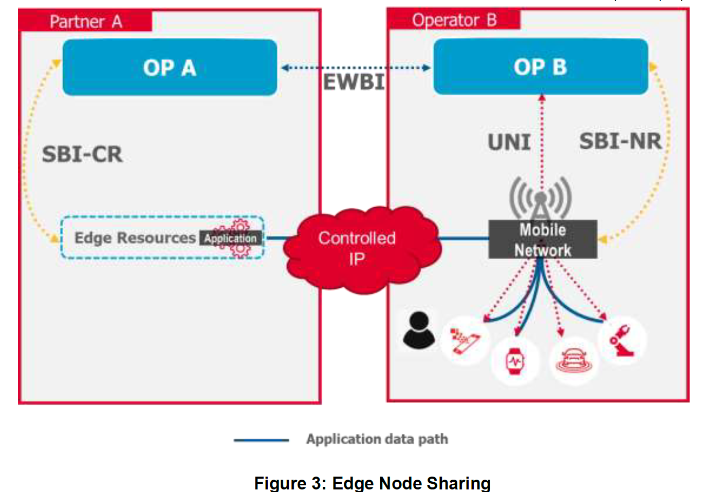
Q1: Figure 3 shows that Operator B provides PLMN connectivity to the UE. Considering, the mobile network of both operators covers the whole country, SA6 assumes that the UE can be located in the North Region and be served by operator B’s PLMN to consume an application on Partner A's edge node deployed in the North region. When UE moves into the South Region, is it possible that the application is deployed also on Partner B’s edge node in the South Region, so that the User Client doesn’t need to connect to the shared and relatively far-end application, instead, it can connect to the local application in the South Region?

Q2: In figure 3, when UE is served by Operator B’s mobile network and its User Client is trying to find edge application resources, is User Client aware of the information of OP A?

Q3: Figure 3 shows that the UNI request is towards OP B, can UNI request be sent towards OP A of Partner A in edge node sharing case, directly?

In addition, reading the following text from clause 3.5.4.3.3 in GSMA OPG requirement:

Edge node sharing is a scenario wherein an OP, when serving the UNI requests originating from (its own) UCs, decides to provide the application from the Edge nodes of a partner OP (where the application is available). Like the scenario discussed in section 3.3.5, this decision may be due to the Operator's policy controls, specific Application Provider restrictions, due to constraints originating from the federation agreement between the Operators and others. An E/WBI service is required to support the publishing of application and Availability Zone information to enable specific applications to be served from a Leading OP’s Edge Cloud in the following scenarios:
• In a roaming scenario where local breakout (i.e. data plane access to Edge Cloud resources in visited network) is not available, the applications need to be served from the Home OP for consumption by roaming UCs;
• In a non-roaming scenario where an OP needs to allow its own UCs, the consumption of applications published by a Partner OP served from that partner’s Edge Cloud.

Q4a: In SA6 understanding, it is Application Client which consumes the service provided by application instances, not User Client. Can GSMA OPG clarify in which case the User client consumes the application instances?
Q4b: With SA6 understanding that User Client consumes services provided by OP, not Application Instance. If above requirement actually means UC serving Application Client trying to find application instance for AC to consume, is it possible that OP B will set certain limitation to allow only its own User Client to find an application instance deployed in its partner OP A for its AC to consume, or the application instance in the partner OP can be found by any other User client (e.g. OP-A’s User Clients) to service its AC?

Q4c) Further, can User Client of OP B find only application instance deployed by OP B in OP A to service its AC or they can find other application instances also deployed in OP A to service its AC?

Q5: In SA6 context, Edge Computing Service Provider (which can be mapped to Operator Platform provider) can be a PLMN operator or a 3rd party. Is it possible that the OP is a 3rd party in figure 3 for the Edge Node Sharing case?

SA6 would like to request answers to the above questions from GSMA OPG

2 Actions
To GSMA OPG
ACTION: SA6 requests GSMA to provide response to the questions in order to proceed the work in SA6 for edge node sharing.

3 Dates of next TSG SA WG 6 meetings
SA6#50-e 22nd August – 31st August 2022 online meeting
SA6#51-e 10th October – 19th October 2022 online meeting

