3GPP TSG-SA WG6 Meeting #43 S6-21xxxx
e-meeting, 24th May - 2nd June 2021

Source: Huawei, Hisilicon
Title: Coordination of the relocation of EEC context and application context
Spec: 3GPP TS 23.558 v2.1.0
Agenda item: 7.6
Document for: Approval
Contact: Huyajie (Huyajie1@huawei.com)

1. Introduction
The contribution is introduced to coordination of the relocation of EEC context and application context in the ACR procedure.
2. Reason for Change
For EEC context, there are two kinds of EEC context residing in the EES including EEC registration information and the subscription information of EES capability exposure to EAS. And the EEC context should be transferred along with the application context.
However, during the ACR procedure, if the EEC context and the application context transmission fail, it is necessary to introduce a mechanism to deal with the failure.
3. Proposal
It is proposed to agree the following changes to 3GPP TS 23.558 v2.1.0.

* * * First Change * * * *

8.8.2.3 EEC executed ACR via S-EES
Figure 8.8.2.3-1 illustrates the procedure for the EEC to execute the ACR via S-EES.
Pre-condition:
1. The AC at the UE already has a connection to the S-EAS; and
2. The EEC is able to communicate with the S-EES.
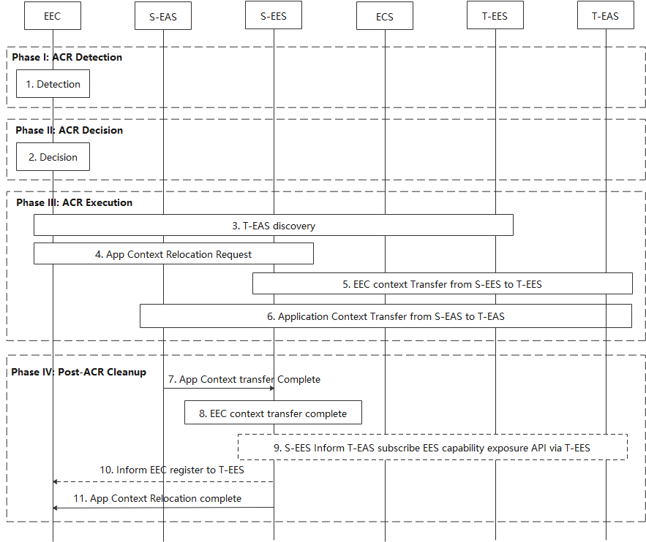
Figure 8.8.2.3-1: EEC executed ACR procedure
Phase I: ACR Detection
1. The EEC detects that ACR may be required as described in clause 8.8.1. The EEC may detect that ACR may be required for an expected or predicted UE location in the future as described in clause 8.8.1.
Phase II: ACR Decision
2. The EEC decides to proceed required procedures for triggering ACR.
Phase III: ACR Execution
3. The EEC determines the T-EES by using the provisioned information or performing service provisioning procedure per clause 8.3 of the present document. When in step 1 the ACR for service continuity planning is triggered, then the Connectivity information and UE Location in the Service Provisioning (as specified in clause 8.3) procedure contains the expected Connectivity information and expected UE Location. If the UE is within the service area of the T-EES, upon selecting T-EES the UE may need to establish a new PDU connection to the target EDN. The EEC can then discover and select T-EAS by performing EAS Discovery with the T-EES per clause 8.5.2 of the present document.
4. The EEC performs ACR launching procedure (as described in 8.8.3.4) to the S-EES with the ACR action indicating ACR initiation and the corresponding ACR initiation data (with the need to notify the EAS). The S-EES authorises the request from the EEC. The S-EES decides to execute ACR based on the information received from the EEC, EEC context and/or EAS profile, The S-EES may apply the AF traffic influence with the N6 routing information of the T-EAS in the 3GPP Core Network (if applicable) and sends the ACR Notify message to the S-EAS to initiate ACT between the S-EAS and the T-EAS. The EEC also subscribes to receive ACR information notifications for ACR complete events from the S-EES, as described in clause 8.8.3.5.2.
5. If f the T-EES is different than the S-EES, the S-EES initiates EEC Context Push relocation with the T-EES.
6. The S-EAS transfers the application context to the T-EAS at implementation specific time. This process is out of scope of the present specification.
Phase IV: Post-ACR Clean up
When in step 1 the ACR has been triggered for service continuity planning, if the UE does not move to the predicted location, the EEC does not connect to T-EES, the AC does not connect to the T-EAS. Steps 6 and 7 are skipped.
NOTE: When in step 1 the ACR for service continuity planning is triggered, steps 6 and 7 are performed after the UE moves to the predicted location.
7. The S-EAS sends the ACR Complete message to the S-EES to confirm that the ACR has completed.
8. S-EES detects the EEC context transfer complete.
9-10. If S-EES detects the application context transmission is success and the EEC context transmission is failed, the S-EES determines to inform the T-EAS via T-EES to subscribe EES capability exposure API and informs the EEC to register to T-EES, or S-EES determines to re-transfer the EEC context to the T-EES.
11. The S-EES sends the ACR information notification message to the EEC to confirm that the ACR has completed as specified in clause 8.8.3.5.3.

* * * Next Change * * * *

8.8.2.4 S-EAS decided ACR scenario
The procedure in this clause illustrates the scenario for S-EAS decided ACR.
In this procedure, the S-EAS may detect the need of ACR locally or is notified by the S-EES. The S-EAS make the decision about whether to perform the ACR, and starts the ACR at a proper time.
Pre-conditions:
1. The S-EAS may depend on the receipt of certain User plane path management events from the S-EES, e.g. "user plane path change" events or "ACR monitoring" events, to detect the need for an ACR. For the following procedure it is assumed that the S-EAS has subscribed to continuously receive the respective events from the S-EES; and
2. The EEC has subscribed to receive ACR information notifications for target information notification events and ACR complete events from the S-EES, as described in clause 8.8.3.5.2.
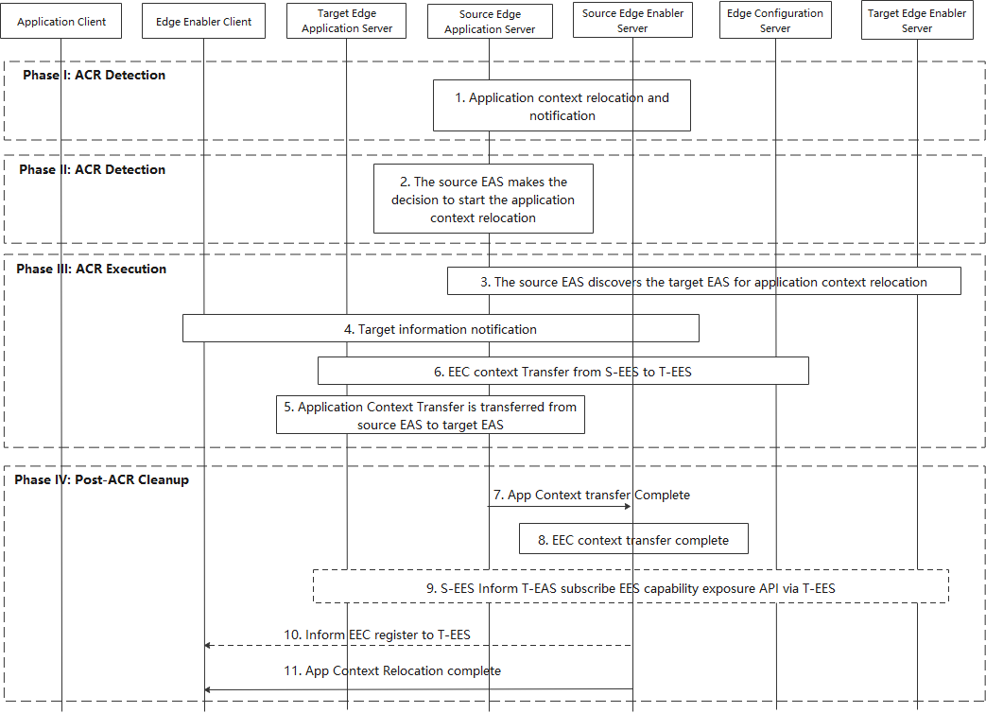
Figure 8.8.2.4-1: S-EAS decided ACR scenario
The S-EAS decided ACR scenario is outlined with four main phases: detection, decision, execution and clean up.
Phase I: ACR Detection
1. The S-EAS either receives notifications from source Edge Enabler Sever indicating that ACR may be required ("ACR monitoring" event), or self detects the need for ACR (e.g. upon receipt of a "user plane path change" event). If the notification indicates "ACR monitoring" event, then the notification will also contain the T-EAS information (see clause 8.6.3.2.3). The S-EAS may detect that ACR may be required for an expected or predicted UE location in the future as described in clause 8.8.1.
NOTE 1: How the S-EAS self detects the local need for ACR is outside the scope of this specification.
Phase II: ACR Decision
2. The S-EAS makes the decision to perform the ACR
NOTE 2: How the S-EAS determines when to start the ACR is outside the scope of this specification.
Phase III: ACR Execution
3. The S-EAS discovers the T-EAS as described in clause 8.8.3.2. When in step 1 the ACR has been triggered for service continuity planning, then UE Location and Target DNAI values in the Retrieve T-EES procedure contain the expected UE Location and expected Target DNAI. After S-EAS determines the T-EAS to use, the S-EAS may apply the AF traffic influence with the N6 routing information of the T-EAS in the 3GPP Core Network (if applicable).
4. The S-EES sends the target information notification to the EEC as described in clause 8.8.3.5.3.
5. If the T-EES is different than the S-EES, the S-EES initiates EEC Context Push relocation with the T-EES.
6. The S-EAS transfers the application context to the T-EAS selected in step 3. This process is out of scope of the present specification.
Phase IV: Post-ACR clean up
When in step 1 the ACR has been triggered for service continuity planning, if the UE does not move to the predicted location, the EEC does not connect to T-EES, the AC does not connect to the T-EAS. Step 6 is skipped.
NOTE 3: When in step 1 the ACR has been triggered for service continuity planning, step 6 would only be performed after the UE moves to the expected location.
7. All required entities perform clean-up. The S-EAS informs the S-EES of the complete of ACT
8. S-EES detects the EEC context transfer complete.
9-10. If S-EES detects the application context transmission is success and the EEC context transmission is failed, the S-EES determines to inform the T-EAS via T-EES to subscribe EES capability exposure API and informs the EEC to register to T-EES, or S-EES determines to re-transfer the EEC context to the T-EES.
11. The S-EES informs the EEC of the completion of ACR as described in clause 8.8.3.5.3, when the application context transmission and EEC context transmission are both success or failed.

* * * Next Change * * * *

8.8.2.5 S-EES executed ACR
Figure 8.8.2.5-1 illustrates the procedure for the S-EES to detect, decide and execute the ACR from the S-EAS to the T-EAS. This procedure may support automated ACR by S-EES when initiated by S-EAS as per clause 8.8.3.6.
Editor's note: Usage of network path information for the scenarios in clause 8.8.2.5 is FFS.
Pre-condition:
1. The AC at the UE already has a connection to the S-EAS;
2. The EEC is able to communicate with the S-EES; and
3. The EEC has subscribed to receive ACR information notifications for target information notification events and ACR complete events from the S-EES, as described in clause 8.8.3.5.2.
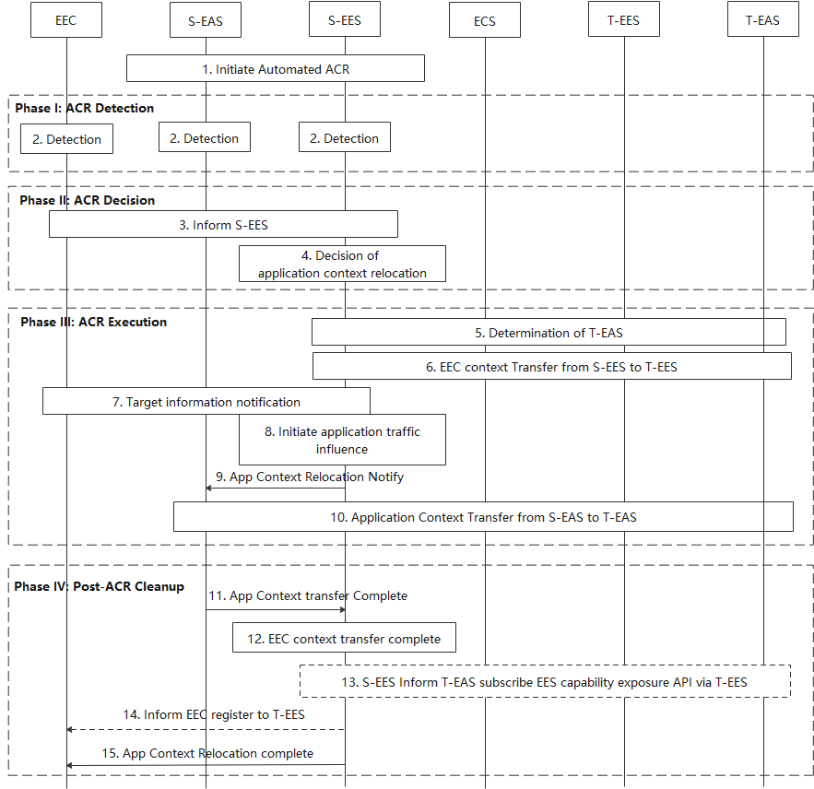
Figure 8.8.2.5-1: S-EES executed ACR procedure
1. The S-EAS may initiate Automated ACR with S-EES as specified in clause 8.8.3.6. In this step, the S-EAS and S-EES negotiate an address of the Application Context storage to S-EES. The S-EAS puts the Application Context at this address which can be further accessed by the S-EES when the ACT is required.
In this case, the S-EES executes steps 2 (i.e., S-EES detection), 4, 5, 6, 7, 8, 9 and 11. Rest of steps are skipped.
Phase I: ACR Detection
2. Detection entities (S-EAS, S-EES, EEC) detects that ACR may be required as described in clause 8.8.1. The detection by the S-EES may be triggered by the User Plane path change notification received from the 3GPP Core Network due to S-EAS request for "ACR facilitation" event (see clause 8.6.3).
The detection entity may detect that ACR may be required for an expected or predicted UE location in the future as described in clause 8.8.1.
3. The detection entity performs ACR launching procedure (as described in 8.8.3.4) with the ACR action indicating ACR determination and the corresponding ACR determination data.
Phase II: ACR Decision
4. The S-EES authorises the message if received. The S-EES decides to execute ACR based on the information received or local detection, and the information of EEC context or EAS profile, and then proceed the below steps.
Phase III: ACR Execution
5. The S-EES determines T-EES and T-EAS via the Discover T-EAS procedure in clause 8.8.3.2 of the present document. When in step 2 the ACR has been triggered for service continuity planning, then UE Location and Target DNAI values provided in the Retrieve T-EES procedure contain the expected UE Location and expected Target DNAI. The S-EES may decide not to perform ACR if T-EAS is not available.
6. If the T-EES is different than the S-EES, the S-EES initiates EEC Context Push relocation with the T-EES.
7. The S-EES sends the target information notification to the EEC as described in clause 8.8.3.5.3.
8. The S-EES may apply the AF traffic influence with the N6 routing information of the T-EAS in the 3GPP Core Network (if applicable).
9. The S-EES sends the ACR Notify message (e.g. as notification for "ACR facilitation" event) to the S-EAS to initiate ACT between the S-EAS and the T-EAS.
10. The Application Context is transferred from S-EAS to the T-EAS at implementation specific time. In the case of automated ACR, the S-EES accesses the Application Context from the address as per step 1 and the S-EES and T-EES engage in the ACT from S-EAS to the T-EAS (obtained as per step 5) in a secure way. Further the T-EAS accesses the Application Context made available by the T-EES. If S-EAS performs the ACT directly with T-EAS, the specification of such process is out of scope of the present document.
NOTE 1: The Application Context is encrypted and protected by the application layer. The S-EES and the T-EES engage in the packet level transport of the Application Context and they have no visibility to the content of the Application Context.
Phase IV: Post-ACR Clean up
When in step 2 the ACR has been triggered for service continuity planning, if the UE does not move to the predicted location, the EEC does not connect to T-EES, the AC does not connect to the T-EAS. Steps 10 and 11 are skipped.
NOTE 2: When in step 2 the ACR has been triggered for service continuity planning, steps 10 and 11 would only be performed after the UE moves to the expected location.
11. The S-EAS sends the ACR Complete message to the S-EES to confirm that the ACR has completed.
12. S-EES detects the EEC context transfer complete.
13-14. If S-EES detects the application context transmission is success and the EEC context transmission is failed, the S-EES determines to inform the T-EAS via T-EES to subscribe EES capability exposure API and informs the EEC to register to T-EES, or S-EES determines to re-transfer the EEC context to the T-EES.
15. The S-EES sends the ACR information notification message to the EEC to confirm that the ACR has completed as specified in clause 8.8.3.5.3.
NOTE 3: The Application Client mechanism to support switchover of the application traffic to T-EAS is out of scope of the specification.

* * * Next Change * * * *

8.8.2.6 EEC executed ACR via T-EES
Figure 8.8.2.6-1 illustrates the procedure for the EEC to execute the ACR via T-EES.
Pre-condition:
1. The EEC has the S-EAS information that serves the AC.
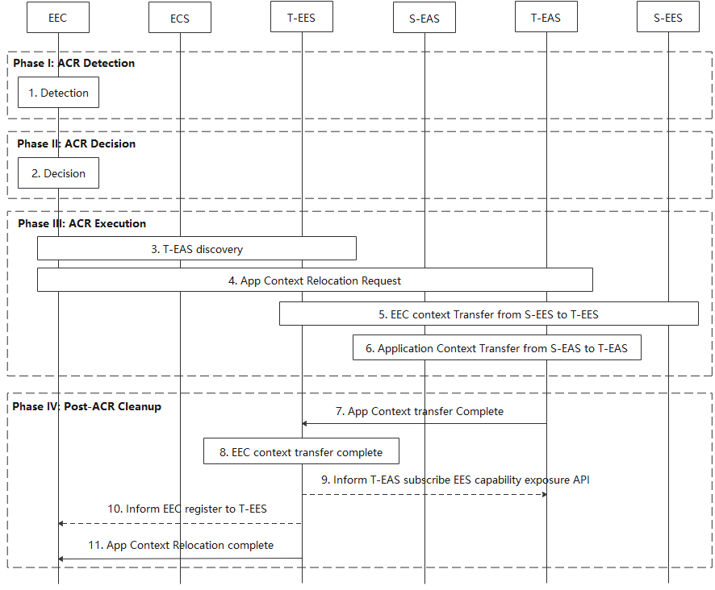
Figure 8.8.2.6-1: EEC executed ACR via T-EES
Phase I: ACR Detection
1. The EEC detects that ACR may be required as described in clause 8.8.1. The EEC may detect that ACR may be required for an expected or predicted UE location in the future as described in clause 8.8.1.
Phase II: ACR Decision
2. The EEC decides to proceed with required procedures for ACR.
NOTE 1: If supported, the AC can be involved in the decision. It is out of scope of the present document how the AC is involved.
Phase III: ACR Execution
3. The EEC determines the T-EES by using the provisioned information or performing service provisioning procedure per clause 8.3. When in step 1 the ACR for service continuity planning is triggered, then the Connectivity information and UE Location used in the service provisioning procedure contain the expected Connectivity information and expected UE Location. If the UE is within the service area of the T-EES, upon selecting the T-EES the UE may need to establish a new PDU connection to the target EDN. The EEC performs EAS Discovery with the T-EES per clause 8.5.2.
4. The EEC performs ACR launching procedure (as described in 8.8.3.4) to the T-EES with the ACR action indicating ACR initiation and the corresponding ACR initiation data (with the need to notify the EAS). The T-EES may apply the AF traffic influence with the N6 routing information of the T-EAS in the 3GPP Core Network (if applicable). Then the T-EES sends the ACR Notify message to the T-EAS. The EEC also subscribes to receive ACR information notifications for ACR complete events from the T-EES, as described in clause 8.8.3.5.2.
5. If the T-EES is different than the S-EES, the T-EES initiates EEC Context Pull relocation with the T-EES.
6. The T-EAS initiates ACT between the S-EAS and the T-EAS. This process is out of scope of the present specification.
Phase IV: Post-ACR clean up
When in step 1 the ACR has been triggered for service continuity planning, if the UE does not move to the predicted location the EEC does not connect to T-EES, the AC does not connect to the T-EAS. Steps 6 and 7 are skipped.
NOTE 2: When in step 1 the ACR has been triggered for service continuity planning, steps 6 and 7 would only be performed after the UE moves to the expected location.
7. The T-EAS sends the ACR Complete message to the T-EES to confirm that the ACR has completed.
8. T-EES detects the EEC context transfer complete.
9-10. If T-EES detects the application context transmission is success and the EEC context transmission is failed, the T-EES determines to inform the T-EAS to subscribe EES capability exposure API and informs the EEC to register to T-EES if it is required.
11. The T-EES sends the ACR information notification message to the EEC as described in clause 8.8.3.5.3, when the application context transmission and EEC context transmission are both success or failed.
If the procedure fails after step 4, it will be terminated with an appropriate cause in the ACR Response message to the EEC in step 7. The EEC may then proceed attempting to obtain services from the T-EAS discovered in step 3 without service continuity support. Alternatively, the EEC may resume the present procedure starting with step 3 and selecting a different T-EES.
NOTE 3: The support of ACR between EDNs operated by different ECSPs is dependent on business agreement between the ECSPs.
Editor's note: When the procedure fails, the use of other mechanisms to alleviate this failure is FFS.

* * * End of Change * * * *

