3GPP TS 32.275 V9.6.0 (2013-09)
Technical Specification



3rd Generation Partnership Project;
Technical Specification Group Services and System Aspects;
Telecommunication management;
Charging management;
MultiMedia Telephony (MMTel) charging
(Release 9)
Keywords
charging, accounting, management AVP, IMS, MMTel, Multimedia, Supplementary Service
3GPP
Postal address

3GPP support office address
650 Route des Lucioles - Sophia Antipolis
Valbonne - FRANCE
Tel.: +33 4 92 94 42 00 Fax: +33 4 93 65 47 16
Internet
http://www.3gpp.org
Copyright Notification
No part may be reproduced except as authorized by written permission.
The copyright and the foregoing restriction extend to reproduction in all media.

© 2013, 3GPP Organizational Partners (ARIB, ATIS, CCSA, ETSI, TTA, TTC).
All rights reserved.
UMTS™ is a Trade Mark of ETSI registered for the benefit of its members
3GPP™ is a Trade Mark of ETSI registered for the benefit of its Members and of the 3GPP Organizational Partners
LTE™ is a Trade Mark of ETSI currently being registered for the benefit of its Members and of the 3GPP Organizational Partners
GSM® and the GSM logo are registered and owned by the GSM Association
Contents
Foreword 6
1 Scope 7
2 References 8
3 Definitions and abbreviations 10
3.2 Abbreviations 10
4 Architecture Considerations 11
4.1 High level MMTel architecture 11
4.2 MMTel offline charging architecture 11
4.3 MMTel online charging architecture 12
5 MMTel charging principles and scenarios 13
5.1 MMTel charging principles 14
5.1.1 Supplementary services invocation 14
5.1.1.1 OIP charging 14
5.1.1.2 OIR charging 14
5.1.1.3 TIP charging 15
5.1.1.4 TIR charging 15
5.1.1.5 HOLD charging 15
5.1.1.6 CB charging 15
5.1.1.7 CDIV charging 15
5.1.1.8 CW charging 16
5.1.1.9 ECT charging 16
5.1.1.10 MWI charging 16
5.1.1.11 CONF charging 16
5.1.1.12 CCBS charging 17
5.1.1.13 CCNR charging 17
5.1.1.14 Flexible Alerting charging 17
5.1.1.15 MCID charging 17
5.1.1.16 CAT charging 18
5.1.1.17 CUG charging 18
5.1.1.18 Personal Network Management Charging 18
5.1.1.19 Customized Ringing Signal Charging 18
5.1.1.20 Reverse Charging 18
5.1.2 Supplementary services management by User 19
5.2 MMTel offline charging scenarios 19
5.2.2 Diameter message flows 19
5.2.2.1 Message Flows - Successful Cases and Scenarios 19
5.2.2.1.1 OIP Originating Identification Presentation 19
5.2.2.1.2 Originating Identification Restriction (OIR) 20
5.2.2.1.3 Terminating Identification Presentation (TIP) 21
5.2.2.1.4 Terminating Identification Restriction (TIR) 22
5.2.2.1.5 Communication Hold (HOLD) 23
5.2.2.1.6 Communication Barring – CB (ICB/ACB) 24
5.2.2.1.6.1 Communication Barring (CB) – ICB and ACR 24
5.2.2.1.6.2 Communication Barring (CB) – OCB 25
5.2.2.1.7 Communications Diversion (CDIV) 26
5.2.2.1.7.1 Communications Diversion (CDIV) – successful establishment 26
5.2.2.1.7.2 Communications Diversion (CDIV) – release 28
5.2.2.1.8 Communication Waiting (CW) Charging 29
5.2.2.1.9 Explicit Communication transfer (ECT) 31
5.2.2.1.9.1 Explicit Communication transfer (ECT) : Blind Transfer 31
5.2.2.1.9.2 Explicit Communication transfer (ECT)) : Release 34
5.2.2.1.10 Message Waiting Indication Charging (MWI) 35
5.2.2.1.11 CONF Charging 36
5.2.2.1.11.1 CONF Charging – user creating a conference 37
5.2.2.1.11.2 CONF Charging – user joining a conference 38
5.2.2.1.11.3 CONF Charging – user inviting another user to a conference 39
5.2.2.1.11.4 CONF Charging – user leaving a conference 39
5.2.2.1.11.5 Three-Party (3PTY) Charging – successful establishment 40
5.2.2.1.11.6 Three-Party (3PTY) Charging – release 42
5.2.2.1.12 CCBS Charging 43
5.2.2.1.13 CCNR Charging 45
5.2.2.1.14 Flexible Alerting (FA) 47
5.2.2.1.14.1 Flexible Alerting (FA) - establishment 47
5.2.2.1.14.2 Flexible Alerting (FA) – call release 49
5.2.2.1.15 Malicious Communication Identification (MCID) 49
5.2.2.1.16 Customized Alerting Tone (CAT) 51
5.2.2.1.17 Closed User Group (CUG) 53
5.2.2.1.17.1 Closed User Group (CUG): Originating 53
5.2.2.1.17.2 Closed User Group (CUG): Terminating 54
5.2.2.1.18 Personal Network Management 55
5.2.2.1.19 Customized Ringing Signal (CRS) 57
5.2.3 GTP’ record transfer flows 59
5.2.4 B_{I} CDR file transfer 59
5.3 MMTel online charging scenarios 59
5.3.1 Basic principles 59
5.3.2 Diameter message flows 59
5.3.2.1 Message Flows - Successful Cases and Scenarios 60
5.3.2.1.0 Interaction with IMS-GWF 60
5.3.2.1.1 Communications Diversion (CDIV) 61
5.3.2.1.1.1 Communications Diversion (CDIV) – successful establishment 61
5.3.2.1.1.2 Communications Diversion (CDIV) – release 62
5.3.2.1.2 Flexible Alerting (FA) 62
5.3.2.1.3 Closed User Group (CUG) 64
5.3.2.1.3.1 Closed User Group (CUG): Originating 64
5.3.2.1.3.2 Closed User Group (CUG): Terminating 66
5.3.2.1.4 Conference (CONF) 68
5.3.2.1.4.1 CONF – user creating a conference - ECUR mode 68
5.3.2.1.4.2 CONF – user creating a conference - SCUR mode 69
5.3.2.1.4.3 CONF – user joining a conference (SCUR mode) 70
5.3.2.1.4.4 CONF – user inviting another user to a conference (SCUR mode) 71
5.3.2.1.4.5 CONF – user leaving a conference (SCUR mode) 72
5.3.2.1.4.6 CONF (3PTY) – successful establishment 73
5.3.2.1.5 Explicit Communication transfer (ECT) 75
5.3.2.1.5.1 Explicit Communication transfer (ECT): Blind Transfer with sending REFER 75
5.3.2.1.5.2 Explicit Communication transfer (ECT): Blind Transfer with 3PCC 79
5.3.2.1.5.3 Explicit Communication transfer (ECT): Release 80
5.2.2.2 Message Flows - Error Cases and Scenarios 82
6 Definition of charging information 83
6.1 Data description for MMTel offline charging 83
6.1.1 Rf message contents 83
6.1.1.1 Charging Data-Request Message Description 83
6.1.1.2 Charging Data Response Message Description 83
6.1.2 GTP’ message contents 83
6.1.3 CDR Description on the Bi Interface 83
6.1.3.1 CDR Field Type 83
6.1.3.2 CDR Triggers 84
6.1.3.3 MMTel-AS CDR Content 85
6.2 Data description for MMTel online charging 86
6.2.1 Ro message contents 86
6.2.1.1 Debit and Reserve Units Request Message 86
6.2.1.2 Debit and Reserve Units Response Message 86
6.3 MMTel Charging Specific Parameters 86
6.3.1 Definition of MMTel charging information 86
6.3.1.1 MMTel charging information assignment for Service Information 87
6.3.1.2 Definition of the MMTel Information 87
6.3.1.3 Support of MMTel Information in MMTel Offline Charging 88
6.3.1.4 Support of MMTel Information in MMTel Online Charging 89
Annex A (informative): Bibliography 91
Annex B (informative): Change history 92

Foreword
This Technical Specification has been produced by the 3rd Generation Partnership Project (3GPP).
The contents of the present document are subject to continuing work within the TSG and may change following formal TSG approval. Should the TSG modify the contents of the present document, it will be re-released by the TSG with an identifying change of release date and an increase in version number as follows:
Version x.y.z
where:
x the first digit:
1 presented to TSG for information;
2 presented to TSG for approval;
3 or greater indicates TSG approved document under change control.
y the second digit is incremented for all changes of substance, i.e. technical enhancements, corrections, updates, etc.
z the third digit is incremented when editorial only changes have been incorporated in the document.

1 Scope
The present document is part of a series of documents that specify charging functionality and charging management in GSM/UMTS networks. The GSM/UMTS core network charging architecture and principles are specified in 3GPP TS 32.240 [1], which provides an umbrella for other charging management TSs that specify:
- the content of the CDRs per domain and subsystem (offline charging),
- the content of real-time charging messages per domain / subsystem (online charging);
- the functionality of online and offline charging for those domains and subsystems;
- the interfaces that are used in the charging framework to transfer the charging information (i.e. CDRs or charging events)
The complete document structure for these TSs is defined in TS 32.240 [1].
The present document specifies the Offline and Online Charging for MultiMedia Telephony (MMTel) service and supplementary services, based on the functional description of MMTel in 3GPP TS 22.173 [200]. Charging for the following supplementary services is specified:
- Communications Diversion (CDIV)
- Communication Hold (HOLD)
- CONFerence (CONF)
- Message Waiting Indication (MWI)
- Originating Identity Presentation (OIP) / Originating Identity Restriction (OIR)
- Terminating Identity Presentation (TIP) / Terminating Identity Restriction (TIR)
- Call Barring (CB)
- Explicit Call Transfer (ECT)
- Communication Wait (CW)
- Completion of Communications to Busy Subscriber (CCBS)
- Completion of Communications by No Reply (CCNR)
- Malicious Communication Identification (MCID)
- Customized Alerting Tone (CAT)
- Closed User Group (CUG)
- Personal Network Management (PNM)
- Customized Ringing Signal (CRS)
- Reverse Charging
Charging of these supplementary services is performed at the respective MMTel AS. The MMTel charging aspects are an extension of the basic IMS charging capabilities as specified in the TS 32.260 [20].
This charging description includes the offline and online charging architecture and scenarios specific to the MMTel, as well as the mapping of the common 3GPP charging architecture specified in TS 32.240 [1] onto the MMTel. It further specifies the structure and content of the CDRs for offline charging, and the charging events for online charging.
The present document is related to other 3GPP charging TSs as follows:
- The common 3GPP charging architecture is specified in TS 32.240 [1];
- The common IMS charging principles are specified in the TS 32.260 [20].
- The parameters, abstract syntax and encoding rules for these CDR types are specified in TS 32.298 [51].
- A transaction based mechanism for the transfer of CDRs within the network is specified in TS 32.295 [54].
- The file based mechanism used to transfer the CDRs from the network to the operator’s billing domain (e.g. the billing system or a mediation device) is specified in TS 32.297 [52].
- The 3GPP Diameter application that is used for MMTel offline and online charging is specified in
TS 32.299 [50].
All references, abbreviations, definitions, descriptions, principles and requirements, used in the present document, that are common across 3GPP TSs, are defined in the 3GPP Vocabulary, TR 21.905 [100]. Those that are common across charging management in GSM/UMTS domains or subsystems are provided in the umbrella document TS 32.240 [1]. Finally, those items that are specific to the present document are defined exclusively in the present document.

2 References
The following documents contain provisions which, through reference in this text, constitute provisions of the present document.
- References are either specific (identified by date of publication, edition number, version number, etc.) or non-specific.
- For a specific reference, subsequent revisions do not apply.
- For a non-specific reference, the latest version applies. In the case of a reference to a 3GPP document (including a GSM document), a non-specific reference implicitly refers to the latest version of that document in the same Release as the present document.
[1] 3GPP TS 32.240: "Telecommunication management; charging management; charging architecture and principles".
[2]-[19] Void
[20] 3GPP TS 32.260: "Telecommunication management; Charging management; IP Multimedia Subsystem (IMS) charging".
[21]-[49] Void.
[50] 3GPP TS 32.299: "Telecommunication management; Charging management; Diameter charging application".
[51] 3GPP TS 32.298: "Telecommunication management; Charging management; Charging Data Record (CDR) parameter description".
[52] 3GPP TS 32.297: "Telecommunication management; Charging management; Charging Data Record (CDR) file format and transfer".
[53] 3GPP TS 32.296: "Telecommunication management; Charging management; Online Charging System (OCS) applications and interfaces".
[54] 3GPP TS 32.295: "Telecommunication management; Charging management; Charging Data Record (CDR) transfer".
[55]-[99] Void.
[100] 3GPP TR 21.905: "Vocabulary for 3GPP Specifications".
[101] 3GPP TS 22.101: "Service aspects; Service Principles".
[102] 3GPP TS 22.115: "Service aspects; Charging and billing".
[103] 3GPP TS 23.002: "Network Architecture".
[104]-[199] Void.
[200] 3GPP TS 22.173: " Multimedia Telephony Service and supplementary services;stage 1".
[201] 3GPP TS 24.173: "IMS multimedia telephony communications service and supplementary services stage3".
[202] 3GPP TS 24.604: "TISPAN- PSTN/ISDN simulation services: Communication Diversion (CDIV);
Protocol specification".
[203] 3GPP TS 24.605: . "Conference (CONF) using IP Multimedia (IM) Core Network (CN) subsystem; Protocol specification".
[204] 3GPP TS 24.606: "Message Waiting Indication (MWI) using IP Multimedia (IM) Core Network (CN) subsystem; Protocol specification". .
[205] 3GPP TS 24.607: "Originating Identification Presentation (OIP) and Originating Identification Restriction (OIR) using IP Multimedia (IM) Core Network (CN) subsystem; Protocol specification".
[206] 3GPP TS 24.608: "Terminating Identification Presentation (TIP) and Terminating Identification Restriction (TIR)using IP Multimedia (IM) Core Network (CN) subsystem; Protocol specification".
[207] 3GPP TS 24.610: "Communication HOLD (HOLD) using IP Multimedia (IM) Core Network (CN) subsystem; Protocol specification".
[208] 3GPP TS 24.611: "Anonymous Communication Rejection (ACR) and Communication Barring (CB)using IP Multimedia (IM) Core Network (CN) subsystem; Protocol specification".
[209] 3GPP TS 24.615: "Communication Waiting (CW) using IP Multimedia (IM) Core Network (CN) subsystem; Protocol Specfication".
[210] 3GPP TS 24.616: "Malicious Communication Identification (MCID) using IP Multimedia (IM) Core Network (CN) subsystem; Protocol specification".
[211] 3GPP TS 24.623: "Extensible Markup Language (XML) Configuration Access Protocol (XCAP) over the Ut interface for Manipulating Simulation Services".
[212] 3GPP TS 24.629: "Explicit Communication Transfer (ECT) using IP Multimedia (IM)Core Network (CN) subsystem;; Protocol specification".
[213] 3GPP TS 24.642: "Completion of Communications to Busy Subscriber (CCBS) and Completion of Communications by No Reply (CCNR) using IP Multimedia (IM)Core Network (CN) subsystem; Protocol Specification".
[214] 3GPP TS 24.647: "Advice Of Charge (AOC) using IP Multimedia (IM)Core Network (CN) subsystem; Protocol Specification".
[215] 3GPP TS 24.654: "Closed User Group (CUG) using IP Multimedia (IM) Core Network (CN) subsystem, Protocol Specification".
[216] 3GPP TS 24.239: "Flexible Alerting (FA) using IP Multimedia (IM) Core Network (CN) subsystem, Protocol Specification".
[217] 3GPP TS 24.182: "IP Multimedia Subsystem (IMS) Customized Alerting Tones (CAT); Protocol specification".
[218] 3GPP TS 23.259: "Personal Network Management (PNM); Procedures and Information Flows; Stage 2".
[219] 3GPP TS 24.183: "IP Multimedia Subsystem (IMS) Customized Ringing Signal CRS); Protocol specification".
[220] - [400] Void.
[401] IETF RFC 3588: "diameter base protocol".
[402] IETF RFC 4006: "Diameter Credit Control Application".
[403]-[499] Void.

3 Definitions and abbreviations
For the purposes of the present document, the following terms and definitions given in 3GPP TR 21.905 [100], 3GPP TS 32.240 [1].

3.2 Abbreviations
For the purposes of the present document, the abbreviations defined in 3GPP TR 21.905 [100], 3GPP TS 32.240 [1] and the following apply:
3PCC Third Party Call Control
MMTel MultiMedia Telephony
CAT Customized Alerting Tone
CB Communication session Barring
CCBS Completion of Communication sessions to Busy Subscriber
CCNR Completion of Communications on No Reply
CD Communication Deflection
CDIV Communication DIVersion
CDIVN CDIV Notification
CFB Communication Forwarding Busy
CFU Communication Forwarding Unconditional
CFNL Communication Forwarding on Not Logged-in
CFNR Communication Forwarding No Reply
CFNRc Communication Forwarding on Subscriber Not Reachable
CFUDB Communication Forwarding User Determined Busy
CONF CONFerence
CUG Closed User Group
CW Communication Waiting
ECT Explicit Communication Transfer
FA Flexible Alerting
HOLD Communication HOLD
ICB Incoming Communication Barring
MCID Malicious Communication Identification
3PTY Three-Party
MWI Message Waiting Indication
NDUB Network Determined User Busy
OCB Outgoing Communication Barring
OIP Originating Identity Presentation
OIR Originating Identity Restriction
PNM Personal Network Management
CRS Customized Ringing Signal
TIP Terminating Identity Presentation
TIR Terminating Identity Restriction
URN Uniform Resource Name

4 Architecture Considerations

4.1 High level MMTel architecture
Figure 4.1 depicts the IMS reference architecture, as described in 3GPP TS 23.002 [103], with "colorized " AS as entity involved in MMTel service and supplementary services charging described in this specification.
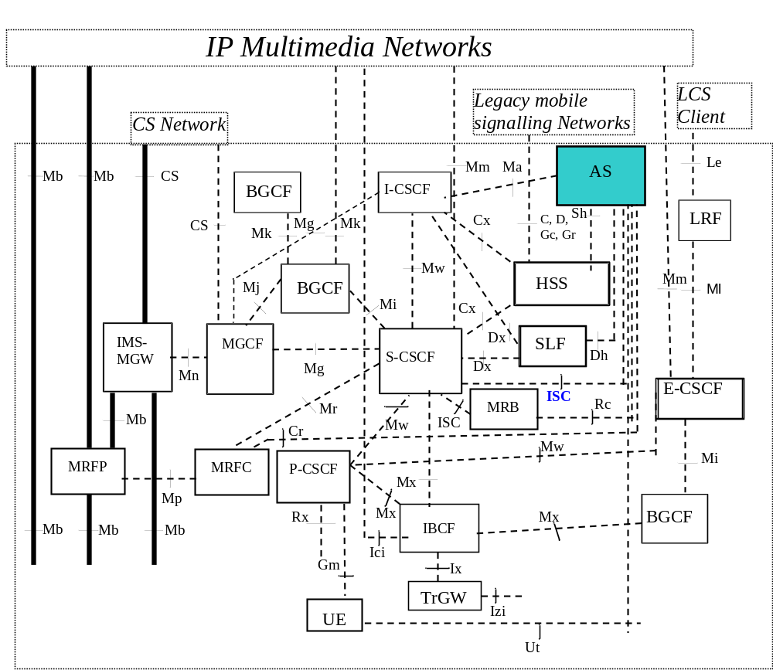

Figure 4.1-1: Entities involved in MMTel service charging in IMS logical architecture
The AS provides the application level network functionality for MMTel service and supplementary services, whereas the overall IMS Network provides the basic IMS capabilities supporting MMTel service.

4.2 MMTel offline charging architecture
Figure 4.2 depicts the MMTel offline charging architecture.
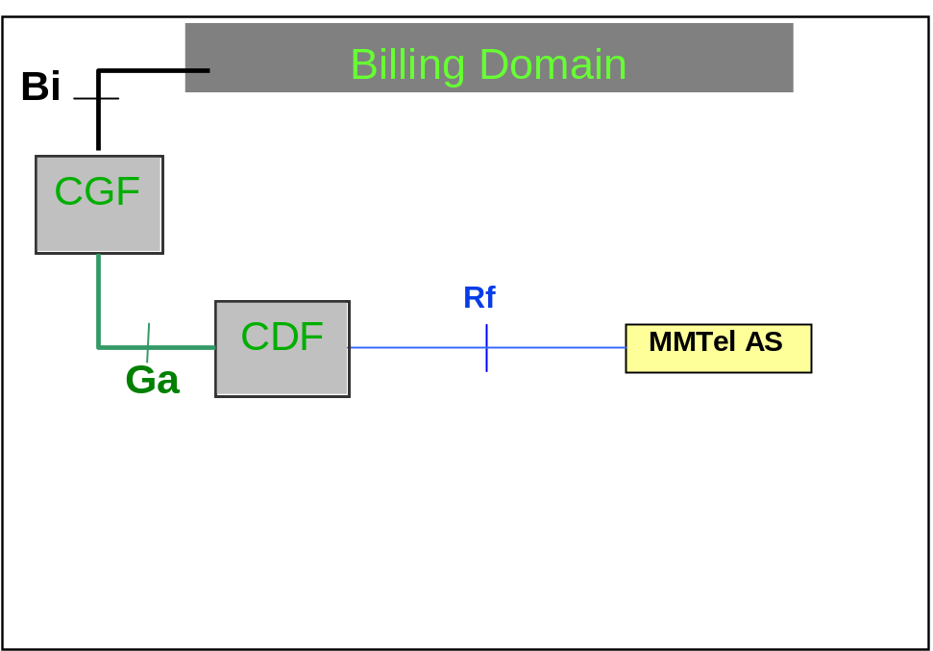
Figure 4.2-1: MMTel Offline Charging architecture
This MMtel Offline Charging architecture is based on the IMS offline charging architecture described in TS 32.260 [20], with service CTFs supporting MMtel specific service charging, interfacing the CDF through the Rf reference point.
The CTFs considered in the MMTel Offline Charging architecture reside in the Application level network functionality providing MMTel service and supplementary services.
The CTFs related to charging for the IMS basic capabilities supporting MMTel service, are described in TS 32.260 [20], and reside in the set of IMS Nodes (S-CSCF, MRFC…) reflected in IMS offline architecture.

4.3 MMTel online charging architecture
The architecture for MMTel online charging is described in the following figure.

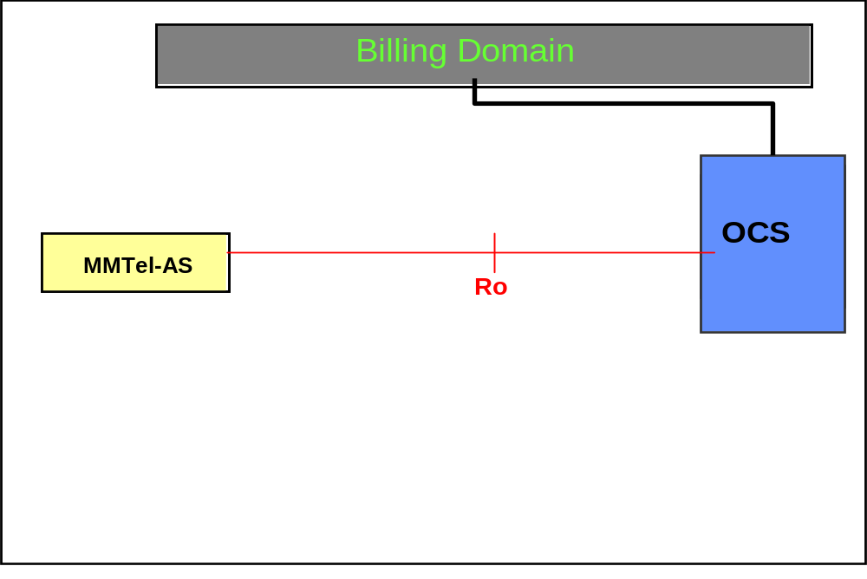
Figure 4.3-1: MMTel Online Charging architecture
This MMtel Online Charging architecture is based on the IMS online charging architecture described in TS 32.260 [20], with service CTFs supporting MMtel specific service charging, interfacing the OCS through the Ro reference point.
The CTFs considered in the MMTel Online Charging architecture reside in the Application level network functionality providing MMTel service and supplementary services.
The CTFs related to charging for the IMS basic capabilities supporting MMTel service, are described in TS 32.260 [20], and reside in the set of IMS Nodes (S-CSCF, MRFC…) reflected in IMS online architecture.

5 MMTel charging principles and scenarios
There are a variety of multimedia telephony supplementary services implemented at different IMS nodes. All the services should support subscription based charging, and some also consumption based charging. The subscription based charging is out of the scope of the present specifications.
The following table 5.1 summarizes which of the services are applicable for offline and online charging.

Table 5.1: Relevance of the services for offline and online charging
Supplementary services | Offline Charging | Online Charging
OIP | X | -
OIR | X | -
TIP | X | -
TIR | X | -
CW | X | -
HOLD | X | -
CB | X | -
MWI | X | -
CONF | X | X
CCBS | X | -
CCNR | X | -
CDIV | X | X
CDIVN | X | X
ECT | X | X
FA | X | X
MCID | X | -
CAT | X | -
CUG | X | X
PNM | X | -
CRS | X | -

5.1 MMTel charging principles
The MMTel charging encompasses the Multimedia telephony service (e.g. multimedia conversational communications between two or more users, with speech as a typical usage, and also others combinations of media) together with the associated supplementary services charging aspects.
Every Supplementary services described in TS 22.173 [202] are subject to be involved in MMTel charging function description.
MMTel service and supplementary services charging function focuses on charging information provided by the CTFs supporting MMtel specific service charging: calling user identification, called user identification, media component characteristics and usage (speech only, speech with other component, add/retrieve components..), supplementary services applied …It enables to apply different flexible charging based on supplementary service type and options.
All the CTFs supporting MMtel specific service charging (AS) pertain to IMS domain, and as explained in TS 32.260 [20], it is possible to correlate session/transaction related charging data generated from these different Nodes (AS), and others IMS Nodes involved in the session used for MMTel service handling , based on IMS Charging Identifier (ICID).

5.1.1 Supplementary services invocation

5.1.1.1 OIP charging
The OIP service provides the terminating user with the possibility of receiving trusted (i.e. network-provided) identity information in order to identify the originating user.
The charging of the OIP subscribers is measured by the MMTel AS handling OIP in offline charging only.

5.1.1.2 OIR charging
The OIR service is a service offered to the originating user. It restricts presentation of the originating user's identity information to the terminating user.
The charging of the OIR subscribers is measured by the MMTel AS handling OIR in offline charging only.

5.1.1.3 TIP charging
The Terminating Identification Presentation (TIP) service provides the originating party with the possibility of receiving trusted information in order to identify the terminating party.
The charging of the TIP subscribers is measured by the MMTel AS handling TIP in offline charging only.

5.1.1.4 TIR charging
The Terminating Identification Restriction (TIR) is a service offered to the terminating party which enables the terminating party to prevent presentation of the terminating identity information to originating party.
The charging of the TIP subscribers is measured by the MMTel AS handling TIR in offline charging only.

5.1.1.5 HOLD charging
The Communication Hold supplementary service enables a user to suspend the media stream(s) of an established IP multimedia session, and resume the media stream(s) at a later time.
The charged parties may be any of the Hold parties. These roles are:
- Calling Party;
- Called Party;

Editor’s note: When one of the parties originates a new call to a third party and the new call overbooks the bearer resource reserved by the held call, overbooking may be taken into account in charging. The solution for that is ffs

5.1.1.6 CB charging
The Communication Barring (CB) service offers the following services:
- The Incoming Communications Barring (ICB) is a service that rejects incoming communications that fulfil certain provisioned or configured conditions on behalf of the terminating user.
- The Anonymous Communication Rejection (ACR) is a particular case of the ICB service, that allows barring of incoming communications from an anonymous originator on behalf of the terminating user.
- The Outgoing Communication Barring (OCB) is a service that rejects outgoing communications that fulfil certain provisioned or configured conditions on behalf of the originating user.
The charging of the CB subscribers is measured by the MMTel AS handling CB in offline charging only.

5.1.1.7 CDIV charging
The Communications Diversion (CDIV) services enables the diverting user, to divert the communications addressed to the diverting user to another destination.
There are three actors active in a CDIV service of one diversion with the following roles:
- Diverting user; the party that initiates the diversion of an incoming communication.
- Originating user; the party which has initiated the communication and that stays in the communication which is diverted;
- Diverted to user;
In case there is another diversion, the user that was first the diverting user (user B), will be the originating user in the second diversion. The diverted to user of the first diversion (user C) will be the diverting user of the second diversion.
The charging of the diverting user for the B-C leg is measured by the MMTel AS handling the CDIV service, i.e. by the MMTel AS of the diverting user (user B). For the diverting user a separate charging dialog (online and/or offline charging) is needed. Charging of the originating and the terminating user (user C) is done in alignment with the TS 32.260 [20].
Typically the diverting user is charged for the forwarded leg (B-C leg), however, normal roaming charging principles apply for the diverted to user also in case of communication diversion. If there is another diversion, the user that performs the second diversion (user C) is charged (typically) for the new forwarded leg (C-D leg).
Charging at the S-CSCF is done in alignment with the TS 32.260 [20] but the S-CSCF has no knowledge of the CDIV service.

5.1.1.8 CW charging
The CW (Communication Waiting) service enables the application server to indicate to the subscriber, that there is at least one new communication is requested, and that no resources are available for that incoming communication. The user has then the choice of accepting, rejecting or ignoring the incoming communication. The maximum number of communications that may be waiting is a service provider option. If the current number of communications waiting is equal to the maximum, then any new attempted incoming communication request shall be rejected with a busy cause.
The charging of the CW subscribers is measured by the MMTel AS handling CW in offline charging only.

5.1.1.9 ECT charging
The Explicit Communication Transfer (ECT) service provides a party involved in a communication to transfer that communication to a third party.
There are three actors active in a transfer, they are acting in the following roles:
- transferor: the party that initiates the transfer of the active communication that it has with the transferee;
- transferee: the party which stays in the communication which is transferred;
- transfer target: the party which the communication is transferred to and which replaces the transferor in the communication.
The charging of the Transferor is measured by the MMTel AS handling the ECT service for the Transferor. The charging of the Transferee is measured by the MMTel AS handling the ECT service for the Transferee.

5.1.1.10 MWI charging
The MWI service enables the application server to indicate to the subscriber, that there is at least one message waiting. The indication is delivered to the subscriber's UE after successful subscription to the Message Waiting Indication service as described in the present document.
The charging of the MWI subscribers is measured by the MMTel AS handling MWI in offline charging only.

5.1.1.11 CONF charging
The CONFerence (CONF) service enables a user to participate in and control a simultaneous communication involving a number of users.
CONF Charging for the conference owner could be based on:
- establishment of the conference
- number of participants
- duration

CONF Charging for the conference participants could be based on:
- duration
The charging of the conference owners and participants is measured by the SIP AS and MRFC handling conference service. For each participant (call leg) a separate charging dialog (online and/or offline charging) at the SIP AS is needed.

5.1.1.12 CCBS charging
The CCBS (Completion of Communication to Busy Subscriber) service enables user A, encountering a busy destination B, to have the communication completed without the user having to manually initiate a new communication attempt when the destination B becomes not busy.
When user A requests the CCBS supplementary service, the network will monitor for destination B becoming free again.
When destination B becomes free again, the network will wait a short time in order to allow the resources to be re-used for originating a communication. If the resources are not re-used by destination B within this time, the network will automatically recall user A.
When user A accepts the CCBS recall, the network will automatically generate a CCBS call to destination B.
The charging of the CCBS suscribers is measured by the MMTel AS handling CCBS in offline charging only.

5.1.1.13 CCNR charging
The CCNR (Completion of Communications on No Reply) service enables user A, encountering a destination B which does not answer the communication (No Reply), to have the communication completed without the user having to manually initiate a new communication attempt when the destination becomes not busy after having initiated and completed a new communication.
When user A encounters a destination B which does not answer the communication (No Reply), user A can request the CCNR supplementary service.
When user A requests the CCNR supplementary service, the network will monitor for destination B becoming not busy after having initiated and completed a new communication.
When destination B becomes not busy after having initiated and completed a new communication, the network will wait a short time (as defined by the destination B idle guard timer) in order to allow the resources to be reused for originating a communication. If the resources are not reused by destination B within this time, the network will automatically recall user A.
When user A accepts the CCNR recall, then the network will automatically generate a CCNR call to destination B.
The charging of the CCNR suscribers is measured by the MMTel AS handling CCNR in offline charging only.

5.1.1.14 Flexible Alerting charging
Flexible Alerting (FA) causes a call to a “Pilot Identity” to branch the call into several legs to alert several termination addresses (FA group members) simultaneously. Additional calls may be delivered to the FA Pilot Identity at any time. The first leg to be answered is connected to the calling party. The other call legs are abandoned.
The FA group, identified by the “Pilot Identity” consists of a list of FA group members alerted through their the public addressable identity.
The charging of the “Pilot Identity” is measured by the MMTel AS handling Flexible Alerting for the “Pilot Identity”.

5.1.1.15 MCID charging
The MCID service enables an incoming communication to be identified as malicious and registered.
The Network shall register the communication related information (such as Terminating Identity Information, Originator Identity Information, Local Time and Date…), which shall be kept under Network Operator’s control (i.e not available to the terminating entity nor the originating entity).
This service has two modes: permanent mode and temporary mode. The permanent mode is active for all incoming communications, and the temporary mode is active only for the incoming communications declared by the served user.
The MCID service can be invoked during the active phase of the communication, or after the active phase for a limited period (but never after communication termination) by the served user, or, automatically invoked during the alerting phase.
The charging of the MCID subscriber is measured by the MMTel AS handling MCID service for the called subscriber in offline charging only.

5.1.1.16 CAT charging
The Customized Alerting Tone Service (CAT service) is an operator specific service by which an operator enables the subscriber to customize the alerting tone which is played to the calling party.
The charging of the CAT subscriber is measured by the MMTel AS handling CAT service for the called subscriber, in offline charging only.

5.1.1.17 CUG charging
The CUG service enables users to form groups of members, whose communication profile is restricted for incoming and outgoing communications. Members of a specific CUG can communicate among themselves but not, in general, with users outside the group.
Specific CUG members can have additional capabilities that allow them to initiate outgoing communications to users outside the group, and/or to accept incoming communications from users outside the group. Specific CUG members can have additional restrictions that prevent outgoing communications to other members of the CUG, or prevent incoming communications from other members of the CUG.
A specific user may be a member of one or more CUGs.
The charging of the CUG subscribers is measured by the MMTel AS handling CUG service for offline and online charging.

5.1.1.18 Personal Network Management Charging
The Personal Network Management (PNM) service allows a user to manage his UEs in regard to terminating services according to preferences set by the user, capabilities and availabilities of devices. Charging for the “PN UE redirection” functionality of the defined PNM service, is considered in the scope of MMTel supplementary service charging, and applies to the active UE the terminating services are delivered to.
The charging of the PNM subscribers is measured by the MMTel AS handling PNM in offline charging only.

5.1.1.19 Customized Ringing Signal Charging
The Customized Ringing Signal (CRS service) is an operator specific service by which an operator enables the subscriber to customize the ringing signal which is played to the called party.
The charging of the CRS subscriber is measured by the MMTel AS handling CRS service for the called or the calling subscriber, in offline charging only.

5.1.1.20 Reverse Charging
The Reverse Charging at communication set up time service allows the terminating party to be charged for the entire communication. The service, requested by the originating party at communication set up time, is explicitly indicated to the terminating party so he can accept or deny the reverse charge communication request.
Editor’s Note: no stage 3 description for Reverse Charging in this Release: ffs

5.1.2 Supplementary services management by User
When an IMS supplementary service control can be provided to the UE as a subscription option, every action performed by the user for this service (Provision/Withdrawal, Registration/Erasure, Activation/Deactivation, interrogation) may be subject to produce charging information, but this aspect is out of the scope of the present specification.

5.2 MMTel offline charging scenarios

5.2.1 Basic principles
The MMTel offline charging functionality is based on the CTFs reporting accounting information, by sending Diameter Accounting Requests (ACR) [start, interim, stop and event] to the CDF.
The circumstances on which the Diameter client uses ACR start, interim and stop, or Events depend on the supplementary service type and is determined for each of them. Further details are specified in clause 5.2.2.
These Diameter Accounting Request triggers may be configured in such a way several MMTel supplementary services can be regrouped. Providing this flexibility will allow to improve situations where several MMTel supplementary services are handled within the same AS for complying with interactions requirements associated to these MMTel supplementary services.

5.2.2 Diameter message flows
The flows described in the present document specify the charging communications between the different CTF entities and the charging functions for different charging scenarios. The SIP messages and Diameter transactions associated with these charging scenarios are shown primarily for general information and to illustrate the charging triggers. They are not intended to be exhaustive of all the SIP message flows discussed in TS 24.228 [200] and they depend on the Diameter Accounting Requests triggers configured by the operator.
Although each MMTel supplementary service is described by separated flows illustrating the dedicated trigger(s) for this MMTel supplementary service, the Diameter Accounting Request triggers (as stated in 5.2.1), may be configured with several MMtel supplementary services information.

5.2.2.1 Message Flows - Successful Cases and Scenarios
Following message flows are defined in TS 32.260 [20], and can be re-used for charging the basic multimedia telephony capabilities:
- Session Establishment - IMS Origination
- Session Establishment – IMS Termination
- Mid-Session Procedures
- Session Release - Mobile Initiated

5.2.2.1.1 OIP Originating Identification Presentation

Figure 5.2.2.1.1-1 shows the Diameter transactions that are required between Application Server and CDF, which implements the OIP service, and CDF after service execution.

UE-B
S-CSCF A
S-CSCF B
CDF
(home)

4. ACR [Start/Event]
UE-A
Terminating UE-B Home Network
AS-B
1. INVITE
1. INVITE
2. INVITE
UE-B is Subscribed to OIP

2. INVITE
UE-A is calling

3. 200 OK
3. 200 OK
3. 200 OK
3. 200 OK
3. 200 OK
5. ACA
Open/Create an AS CDR Indicate OIP on the AS CDR

6. ACK
6. ACK
6. ACK
6. ACK
6. ACK
1. INVITE
Originating UE-A Home Network
Figure 5.2.2.1.1-1: Message Sequence Chart for Offline charging of OIP service.

5.2.2.1.2 Originating Identification Restriction (OIR)

Figure 5.2.2.1.2-1 shows the Diameter transactions that are required between Application Server and CDF, which implements the OIR service, and CDF after service execution.

UE-B
S-CSCF
x-CSCF/AS
CDF
(home)

4. ACR [Start/Event]
UE-A
Originating UE-A Home Network
Terminating UE-B Home Network
AS
If UE-A is Subscribed to OIR “Privacy: ID” info is added if not existing already

5. ACA
Open/Create an AS CDR Indicate OIR on the AS CDR

1. INVITE
1. INVITE (Privacy: ID)

IFC for A

2. INVITE (Privacy: ID)

2. INVITE (Privacy: ID)

2. INVITE (Privacy: ID)

“Presentity withheld”

3. 200 OK
3. 200 OK
3. 200 OK
3. 200 OK
3. 200 OK
6. ACK
6. ACK
6. ACK
6. ACK
6. ACK
Figure 5.2.2.1.2-1: Message Sequence Chart for Offline charging of OIR service.

5.2.2.1.3 Terminating Identification Presentation (TIP)
Figure 5.2.2.1.3-1 shows the Diameter transactions that are required between Application Server and CDF, which implements the TIP service, and CDF after service execution.

UE-B
S-CSCF
x-CSCF/AS
CDF
(home)

2. ACR [Start/Event]
UE-A
Originating UE-A Home Network
Terminating UE-B Home Network
AS
3. ACA
Open/Create an AS CDR Indicate TIP on the AS CDR

1.200 OK (Privacy: none)

4. ACK
4. ACK
4. ACK
4. ACK
4. ACK
Session Initiation
1.200 OK (Privacy: none)

1.200 OK (Privacy: none)

UE-A is subscribed to the TIP service.

1.200 OK (Privacy: none)

1.200 OK (Privacy: none)

Figure 5.2.2.1.3-1: Message Sequence Chart for Offline charging of TIP service.

5.2.2.1.4 Terminating Identification Restriction (TIR)
Figure 5.2.2.1.4-1 shows the Diameter transactions that are required between Application Server and CDF, which implements the TIR service, and CDF after service execution.

UE-B
X-CSCF/AS
x-CSCF B
CDF
(home)

2. ACR [Start/Event]
UE-A
Originating UE-A Home Network
Terminating UE-B Home Network
AS - B
UE-B is subscribed to the TIR service and can add the Privacy: ID header and value if they are missing.

3. ACA
Open/Create an AS CDR Indicate TIR service on AS CDR

4. ACK
4. ACK
4. ACK
4. ACK
4. ACK
Session initiation

1. 200 OK (Privacy: ID)
1. 200 OK (Privacy: ID)
1. 200 OK (Privacy: ID)
1. 200 OK (Privacy: ID)
1. 200 OK (Privacy: ID)
“Connected with unknown”

Figure 5.2.2.1.4-1: Message Sequence Chart for Offline charging of TIR service.

5.2.2.1.5 Communication Hold (HOLD)

Figure 5.2.2.1.5-1 shows the Diameter transactions that are required between AS which implements the HOLD service, and CDF after service execution. The involvement of the AS is optional as it is involved to the HOLD service provision only for announcement purposes.

UE-B
S-CSCF
x-CSCF/AS
CDF
(home)

3. ACR [Start/Interim/Event]

UE-A
Originating UE-A Home Network
Terminating UE-B Home Network
AS
4. ACA
Open/Update/Create the AS CDR Indicate HOLD on the AS CDR

5. ACK
5. ACK
5. ACK
5. ACK
Ongoing Session
1.UPDATE…

UE-A initiates session on hold

1.UPDATE…

1.UPDATE…

“HOLD”

2.200 OK
2.200 OK
2.200 OK
2.200 OK
2.200 OK
1. UPDATE sip:[5555::5:6:7]:1006;comp=sigcomp SIP/2.0… (SDP) a=sendonly / a=inactive
Figure 5.2.2.1.5-1: Message Sequence Chart for Offline charging of HOLD service.

Note: Based on TS 24.610 a scenarion triggerted by Re-Invite is also possible.

5.2.2.1.6 Communication Barring – CB (ICB/ACB)

5.2.2.1.6.1 Communication Barring (CB) – ICB and ACR

Figure 5.2.2.1.6.1-1 shows the Diameter transactions that are required between Application Server and CDF, which implements the CB service, and CDF after service execution.

UE-B
X-CSCF/AS
x-CSCF B
CDF
(home)

2. ACR [Event]
UE-A
Originating UE-A Home Network
Terminating UE-B Home Network
AS -B
UE-B has matching ICB/ACR activated

3. ACA
Create an AS CDR Indicate ICB/ACR on the AS CDR

1. INVITE
1. INVITE
1. INVITE
4. 603 (Decline) / 433 ( Anonymity Disallowed)
4. 603 (Decline) / 433 ( Anonymity Disallowed)
4. 603 (Decline) / 433 ( Anonymity Disallowed)
Figure 5.2.2.1.6.1-1: Message Sequence Chart for Offline charging of CB service.

5.2.2.1.6.2 Communication Barring (CB) – OCB

Figure 5.2.2.1.6.2-1 shows the Diameter transactions that are required between Application Server and CDF, which implements the CB service, and CDF after service execution.

UE-B
X-CSCF
CDF
(home)

2. ACR [Event]

UE-A
Originating UE-A Home Network
AS
3. ACA
Create an AS CDR Indicate OCB on the AS CDR

UE-A has matching OCB activated

1.INVITE

1.INVITE

4. 603 (Decline)
4. 603 (Decline)
Figure 5.2.2.1.6.2-1: Message Sequence Chart for Offline charging of CB service.

5.2.2.1.7 Communications Diversion (CDIV)

5.2.2.1.7.1 Communications Diversion (CDIV) – successful establishment
The following figure shows the Diameter transactions that are required between Application Server,implementing the CDIV service and CDF for a successful communication forwarding on no reply.
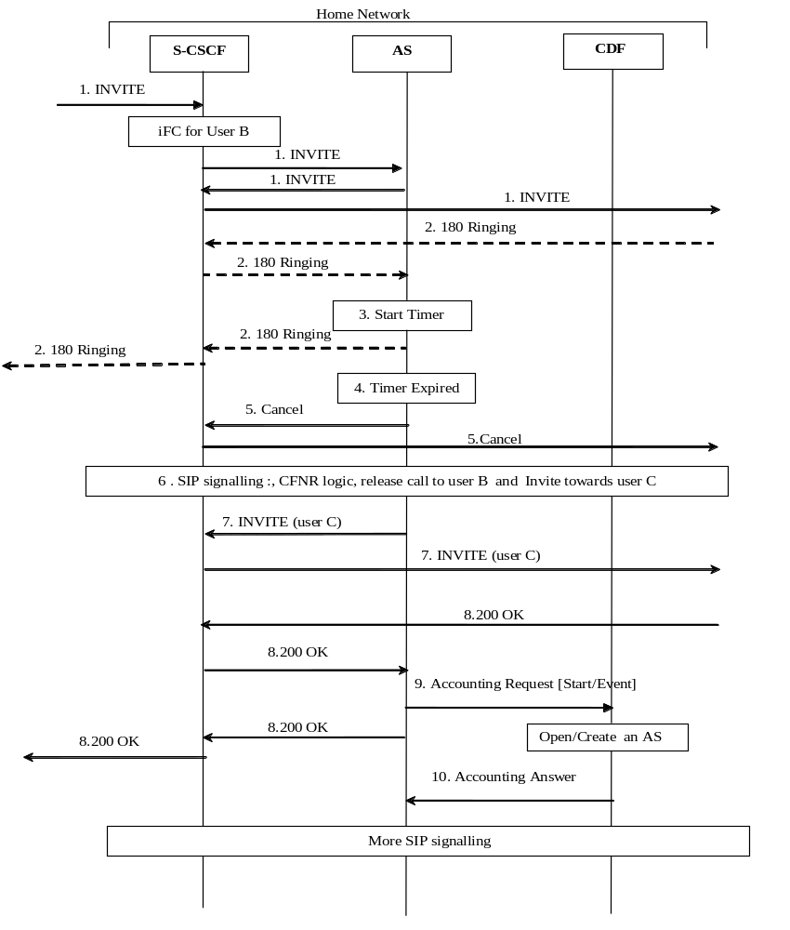
Figure 5.2.2.1.7.1-1 : Message Sequence Chart for Offline charging of CDIV service - establishment
A communication is requested towards User B, user B has activated the CFNR
1) INVITE request incoming for User B. Based on the Initial Filter Criteria (IFC) Rules, indicating that User B is subscribed to the CDIV supplementary services, the communication is forwarded to an AS implementing AS implementing CDIV. Then INVITE is forwarded to User B.
2) 180 ringing is sent back from User B.
3) The non-reply timer in the AS is started .
4) The timer expires.
5 to 7) The AS implementing the CDIV service performs the Call Forwarding No Reply logic : release the communication to User B, and forward the call towards user C (INVITE request including URI-C as destination).
Depending on the value of subscription option “Originating user receives notification that his communication has been diverted (forwarded or deflected)”, a 181 (Call Is Being Forwarded) response is sent towards the User A indicating that the communication is diverted (not shown in the call flow).
8) The destination User C party answers and a final response is received.
9) Upon reception of the final response, the AS implementing the CDIV service sends an Accounting-Request with Accounting-Record-Type indicating START_RECORD/EVENT_RECORD to record call forwarding execution (start of the forwarded leg from User B to User C): basic communication information are transferred with specific call forwarding information ( service mode= “CFNR”, associated number = “ user B” as the user who invoked the call forwarding).
10) The CDF acknowledges the reception of the data and opens/creates an AS CDR to record the forwarded leg from User B to User C.
NOTE : Although only the “call forwarding on no reply” case is depicted here , it serves as a basis for all other call forwarding modes description (Call Forwarding Unconditional, Call Deflection, Call Forwarding on Busy, Call Forwarding Not Logged-in ) for ACR generation : In all these cases, the AS AS implementing the CDIV service sends an Accounting-Request with Accounting-Record-Type indicating START_RECORD to record call forwarding execution (whatever the mode), when the final response is received from user-C.

5.2.2.1.7.2 Communications Diversion (CDIV) – release

The next figure shows the Diameter transactions occurring on release of the previous established communication, initiated by user C:
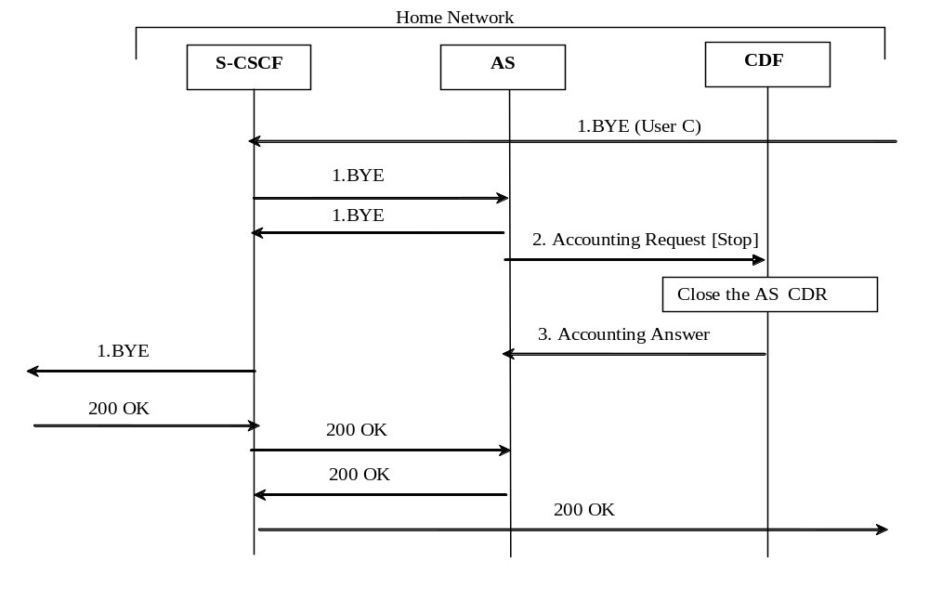
Figure 5.2.2.1.7.2-1: Message Sequence Chart for Offline charging of CDIV service -release
1) User C initiates release of the communication
2) At session termination the AS implementing the CDIV service, sends an Accounting-Request with Accounting-Record-Type indicating STOP_RECORD to record stop the call for which User B has been forwarded. The AS CDR is closed.

5.2.2.1.8 Communication Waiting (CW) Charging
The following figure shows the Diameter transactions that are required between Application Server, which implements the CW service and CDF for the callee (subscriber of CW).
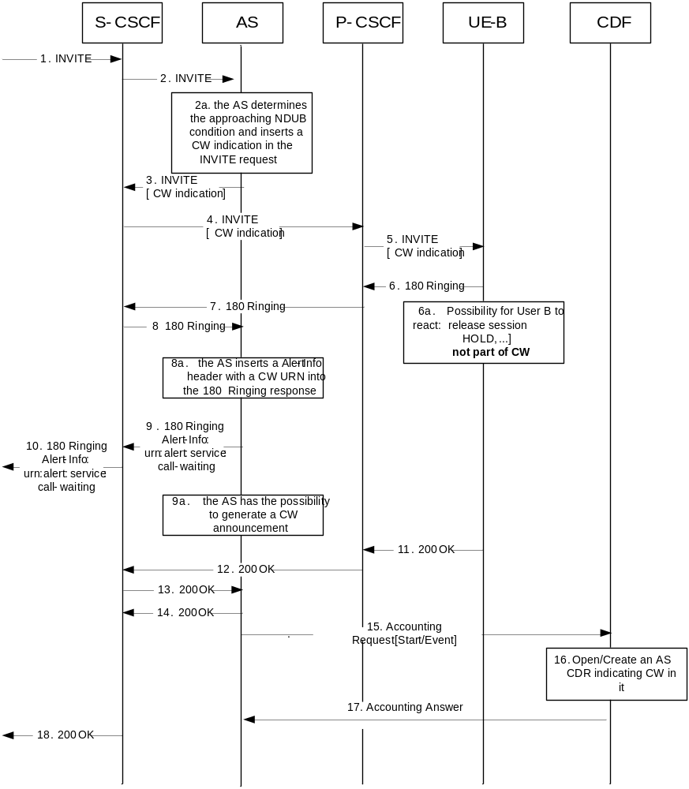
Figure 5.2.2.1.8-1: Message Sequence Chart for Offline charging of CW service
1-2). The communication is initiated by UE-A by sending an INVITE request. The Request URI will include the URI of UE-B. After IFC evaluation in the S-CSCF the INVITE request is routed to the CW AS.
2a). The AS detects the CW condition and inserts a CW indication into the INVITE request per procedures.
3-4). The INVITE is routed to UE-B.
5). UE-B recognizes the CW indication per procedures.
6). UE-B sends back a 180 (Ringing) response.
6a). out of scope: user B uses the HOLD service or releases a session in order to free resources]
7-8). The 180 (Ringing) response is routed back to the AS.
8a). The AS optionally inserts a Alert-Info with a 'CW' URN into the 180 (Ringing) response.
9-10). The 180 (Ringing) response is routed back to the communication origin.
9a). The AS may initiate an announcement to the calling user that the communication is a waiting communication, in accordance with 3GPP TS 24.628 [4].]
11-14). UE-B sends back a 200 (OK) response to the CW AS and CW AS sends it to the S-CSCF.
15-17). The CW AS sends an Accounting-Request[Start]/Accounting-Request[Event] to CDF, then the CDF opens/creates an AS CDR for the Communication Waiting with CW indication on the AS CDR and returns Accounting Answer to the CW AS.
18). S-CSCF sends back a 200(OK) response to UE-A.

5.2.2.1.9 Explicit Communication transfer (ECT)

5.2.2.1.9.1 Explicit Communication transfer (ECT) : Blind Transfer
The following figure shows the Diameter transactions that are required between Application Servers implementing the ECT service for the transferor and for the transferee, and CDF: a successful Blind Transfert from User A to User C, initiated by User B
For diagram simplification, only one CDF is shown.
5.202 Accepted
1. REFER (User C)
1. REFER (ECT session id)
1. REFER
1. REFER
4. forward to AS
1. REFER
1. REFER
7. Accounting Request [Stop]

8. Accounting Answer

1. REFER (user-C)
6. BYE

6. BYE

6. BYE

6. BYE

6. BYE

6. BYE

6. BYE

9.200 OK
CDF
AS B
S-CSCF B

AS A

S-CSCF A
A and B established communication – B puts A on Hold
2. forward to AS
3. User-C =>ECT session-id
More 202 Accepted signalling between (A,x-CSCF,AS-A ) and (x-CSCF,AS-B, B)
Close AS CDR

More 200 OK signalling between (A,x-CSCF,AS-A ) and (x-CSCF,AS-B, B)
Media between User A and User B are terminated
10. More signalling between (A,x-CSCF,AS-A ) and (x-CSCF,AS-B, B) are transferred
Figure 5.2.2.1.9.1-1 : Message Sequence Chart for Offline charging of ECT service – Blind Transfer (part1)
11. INVITE (ECT session-id)
11. INVITE
11. INVITE
11. INVITE
11. INVITE (User C)
11. INVITE (User C)
13. 200 OK
11. INVITE
12.ECT-session-id => User C
13. 200 OK
13. 200 OK
Open/Create an AS CDR for AS B
15. Accounting Answer
14. Accounting Request [Start/Event]
13. 200 OK
13. 200 OK
13. 200 OK
Open/Create an AS CDR for AS A
17. Accounting Answer
16. Accounting Request [Start/Event]
13. 200 OK
CDF
AS B
S-CSCF B

AS A

S-CSCF A
Figure 5.2.2.1.9.1-2 : Message Sequence Chart for Offline charging of ECT service – Blind Transfert (part 2)
In this scenario User A is the transferee, User B is the transferor, and User C is the transfer target.
User A and User B are in an established communication for which, based on the Initial Filter Criteria (IFC) Rules indicating that User B is subscribed to the ECT supplementary service, the INVITE was forwarded to an AS implementing ECT (for User A and User B).
User B puts User A on Hold
1) User B sends REFER request in the existing A-B dialog, to initiate transfer User A to User C.
2) this subsequent request is forwarded to the AS implementing ECT.
3) AS generates an ”ECT Session Identifier” replacing User C as the new destination information, for remaining in the loop, for transferor’s role.
4) On REFER receipt, this request is forwarded the AS implementing ECT.
5) The REFER is accepted by User A, and 202 Accepted is transferred from User A to User B.
6-9) User B sends BYE for terminating original INVITE with User A, acknowledged by 200 OK from User A. AS B releases the media between User A and User B which are on hold, then sends an Accounting-Request with Accounting-Record-Type indicating STOP_RECORD to record termination of the dialogue between User A and User B.
10) More signalling between (User A,x-CSCF,AS-A ) and (x-CSCF,AS-B,User B) :
User A sends NOTIFY(100 Trying) associated to the received REFER, and User B acknowledges by 200 OK
11) User A initiates a new session by sending an INVITE request with “ ECT Session Identifier” .
12) AS implementing the ECT service correlates this INVITE to the initial session to be transferred and replaces “ECT Session Identifier” with User C for creating an INVITE towards UE-C.
13) The destination User C party answers and a final response is received.
14) Upon reception of the final response, the AS implementing the ECT service for the transferor, sends an Accounting-Request with Accounting-Record-Type indicating START_RECORD/EVENT_RECORD to record Transfer execution.
15) The CDF acknowledges the reception of the data and opens/creates an AS CDR.
16) Upon reception of the final response, the AS implementing the ECT service for the transferee, sends an Accounting-Request with Accounting-Record-Type indicating START_RECORD/EVENT_RECORD to record User A is transferred, with specific indicator on the transferee’s “subscriber role” (whether the transferee was engaged in an originating call or in a terminating call) before the transfer execution.
17) The CDF acknowledges the reception of the data and opens/creates an AS CDR.
NOTE : The "Consultative Transfer" scenario mainly differs from the "Blind transfer" on the transfer establishment phase : when User B has put User A on Hold, User B establishes a communication towards User C and puts User C on Hold, then User B initiates the REFER for the transfer triggering. The Accounting-Record-Type indicating START_RECORD for recording Transfer execution occurs at the same steps for both scenario: on the final response associated to INVITE towards User C for the transferor and for the transferee.

5.2.2.1.9.2 Explicit Communication transfer (ECT)) : Release
The following figure shows the Diameter transactions that are required between Application Servers implementing the ECT service for the transferor and for the transferee, and CDF: release from User A, after a successful Blind Transfer from User A to User C, initiated by User B.
CDF
S-CSCF A
AS A
S-CSCF B
AS B
1. BYE
User A a1. REFER
establi11. REFER (ECT sess1. REFER (User C)
B
1. BYE
1. BYE
1. BYE
Close AS CDR
3. Accounting Answer
2. Accounting Request [Stop]
1. BYE
1. BYE
1. BYE (User-C)
Close AS CDR
5. Accounting Answer
4. Accounting Request [Stop]
Figure 5.2.2.1.9.2-1 : Message Sequence Chart for Offline charging of ECT service – Release
1) User A initiates release of the communication
2-3) At session termination the AS implementing the ECT service for the transferee, sends an Accounting-Request with Accounting-Record-Type indicating STOP_RECORD to record stop the call for which User A has been transferred.
4-5) At session termination the AS implementing the ECT service for the transferor, sends an Accounting-Request with Accounting-Record-Type indicating STOP_RECORD to record stop the call transferred by User B. The AS CDR is closed.

5.2.2.1.10 Message Waiting Indication Charging (MWI)
The following figure shows the Diameter transactions that are required between Application Server (MWI), which implements the MWI service and CDF.
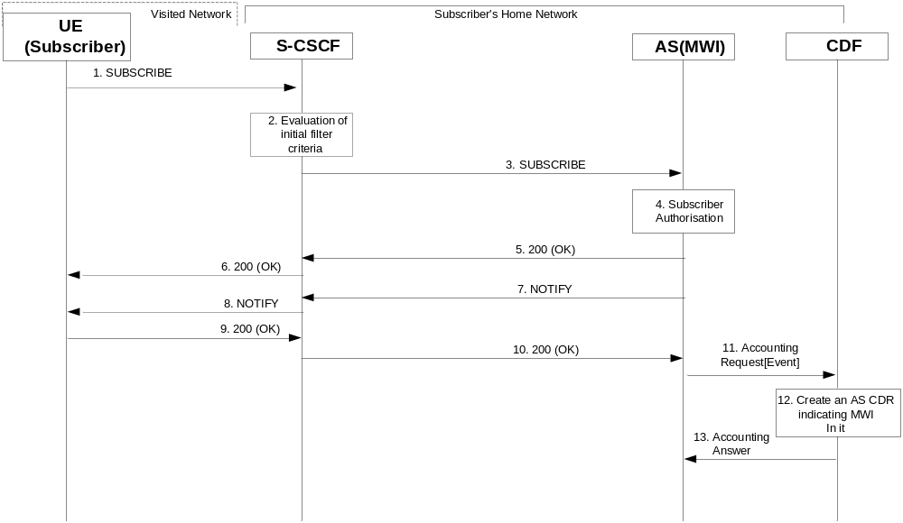

Figure 5.2.2.1.10-1 : Message Sequence Chart for Offline charging of MWI service
1-6) UE subscribes to AS (MWI) and the AS (MWI) returns 200 OK.
7-10) The AS (MWI) sends NOTIFY request to S-CSCF and the subscriber UE acknowledges the NOTIFY request.
11-13) The AS (MWI) sends Accounting Request [Event] message to CDF, CDF creates an AS CDR and returns Accounting Answer to the AS (MWI).

5.2.2.1.11 CONF Charging
During a conference, user could create the conference, join the conference, invite another user to the conference and leave the conference, according to 3GPP TS24.605. The following subclauses respectively show the Diameter transactions that are required between Application Server, which implements the CONF service and CDF corresponding different conference scenarios.

5.2.2.1.11.1 CONF Charging – user creating a conference
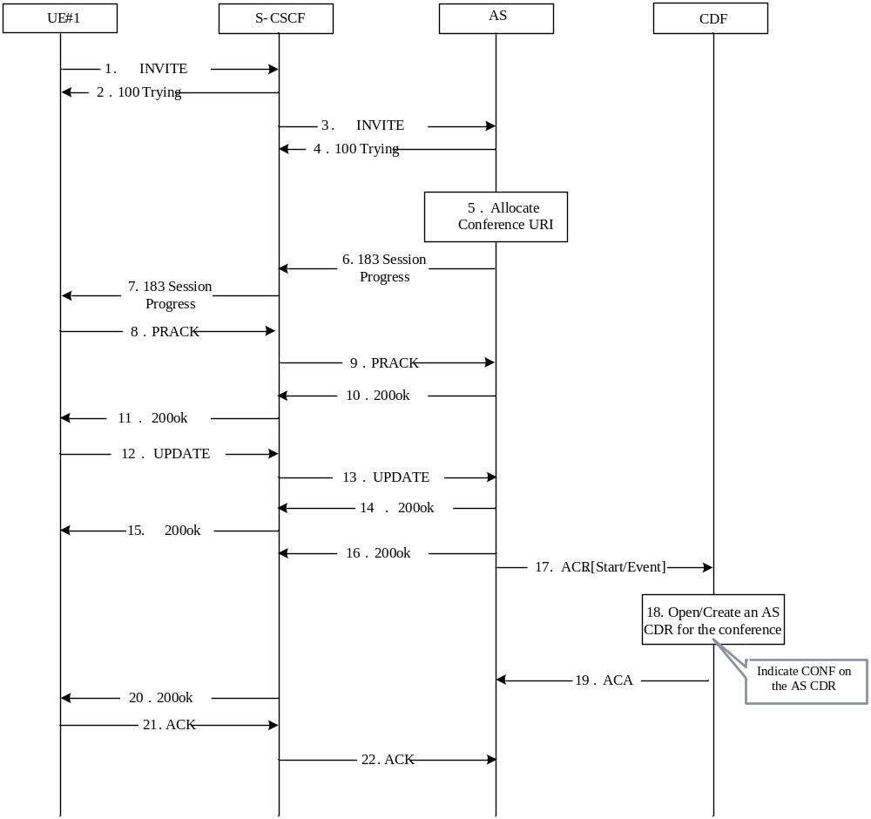

Figure 5.2.2.1.11.1-1 : Message Sequence Chart for Offline charging of CONF service- User creating a conference

1-2). The communication is initiated by UE#1 by sending an INVITE request to S-CSCF. And S-CSCF sends back 100 Trying reponse to inform UE#1 to wait for a while because the request is being treated.
3-4). S-CSCF transfers INVITE request from UE#1 to CONF AS and the CONF AS sends back 100 Trying response to inform S-CSCF to wait for a while because the request is being treated.
5). The CONF AS allocates the conference URI.
6-16). After the media resource negociation process, the CONF AS sends back 200 ok response.
17-19). The CONF AS sends Accounting Request[Start]/Accounting Request[Event] to CDF, then the CDF opens/creates an AS CDR for the conference with CONF indication on the AS CDR and renturns Accounting Answer to the CONF AS.

5.2.2.1.11.2 CONF Charging – user joining a conference
The following figure shows the Diameter transactions that are required between Application Server, which implements the CONF service and CDF corresponding to the conference scenario: user joining a conference.

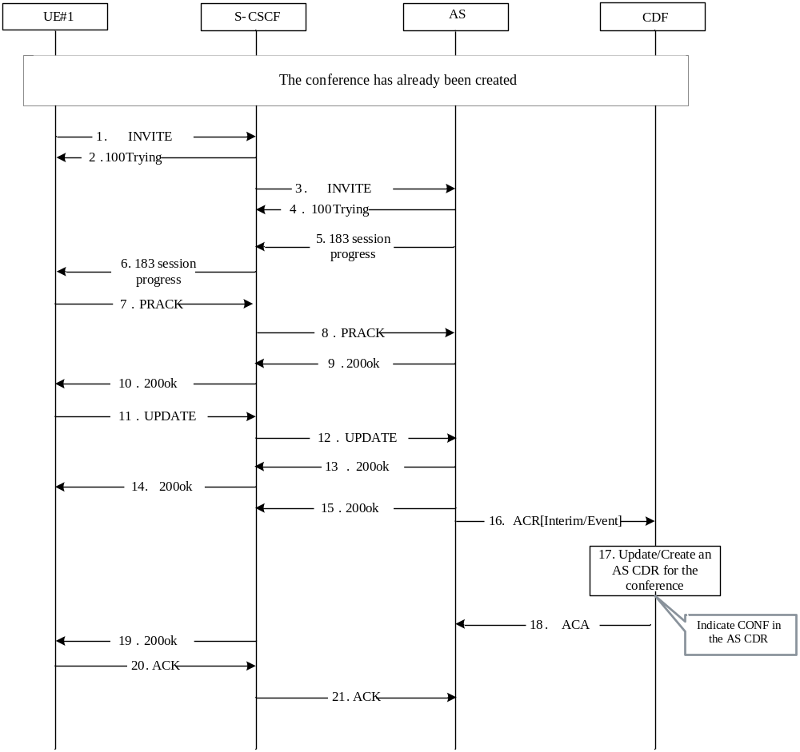
Figure: 5.2.2.1.11.2-1 CONF Charging – user joining a conference
1-2). The conference has already been created. UE#1 sends an INVITE request to S-CSCF in order to join in the conference. And S-CSCF sends back SIP 100 Trying reponse to inform UE#1 to wait for a while because the request is being treated.
3-4). S-CSCF transfers INVITE request from UE#1 to CONF AS and the CONF AS sends back SIP 100 Trying response to inform S-CSCF to wait for a while because the request is being treated.
5-15). After the media resource negociation process, the CONF AS sends back SIP 200 ok response.
16-18). The CONF AS sends Accounting Request[Interim/Event] to CDF, CDF updates or creates an AS CDR for the conference and renturns Accounting Answer to the CONF AS.

5.2.2.1.11.3 CONF Charging – user inviting another user to a conference
The following figure shows the Diameter transactions that are required between Application Server, which implements the CONF service and CDF corresponding to the conference scenario: user being invited into a conference.
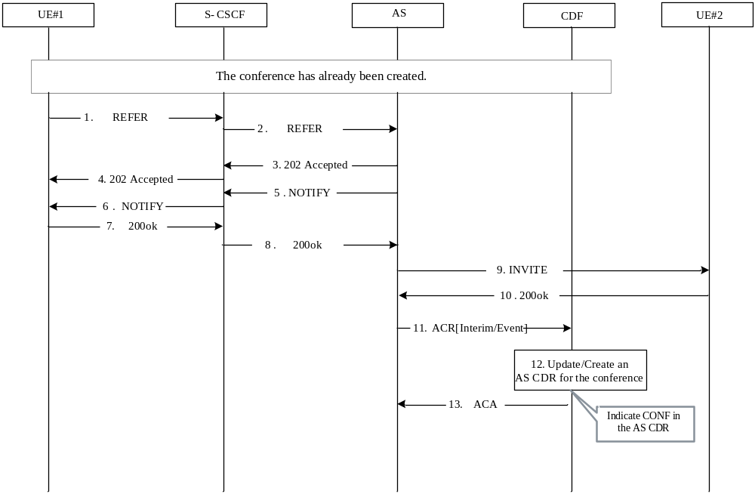
Figure: 5.2.2.1.11.3-1 CONF Charging – user inviting another user to a conference

1-2). The conference has already been created. UE#1 sends a REFER request to S-CSCF in order to invite UE#2 into the conference.
3-4). The CONF AS sends back 202 Accepted response to UE#1 via some related NEs like S-CSCF to indicate that he has received the REFER request successfully.
5-6). The CONF AS sends a NOTIFY request corresponding the REFER request to UE#1.
7-8). UE#1 sends back SIP 200 ok reponse to the CONF AS.
9-10). The CONF AS sends an INVITE request to UE#2 in order to invite him into the conference. And UE#2 sends back SIP 200 ok response to the CONF AS.
11-13) The CONF AS sends Accounting Request [Interim/Event] to CDF, CDF updates or creates an AS CDR for the conference and renturns Accounting Answer to the CONF AS.

5.2.2.1.11.4 CONF Charging – user leaving a conference
The following figure shows the Diameter transactions that are required between Application Server, which implements the CONF service and CDF corresponding to the conference scenario: user leaving a conference.

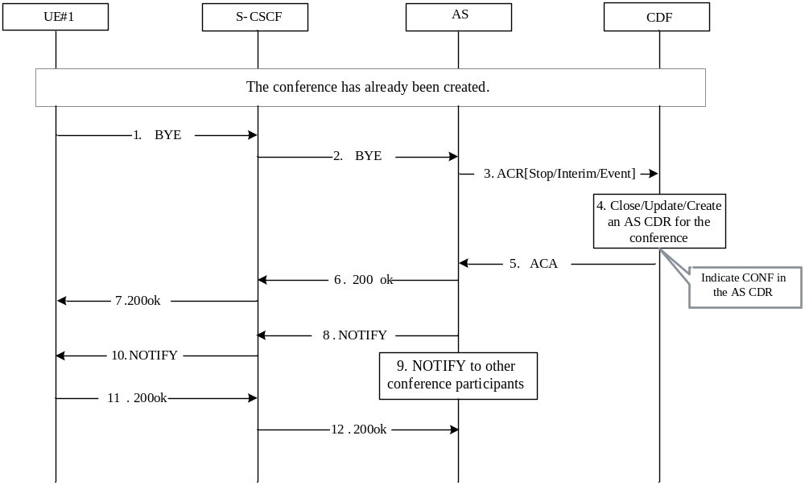
Figure: 5.2.2.1.11.4-1 CONF Charging – user leaving a conference
1-2). The conference has already been created. UE#1 sends a BYE request to the CONF AS in order to quit the conference.
3-5). The CONF AS sends Accounting Request[Interim/Event] to CDF, CDF updates or creates an AS CDR for the conference and renturns Accounting Answer to the CONF AS. Conference termination should refer to the description of subclause 5.3.2.7 in TS 24.147, e.g. If there isn’t any conference policy and the last online conference user quits the conference could be considered as the conference termination, when the last online conference user quits the conference (sends a BYE request to the CONF AS), the CONF AS sends Accounting Request [Stop/Event] to CDF, CDF stops or creates an AS CDR for the conference and returns Accounting Answer to the CONF AS.
6-7). The CONF AS sends back SIP 200 ok response to UE#1.
8-10). The CONF AS sends a NOTIFY request to other conference participants that UE#1 has quitted the conference.
11-12). Other conference participants sends back SIP 200 ok response to the CONF AS.

5.2.2.1.11.5 Three-Party (3PTY) Charging – successful establishment
The following figure shows the Diameter transactions that are required between Application Server, which implements the 3PTY service and CDF corresponding to the 3PTY scenario: 3PTY service successful establishment.

Figure 5.2.2.1.11.5-1: Three-Party (3PTY) Charging – successful establishment
18. 200 OK
17. BYE
12. Invite
13. 200OK
15. NOTIFY
16. 200OK
16. 200OK
15. NOTIFY
14. ACK
12. Invite
13. 200OK
11. 200OK
11. 200OK
10. NOTIFY
9. 200 Accepted
20. 200 OK
20. 200 OK
8. REFER Refer-To: 3PTY AS

2. Invite (UE-C)
4. ACK
7. ACK
7. ACK
6. 200OK
3. 200OK
4. ACK
2. Invite (UE-C)
UE-A
S-CSCF
CDF
UE-C
UE-B
3.200OK
5. Invite (3PTY AS)
1. UE-A and UE-B has established communication. UE-A puts UE-B on hold
Media path between UE-A and UE-C
5. Invite (3PTY AS)
6.200OK
14. ACK
9. 200 Accepted
8. REFER Refer-To: 3PTY AS

10. NOTIFY
17. BYE
18. 200 OK
19. Repeats step 8 to 17 on UE-Aand UE-C to terminate the call between UE-A and UE-C
22. Open/Update /Create an AS CDR indicating 3PTY in it
21. Accounting Request [Start/Interim/Event]
23. Accounting Answer
20. 200 OK
AS (3PTY)
1) UE-A and UE-B has established communication. UE-A puts UE-B on hold before invoking the 3-Way Calling with UE-C.
2-4) UE-A establishes a call with UE-C following normal call setup procedure and gets UE-C’s permission to start the 3-Way Calling.
5) UE-A sends an INVITE request to the 3PTY AS to establish a 3PTY session.
6-7) The 3PTY AS sends a 200 OK response and receives an ACK request from UE-A.
8-9) UE-A sends a REFER request to UE-B with the Refer-To header set to the address of the 3PTY AS; UE-B accepts the REFER request.
10-11) UE-B sends a NOTIFY request to UE-A to indicate that UE-B is acting on the REFER request.
12) UE-B sends an INVITE request to the 3PTY AS to join the 3PTY session.
13-14) The 3PTY AS sends a 200 OK response to UE-B and receives an ACK request.
15-16) UE-B sends a NOTIFY request to UE-A to indicate that it has finished action required by the REFER request.
17-18) UE-A sends a BYE request to terminate the call between UE-A and UE-B.
19-20) Repeats step 8 to 18 on UE-Aand UE-C to terminate the call between UE-A and UE-C.
21-23) 3PTY AS sends an Accounting Request [Start/Interim/Event] to CDF, CDF opens or updates or create an 3PTY AS CDR for the 3PTY service and returns Accounting Answer to the 3PTY AS.

5.2.2.1.11.6 Three-Party (3PTY) Charging – release
The following figure shows the Diameter transactions that are required between Application Server, which implements the 3PTY service and CDF corresponding to the 3PTY scenario: release the 3PTY service.

5. 200OK
5. 200OK
1. BYE
1. BYE
UE-A
S-CSCF
CDF
UE-C
UE-B
The 3PTY has already been established
AS (3PTY)
3. Close/Create an AS CDR indicating 3PTY in it
2. Accounting Request [Stop/Event]
4. Accounting Answer

6. Notify to other 3PTY participants, release the 3PTY service
Figure 5.2.2.1.11.6-1: Three-Party (3PTY) Charging – release
1) The 3PTY has already been established. UE-A sends a BYE request to the 3PTY AS in order to release from the 3PTY service.
2-4) At session termination 3PTY AS, sends an Accounting-Request [Stop/Event] to CDF, CDF stops or creates an AS CDR for the 3PTY service and returns Accounting Answer to the 3PTY AS.
5) The 3PTY AS sends back SIP 200 OK response to UE-A.
6) The 3PTY AS sends a NOTIFY request to other participants that 3PTY service has released.

5.2.2.1.12 CCBS Charging
The following figure shows the Diameter transactions that are required between Application Server and CDF, which implements the CCBS service, and CDF after service execution.
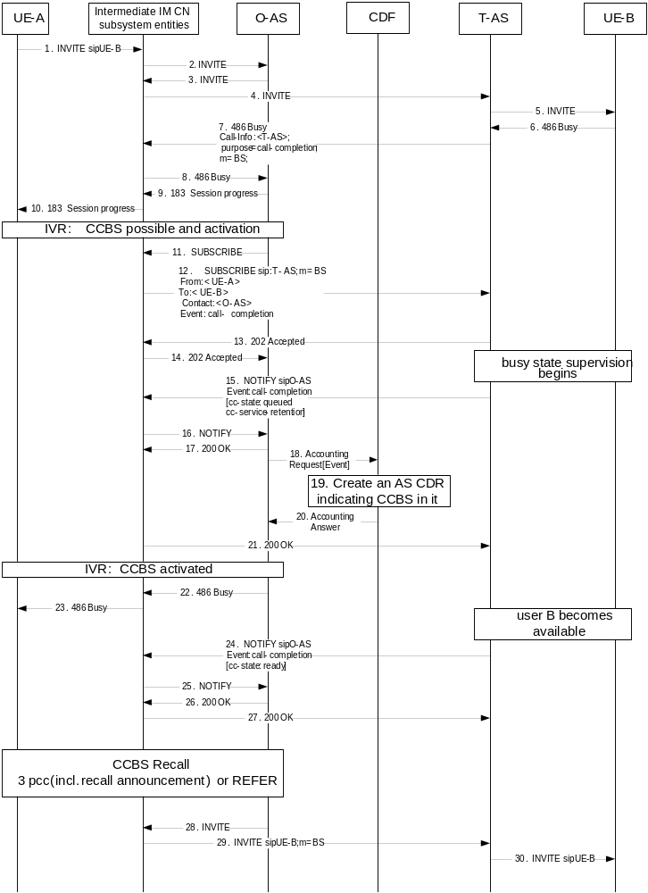
Figure 5.2.2.1.12-1 : Message Sequence Chart for Offline charging of CCBS service
1-5). The communication is initiated by UE-A by sending an INVITE request.
6). UE-B answers with a 486 (Busy Here) response. The 486 (Busy Here) response is routed back to the terminating AS.
7-8). The terminating AS inserts a Call-Info header field in the 486 (Busy Here) response. The Call-Info header field will contain the URI of the terminating AS with an "m" header field parameter set to "BS" (busy subscriber). It further includes a "purpose" header field parameters set to "call-completion". The 486 (Busy Here) response is routed back to the originating AS.
9-10). The originating AS sends back a 183 (Session Progress) response to UE-A and initiates IVR procedures. User A is informed that CCBS is possible. User A activates CCBS.
11-14). The originating AS subscribes for the call-completion event package. The terminating AS accepts the subscription and starts busy state supervision procedures on the callee.
15-17). The terminating AS sends a notification to the originating AS.
18-20). The originating AS sends Accounting Request[Event] to CDF, then the CDF creates an AS CDR for the CCBS service subscriber with CCBS indication on the AS CDR and returns Accounting Answer to the originating AS.
21). After confirmation of the notification the originating AS starts announcements procedures informing about the activation of CCBS.
22-23). The originating AS forwards the 486 (Busy Here) response to UE-A.
24-27). When UE-B becomes available, the terminating AS sends a NOTIFY request to the originating AS,
28-29). The originating AS starts the CCBS recall by sending an INVITE request to UE-B. In order to mark the INVITE request as a prioritized request for call-completion, the originating AS adds the "m" SIP URI parameter with the value 'BS' to the Request-URI.

5.2.2.1.13 CCNR Charging
The following figure shows the Diameter transactions that are required between Application Server and CDF, which implements the CCNR service, and CDF after service execution.

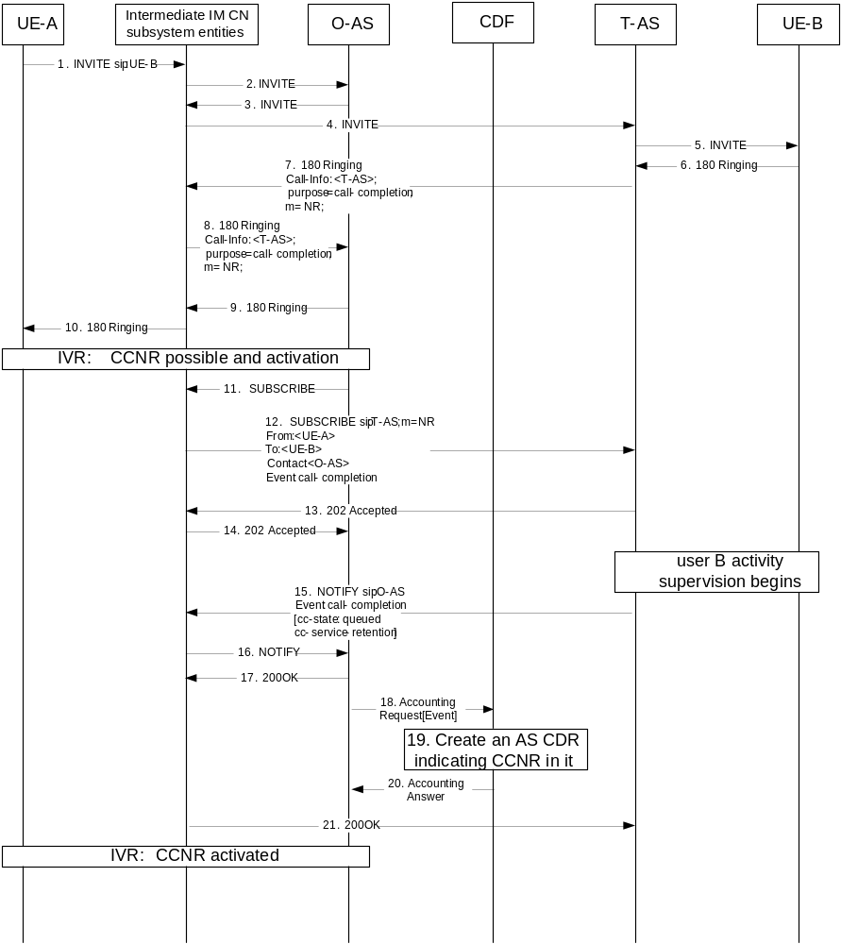
Figure 5.2.2.1.13-1 : Message Sequence Chart for Offline charging of CCNR service
1-5). The communication is initiated by UE-A by sending an INVITE request.
6). UE-B answers with a 180 (Ringing) response. The 180 (Ringing) response is routed back to the terminating AS.
7-8). The terminating AS inserts a Call-Info header field in the 180 (Ringing) response. The Call-Info header field will contain the URI of the terminating AS with a "m" header field parameter set to "NR" (no reply). It further includes a "purpose" header field parameter set to "call-completion". The 180 (Ringing) response is routed back to the originating AS.
9-10). The originating AS removes the Call-Info header field, forwards the 180 (Ringing) response to UE-A and initiates IVR procedures. User A is informed that CCNR is possible. User A activates CCNR.
11-14). The originating AS subscribes for the call-completion event package. The terminating AS accepts the subscription and starts activity supervision procedures on the callee.
15-17). The terminating AS sends a notification to the originating AS,.
18-20). The originating AS sends Accounting Request[Event] to CDF, then the CDF creates an AS CDR for the CCNR service subscriber with CCNR indication on the AS CDR and returns Accounting Answer to the originating AS.
21). After confirmation of the notification the originating AS starts announcements procedures informing about the activation of CCNR.

5.2.2.1.14 Flexible Alerting (FA)

5.2.2.1.14.1 Flexible Alerting (FA) - establishment

The following figure shows the Diameter transactions that are required between Application Server, implementing the FA service and CDF, with answer from one of FA group members.
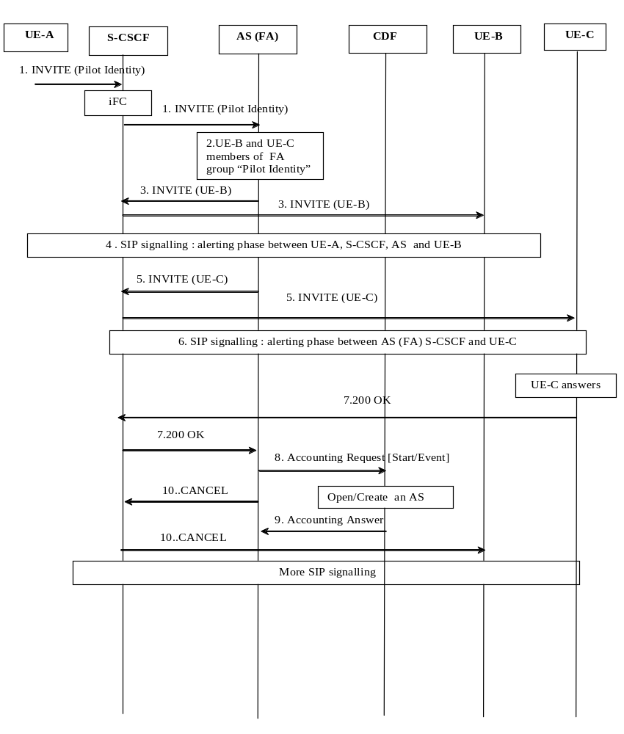
Figure 5.2.2.1.14.1-1: Message Sequence Chart for Offline charging of FA service - Answered

UE-B and UE-C are FA group members of the FA group identified by the “Pilot Identity”.
A communication is requested from UE-A towards the “Pilot Identity”.
1) INVITE request incoming for “Pilot Identity”. Based on the Initial Filter Criteria (IFC), indicating the request must be forwarded to an AS implementing FA for this “Pilot Identiry”.
2) The AS implementing FA maps the Pilot Identity to the list of FA group members: UE-B and UE-C, and forwards INVITE to all FA members.
3 to 4) INVITE forwarded towards UE-B and alerting phase signalling occurs with UE-A.
5 to 6) INVITE forwarded towards UE-C and alerting phase signalling occurs with UE-A.
7) UE-C answers.
8 to 10) Upon reception of the 200 OK answer from UE-C, AS implementing the FA service:
  - Sends an Accounting-Request [Start] with FA MMTel supplementary service indication.The CDF creates an AS CDR and returns Accounting Answer to the AS.
  - Sends CANCEL to other FA group member being alerted, UE-B.

5.2.2.1.14.2 Flexible Alerting (FA) – call release
The following figure shows the Diameter transactions that are required between Application Server, implementing the FA service and CDF, when previous successfully established call is released.
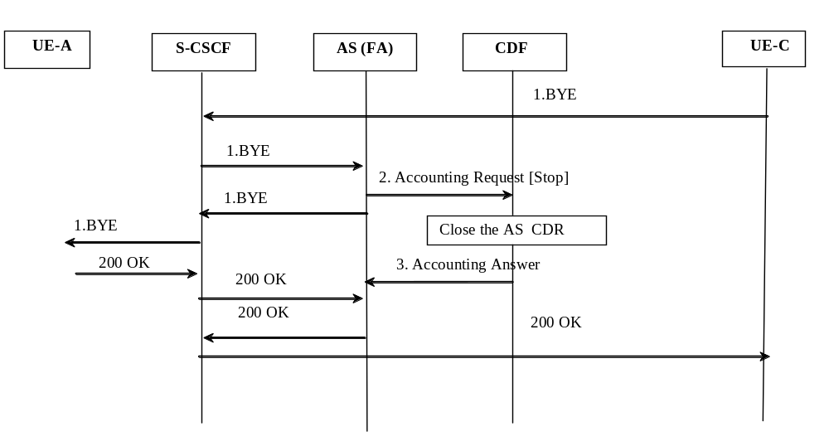
Figure 5.2.2.1.14.2-1: Message Sequence Chart for Offline charging of FA service - Release

1) UEC initiates release of the communication
2 to 3) At session termination the AS implementing the FA service, sends an Accounting-Request [Stop] and the AS CDR is closed.

5.2.2.1.15 Malicious Communication Identification (MCID)
The following figure shows the Diameter transactions that are required between Application Server implementing the MCID service and CDF for a successful MCID delivery for permanent mode or temporary mode.
iFC for B
1.INVITE
5. 200 OK
2. Temporary Storing data for MCID
Create an AS CDR
4. Accounting Answer
3. Accounting Request [Event]
Create/Update AS CDR
10. Accounting Answer
9. Accounting Request [Event/interim]
Terminating UE-B Home Network
S-CSCF
AS
CDF

UE B

1.INVITE
1.INVITE
1.INVITE
5. 200 OK
5. 200 OK
5. 200 OK
7. re-INVITE
7. re-INVITE
8. Storing data for MCID
6. SIP signalling
Figure 5.2.2.1.15-1: Message Sequence Chart for Offline charging of MCID service
A communication is requested towards User B, and User B is subscribed to MCID service.
1) INVITE request incoming for User B. Based on the Initial Filter Criteria (IFC) Rules, indicating that User B is subscribed to the MCID supplementary services, the communication is forwarded to an AS implementing MCID.
2-4) In case of MCID temporary mode, AS stores relevant data temporarily, in case permanent mode AS registers the data and sends Accounting-Request [Event] to record invocation of MCID, acknowledged by the CDF when AS CDR is created.Then INVITE is forwarded to User B.
5) 200 OK answer received from User B.
6) Further SIP signalling for communication establishment, or mid-communication take place, before BYE from User-B.
7-10) Upon reception of re-INVITE from User-B, indicating temporary MCID request, AS registers the data previously stored and sends Accounting-Request [Event/interim] message to CDF to record invocation of MCID, the CDF creates/updates AS CDR and returns Accounting Answer.

5.2.2.1.16 Customized Alerting Tone (CAT)
Although CAT Supplementary services may be delivered according to different models (CAT forking, CAT early session, CAT Gateway) as described in TS 24.182 [217], only one scenario is depicted here, and serves as a basis for CAT charging description, as the same principle applies.
The following figure shows the Diameter transactions that are required between Application Server implementing the CAT service and CDF for a successful communication establishment with CAT delivery.
1.INVITE
Terminating UE-B Home Network
S-CSCF
AS
CDF

UE A

UE B

iFC for B
2. Reserve CAT resources
1.INVITE
3. 180 Ringing
1.INVITE
1.INVITE
3. 180 Ringing
4. 183 (session progress)
4. 183 (session progress)
5. PRACK
5. PRACK
6. Start CAT media

7.200 (PRACK)
7.200 (PRACK)
8.200 OK
8.200 OK
9. Stop CAT media

Open/Create an AS CDR
10. Accounting Request [Start/Event]
11. Accounting Answer
More SIP signalling
Figure 5.2.2.1.16-1: Message Sequence Chart for Offline charging of CAT service delivery
A communication is requested towards User B, user B has subscribed to CAT service.
1) INVITE request incoming for User B. Based on the Initial Filter Criteria (IFC) Rules, indicating that User B is subscribed to the CAT supplementary service, the communication is forwarded to an AS implementing CAT.
2) The AS proceeds to CAT resources reservation and forwards INVITE towards User B..
3) 180 ringing is sent back from User B.
4) The AS sends a reliable 183 (session progress) response to User A with codecs to be used for CAT., acknowledged by PRACK from User A.
5 to 7) Upon acknowledgment from User A (PRACK), the AS starts CAT media playing (alerting tone), and sends 200 response to PRACK towards User A.
- 8 to 11) Upon 200 OK answer received from User B, AS stops CAT media playing (alerting tone), and sends an Accounting-Request [Start/Event] message to CDF, CDF opens/creates an AS CDR and returns Accounting Answer.
NOTE: The same following principle applies for all others CAT delivery scenarii : an Accounting-Request [START] is sent from AS to record beginning of alerting tone playing, and Accounting-Request [STOP] is sent to record end of alerting tone playing .

5.2.2.1.17 Closed User Group (CUG)

5.2.2.1.17.1 Closed User Group (CUG): Originating
The following figure shows the Diameter transactions that are required between Application Server implementing the CUG service and CDF for a successful originating communication from User-A CUG member.
iFC for A
1.INVITE (User B)
4. 200 OK
2. Check on request validity regarding CUG
Open/Create AS CDR
6. Accounting Answer
5. Accounting Request [Start/Event]
Originating UE-A Home Network
S-CSCF
AS
CDF

UE A

1.INVITE
4. 200 OK
3. SIP signalling
4. 200 OK
4. 200 OK
1.INVITE (User B, CUG information)
1.INVITE (User B, CUG information)
Figure 5.2.2.1.17.1-1: Message Sequence Chart for Offline charging of CUG service - originating call
User-A is subscribed to CUG service. and initiates a communication towards User B.
1) User-A initiates a communication towards User B sending INVITE request. Based on the Initial Filter Criteria (IFC) Rules, indicating that User A is subscribed to the CUG supplementary service, the communication is forwarded to an AS implementing CUG.
2) AS performs checks from the request received regarding User A CUG subscription profile, and determines the CUG-communication is allowed for CUG member User-A towards User-B : AS forwards INVITE towards User-B with CUG information included.
Note: In case the result from AS checks indicates non-CUG communication behaviour (for CUG communication with outgoing access…), CUG information is not included, and non-CUG communication charging applies.
3) SIP signalling for communication establishment.
4-6) 200 OK answer received from User B, and AS sends Accounting-Request [Start/Event] message to CDF to record start of the CUG-communication for User A CUG member. The CDF opens/creates an AS CDR and returns Accounting Answer.

5.2.2.1.17.2 Closed User Group (CUG): Terminating
The following figure shows the Diameter transactions that are required between Application Server implementing the CUG service and CDF for a successful terminating communication towards User-B CUG member.
iFC for B
1.INVITE (User B, CUG Information)
4. 200 OK
2. Check on request validity regarding CUG
Open/Create AS CDR
6. Accounting Answer
5. Accounting Request [Start/Event]
Terminating UE-B Home Network
S-CSCF
AS
CDF

UE B

1.INVITE
4. 200 OK
3. SIP signalling
4. 200 OK
4. 200 OK
1.INVITE (User B)
1.INVITE (User B, CUG Information)
Figure 5.2.2.1.17.2-1: Message Sequence Chart for Offline charging of CUG service - terminating call
User-B is subscribed to CUG service.
1) incoming INVITE request towards User-B. Based on the Initial Filter Criteria (IFC) Rules, indicating that User B is subscribed to the CUG supplementary services, the communication is forwarded to an AS implementing CUG.
2) AS performs checks from the request received regarding User B CUG subscription profile, and determines the CUG-communication is allowed for CUG member User-B from User A: AS forwards INVITE towards User-B.
Note: In case the result from AS checks indicates non-CUG communication behaviour (incoming access from non-CUG member…), non-CUG communication charging applies.
3) SIP signalling for communication establishment.
4-6) 200 OK answer received from User B, and AS sends Accounting-Request [Start/Event] message to CDF to record start of the CUG-communication for User B CUG member. The CDF opens/creates an AS CDR and returns Accounting Answer.

5.2.2.1.18 Personal Network Management
The following figure shows the Diameter transactions that are required between Application Server implementing the “Personal Network Management” service and CDF for a successful “PN UE redirection” for a terminating communication, as described in TS 23.259 [218].
.
1. INVITE UE-1
User-B Home Network
S-CSCF-1
S-CSCF-2
1. INVITE UE-1
CDF
5. 200 OK
More SIP signalling
PNM AS
iFC for UE-1(B)
PNM redirection: active UE is UE-2

2. INVITE UE-2
3. iFC for UE-2(B)

2. INVITE UE-2
2. INVITE UE-2
2. INVITE UE-2
2. INVITE UE-2
4. PNM redirection: active UE is UE-2

5. 200 OK
5. 200 OK
5. 200 OK
5. 200 OK
Open/Create an AS CDR
6. Accounting Request [Start/Event]
7. Accounting Answer
Figure 5.2.2.1.18-1: Message Sequence Chart for Offline charging of “PNM-redirection” service.
1) Incoming INVITE request for UE-1 of User B. Based on the Initial Filter Criteria (IFC) Rules, for UE-1, the communication is forwarded to the AS implementing PNM. From PN-user’s PN configuration, the PNM AS determines the initial request is to be redirected to the default UE of the PN, i.e. to the UE-2.
2) INVITE is forwarded towards UE-2.
3) Based on the Initial Filter Criteria (IFC) Rules, for UE-2, the communication is forwarded to the AS implementing PNM.
4) From PN-user’s PN configuration, the PNM AS determines the initial request is to be sent to the default UE of the PN, i.e. to the UE-2. INVITE is forwarded towards UE-2.
5) The destination UE-2 party answers and a final response is received.
5) Upon reception of the final response, the AS implementing the PNM service sends an Accounting-Request with Accounting-Record-Type indicating [START_RECORD/EVENT_RECORD] to record “PN UE redirection” execution to CDF.
6) The CDF acknowledges the reception of the data and opens/creates an AS CDR.

5.2.2.1.19 Customized Ringing Signal (CRS)
Although CRS Supplementary services may be delivered according to different models (download and play model, DTMF...) as described in TS 24.183 [219], only one scenario is depicted here, and serves as a basis for CRS charging description, as the same principle applies.
The following figure shows the Diameter transactions that are required between Application Server implementing the CRS service and CDF for a successful communication establishment with CRS delivery.
1. INVITE
Terminating UE-B Home Network
S-CSCF
AS
CDF

UE A

UE B

iFC for B
1. INVITE
2. 180 Ringing
1. INVITE
1. INVITE
2. 180 Ringing
3. PRACK
3. PRACK
4. Reserve CRS resource
5.200 (PRACK)
7.200 OK
7.200 OK
8. Stop CRS media

Open/Create an AS CDR
9. Accounting Request [Start/Event]
10. Accounting Answer
2. 180 Ringing
2. 180 Ringing
3. PRACK
3. PRACK
5.200 (PRACK)
5.200 (PRACK)
5.200 (PRACK)
6. Start CRS media
7.200 OK
7.200 OK
Figure 5.2.2.1.19-1: Message Sequence Chart for Offline charging of “CRS” service delivery.

A communication is requested towards User B, user B has subscribed to CRS service.
1) INVITE request incoming for User B. Based on the Initial Filter Criteria (IFC) Rules, indicating that User B is subscribed to the CRS supplementary service, the communication is forwarded to an AS implementing CRS. The INVITE is forwarded towards User B.
2) 180 ringing is sent back from User B.
3 to 4) Upon acknowledgment from User A (PRACK), the AS reserves CRS media, and forwards PRACK towards User B.
5-6) Upon 200 OK(PRACK acknowledgment) from User B, the AS starts CRS media playing, and forwards 200 OK towards User A.
7-10) Upon 200 OK answer received from User B, the AS stops CRS media playing, and sends an Accounting-Request [Start/Event] message to CDF, CDF opens/creates an AS CDR and returns Accounting Answer. The AS forwards 200 OK towards User A.
NOTE: The same following principle applies for all others CRS delivery scenarii: an Accounting-Request [Start/Event] is sent from AS to record CRS service delivery.

5.2.3 GTP’ record transfer flows
As in IMS offline charging, GTP’ is not used between CDF and CGF for MMTel offline charging, because CDF and CGF are combined into CCF.

5.2.4 B_{I} CDR file transfer

For further details on the Bi protocol application refer to 3GPP TS 32.297 [52].

5.3 MMTel online charging scenarios

5.3.1 Basic principles
Online charging of MMTel services is done according to the general principles of Diameter Credit-Control Applications (DCCA) as specified in TS 32.299 [50].
The CTFs implementing the MMTel online charging functionality may apply:
- Immediate Event Charging (IEC) with CCR [event] generated, or
- Event Charging with Unit Reservation (ECUR), or Session Charging with Unit Reservation (SCUR), both with CCR [Initial or Termination] generated.
The circumstances on which IEC, ECUR or SCUR are applied, depend on the MMTel supplementary service and/or operator's policy. Further details are specified in clause 5.3.2.

5.3.2 Diameter message flows
The flows described in the present document specify the charging communications between the different CTF entities and the charging functions for different online charging scenarios. The SIP messages and Diameter transactions associated with these online charging scenarios are shown primarily for general information and to illustrate the charging triggers. They are not intended to be exhaustive of all the SIP message flows discussed in TS 24.228 [200] and they depend on the Diameter Credit Control Request triggers configured by the operator.
Each MMTel supplementary service is described by specific flows illustrating the dedicated trigger(s) for this MMTel supplementary service.
Following message flows are defined in TS 32.260 [20], and can be re-used for charging the basic multimedia telephony capabilities:
- Successful Session Establishment
- Successful Session Establishment with Early Media Negotiation
- Mid-Session Procedures
- Session Release

5.3.2.1 Message Flows - Successful Cases and Scenarios

5.3.2.1.0 Interaction with IMS-GWF
As an MMTel principle, when Online Charging has to be applied for an MMTel supplementary service, and the trigger list includes IMS-GWF together with MMTel AS (implementing the MMTel supplementary service), filter criteria should be configured to have the MMTel AS triggered before IMS-GWF, in order to prevent improper charging.
The following figure shows the Diameter transactions that are required between MMTel AS, IMS-GWF and OCS, when online charging is applied for MMTel supplementary service.
iFC for A
1. INVITE
Originating UE-A Home Network
S-CSCF
AS
1. INVITE
OCS
IMS-GWF
UE A
2. CCR (initial, service = X, ICID, RSU)
Reserve units for MMTel serv.
3. CCA (initial, GSU)
4. CCR (initial, ICID, RSU)
6. CCA (Initial, CC_not_applicable / GSU)
5. Reserve units for session towards User B (same ICID).
1. INVITE
1. INVITE
1. INVITE
1. INVITE
Figure 5.3.2.1.0-1: Message Sequence Chart for Online charging – IMS-GWF, MMTel AS and OCS
1) User-A initiates a session by sending INVITE request. Based on the Initial Filter Criteria (IFC) Rules, indicating that User A is subscribed to the MMTel supplementary service X, the communication is forwarded to an AS implementing this service.
2-3) As “online charging” is activated for User A, the AS sends a Credit-Control-Request (INITIAL_REQUEST, service X, ICID.) to the OCS for requesting units for the X supplementary service.The OCS grants units in the Credit-Control-Answer response for this request. The AS forwards INVITE via the S-CSCF.
4) As “online charging” is activated for User A, IMS-GWF is triggered by the S-CSCF, and IMS-GWF sends a Credit-Control-Request (INITIAL_REQUEST, ICID.) to the OCS for requesting units for the session identified by ICID.
5-6) The OCS detects this request is within a session for which there is already an ongoing online credit control Diameter session (same ICID). Based on operator policy the OCS can use either Credit_Control_not_applicable to supersede online charging in S-CSCF or grant appropriate service units (GSU).

5.3.2.1.1 Communications Diversion (CDIV)

5.3.2.1.1.1 Communications Diversion (CDIV) – successful establishment
The following figure shows the Diameter transactions that are required between Application Server implementing the CDIV service and OCS, when online charging is applied to a successful CFU communication.

iFC for B
1. INVITE
UE-B Home Network
S-CSCF
AS
1. INVITE
OCS
2. CCR (initial, service = CDIV, RSU)
Reserve units CDIV session for user B
3. CCA (initial, GSU)
6. CCR (update, USU)
new Units requested
4. INVITE (user C)

CFU for user B

4. INVITE (user C)
5. 200 OK
5. 200 OK
7. CCA (update, GSU)
)
5. 200 OK
More SIP signalling
Figure 5.3.2.1.1.1-1 : Message Sequence Chart for online charging of CDIV service - establishment
A communication is requested towards User B: CFU and online-based charging activated for user B.
1) INVITE request incoming for User B. Based on the iFC, indicating that User B is subscribed to the CDIV supplementary service, the communication is forwarded to AS implementing CDIV, where CFU is detected.
2) As the subscriber is “online charging”, the AS sends a Credit-Control-Request (INITIAL_REQUEST, service CDIV, ICID..) to the OCS for requesting units for the CDIV (CFU) supplementary service.
3) The OCS grants units in the Credit-Control-Answer response for this request.
4) The CDIV (CFU) can now be delivered: an Invite is sent towards user C via the S-CSCF.
5-6) On answer from User-C (200 OK), the AS sends a Credit-Control-Request (UPDATE, USU) with possible already used units and requests new units to continue.
7) New units are granted via Credit-Control-Answer and the 200 OK is propagated.

5.3.2.1.1.2 Communications Diversion (CDIV) – release
The next figure shows the Diameter transactions occurring on release of the previous established communication, initiated by user C:

1. BYE (User C)
UE-B Home Network
S-CSCF
AS
1. BYE
OCS
2. CCR (terminate, service = CDIV, USU)
End Credit Control
3. CCA (terminate)
4. 200 OK
1. BYE
1. BYE
4. 200 OK
4. 200 OK
4. 200 OK
Figure 5.3.2.1.1.2-1: Message Sequence Chart for Offline charging of CDIV service -release
1) User C initiates release of the communication
2) At session termination the AS implementing the CDIV service, sends a Credit-Control-Request (TERMINATION_REQUEST, used service units) for ending credit control.

5.3.2.1.2 Flexible Alerting (FA)
The following figure shows the Diameter transactions that are required between Application Server implementing the FA service and OCS, when online charging is applied to a successful FA communication.
iFC
“Pilot Identity” Home Network
S-CSCF
OCS
UE B

1. INVITE (Pilot Identity)
1. INVITE (Pilot Identity)
UE C

AS
3. CCR (initial, service = FA, ICID-B, RSU)
Reserve units for FA towards user B and user C
4. CCA (initial, GSU)
5. INVITE (UE-B)
5. INVITE (UE-B)
6. SIP Signalling: alerting phase between UE-A, S-CSCF, AS and UE-B
2. UE-B and UE-C members of FA group “Pilot Identity”

7. Parallel scenario from step 3 to step 6 towards User C
UE-C answers
8.200 OK
8.200 OK
9. CANCEL (User B)
10. More SIP signalling
14. CCA (update, GSU)
13. CCR (update, USU)
New Units requested
15.200 OK
11.487 (Request Terminated)
12. ACK
15.200 OK
Figure 5.3.2.1.2-1: Message Sequence Chart for Online charging of FA service
UE-B and UE-C are FA group members of the FA group identified by the “Pilot Identity”.
A communication is requested from UE-A towards the “Pilot Identity”.
1) INVITE request incoming for “Pilot Identity”. Based on the Initial Filter Criteria (IFC), indicating the request must be forwarded to an AS implementing FA for this “Pilot Identity”.
2) As “online charging” is activated for the “Pilot Identity”, the AS implementing FA has to initiate parallel Invite towards each of FA group members.
3) For FA member User B, the AS sends a Credit-Control-Request (INITIAL_REQUEST, service FA, ICID-B) to the OCS for requesting units for the FA supplementary service.
4) The OCS grants units in the Credit-Control-Answer response for this request.
5) INVITE is sent towards User B via the S-CSCF.
6) Alerting phase signalling occurs with UE-A.
7) A parallel (from step 3 to step 6) scenario occurs towards User-C with session identified by ICID-C.
8-9) Upon reception of the 200 OK answer from UE-C, AS sends CANCEL to other FA group member being alerted (UE-B).
10) More signalling for CANCEL transactions
11-13) When the last CANCEL transaction is terminated, AS sends a Credit-Control-Request (UPDATE, USU) with possible already used units, and requests new units to continue the communication between User A and User C.
14) New units are granted via Credit-Control-Answer
15) 200 OK is propagated towards User A.

5.3.2.1.3 Closed User Group (CUG)

5.3.2.1.3.1 Closed User Group (CUG): Originating
The following figure shows the Diameter transactions that are required between Application Server implementing the CUG service and OCS, when online charging is applied to a successful originating communication from User-A CUG member.
iFC for A
1. INVITE (User B)
2. Check on request validity regarding CUG
Originating UE-A Home Network
S-CSCF
AS
1. INVITE
OCS
UE A
3. CCR (initial, service = CUG, RSU)
Reserve units for CUG towards user B
4. CCA (initial, GSU)
1. INVITE (User B, CUG information)
6. 200 OK
5. SIP signalling
1. INVITE (User B, CUG information)
6. 200 OK
7. CCR (update, USU)
New Units requested
6. 200 OK
SIP signalling
8. CCA (update, GSU)
Figure 5.3.2.1.3.1-1: Message Sequence Chart for Online charging of CUG service - originating call
User-A is subscribed to CUG service, and initiates a communication towards User B.
1) User-A initiates a communication towards User B sending INVITE request. Based on the Initial Filter Criteria (IFC) Rules, indicating that User A is subscribed to the CUG supplementary service, the communication is forwarded to an AS implementing CUG.
2) AS performs checks from the request received regarding User A CUG subscription profile, and determines the CUG-communication is allowed for CUG member User-A towards User-B.
3-4) As “online charging” is activated for User A, the AS sends a Credit-Control-Request (INITIAL_REQUEST, service CUG, ICID.) to the OCS for requesting units for the CUG supplementary service.The OCS grants units in the Credit-Control-Answer response for this request. The AS forwards INVITE via the S-CSCF towards User-B with CUG information included.
NOTE: In case the result from AS checks indicates non-CUG communication behaviour (for CUG communication with outgoing access…), non-CUG communication charging applies, and CUG information is not included in the forwarded Invite.
5) SIP signalling for communication establishment.
6-8) 200 OK answer received from User B, and AS sends a Credit-Control-Request (UPDATE, USU) with possible already used units, and requests new units to continue the CUG communication between User A and User B. New units are granted via Credit-Control-Answer, and 200 OK is propagated towards User A.

5.3.2.1.3.2 Closed User Group (CUG): Terminating
The following figure shows the Diameter transactions that are required between Application Server implementing the CUG service and OCS, when online charging is applied to a successful terminating communication towards User-B CUG member.
iFC for B
S-CSCF
AS
OCS
3. CCR (initial, service = CUG, RSU)
Reserve units for incoming CUG for user B
4. CCA (initial, GSU)
1. INVITE (User B)
6. 200 OK
5. SIP signalling
6. 200 OK
8. CCA (update, GSU)
7. CCR (update, USU)
New Units requested
6. 200 OK
SIP signalling
Terminating UE-B Home Network
UE B
1. INVITE (User B, CUG Information)
1. INVITE (User B, CUG Information)
2. Check on request validity regarding CUG
1. INVITE (User B)
Figure 5.3.2.1.3.2-1: Message Sequence Chart for Online charging of CUG service - terminating call
User-B is subscribed to CUG service.
1) Incoming INVITE request with CUG information towards User-B.Based on the Initial Filter Criteria (IFC) Rules, indicating that User B is subscribed to the CUG supplementary services, the communication is forwarded to an AS implementing CUG.
2) AS performs checks from the request received regarding User B CUG subscription profile, and determines the CUG-communication is allowed for CUG member User-B from User A.
3-4) As “online charging” is activated for User B, the AS sends a Credit-Control-Request (INITIAL_REQUEST, service CUG, ICID.) to the OCS for requesting units for the CUG supplementary service.The OCS grants units in the Credit-Control-Answer response for this request. The AS forwards INVITE via the S-CSCF towards User-B.
NOTE: In case the result from AS checks indicates non-CUG communication behaviour (incoming access from non-CUG member…), non-CUG communication charging applies.
5) SIP signalling for communication establishment.
6-8) 200 OK answer received from User B, and AS sends a Credit-Control-Request (UPDATE, USU) with possible already used units, and requests new units to continue the CUG communication between User B and User A. New units are granted via Credit-Control-Answer, and 200 OK is propagated towards User A.

5.3.2.1.4 Conference (CONF)
The following figures show the Diameter transactions that are required between Application Server implementing the CONF service and OCS, when online charging is applied to different conference scenarios.
For CONF service, two different set of scenarios are provided for illustrating the situation where ECUR or SCUR apply, depending on operator's policy.

5.3.2.1.4.1 CONF – user creating a conference - ECUR mode
iFC for A
1. INVITE (conference factory URI)
2. Allocate Conference resource
Originating UE-A Home Network
S-CSCF
AS
1. INVITE
OCS
UE A
3. CCR (initial, service = CONF, RSU)
Reserve units for CONF creation
4. CCA (initial, GSU)
6. 200 OK
7. ACK
7. ACK
6. 200 OK
5. Media resource negociation process.
End credit control
8. CCR (terminate, USU)
9. CCA (terminate)
Figure 5.3.2.1.4.1-1: Message Sequence Chart for Online charging of CONF service- User creating a conference - ECUR mode
1). User-A initiates a conference by sending an INVITE request to S-CSCF. Based on the Initial Filter Criteria (IFC) Rules, indicating that User A is subscribed to the CONF supplementary service, the communication is forwarded to an AS implementing CONF.
2). The CONF AS allocates the conference resource.
3-4) As “online charging” is activated, the AS sends a Credit-Control-Request (INITIAL_REQUEST, service CONF, creation) to the OCS for requesting units for the CONF supplementary service creation.The OCS grants units in the Credit-Control-Answer response for this request.
5) Media resource negociation process.
6-7) The AS (CONF) sends a 200 OK response replied by ACK from UE-A.
8-9) On successful service delivery, AS (CONF) sends Credit-Control-Request (TERMINATION_REQUEST, USU) for ending credit control, with granted units used for CONF creation.

5.3.2.1.4.2 CONF – user creating a conference - SCUR mode
iFC for A
1. INVITE (conference factory URI)
2. Allocate Conference resource
Originating UE-A Home Network
S-CSCF
AS
1. INVITE
OCS
UE A
3. CCR (initial, service = CONF, RSU)
Reserve units for CONF creation
4. CCA (initial, GSU)
6. 200 OK
7. ACK
7. ACK
6. 200 OK
5. Media resource negociation process.
9. CCA (update, GSU)
8. CCR (update, USU)
new Units requested
Figure 5.3.2.1.4.2-1: Message Sequence Chart for Online charging of CONF service- User creating a conference - SCUR mode
1). User-A initiates a conference by sending an INVITE request to S-CSCF. Based on the Initial Filter Criteria (IFC) Rules, indicating that User A is subscribed to the CONF supplementary service, the communication is forwarded to an AS implementing CONF.
2). The CONF AS allocates the conference resource.
3-4) As “online charging” is activated, the AS sends a Credit-Control-Request (INITIAL_REQUEST, service CONF, creation) to the OCS for requesting units for the CONF supplementary service creation.The OCS grants units in the Credit-Control-Answer response for this request.
5) Media resource negociation process.
6-7) The AS (CONF) sends a 200 OK response replied by ACK from UE-A.
8-9) As CONF charging is based on duration or other CONF parameters, from start of the service on step 7), new units are subsequently requested by sending Credit-Control-Request (UPDATE, USU) with already used units, for continuing the service when new CONF parameters or values are provided.

5.3.2.1.4.3 CONF – user joining a conference (SCUR mode)
1. INVITE (conference URI)
Originating UE-B Home Network
S-CSCF
AS
1. INVITE
OCS
UE B
5. CCR (update, USU)
New units as new participant joining CONF
6. CCA (update, GSU)
3. 200 OK
4. ACK
4. ACK
3. 200 OK
2. Media resource negociation process.
UE-B to be added to CONF created by UE-A

Figure 5.3.2.1.4.3-1: Message Sequence Chart for Online charging of CONF service- User joining a conference - SCUR mode
1) The conference has already been created by User A. User-B sends an INVITE request to S-CSCF in order to join in the conference identified by the conference URI. The communication is forwarded to AS addressed by conference URI.
2) Media resource negociation process for adding UE-B to the conference.
3-4) The AS (CONF) sends a 200 OK response replied by ACK from UE-B.
5-6) This step applies for SCUR mode, when “Nb of participants” is needed for the “online charging” running for this conference: the AS(CONF) sends a Credit-Control-Request (UPDATE, USU) with possible already used units, for requesting new units with new number of participants. The OCS grants units in the Credit-Control-Answer response for this request.

5.3.2.1.4.4 CONF – user inviting another user to a conference (SCUR mode)
1. REFER (conference URI)
Originating UE-A Home Network
S-CSCF
AS
1. REFER
OCS
UE A
2. 202 Accepted
4. 200 OK
10. CCA (update, GSU)
9. CCR (update, USU)
New Units requested
3. NOTIFY
4. 200 OK
7. 200 OK
UE B
3. NOTIFY
2. 202 Accepted
5. INVITE
6. Media resources negociation for adding UE-B
8. ACK
Figure 5.3.2.1.4.4-1: Message Sequence Chart for Online charging of CONF service- User inviting another user to a conference – SCUR mode

1) The conference has already been created by User A. User A sends a REFER request to S-CSCF with the conference URI in order to invite User B into the conference. The communication is forwarded to the AS addressed by conference URI.
2-4) Sequence between UE-A and AS (CONF) to proceed the REFER (accept, NOTIFY...).
5) User B is invited to the Conference by INVITE from AS (CONF).
6) Media resource negociation process for adding UE-B to the conference.
7-8) UE-B sends 200 OK response when he joins the conf, replied by ACK from AS (CONF).
9-10) This step applies for SCUR mode, when “Nb of participants” is needed for the “online charging” running for this conference: the AS(CONF) sends a Credit-Control-Request (UPDATE, USU) with possible already used units, for requesting new units with new number of participants. The OCS grants units in the Credit-Control-Answer response for this request.

5.3.2.1.4.5 CONF – user leaving a conference (SCUR mode)

1. BYE
Originating UE-B Home Network
S-CSCF
AS
OCS
UE B
4. 200 OK
6. 200 OK
5. NOTIFY
6. 200 OK
1. BYE
4. 200 OK
5. NOTIFY
7. Notify other participants
2. CCR (update/terminate, USU)
New units as a participant leaving CONF/ end credit control
3. CCA (update/terminate) GSU)

Figure 5.3.2.1.4.5-1: Message Sequence Chart for Online charging of CONF service- User leaving a conference SCUR mode

1) The conference has already been created. User B sends a BYE request request to the AS (CONF) in order to quit the conference.The communication is forwarded to the AS addressed by conference URI.
2-3) This step applies for SCUR mode:
- In case “Nb of participants” is needed for the “online charging” running for this conference, and UE-B leaving does not cause conference termination: the AS(CONF) sends a Credit-Control-Request (UPDATE, USU) with possible already used units, for requesting new units with new number of participants. The OCS grants units in the Credit-Control-Answer response for this request.
- In case UE-B leaving does cause conference termination, the AS(CONF) sends a Credit-Control-Request (TERMINATION_REQUEST, USU) with used units, for ending credit control.
4) The AS (CONF) sends back SIP 200 ok response to UE-B.
5-6) The AS (CONF) sends a NOTIFY request to UE-B for unsubscribe UE-B to conf event package, replied by 200 OK from UE-B.
7) This step does not apply if conference has terminated: Other conference participants are Notified UE-B has quit the conference.

5.3.2.1.4.6 CONF (3PTY) – successful establishment
The following figures show the Diameter transactions that are required between Application Server implementing the CONF (3PTY) service and OCS, when online charging is applied to a successful 3PTY conference scenario.
11. ACK
10. 200OK
6. ACK
6. ACK
7. REFER

6. ACK
5.200OK
UE-A
S-CSCF
UE-C
UE-B
1. UE-A and UE-B has established communication. UE-A puts UE-B on hold. UE-A establishes a media path with UE-C
7. REFER

AS (CONF)
OCS
2. INVITE
3. CCR (initial, service CONF (3PTY), RSU)
Res. Units for CONF (3PTY)
4. CCA (initial, GSU)
2. INVITE
5. 200OK
8. SIP signalling for 3PTY establishment
11. ACK
10. 200OK
9. INVITE
9. INVITE
14. “Previously established communication between UE-A and UE-C” termination sequence
13. CCA (terminate/update, GSU)
12. CCR (terminate/update, USU)
End Credit Control (ECUR)/ new Units requested (SCUR)
Figure 5.3.2.1.4.6-1: Message Sequence Chart for online charging of CONF (3PTY) service - establishment

1) UE-A and UE-B have established communication. UE-A puts UE-B on hold.Before invoking the 3-Way Calling UE-A establishes a communication with UE-C.
2) UE-A sends an INVITE request to the AS (CONF) to establish a 3PTY session.
3-4) As “online charging” is activated, the AS (CONF) sends a Credit-Control-Request (INITIAL_REQUEST, service CONF (3PTY)) to the OCS for requesting units for the service.The OCS grants units in the Credit-Control-Answer response for this request.
5-6) The AS (CONF) sends a 200 OK response replied by ACK from UE-A.
7) UE-A sends a REFER request to UE-B with the Refer-To header set to the address of the AS (CONF).
8) Sequence for 3PTY establishment:
- REFER sequence (accept, NOTIFY...) between UE-B and UE-A.
- INVITE from UE-B sequence for joining
- Original communication UE-A UE-B sequence termination
- REFER sequence (accept, NOTIFY...) between UE-A and UE-C.
9-11) INVITE from UE-C sequence for joining the CONF (3PTY)
12-13) In case ECUR mode applies to CONF (3PTY) Charging, on ACK receipt , AS (CONF) sends Credit-Control-Request (TERMINATION_REQUEST, USU) for ending credit control, with granted units used for 3PTYcreation.
In case SCUR mode applies to CONF (3PTY) Charging (charging to be based on duration or other parameters), from ACK receipt, new units are subsequently requested by sending Credit-Control-Request (UPDATE, USU) with already used units, for continuing the service when new CONF parameters or values have are provided.
14) Original communication UE-A UE-C sequence termination, occuring at any time from step 11.

5.3.2.1.5 Explicit Communication transfer (ECT)
The following figure shows the Diameter transactions that are required between Application Server implementing the ECT service and OCS, when online charging is applied to a successful Blind Transfert from User A to User C, initiated by User B.
For diagram simplification, only one OCS is shown.

5.3.2.1.5.1 Explicit Communication transfer (ECT): Blind Transfer with sending REFER

1. REFER (User C)
1. REFER (ECT session id) INVITE

1. REFER
1. REFER
1. REFER (user-C)
A and B established communication – B puts A on Hold
iFC
User-C =>ECT session-id
6. More signalling between (A, x-CSCF, AS-A) and (x-CSCF, AS-B, B) for previous A-B media termination
2. CCR (initial, service = ECT, RSU)
Reserve Units for ECT for B
3. CCA (initial, GSU)
4. CCR (initial, service=ECT, RSU)
5. CCA (initial, GSU)
1. REFER
1. REFER
AS A
AS B
S-CSCF A
S-CSCF B
OCS
Reserve Units for ECT for A
iFC

Figure 5.3.2.1.5.1-1: Message Sequence Chart for online charging of ECT service establishment – Blind Transfer (part 1)
7. INVITE
17. More signalling between (A, x-CSCF, AS-A) and (x-CSCF, AS-B, B)
AS A
AS B
S-CSCF A
S-CSCF B
OCS
8. CCR (update, USU)
7. INVITE
New Units requested
9. CCA (update, GSU)
7. INVITE
7. INVITE
New Units requested
12. 200 OK
New Units requested
New Units requested
7. INVITE
7. INVITE
7. INVITE
10. CCR (update, USU)
11. CCA (update, GSU)
12. 200 OK
13. CCR (update, USU)
14. CCA (update, GSU)
12. 200 OK
12. 200 OK
12. 200 OK
15. CCR (update, USU)
16. CCA (update, GSU)
12. 200 OK
12. 200 OK

Figure 5.3.2.1.5.1-2: Message Sequence Chart for online charging of ECT service establishment – Blind Transfer (part 2)
In this scenario User A is the transferee, User B is the transferor, and User C is the transfer target.
User A and User B are in an established communication, User B puts User A on Hold.
1) User B sends REFER request in the existing A-B dialog, to initiate transfer User A to User C. Based on the iFC, indicating that User B is subscribed to the ECT supplementary service, the communication is forwarded to AS implementing ECT.
2-3) As “online charging” is activated, the AS sends a Credit-Control-Request (INITIAL_REQUEST, service ECT) to the OCS for requesting units for the ECT supplementary service. The OCS grants units in the Credit-Control-Answer response for this request. The AS generates an ”ECT Session Identifier” replacing User C as the new destination information and forwards REFER towards User A.
4-5) As “online charging” is activated for User A, the AS sends a Credit-Control-Request (INITIAL_REQUEST, service ECT) to the OCS for requesting units for the ECT supplementary service for the transferee. The OCS grants units in the Credit-Control-Answer response for this request. The AS forwards REFER towards User-A.
6) More signalling between (User A, x-CSCF, AS-A) and (x-CSCF, AS-B, User B) for REFER acceptation sequence and terminating previous media between User A and User B.
7) User A initiates a new session by sending an INVITE request with “ECT Session Identifier”.
8-9) AS implementing the ECT service for the transferee correlates this INVITE to the transfer being processed, and new units are requested by sending Credit-Control-Request (UPDATE, USU) with already used units, for continuing the service. The AS forwards INVITE request.
10-11) AS implementing the ECT service for the transferor correlates this INVITE to the initial session to be transferred and new units are requested by sending Credit-Control-Request (UPDATE, USU) with already used units, for continuing the service, prior to forwarding INVITE towards UE-C.
12) The destination User C party answers, and a final response is received.
13-14) On transfer execution, the AS sends a Credit-Control-Request (UPDATE, USU) with possible already used units and requests new units for transferor to continue.
15-16) On transfer execution, the AS sends a Credit-Control-Request (UPDATE, USU) with possible already used units and requests new units for transferee to continue.
NOTE: For "Consultative Transfer" scenario, the same steps apply for interactions with OCS for transferee and transferor: Credit-Control-Request (INITIAL_REQUEST ...) on REFER initiating, intermediate Credit-Control-Request (UPDATE...) for more units on INVITE for new session, and Credit-Control-Request (UPDATE...) for more units on transfer execution when User C answers.

5.3.2.1.5.2 Explicit Communication transfer (ECT): Blind Transfer with 3PCC
1. REFER (User C)
1. REFER (user-C)
A and B established communication – B puts A on Hold
iFC
4. More signaling between AS-B, x-CSCF, and B for REFER handling
2. CCR (initial, service = ECT, RSU)
Reserve Units for ECT for B
3. CCA (initial, GSU)
AS A
AS B
S-CSCF A
S-CSCF B
OCS
New Units requested
5. INVITE (user-C)
6. Provisional resp. 18x
7. CCR (update, USU)
8. CCA (update, GSU)
6. Provisional resp. 18x
9. RE-INVITE
9. RE-INVITE
9. RE-INVITE
10. 200 OK
New Units requested
11. CCR (update, USU)
12. CCA (update, GSU)
10. 200 OK
10. 200 OK
13. ACK
13. ACK
13. ACK
More signaling between AS-B, x-CSCF, and User C
New Units requested
15. CCR (update, USU)
16. CCA (update, GSU)
14. 200 OK
14. 200 OK
5. INVITE (user-C)
Figure 5.3.2.1.5.2-1: Message Sequence Chart for online charging of ECT service establishment – Blind Transfer with 3PCC
In this scenario User A is the transferee, User B is the transferor, and User C is the transfer target, and the User B’s AS acts as a 3PCC (Third Party Call Control) initiating B2BUA:
User A and User B are in an established communication, User B puts User A on Hold.
1) User B sends REFER request in the existing A-B dialog, to initiate transfer User A to User C. Based on the iFC, indicating that User B is subscribed to the ECT supplementary service, the communication is forwarded to AS implementing ECT in a 3PCC mode.
2-3) As “online charging” is activated, the AS sends a Credit-Control-Request (INITIAL_REQUEST, service ECT) to the OCS for requesting units for the ECT supplementary service. The OCS grants units in the Credit-Control-Answer response for this request.
4-5) AS B performs the REFER procedure with User B, and sends INVITE towards User C.
6-8) On Provisionnal response from User C, the AS sends a Credit-Control-Request (UPDATE, USU) with possible already used units and requests new units for transferor to continue.
9) AS B sends Re-INVITE towards User A on existing dialog. From User A side, the basic Re-INVITE procedure applies (ECT service not invoked).
10-13) On 200 OK response from User A, the AS sends a Credit-Control-Request (UPDATE, USU) with possible already used units and requests new units for transferor to continue, and sends ACK back to User A.
14-16) On 200 OK response from User C, the AS sends a Credit-Control-Request (UPDATE, USU) with possible already used units and requests new units for transferred communication to continue.

5.3.2.1.5.3 Explicit Communication transfer (ECT): Release
The following figure shows the Diameter transactions that are required between Application Servers implementing the ECT service for the transferor and for the transferee, and OCS: release from User A, after a successful Blind Transfer from User A to User C, initiated by User B.
End Credit Control for A
AS A
AS B
S-CSCF A
S-CSCF B
OCS
1. BYE
1. BYE
2. CCR (terminate, USU)
3. CCA (terminate)
1. BYE
1. BYE
1. BYE
4. CCR (terminate, USU)
End Credit Control for B
5. CCA (terminate)
1. BYE
1. BYE
6. More signalling between (A, x-CSCF, AS-A) and (x-CSCF, AS-B, B) for termination
Figure 5.3.2.1.5.3-1: Message Sequence Chart for Offline charging of ECT service – Release

1) User A initiates release of the communication
2-3) At session termination the AS implementing the ECT service for the transferee, sends a Credit-Control-Request (TERMINATION_REQUEST, USU) with used units, for ending credit control.
4-5) At session termination the AS implementing the ECT service for the transferor, sends a Credit-Control-Request (TERMINATION_REQUEST, USU) with used units, for ending credit control.
NOTE: For "Blind Transfer with 3PCC" release scenario, only interactions between AS-B and OCS apply for ECT service.

5.2.2.2 Message Flows - Error Cases and Scenarios
Error cases and Scenarios for SIP related procedures and Diameter related procedures used for MMTel Service and Supplementary Services Charging are defined in TS 32.260 [20].

6 Definition of charging information

6.1 Data description for MMTel offline charging

6.1.1 Rf message contents
For offline charging, the different service CTFs supporting MMtel specific service charging generate accounting information transferred to the CDF using the Diameter accounting application, as described in the TS 32.299 [50].
The Charging Data Request and Charging Data Response are used for this MMTel service offline charging, as described in TS 32.260 [20].

6.1.1.1 Charging Data-Request Message Description
The generic Charging Data-Request message described in TS 32.260[20] used for MMTel offline charging is enhanced with specific MMTel service information.
The following table illustrates the overall Charging Data-Request message as used for MMTel offline charging.
Table 6.1.1.1 : Charging Data Request Message Contents
Field | Category | Description
See Charging Data-Request message fields described in TS 32.260 [20]

Service Information | O_{M} | This field holds the MMTel specific parameter and is described in clause 6.3.

NOTE: Detailed descriptions of the fields are provided in 3GPP TS 32.299 [50].

6.1.1.2 Charging Data Response Message Description
The generic Charging Data-Responset message described in TS 32.260[20] is used for MMTel offline charging.

6.1.2 GTP’ message contents
Not applicable. Refer to subclause 5.2.3 for further information.

6.1.3 CDR Description on the Bi Interface

6.1.3.1 CDR Field Type
The MMTel CDR content and format description is based on TS 32.260[20] AS-CDR description, enhanced with specific MMTel service information.
The content of MMTel CDR type is defined in the table in clause 6.1.3.3. The field definition includes the field name, category and description. The detailed field descriptions are provided in TS 32.298 [51].
The CDF provides the CDRs at the Bi interface in the format and encoding described in TS 32.298 [51]. Additional CDR formats and contents may be available at the interface to the billing system to meet the requirements of the billing system, these are outside of the scope of 3GPP standardisation.

6.1.3.2 CDR Triggers
Accounting information for MMTel services charging is transferred from the CTFs supporting MMtel service charging to the CDF, using Charging Data Request start, interim stop or Event messages, depending on MMTel service behaviour (detailed in clause 5.2.2). Within the CDF, the CDRs triggering follows the same principle as described for SIP sessions in TS 32.260[20] : MMTel CDR is opened upon reception of a Charging Data Request [start] message, closed upon reception of a Charging Data Request [stop] message, updated upon reception of a Charging Data Request [Interim], and created upon reception of a Charging Data Request [event].

6.1.3.3 MMTel-AS CDR Content
The MMTel CDR content and format description is based on TS 32.260[20] AS-CDR description, enhanced with specific MMTel service informations.
The following table illustrating the overall MMTel CDR content, is extracted from TS 32.260[20] AS-CDR Charging data table, and adaptated for MMTel service, with specific descriptions and new MMtel information field.
The detailed description of the field is provided in TS 32.298 [51].

Table 6.1.3.3: Charging Data of MMTel CDR
Field | Category | Description
Record Type | M | Identifies the MMTel service record.
Retransmission | O_{C} | Used as defined in 3GPP TS 32.260 [20].
SIP Method | O_{C} | Used as defined in 3GPP TS 32.260 [20].
Event | O_{C} | Used as defined in 3GPP TS 32.260 [20].
Expires Information | O_{C} | Used as defined in 3GPP TS 32.260 [20].
Role of node | O_{M} | This fields indicates the role of the AS implementing MMTel service and supplementary services
Node Address | O_{M} | Used as defined in 3GPP TS 32.260 [20].
Session ID | O_{M} | Used as defined in 3GPP TS 32.260 [20].
Session Priority | O_{C} | Used as defined in 3GPP TS 32.260 [20].
List Of Calling Party Address | O_{M} | Used as defined in 3GPP TS 32.260 [20].
Called Party Address | O_{M} | Used as defined in 3GPP TS 32.260 [20].
Number Portability routing information | O_{C} | Used as defined in 3GPP TS 32.260 [20].
Carrier Select routing information | O_{C} | Used as defined in 3GPP TS 32.260 [20].
Requested Party Address | O_{C} | Used as defined in 3GPP TS 32.260 [20].
List of Subscription Id | O_{M} | Used as defined in 3GPP TS 32.260 [20].
List of Called Asserted Identity | O_{C} | Used as defined in 3GPP TS 32.260 [20].
Service Request Time Stamp | O_{M} | Used as defined in 3GPP TS 32.260 [20].
Service Delivery Start Time Stamp | O_{M} | Used as defined in 3GPP TS 32.260 [20].
Service Delivery End Time Stamp | O_{C} | Used as defined in 3GPP TS 32.260 [20].
Record Opening Time | O_{C} | Used as defined in 3GPP TS 32.260 [20].
Record Closure Time | O_{M} | Used as defined in 3GPP TS 32.260 [20].
Inter Operator Identifiers | O_{C} | Used as defined in 3GPP TS 32.260 [20].
Local Record Sequence Number | O_{M} | Used as defined in 3GPP TS 32.260 [20].
Record Sequence Number | O_{C} | Used as defined in 3GPP TS 32.260 [20].
Cause For Record Closing | O_{M} | Used as defined in 3GPP TS 32.260 [20].
Incomplete CDR Indication | O_{C} | Used as defined in 3GPP TS 32.260 [20].
IMS Charging Identifier | O_{M} | Used as defined in 3GPP TS 32.260 [20].
List of Early SDP Media Components | O_{C} | Used as defined in 3GPP TS 32.260 [20].
List of SDP Media Components | O_{C} | Used as defined in 3GPP TS 32.260 [20].
GGSN Address | O_{C} | Used as defined in 3GPP TS 32.260 [20].
Service Reason Return Code | O_{M} | Used as defined in 3GPP TS 32.260 [20].
List of Message Bodies | O_{C} | Used as defined in 3GPP TS 32.260 [20].
Access Network Information | O_{C} | Used as defined in 3GPP TS 32.260 [20].
Service Context Id | O_{M} | Used as defined in 3GPP TS 32.260 [20].
IMS Communication Service ID | O_{C} | Used as defined in 3GPP TS 32.260 [20].
MMTel information | O_{C} | This field includes a list of MMTel supplementary services which may occur within the same AS.  The MMTel supplementary services related informations are described in Clause 6.3.1.2.
Record Extensions | O_{C} | Used as defined in 3GPP TS 32.260 [20].

6.2 Data description for MMTel online charging

6.2.1 Ro message contents
For online charging, the different service CTFs supporting MMTel specific service charging, generate debit and reserve units information transferred to the OCF. For this purpose, MMTel online charging utilises the Debit Units and Reserve Units procedure specified in the Debit / Reserve Units operation in TS 32.299 [50].
The Debit / Reserve Units Request and Debit / Reserve Units Response messages are used for this MMTel service online charging, as described in TS 32.260 [20].

6.2.1.1 Debit and Reserve Units Request Message
The generic Debit / Reserve Units Request message described in TS 32.260[20], used for MMTel online charging is enhanced with specific MMTel service information.
The following table illustrates the overall Debit / Reserve Units Request message as used for MMTel online charging.
Table 6.2.1.1: Debit and Reserve units Request Message Contents
Field | Category | Description
See Debit / Reserve Units Request message fields described in TS 32.260 [20].

Service Information | O_{M} | This field holds the MMTel specific parameter and is described in clause 6.3.

NOTE: Detailed descriptions of the fields are provided in TS 32.299 [50].

6.2.1.2 Debit and Reserve Units Response Message
The generic Debit / Reserve Units Response message described in TS 32.260[20] is used for MMTel online charging.

6.3 MMTel Charging Specific Parameters

6.3.1 Definition of MMTel charging information
The MMTel Information parameter used for MMTel charging is provided in the Service Information parameter.

6.3.1.1 MMTel charging information assignment for Service Information
The components in the Service Information that are use for MMTel charging can be found in Table 6.3.1.1.
Table 6.3.1.1: Service Information used for MMTel Charging
Field | Category | Description
Service Information | OM | A set of fields hold the 3GPP specific parameter as defined in 3GPP TS 32.299 [50].
Subscription Id | OM | Used as defined in 3GPP TS 32.260 [20].
IMS Information | OC | A set of fields hold the IMS specific parameters. The details are defined in 3GPP TS 32.260 [20].
Event Type | OC | Used as defined in 3GPP TS 32.260 [20].
Role of Node | OC | Used as defined in 3GPP TS 32.260 [20].
Node Functionality | OM | Used as defined in 3GPP TS 32.260 [20].
User Session ID | OC | Used as defined in 3GPP TS 32.260 [20].
Session Priority | O_{C} | Used as defined in 3GPP TS 32.260 [20].
Calling Party Address | OC | Used as defined in 3GPP TS 32.260 [20].
Called Party Address | OC | Used as defined in 3GPP TS 32.260 [20].
Number Portability routing information | OC | Used as defined in 3GPP TS 32.260 [20].
Carrier Select routing information | OC | Used as defined in 3GPP TS 32.260 [20].
Requested Party Address | OC | Used as defined in 3GPP TS 32.260 [20].
Called Asserted Identity | OC | Used as defined in 3GPP TS 32.260 [20].
Time stamp | OC | Used as defined in 3GPP TS 32.260 [20].
Inter Operator Identifier | OC | Used as defined in 3GPP TS 32.260 [20].
IMS Charging Identifier | OC | Used as defined in 3GPP TS 32.260 [20].
Early Media Description | OC | Used as defined in 3GPP TS 32.260 [20].
SDP Session Description | OC | Used as defined in 3GPP TS 32.260 [20].
SDP Media Components | OC | Used as defined in 3GPP TS 32.260 [20].
Message Bodies | OC | Used as defined in 3GPP TS 32.260 [20].
Access Network Information | OC | Used as defined in 3GPP TS 32.260 [20].
IMS Communication Service Id | OC | Used as defined in 3GPP TS 32.260 [20].
Cause Code | OC | Used as defined in 3GPP TS 32.260 [20].
MMTel Information | OM | This field holds a set of MMTel services with theirs specific parameters. The details are defined in clause 6.3.1.2.

6.3.1.2 Definition of the MMTel Information
MMTel specific charging information is provided within the MMTel Information, and the detailed structure of the MMTel Information can be found in table 6.3.1.2.
Table 6.3.1.2: Structure of the MMTel Information
Field | Category | Description
Supplementary Service | O_{M} |  | This is a grouped field comprising several sub-fields associated with one supplementary service. It can be present multiple times as necessary to present the parallel activity of the different supplementary services.
Service Type | O_{M} |  | This field holds the type of the Supplementary Service, i.e. OIP, OIR, TIP, TIR, CW, HOLD, CB, MWI, CONF, CDIV, ECT, FA, MCID, CAT, CUG, PNM, CRS.
Service Mode | O_{C} |  | This field holds the mode of specific Service Type, i.e. for CB: ACR, ICB, OC, Bfor CDIV: CFU, CFB, CFNR, CFNRc, CFNL, CFUDB and for CONF: 3PTY.
Number of diversions | Oc |  | This field holds the number of diversions for CDIV.
Associated party address | O_{C} |  | This field holds additional party identification needed for the service charging, i.e. for CDIV the “forwarding party”, for ECT the “transferor”, for FA the “Pilot Identity”, for 3PTY the “Initiator party”.
Service id | O_{C} |  | This field holds the conference ID for CONF supplementary service
Change Time | O_{C} |  | This field holds the time of the requested action indicated in the “Participant Action Type” during the CONF supplementary service. It provides the time stamps for the CONF supplementary service parameters reporting.  When the action is set to “CREATE”, this field indicates the start time of the CONF supplementary service.  When the action is set to “QUIT” and Number Of Participants holds the value “0”, this field indicates the end time of the CONF supplementary service.
Number Of Participants | O_{C} |  | This field holds the number of parties who are currently attached to the Conference at the time stamped indicated in the “Change Time”, for the CONF supplementary service.
Participant Action Type | O_{C} |  | This field holds the participant action type for CONF supplementary service (CREATE_CONF, JOIN_CONF, INVITE_CONF, QUIT_CONF) at the time stamped indicated in the “Change Time”.
CUG Information | O_{C} |  | This field holds the CUG information conveyed by the Network and identifies the CUG-communication : it is the “CUG Interlock Code” .
Subscriber role | O_{M} |  | This field indicates subscriber role (originating party or terminating party) for UE when AS acts as B2BUA role and used for AS only

Support of MMTel Information in MMTel Offline Charging
In table 6.3.1.3, the supported Operation Types for Service Type field within the MMTel Information on the Rf interface are presented. The other MMTel Information fields are not detailed.
The supported Operation Types for Service Information fields, used in the Charging Data Request and Response messages for MMTel charging, other than MMTel Information fields, are described in TS 32.260 [20].
Operation Types for Service Type, encompasse the various situations, where the basic MMTel service Charging Data Request messages are sent from:
- a separate entity (another AS or S-CSCF), than the AS implementing the supplementary service,
the same AS. Each service may be reported through a dedicated Charging Data Request Message or combined Charging Data Request Messages (regrouped supplementary services or with basic MMTel service).
Table 6.3.1.3: Supported values for Service Type in MMTel Information.
Field
Node Type | AS
Supported Operation Types | S/I/S/E
Service Type
OIP (see note 1) | SISE
OIR | SISE
TIP | SISE
TIR (see note 2) | SISE
CW | SISE
HOLD (see note 3) | SISE
CB (see note 2) | ---E
MWI | ---E
CAT | SISE
CCBS | SISE
CCNR | SISE
CONF | SISE
CDIV | SISE
CDIVN | SISE
ECT | SISE
FA | SISE
MCID | SISE
CUG | SISE
PNM | SISE
CRS | SISE
NOTE 1: Only present at terminating side.
NOTE 2: Terminating side service.
NOTE 3: AS may be involved for announcement purposes.

6.3.1.4 Support of MMTel Information in MMTel Online Charging
In table 6.3.1.4 the basic structure of the supported fields within the MMTel Information in the Debit and Reserve Units Request for IMS online charging on the Ro interface are presented. The Operation types are listed in the following order: I (initial)/U (update)/T (terminate)/E (event). Therefore, when all Operation types are possible it is marked as IUTE. If only some Operation types are allowed for a node, only the appropriate letters are used (i.e. IUT or E) as indicated in the table heading. The omission of an Operation type for a particular field is marked with "-" (i.e. IU-E). Also, when an entire filed is not allowed in a node the entire cell is marked as "-".
Table 6.3.1.4: Supported values in Debit and Reserve Units Request Message MMTel Information
Field
Node Type | AS
Supported Operation Types | I/U/T/E
Service Type
OIP (see note 1) | -
OIR (see note 1) | -
TIP (see note 1) | -
TIR (see note 1) | -
CW (see note 1) | -
HOLD (see note 1) | -
CB (see note 1) | -
MWI (see note 1) | -
CAT (see note 1) | -
CCBS (see note 1) | -
CCNR (see note 1) | -
CONF | IUTE
CDIV | IUT-
CDIVN | ---E
ECT | IUT-
MCID (see note 1) | -
PNM (see note 1) | -
FA | IUT-
CUG | IUT-
CRS (see note 1) | -
NOTE 1: Only reported in offline charging.

Annex A (informative):
Bibliography
a) The 3GPP charging specifications
- 3GPP TS 32.250: "Telecommunication management; Charging management; Circuit Switched (CS) domain charging".
- 3GPP TS 32.251: "Telecommunication management; Charging management; Packet Switched (PS) domain charging".
- 3GPP TS 32.252: "Telecommunication management; Charging management; Wireless Local Area Network (WLAN) charging".
- 3GPP TS 32.271: "Telecommunication management; Charging management; Location Services (LCS) charging".
- 3GPP TS 32.272: "Telecommunication management; Charging management; Push-to-talk over Cellular (PoC) charging".
- 3GPP TS 32.273: "Telecommunication management; Charging management; Multimedia Broadcast and Multicast Service (MBMS) charging".
- 3GPP TS 32.274: "Telecommunication management; Charging management; Short Message Service (SMS) charging".
b) Common 3GPP specifications
- 3GPP TS 23.002: "Network architecture".
c) other Domain and Service specific 3GPP / ETSI specifications
- 3GPP TS 22.002: "Circuit Bearer Services (BS) supported by a Public Land Mobile Network
- 3GPP TS 22.003: "Circuit Teleservices Supported by a Public Land Mobile Network (PLMN)".
- 3GPP TS 22.004: "General on Supplementary Services".
- 3GPP TS 23.009: "Handover procedures"
- 3GPP TS 23.040: "Technical realization of the Short Message Service (SMS)".
- 3GPP TS 23.140: "Multimedia Messaging Service (MMS); Functional description; Stage 2".
- 3GPP TS 23.271: "Location Services (LCS); Functional description; Stage 2".
d) Relevant ITU Recommendations
- ITU-T Recommendation E.164: "The international public telecommunication numbering plan".
- ITU-T Recommendation Q.767: "Application of the ISDN user part of CCITT signalling System No.7 for international ISDN interconnections".
- ITU-T Recommendation X.25: "Interface between Data Terminal Equipment (DTE) and Data Circuit-terminating Equipment (DCE) for terminals operating in the packet mode and connected to public data networks by dedicated circuit".
- ITU-T Recommendation X.121: "International numbering plan for public data networks".
e) Relevant IETF RFCs
- IETF RFC 959 (1985): "File Transfer Protocol".
- IETF RFC1350: "The TFTP Protocol (Revision 2)".

Annex B (informative):
Change history
Change history
Date | TSG # | TSG Doc. | CR | Rev | Subject/Comment | Cat | Old | New
Sep 2008 | -- | -- | -- | -- | Presentation to SA Plenary |  | 0.2.0 | 1.0.0
Mar 2009 | SA-43 | SP-090058 | -- | -- | Presentation to SA for approval |  | 2.0.0 | 8.0.0
Jun 2009 | SA-44 | SP-090432 | 005 | -- | Correction of offline charging message flow of Communications Diversion (CDIV) service | F | 8.0.0 | 8.1.0
Jun 2009 | SA-44 | SP-090432 | 007 | -- | Correction of offline charging message flow of Explicit Communication Transfer (ECT) service | F | 8.0.0 | 8.1.0
Jun 2009 | SA-44 | SP-090432 | 012 | -- | Clarification on MMTel charging architecture | F | 8.0.0 | 8.1.0
Jun 2009 | SA-44 | SP-090294 | 1 | - | Add “Flexible Alerting” MMTel supplementary service Charging description
Jun 2009 | SA-44 | SP-090294 | 2 | - | Basic principles description for MMTel online charging | B | 8.1.0 | 9.0.0
Jun 2009 | SA-44 | SP-090294 | 3 | - | R9 CR Add CCNR in MMTel Charging | B | 8.1.0 | 9.0.0
Jun 2009 | SA-44 | SP-090294 | 4 | - | R9 CR Add CCNR in MMTel Charging | B | 8.1.0 | 9.0.0
Jun 2009 | SA-44 | SP-090294 | 6 | - | Add MMTel CDIV online charging scenario | B | 8.1.0 | 9.0.0
Jun 2009 | SA-44 | SP-090294 | 8 | - | Add CCBS and CCNR MMTel supplementary services in Scope chapter. Small cleanups | B | 8.1.0 | 9.0.0
Jun 2009 | SA-44 | SP-090294 | 9 | - | Add “Malicious Communication Identification (MCID)” MMTel supplementary service Charging description | B | 8.1.0 | 9.0.0
Jun 2009 | SA-44 | SP-090294 | 10 | - | Add “Customized Alerting Tone (CAT)” MMTel supplementary service Charging description | B | 8.1.0 | 9.0.0
Jun 2009 | SA-44 | SP-090294 | 11 | - | Add “Closed User Group (CUG)” MMTel supplementary service Charging description | B | 8.1.0 | 9.0.0
Jun 2009 | SA-44 | SP-090294 | 13 | - | Add “Flexible Alerting” MMTel supplementary service Online Charging scenario | B | 8.1.0 | 9.0.0
Jun 2009 | SA-44 | SP-090294 | 14 | - | Add “Closed User Group (CUG)” MMTel supplementary service Online Charging scenario | B | 8.1.0 | 9.0.0
Sep-2009 | SA-45 | SP-090538 | 16 | - | Aligning MMTel Charging error cases with TS 32.260 IMS Charging | A | 9.0.0 | 9.1.0
Sep-2009 | SA-45 | SP-090538 | 17 | - | Refinement on CUG information in MMTel information | F | 9.0.0 | 9.1.0
Sep-2009 | SA-45 | SP-090538 | 19 | - | Setting for Operation Types related to “service type”values in ACR for MMTel charging | A | 9.0.0 | 9.1.0
Sep-2009 | SA-45 | SP-090538 | 20 | - | Add 3PTY MMTel supplementary service charging | B | 9.0.0 | 9.1.0
Sep-2009 | SA-45 | SP-090538 | 21 | - | Clarification on generic behaviour for Supplementary services Online Charging description | C | 9.0.0 | 9.1.0
Dec 2009 | SA-46 | SP-090722 | 22 | - | Add “Conference (CONF)” MMTel supplementary service Online Charging scenario | B | 9.1.0 | 9.2.0
Dec 2009 | SA-46 | SP-090722 | 23 | - | MMTel Online charging scenarios simplification – IMS-GWF interaction removal | C | 9.1.0 | 9.2.0
Dec 2009 | SA-46 | SP-090722 | 24 | - | Add “CONF (3PTY)” MMTel supplementary service Online Charging scenario | B | 9.1.0 | 9.2.0
Dec 2009 | SA-46 | SP-090722 | 25 | - | Add Messages description for MMTel Online Charging | B | 9.1.0 | 9.2.0
Mar 2010 | SA-47 | SP-100044 | 26 | - | Add “Explicit Communication Transfer (ECT)” MMTel supplementary service Online Charging scenario | B | 9.2.0 | 9.3.0
Mar 2010 | SA-47 | SP-100040 | 28 | - | Correction on MMTel CDR description for Ealy SDP - Alignment with TS 32.260 | A | 9.2.0 | 9.3.0
Mar 2010 | SA-47 | SP-100040 | 30 | - | Correction in MMTel Charging for session priority - Alignment with TS 32.260 | A | 9.2.0 | 9.3.0
Mar 2010 | SA-47 | SP-100044 | 31 | - | Add “Personal Network management” MMTel supplementary service charging description. | B | 9.2.0 | 9.3.0
Mar 2010 | SA-47 | SP-100044 | 32 | - | Add “Customized Ringing Signal (CRS)” MMTel supplementary service charging description | B | 9.2.0 | 9.3.0
Mar 2010 | SA-47 | SP-100044 | 33 | - | Add “Reverse Charging” MMTel supplementary service Charging not supported | B | 9.2.0 | 9.3.0
Mar 2010 | SA-47 | SP-100044 | 34 | - | Completion for Supported values setting for MMTel Information - Online Charging | B | 9.2.0 | 9.3.0
Sep 2010 | SA-49 | SP-100496 | 036 | -- | Correction to Message Sequence Chart for Offline Charging of CW Service | A | 9.3.0 | 9.4.0
Sep 2010 | SA-49 | SP-100497 | 037 | -- | Correction to Support of MMTel Information in MMTel Online Charging | F | 9.3.0 | 9.4.0
Dec 2010 | SA-50 | SP-100758 | 038 | 2 | Correction of Communication session Barring (CB) to support MMTel Information in MMTel Offline Charging | F | 9.4.0 | 9.5.0
Dec 2010 | SA-50 | SP-100758 | 039 | 2 | Correction of Communication Waiting (CW) Charging Flow | F | 9.4.0 | 9.5.0
Sept-2013 | SA-61 | SP-130437 | 045 | - | Correction on MMTel Online Charging | F | 9.5.0 | 9.6.0

