3GPP TS 32.762 V10.3.0 (2011-03)
Technical Specification
3rd Generation Partnership Project;
Technical Specification Group Services and System Aspects;
Telecommunication management;
Evolved Universal Terrestrial Radio Access Network
(E-UTRAN) Network Resource Model (NRM)
Integration Reference Point (IRP);
Information Service (IS)
(Release 10)


The present document has been developed within the 3rd Generation Partnership Project (3GPP TM) and may be further elaborated for the purposes of 3GPP.
The present document has not been subject to any approval process by the 3GPP Organizational Partners and shall not be implemented.
This Specification is provided for future development work within 3GPP only. The Organizational Partners accept no liability for any use of this Specification.
Specifications and reports for implementation of the 3GPP TM system should be obtained via the 3GPP Organizational Partners' Publications Offices.

Keywords
E-UTRAN, management
3GPP
Postal address

3GPP support office address
650 Route des Lucioles - Sophia Antipolis
Valbonne - FRANCE
Tel.: +33 4 92 94 42 00 Fax: +33 4 93 65 47 16
Internet
http://www.3gpp.org
Copyright Notification
No part may be reproduced except as authorized by written permission.
The copyright and the foregoing restriction extend to reproduction in all media.

© 2011, 3GPP Organizational Partners (ARIB, ATIS, CCSA, ETSI, TTA, TTC).
All rights reserved.
UMTS™ is a Trade Mark of ETSI registered for the benefit of its members
3GPP™ is a Trade Mark of ETSI registered for the benefit of its Members and of the 3GPP Organizational Partners
LTE™ is a Trade Mark of ETSI currently being registered for the benefit of its Members and of the 3GPP Organizational Partners
GSM® and the GSM logo are registered and owned by the GSM Association
Contents
Foreword 6
Introduction 6
1 Scope 7
2 References 7
3 Definitions and abbreviations 9
3.1 Definitions 9
3.2 Abbreviations 9
4 System overview 9
4.1 Compliance rules 9
5 Modelling approach 10
6 Information Object Classes (IOCs) 10
6.1 Information entities imported and local labels 10
6.2 Class diagram 11
6.2.1 Attributes and relationships 11
6.2.2 Inheritance 17
6.3 Information Object Class (IOC) definitions 18
6.3.1 ENBFunction 18
6.3.1.1 Definition 18
6.3.1.2 Attributes 18
6.3.1.3 Attribute constraints 18
6.3.1.4 Notifications 18
6.3.2 ExternalENBFunction 18
6.3.2.1 Definition 18
6.3.2.2 Attributes 19
6.3.2.3 Attribute constraints 19
6.3.2.4 Notifications 19
6.3.3 EUtranGenericCell 19
6.3.3.1 Definition 19
6.3.3.2 Attributes 20
6.3.3.3 Attribute constraints 20
6.3.3.4 Notifications 20
6.3.4 ExternalEUtranGenericCell 20
6.3.4.1 Definition 20
6.3.4.2 Attributes 21
6.3.4.3 Attribute constraints 21
6.3.4.4 Notifications 21
6.3.5 EUtranCellFDD 21
6.3.5.1 Definition 21
6.3.5.2 Attributes 21
6.3.5.3 Attribute constraints 21
6.3.5.4 Notifications 21
6.3.6 ExternalEUtranCellFDD 21
6.3.6.1 Definition 21
6.3.6.2 Attributes 22
6.3.6.3 Attribute constraints 22
6.3.6.4 Notifications 22
6.3.7 EUtranCellTDD 22
6.3.7.1 Definition 22
6.3.7.2 Attributes 22
6.3.7.3 Attribute constraints 22
6.3.7.4 Notifications 22
6.3.8 ExternalEUtranCellTDD 22
6.3.8.1 Definition 22
6.3.8.2 Attributes 22
6.3.8.3 Attribute constraints 22
6.3.8.4 Notifications 22
6.3.9 EUtranRelation 23
6.3.9.1 Definition 23
6.3.9.2 Attributes 23
6.3.9.3 Attribute constraints 23
6.3.9.4 Notifications 23
6.3.10 Link_ENB_ENB 23
6.3.10.1 Definition 23
6.3.10.2 Attributes 23
6.3.10.3 Attribute constraints 23
6.3.10.4 Notifications 23
6.3.11 Void 24
6.3.12 Void 24
6.3.13 Cdma2000Relation 24
6.3.13.1 Definition 24
6.3.13.2 Attributes 24
6.3.13.3 Attribute constraints 24
6.3.13.4 Notifications 24
6.3.14 MCEFunction 24
6.3.14.1 Definition 24
6.3.14.2 Attributes 24
6.3.14.3 Attribute constraints 24
6.3.14.4 Notifications 24
6.3.15 MBSFNArea 24
6.3.15.1 Definition 24
6.3.15.2 Attributes 25
6.3.15.3 Attribute constraints 25
6.3.15.4 Notifications 25
6.3.16 Link_MCE_ENB 25
6.3.16.1 Definition 25
6.3.16.2 Attributes 25
6.3.16.3 Attribute constraints 25
6.3.16.4 Notifications 25
6.3.17 Link_MCE_MME 25
6.3.17.1 Definition 25
6.3.17.2 Attributes 25
6.3.17.3 Attribute constraints 25
6.3.17.4 Notifications 25
6.3.18 RNFunction 26
6.3.18.1 Definition 26
6.3.18.2 Attributes 26
6.3.18.3 Attribute constraints 26
6.3.18.4 Notifications 26
6.3.19 ExternalRNFunction 26
6.3.19.1 Definition 26
6.3.19.2 Attributes 26
6.3.19.3 Attribute constraints 26
6.3.19.4 Notifications 26
6.3.20 DeNBCapability 26
6.3.20.1 Definition 26
6.3.20.2 Attributes 26
6.3.20.3 Attribute constraints 26
6.3.20.4 Notifications 27
6.3.21 Void 27
6.3.22 EnergySavingProperties 27
6.3.22.1 Definition 27
6.3.22.2 Attributes 27
6.3.22.3 Attribute constraints 27
6.3.22.4 Notifications 27
6.3.23 CellOutageCompensationInformation 27
6.3.23.1 Definition 27
6.3.23.2 Attributes 27
6.3.23.3 Attribute constraints 27
6.3.23.4 Notifications 27
6.3.24 IOC QciDscpMapping 27
6.3.24.1 Definition 27
6.3.24.2 Attributes 28
6.3.24.3 Attribute constraints 28
6.3.24.4 Notifications 28
6.4 Information relationship definitions 28
6.4.1 EUtranNeighbourCellRelation (M) 28
6.4.1.1 Definition 28
6.4.1.2 Roles 28
6.4.1.3 Constraints 28
6.4.2 ExternalEUtranNeighbourCellRelation (M) 28
6.4.2.1 Definition 28
6.4.2.2 Roles 28
6.4.2.3 Constraints 28
6.4.3 ExternalCdma2000NeighbourCellRelation (M) 29
6.4.3.1 Definition 29
6.4.3.2 Roles 29
6.4.3.3 Constraints 29
6.4.4 Void 29
6.4.5 Void 29
6.4.6 Void 29
6.4.7 Void 29
6.4.8 Void 29
6.4.9 MBSFNAreaRelatedCells (M) 29
6.4.9.1 Definition 29
6.4.9.2 Roles 29
6.4.9.3 Constraints 29
6.4.10 ServesRN (O) 29
6.4.10.1 Definition 29
6.4.10.2 Roles 29
6.4.10.3 Constraints 30
6.4.11 ServesExtRN (O) 30
6.4.11.1 Definition 30
6.4.11.2 Roles 30
6.4.11.3 Constraints 30
6.4.12 ServedByEGC (O) 30
6.4.12.1 Definition 30
6.4.12.2 Roles 30
6.4.12.3 Constraints 30
6.4.13 ServedByExtEGC (O) 30
6.4.13.1 Definition 30
6.4.13.2 Roles 30
6.4.13.3 Constraints 30
6.5 Information attribute definitions 31
6.5.1 Definition and legal values 31
6.5.2 Constraints 36
6.6 Common Notifications 36
6.6.1 Alarm and configuration notifications 36
6.6.2 Configuration notifications 36
6.7 System State Model 36
Annex A (informative): Notifications during a Cell Outage Compensation 37
Annex B (informative): Change history 41

Foreword
This Technical Specification has been produced by the 3rd Generation Partnership Project (3GPP).
The contents of the present document are subject to continuing work within the TSG and may change following formal TSG approval. Should the TSG modify the contents of the present document, it will be re-released by the TSG with an identifying change of release date and an increase in version number as follows:
Version x.y.z
where:
x the first digit:
1 presented to TSG for information;
2 presented to TSG for approval;
3 or greater indicates TSG approved document under change control.
y the second digit is incremented for all changes of substance, i.e. technical enhancements, corrections, updates, etc.
z the third digit is incremented when editorial only changes have been incorporated in the document.

Introduction
The present document is part of a TS-family covering the 3rd Generation Partnership Project; Technical Specification Group Services and System Aspects; Telecommunication management; as identified below:
32.761 Evolved Universal Terrestrial Radio Access Network (E-UTRAN) Network Resource Model (NRM) Integration Reference Point (IRP): Requirements
32.762 Evolved Universal Terrestrial Radio Access Network (E-UTRAN) Network Resource Model (NRM) Integration Reference Point (IRP): Information Service (IS)
32.766 Evolved Universal Terrestrial Radio Access Network (E-UTRAN) Network Resource Model (NRM) Integration Reference Point (IRP): Solution Set (SS) definitions

1 Scope
The present document is part of an Integration Reference Point (IRP) named E-UTRAN Network Resource Model (NRM) IRP, through which an IRPAgent can communicate configuration management information to one or several IRPManagers concerning E-UTRAN resources. The E-UTRAN NRM IRP comprises a set of specifications defining Requirements, a protocol neutral Information Service and one or more Solution Set(s).
The present document specifies the protocol neutral E-UTRAN NRM IRP: Information Service (IS). It reuses relevant parts of the Generic NRM IRP: IS in 3GPP TS 32.622 [6], either by direct reuse or sub-classing, and in addition to that defines E-UTRAN specific Information Object Classes.
In order to access the information defined by this NRM, an Interface IRP such as the "Basic CM IRP" is needed (3GPP TS 32.602 [7]). However, which Interface IRP is applicable is outside the scope of the present document.

2 References
The following documents contain provisions which, through reference in this text, constitute provisions of the present document.
- References are either specific (identified by date of publication, edition number, version number, etc.) or non-specific.
- For a specific reference, subsequent revisions do not apply.
- For a non-specific reference, the latest version applies. In the case of a reference to a 3GPP document (including a GSM document), a non-specific reference implicitly refers to the latest version of that document in the same Release as the present document.
[1] 3GPP TS 32.101: "Telecommunication management; Principles and high level requirements".
[2] 3GPP TS 32.102: "Telecommunication management; Architecture".
[3] 3GPP TS 23.003: "Numbering, addressing and identification".
[4] 3GPP TS 32.300: "Telecommunication management; Configuration Management (CM); Name convention for Managed Objects".
[5] 3GPP TS 32.600: "Telecommunication management; Configuration Management (CM); Concept and high-level requirements".
[6] 3GPP TS 32.622: "Telecommunication management; Configuration Management (CM); Generic network resources Integration Reference Point (IRP): Network Resource Model (NRM)".
[7] 3GPP TS 32.602: "Telecommunication management; Configuration Management (CM); Basic CM Integration Reference Point (IRP) Information Service (IS)".
[8] 3GPP TS 32.612: "Telecommunication management; Configuration Management (CM); Bulk CM Integration Reference Point (IRP): Information Service (IS)".
[9] 3GPP TS 23.401: "Technical Specification Group Services and System Aspects; General Packet Radio Service (GPRS) enhancements for Evolved Universal Terrestrial Radio Access Network (E-UTRAN) access".
[10] 3GPP TS 36.331: "Evolved Universal Terrestrial Radio Access (E-UTRA) Radio Resource Control (RRC); Protocol specification".
[11] 3GPP TS 36.300: " Evolved Universal Terrestrial Radio Access (E-UTRA) and Evolved Universal Terrestrial Radio Access Network (E-UTRAN); Overall description; Stage 2 ".
[12] 3GPP TS 36.211: "Evolved Universal Terrestrial Radio Access (E-UTRA); Physical Channels and Modulation"
[13] 3GPP TS 36.101: "Evolved Universal Terrestrial Radio Access (E-UTRA); User Equipment (UE) radio transmission and reception"
[14] 3GPP TS 36.104: "Evolved Universal Terrestrial Radio Access (E_UTRA); Base Station (BS) radio transmission and reception"
[15] 3GPP TS 32.500: " Technical Specification Group Services and System Aspects; Telecommunication Management; Self-Organizing Networks (SON); Concepts and requirements"
[16] 3GPP TS 32.150: " Technical Specification Group Services and System Aspects; Telecommunication management; Integration Reference Point (IRP) Concept and definitions"
[17] 3GPP TS 21.905: " Technical Specification Group Services and System Aspects; Vocabulary for 3GPP Specifications"
[18] 3GPP TS 32.111-2: "Telecommunication management; Fault Management; Part 2: Alarm Integration Reference Point (IRP): Information Service (IS)"
[19] 3GPP TS 23.002: "Network Architecture"
[20] 3GPP TS 32.652: "Telecommunication management; Configuration Management (CM); GERAN network resources Integration Reference Point (IRP); Network Resource Model (NRM)"
[21] 3GPP TS 32.642: "Telecommunication management; Configuration Management (CM); UTRAN network resources Integration Reference Point (IRP); Network Resource Model (NRM)"
[22] 3GPP2 S.S0028-D "OAM&P for cdma2000 (Overview, 3GPP R7 Delta Specification, 3GPP2 Network Resource Model IRP)"
[23] 3GPP TS 32.752: "Telecommunication management; Evolved Packet Core (EPC) Network Resource Model (NRM) Integration Reference Point (IRP): Information Service (IS)"
[24] 3GPP TS 36.423: "Evolved Universal Terrestrial Radio Access Network (E-UTRAN); X2 application protocol (X2AP)".
[25] 3GPP TS 36.213: "Evolved Universal Terrestrial Radio Access (E-UTRA); Physical layer procedures".
[26] 3GPP TS 32.672: "Telecommunication management; Configuration Management (CM); State Management Integration Reference Point (IRP); Information Service (IS)".
[27] 3GPP TS 36.413: "Evolved Universal Terrestrial Access Network (E-UTRAN); S1 Application Protocol (S1AP)".
[28] 3GPP TS 32.443: "Evolved Universal Terrestrial Access Network (E-UTRAN);M2 Application Protocol (M2AP)".
[29] 3GPP TS 22.011: "Service accessibility".
[30] 3GPP TS 32.422: "Telecommunication management; Subscriber and equipment trace; Trace control and configuration management".
[31] 3GPP TS 32.792: "Generic Radio Access Network (RAN) Network Resource Model (NRM) Integration Reference Point (IRP); Information Service (IS) ".
[32] 3GPP TS 32.662: "Telecommunication management; Configuration Management (CM); Kernel CM; Information service (IS)".
[33] 3GPP TS 23.203: "Policy and charging control architecture”.
[34] 3GPP TS 23.207: "End-to-end Quality of Service (QoS) concept and architecture”.
[35] RFC 2474: "Definition of the Differentiated Services Field (DS Field) in the IPv4 and IPv6 Headers".

3 Definitions and abbreviations

3.1 Definitions
For the purposes of the present document, the terms and definitions given in TS 32.150 [16], TS 32.101 [1], TS 32.102 [2] and TS 21.905 [17] and the following apply. A term defined in the present document takes precedence over the definition of the same term, if any, in TS 32.150 [16], TS 32.101 [1], TS 32.102 [2] and TS 21.905 [17], in that order.
Association: In general it is used to model relationships between Managed Objects. Associations can be implemented in several ways, such as:
- name bindings,
- reference attributes, and
- association objects.
This IRP stipulates that containment associations shall be expressed through name bindings, but it does not stipulate the implementation for other types of associations as a general rule. These are specified as separate entities in the object models (UML diagrams).
Managed Element (ME): An instance of the Information Object Class ManagedElement defined in TS 32.622 [6].
eNodeB: A logical node responsible for radio transmission/reception in one or more cells to/from the User Equipment.
It terminates the S1 interface towards the EPC.

3.2 Abbreviations
For the purposes of the present document, the abbreviations given in TS 32.150 [16], TS 32.101 [1], TS 32.102 [2] and TS 21.905 [17] and the following apply. An abbreviation defined in the present document takes precedence over the definition of the same abbreviation, if any, in TS 32.150 [16], TS 32.101 [1], TS 32.102 [2] and TS 21.905 [17], in that order.
DeNB Donor eNodeB
DN Distinguished Name (see 3GPP TS 32.300 [4])
E-UTRA Evolved Universal Terrestrial Radio Access
E-UTRAN Evolved Universal Terrestrial Radio Access Network
ME Managed Element
MO Managed Object
MBSFN Multimedia Broadcast multicast service Single Frequency Network
NR Neighbour cell Relation
PM Performance Management
RDN Relative Distinguished Name (see 3GPP TS 32.300 [4])
RN Relay Node

4 System overview

4.1 Compliance rules
The following defines the meaning of Mandatory and Optional IOC attributes and associations between IOCs, in Solution Sets to the IRP defined by the present document:
- The IRPManager shall support all mandatory attributes/associations. The IRPManager shall be prepared to receive information related to mandatory as well as optional attributes/associations without failure; however the IRPManager does not have to support handling of the optional attributes/associations.
- The IRPAgent shall support all mandatory attributes/associations. It may support optional attributes/associations.

An IRPAgent that incorporates vendor-specific extensions shall support normal communication with a 3GPP SA5-compliant IRPManager with respect to all Mandatory and Optional information object classes, attributes and associations without requiring the IRPManager to have any knowledge of the extensions.
Given that
- rules for vendor-specific extensions remain to be fully specified, and
- many scenarios under which IRPManager and IRPAgent interwork may exist,
it is recognised that the IRPManager, even though it is not required to have knowledge of vendor-specific extensions, may be required to be implemented with an awareness that extensions can exist and behave accordingly.

5 Modelling approach
The modelling approach adopted and used in this IRP is described in TS 32.622 [6].

6 Information Object Classes (IOCs)

6.1 Information entities imported and local labels
Label reference | Local label
3GPP TS 32.672 [26], attribute, administrativeState | administrativeState
3GPP TS 32.672 [26], attribute, availabilityStatus | availabilityStatus
3GPP TS 32.672 [26], attribute, operationalState | operationalState
3GPP TS 32.622 [6], IOC, Top | Top
3GPP TS 32.622 [6], IOC, ManagedElement | ManagedElement
3GPP TS 32.622 [6], IOC, SubNetwork | SubNetwork
3GPP TS 32.622 [6], IOC, ManagedFunction | ManagedFunction
3GPP TS 32.622 [6], IOC, Link | Link
3GPP TS 32.752 [23], IOC, MMEFunction | MMEFunction
3GPP TS 32.752 [23], IOC, ExternalMMEFunction | ExternalMMEFunction
3GPP TS 32.642 [21], IOC, UtranRelation | UtranRelation
3GPP TS 32.792 [31], IOC, AntennaFunction | AntennaFunction
3GPP TS 32.792 [31], IOC, TmaFunction | TmaFunction
3GPP TS 32.652 [20], IOC, GsmRelation | GsmRelation
3GPP2 TS S.S0028 [22], IOC, ExternalSector | ExternalSector
3GPP TS 32.752 [23], IOC, EP_RP_EPS | EP_RP_EPS
3GPP TS 32.752 [23], IOC, QCISet | QCISet
3GPP TS 32.792 [31], IOC, SectorEquipmentFunction | SectorEquipmentFunction

6.2 Class diagram

6.2.1 Attributes and relationships
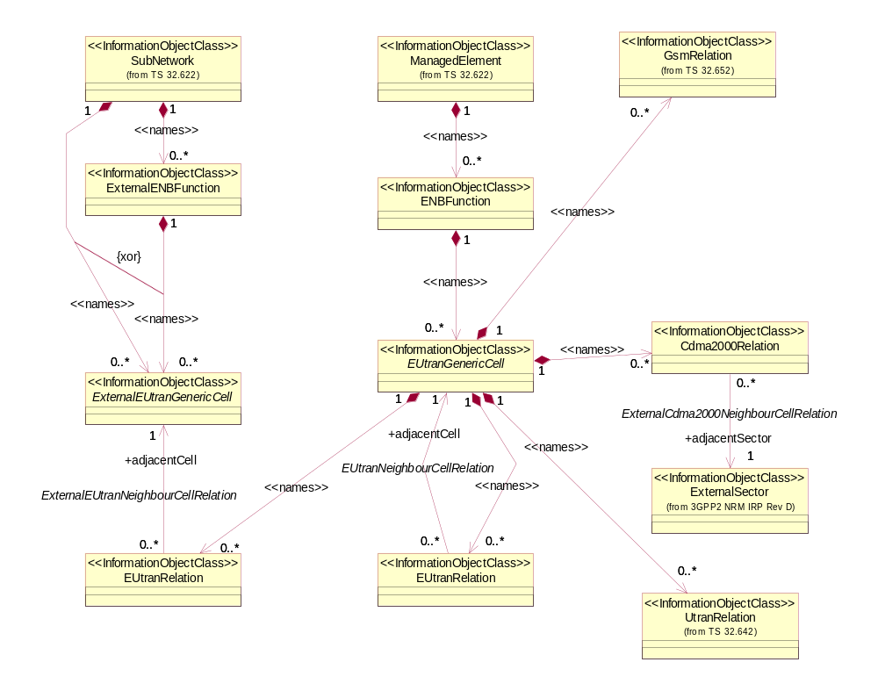
Figure 6.2.1.1: Cell view of E-UTRAN NRM
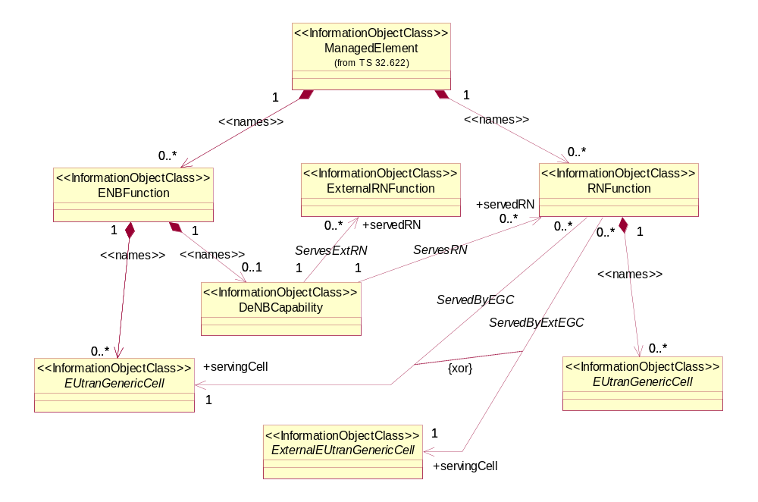
NOTE 1: If an instance of the ServesRN association is present, then a corresponding instance of ServedByEGC must be present. In this case, the ENBFunction and RNFunction instances are under the management scope of the same IRPAgent.
If an instance of the ServesExtRN association is present, then a corresponding instance of ServedByExtEGC must be present. In this case, the ENBFunction and RNFunction instances are under the management scope of two different IRPAgents.
NOTE 2: The modelling of the DeNB capability as a separate IOC or as attributes of ENBFunction is FFS
Figure 6.2.1.2a: E-UTRAN relaying view of E-UTRAN NRM
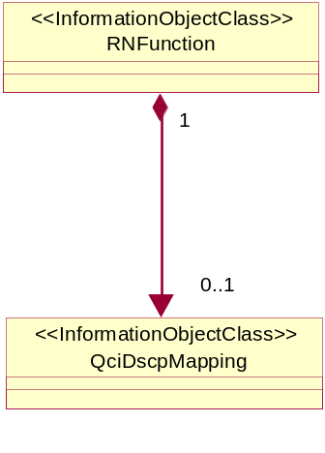
Figure 6.2.1.2b: E-UTRAN relaying view of E-UTRAN NRM_2

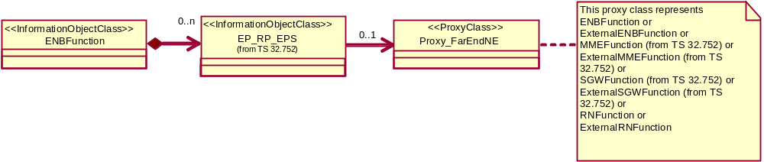
Figure 6.2.1.3: Transport view of E-UTRAN NRM
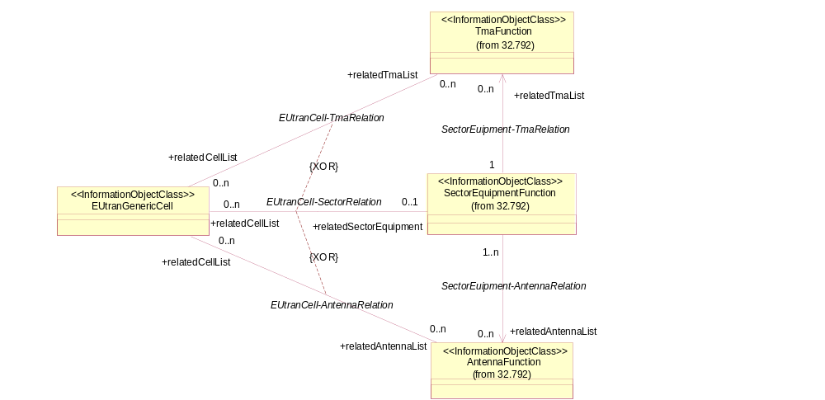
Figure 6.2.1.4: Radio equipment view of E-UTRAN NRM
NOTE: Please see TS 32.792 [31] for the definitions of the associations in this figure.
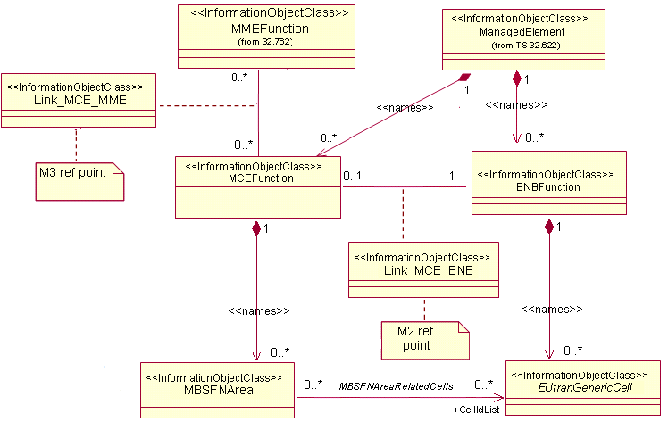
Figure 6.2.1.5: MBMS view of E-UTRAN NRM 1
NOTE 1: This is E-UTRAN NRM containment/relationship Figure form view of MBMS when MCE and ENB belong to one Network Element.
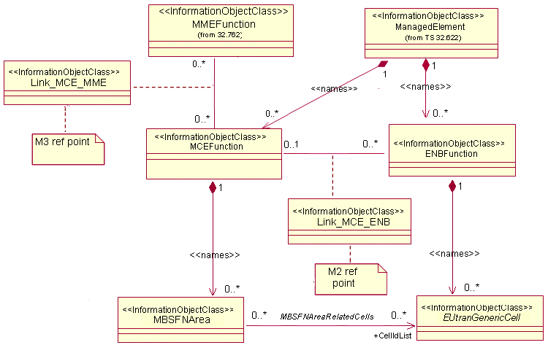
Figure 6.2.1.6: MBMS view of E-UTRAN NRM 2
NOTE 2: This is E-UTRAN NRM containment/relationship Figure form view of MBMS when MCE and ENB belong to different Network Elements.
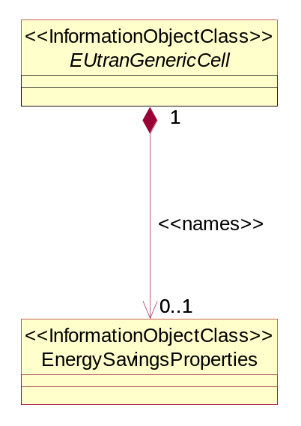
Figure 6.2.1.7: Energy Saving view of E-UTRAN NRM
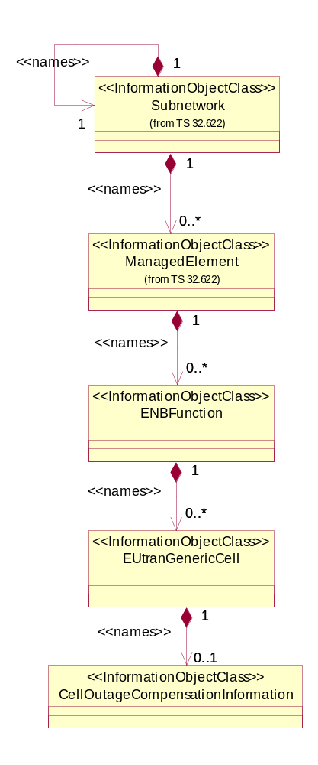
Figure 6.2.1.8: Cell Outage Compensation NRM IOCs (Containment Relationship)

6.2.2 Inheritance
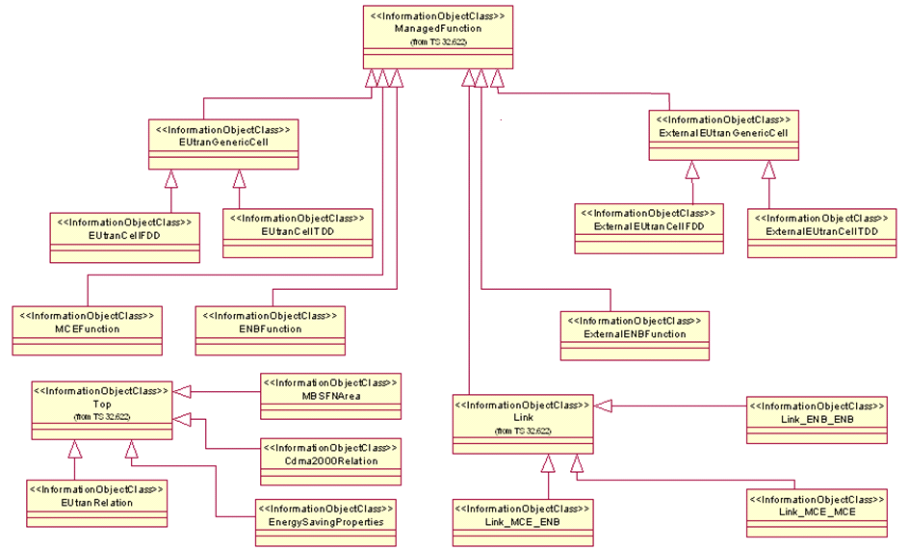
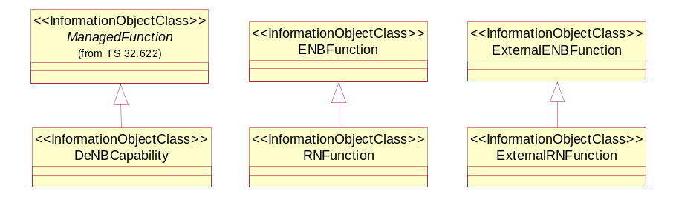
Figure 6.2.2.1: E-UTRAN NRM Inheritance Hierarchy
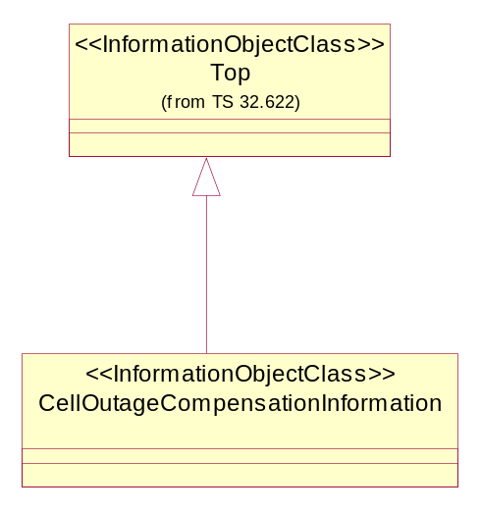
Figure 6.2.2.2: Cell Outage Compensation NRM IOCs (Inheritance Relationship)
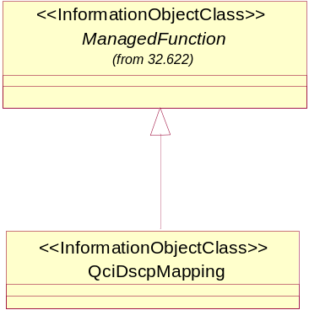
Figure 6.2.2.3: EPC NRM Inheritance Hierarchy_2

6.3 Information Object Class (IOC) definitions

6.3.1 ENBFunction

6.3.1.1 Definition
This IOC represents eNB functionality. For more information about the eNB, see 3GPP TS 23.002 [19].

6.3.1.2 Attributes

Attribute name | Support Qualifier | Read Qualifier | Write Qualifier
id | M | M | -
eNBId | M | M | -
x2BlackList | CM | M | M
x2WhiteList | CM | M | M
x2HOBlackList | CM | M | M
x2IpAddressList | O | M | -
tceIDMappingInfoList | CM | M | M

6.3.1.3 Attribute constraints
Name | Definition
x2BlackList Support Qualifier | The condition is "ANR function is supported".
x2WhiteList Support Qualifier | The condition is "ANR function is supported".
x2HOBlackList Support Qualifier | The condition is "ANR function is supported".
tceIDMappingInfoList | The condition is “MDT function is supported”

6.3.1.4 Notifications
The common notifications defined in subclause 6.6.1 are valid for this IOC, without exceptions or additions.

6.3.2 ExternalENBFunction

6.3.2.1 Definition
This IOC represents an external eNB functionality. For more information about the eNB, see 3GPP TS 23.002 [19].

6.3.2.2 Attributes
Attribute name | Support Qualifier | Read Qualifier | Write Qualifier
id | M | M | -
eNBId | M | M | M

6.3.2.3 Attribute constraints
None.

6.3.2.4 Notifications
The common notifications defined in subclause 6.6.2 are valid for this IOC, without exceptions or additions.

6.3.3 EUtranGenericCell

6.3.3.1 Definition
This abstract IOC represents the common properties of an E-UTRAN generic cell. For more information about cells, see 3GPP TS 23.401 [9].

6.3.3.2 Attributes
Attribute name | Support Qualifier | Read Qualifier | Write Qualifier
id | M | M | -
cellLocalId | M | M | M
cellSize | M | M | M
plmnIdList | M | M | M
tac | M | M | M
pci | M | M | CM
pciList | CM | M | M
maximumTransmissionPower | M | M | CM
referenceSignalPower | M | M | M
pb | M | M | M
partOfSectorPower | CM | M | M
relatedTmaList | CO | M | -
relatedAntennaList | CO | M | -
relatedSector | CM | M | -
cellResvInfo | CM | M | M
allowedAccessClasses | M | M | M
isChangeForEnergySavingAllowed | CM | M | M

Attribute Name | Support Qualifier | Read Qualifier | Write Qualifier
operationalState | O | M | −
administrativeState | O | M | M
availabilityStatus | O | M | -
NOTE: No state or status propagation shall be implied.

6.3.3.3 Attribute constraints
Name | Definition
pci CM Write Qualifier | NM-Centralized PCI assignment (see TS 32.500, ref [15] subclause 6.1.6) is supported.
pciList CM Support Qualifier | Either EM-Centralized or Distributed PCI assignment (see TS 32.500, ref [15] subclause 6.1.6) is supported.
partOfSectorPower CM support qualifier | The IOC SectorEquipmentFunction is used.
maximumTransmissionPower CM Write Qualifier | The IOC SectorEquipmentFunction is not used.
relatedTmaList CO Support Qualifier | The IOC SectorEquipmentFunction is not used.
relatedAntennaList CO Support Qualifier | The IOC SectorEquipmentFunction is not used.
relatedSector CM Support Qualifier | The IOC SectorEquipmentFunction is used.
cellResvInfo CM Support Qualifier | The MBSFN Transmission (see TS 36.300, ref[11] subclause 15.3.3) is supported.
isChangeForEnergySavingAllowed CM Support Qualifier | The energy saving functionality is supported and uses distributed architecture.

Notifications
The common notifications defined in subclause 6.6.1 are valid for this IOC, without exceptions or additions.

6.3.4 ExternalEUtranGenericCell

6.3.4.1 Definition
This abstract IOC represents the properties of an E-UTRAN generic cell controlled by another IRPAgent. This IOC contains necessary attributes for inter-system and intra-system handover. It also contains a subset of the attributes of related IOCs controlled by another IRPAgent. The way to maintain consistency between the attribute values of these IOCs is outside the scope of the present document.

6.3.4.2 Attributes

Attribute name | Support Qualifier | Read Qualifier | Write Qualifier
id | M | M | -
pci | M | M | M
plmnIdList | M | M | M
cellLocalId | M | M | M
eNBId | CM | M | M

6.3.4.3 Attribute constraints
Name | Definition
eNBId CM Support Qualifier | This instance of ExternalEUtranGenericCell IOC is directly contained by SubNetwork.

Notifications
The common notifications defined in subclause 6.6.2 are valid for this IOC, without exceptions or additions.

6.3.5 EUtranCellFDD

6.3.5.1 Definition
This IOC represents the properties of E-UTRAN FDD cell.

6.3.5.2 Attributes
Attribute name | Support Qualifier | Read Qualifier | Write Qualifier
earfcnDl | M | M | M
earfcnUl | M | M | M

6.3.5.3 Attribute constraints
None.

6.3.5.4 Notifications
The common notifications defined in subclause 6.6.1 are valid for this IOC, without exceptions or additions.

6.3.6 ExternalEUtranCellFDD

6.3.6.1 Definition
This IOC represents the common properties of external E-UTRAN FDD cell.

6.3.6.2 Attributes
Table 6.3.5.2.1: Attributes of ExternalEUtranCellFDD
Attribute name | Support Qualifier | Read Qualifier | Write Qualifier
earfcnDl | M | M | M
earfcnUl | M | M | M

6.3.6.3 Attribute constraints
None.

6.3.6.4 Notifications
The common notifications defined in subclause 6.6.2 are valid for this IOC, without exceptions or additions.

6.3.7 EUtranCellTDD

6.3.7.1 Definition
This IOC represents the properties of E-UTRAN cell TDD.

6.3.7.2 Attributes
Attribute name | Support Qualifier | Read Qualifier | Write Qualifier
earfcn | M | M | M
sfAssignment | M | M | M
specialSfPatterns | M | M | M

6.3.7.3 Attribute constraints
None.

6.3.7.4 Notifications
The common notifications defined in subclause 6.6.1 are valid for this IOC, without exceptions or additions.

6.3.8 ExternalEUtranCellTDD

6.3.8.1 Definition
This IOC represents the common properties of external E-UTRAN cell TDD.

Attributes
Attribute name | Support Qualifier | Read Qualifier | Write Qualifier
earfcn | M | M | M

6.3.8.3 Attribute constraints
None.

6.3.8.4 Notifications
The common notifications defined in subclause 6.6.2 are valid for this IOC, without exceptions or additions.

6.3.9 EUtranRelation

6.3.9.1 Definition
This IOC represents a NR from one EUtranGenericCell instance to another EUtranGenericCell or ExternalEUtranGenericCell instance. NRs are directional.

6.3.9.2 Attributes
Attribute name | Support Qualifier | Read Qualifier | Write Qualifier
id | M | M | -
tCI | O | M | M
isRemoveAllowed | CM | M | M
isHOAllowed | CM | M | M
adjacentCell | M | M | M
isICICInformationSendAllowed | CM | M | M
isLBAllowed | CM | M | M
isESCoveredBy | CM | M | M

6.3.9.3 Attribute constraints
Name | Definition
isRemoveAllowed Support Qualifier | The condition is "ANR function is supported".
isHOAllowed Support Qualifier | The condition is "ANR function is supported".
isICICInformationSendAllowed Support Qualifier | The condition is "ICIC function is supported".
isLBAllowed Support Qualifier | The condition is "LB function is supported".
isESCoveredBy Support Qualifier | The condition is “Energy Saving function is supported”.

6.3.9.4 Notifications
The common notifications defined in subclause 6.6.1 are valid for this IOC, without exceptions or additions.

6.3.10 Link_ENB_ENB

6.3.10.1 Definition
This IOC represents the link between two ENBFunction.

Attributes
None.

6.3.10.3 Attribute constraints
None.

6.3.10.4 Notifications
The common notifications defined in subclause 6.6.1 are valid for this IOC, without exceptions or additions.

6.3.11 Void

6.3.12 Void

6.3.13 Cdma2000Relation

6.3.13.1 Definition
This IOC represents a NR from one EUtranGenericCell to a CDMA2000 sector. NRs are directional.
See 3GPP2 TS S.S0028 [22]

6.3.13.2 Attributes

Attribute name | Support Qualifier | Read Qualifier | Write Qualifier
id | M | M | -
adjacentSector | M | M | -

6.3.13.3 Attribute constraints
None.

6.3.13.4 Notifications
The common notifications defined in subclause 6.6.1 are valid for this IOC, without exceptions or additions.

6.3.14 MCEFunction

6.3.14.1 Definition
This IOC represents MCE functionality. For more information about the MCE, see 3GPP TS 36.300 [11].

6.3.14.2 Attributes
Attribute name | Support Qualifier | Read Qualifier | Write Qualifier
id | M | M | -

6.3.14.3 Attribute constraints
None.

6.3.14.4 Notifications
The common notifications defined in subclause 6.6.1 are valid for this IOC, without exceptions or additions.

6.3.15 MBSFNArea

6.3.15.1 Definition
This IOC represents MBSFN Area. For more information about MBSFN Area, see 3GPP TS 36.300 [11].

6.3.15.2 Attributes
Attribute name | Support Qualifier | Read Qualifier | Write Qualifier
id | M | M | -
mbsfnAreaId | M | M | M
cellIdList | M | M | M

6.3.15.3 Attribute constraints
None.

6.3.15.4 Notifications
Name | Qualifier | Notes
notifyAttributeValueChange | See Kernel CM IRP (3GPP TS 32.662 [13])
notifyObjectCreation | See Kernel CM IRP (3GPP TS 32.662 [13])
notifyObjectDeletion | See Kernel CM IRP (3GPP TS 32.662 [13])

6.3.16 Link_MCE_ENB

6.3.16.1 Definition
This IOC models the M2 reference point as defined in TS 36.300 [11].

6.3.16.2 Attributes
None.

6.3.16.3 Attribute constraints
None.

6.3.16.4 Notifications
The common notifications defined in subclause 6.6.1 are valid for this IOC, without exceptions or additions.

6.3.17 Link_MCE_MME

6.3.17.1 Definition
This IOC models the M3 reference point as defined in TS 36.300 [11].

6.3.17.2 Attributes
None.

6.3.17.3 Attribute constraints
None.

6.3.17.4 Notifications
The common notifications defined in subclause 6.6.1 are valid for this IOC, without exceptions or additions.

6.3.18 RNFunction

6.3.18.1 Definition
This IOC represents Relay Node (RN) functionality. For more information about RN, see 3GPP TS 36.300 [11].

6.3.18.2 Attributes
Attribute name | Support Qualifier | Read Qualifier | Write Qualifier
candidateDeNBCells | M | M | M
servingCell | M | M | M
Editor’s note: the need of attribute candidateDeNBCells is for FFS.

6.3.18.3 Attribute constraints
None.

6.3.18.4 Notifications
The common notifications defined in subclause 6.6.1 are valid for this IOC, without exceptions or additions.

6.3.19 ExternalRNFunction

6.3.19.1 Definition
This IOC represents the properties of a Relay Node (RN) controlled by another IRPAgent. For more information about RN, see 3GPP TS 36.300 [11].

6.3.19.2 Attributes
None.

6.3.19.3 Attribute constraints
None.

6.3.19.4 Notifications
The common notifications defined in subclause 6.6.2 are valid for this IOC, without exceptions or additions.

6.3.20 DeNBCapability

6.3.20.1 Definition
This IOC represents the capability for an eNodeB to act as a Donor eNodeB (DeNB) functionality. For more information about the DeNB, see 3GPP TS 36.300 [11].

6.3.20.2 Attributes
Attribute name | Support Qualifier | Read Qualifier | Write Qualifier
id | M | M | -
servedRN | M | M | M
maxNbrRNAllowed | M | M | M

6.3.20.3 Attribute constraints
None.

6.3.20.4 Notifications
The common notifications defined in subclause 6.6.1 are valid for this IOC, without exceptions or additions.

6.3.21 Void

6.3.22 EnergySavingProperties

6.3.22.1 Definition
This abstract IOC represents the energy saving properties of a network element supporting Energy Saving Management functionality.

6.3.22.2 Attributes
Attribute name | Support Qualifier | Read Qualifier | Write Qualifier
energySavingState | M | M | -
energySavingControl | CM | M | M

6.3.22.3 Attribute constraints
Name | Definition
energySavingControl CM Support Qualifier | The condition is "ESM functionality supports and uses centralized architecture".

6.3.22.4 Notifications
The common notifications defined in subclause 6.6.1 are valid for this IOC. Notification notifyAttributeValueChange shall be supported for attribute energySavingState.

6.3.23 CellOutageCompensationInformation

6.3.23.1 Definition
This IOC represents information relevant in case of a Cell Outage Compensation taking place.

6.3.23.2 Attributes
Attribute name | Support Qualifier | Read Qualifier | Write Qualifier
cOCStatus | M | M | -
isCOCAllowed | M | M | M

6.3.23.3 Attribute constraints
None.

6.3.23.4 Notifications
The common notifications defined in subclause 6.6.2 are valid for this IOC, with the addition that notifyAttributeValueChange shall be supported (Support Qualifier M).

6.3.24 IOC QciDscpMapping

6.3.24.1 Definition
This IOC represents a set of mapping between QCI and DSCP.

6.3.24.2 Attributes
Attribute Name | Support Qualifier | Read Qualifier | Write Qualifier
id | M | M | -
qciDscpMappingList | M | M | M

6.3.24.3 Attribute constraints
Null.

6.3.24.4 Notifications
Name | Qualifier | Notes
notifyAttributeValueChange | See Kernel CM IRP (3GPP TS 32.662 [32])
notifyObjectCreation | See Kernel CM IRP (3GPP TS 32.662 [32])
notifyObjectDeletion | See Kernel CM IRP (3GPP TS 32.662 [32])

6.4 Information relationship definitions

6.4.1 EUtranNeighbourCellRelation (M)

6.4.1.1 Definition
This association represents the unidirectional Neighbour cell Relation (NR) from the EUtranGenericCell containing this EUtranRelation to another EUtranGenericCell.

6.4.1.2 Roles
Name | Definition
adjacentCell | This role represents the associated EUtranGenericCell of an EUtranNeighbourCellRelation .

6.4.1.3 Constraints
Associations EUtranNeighbourCellRelation and ExternalEUtranNeighbourCellRelation are mutually exclusive.

6.4.2 ExternalEUtranNeighbourCellRelation (M)

6.4.2.1 Definition
This association represents the unidirectional Neighbour cell Relation (NR) from the EUtranGenericCell containing this EUtranRelation to an ExternalEUtranGenericCell.

6.4.2.2 Roles
Name | Definition
adjacentCell | This role represents the associated ExternalEUtranGenericCell of an ExternalEUtranNeighbourCellRelation.

6.4.2.3 Constraints
Associations EUtranNeighbourCellRelation and ExternalEUtranNeighbourCellRelation are mutually exclusive.

6.4.3 ExternalCdma2000NeighbourCellRelation (M)

6.4.3.1 Definition
This association represents the unidirectional Neighbour cell Relation (NR) from the EUtranGenericCell containing this Cdma2000Relation to an ExternalSector.

6.4.3.2 Roles
Name | Definition
adjacentSector | This role represents the associated ExternalSector of an ExternalCdma2000NeighbourCellRelation.

6.4.3.3 Constraints

6.4.4 Void

6.4.5 Void

6.4.6 Void

6.4.7 Void

6.4.8 Void

6.4.9 MBSFNAreaRelatedCells (M)

6.4.9.1 Definition
This association represents the unidirectional relationship from the MBSFNArea to the EUtranGenericCells it includes.

6.4.9.2 Roles
Name | Definition
cellIdList | This role represents the associated EUtranGenericCell of a MBSFNAreaRelatedCells.

6.4.9.3 Constraints

6.4.10 ServesRN (O)

6.4.10.1 Definition
This unidirectional association represents the relation between a DeNB (represented by an ENBFunction containing a DeNBCapability) and one or more served RNFunction instances.

6.4.10.2 Roles
Name | Definition
servedRN | This role represents the RN instance served by a DeNB instance .

6.4.10.3 Constraints
None.

6.4.11 ServesExtRN (O)

6.4.11.1 Definition
This unidirectional association represents the relation between a DeNB (represented by an ENBFunction containing a DeNBCapability) and one or more served ExternalRNFunction instances.

6.4.11.2 Roles
Name | Definition
servedRN | This role represents the external RN instance served by a DeNB instance .

6.4.11.3 Constraints
None.

6.4.12 ServedByEGC (O)

6.4.12.1 Definition
This unidirectional association represents the relation between one or more RNs and their serving DeNB cell.

6.4.12.2 Roles
Name | Definition
servingCell | This role represents the cell serving one or more RNFunction instances .

6.4.12.3 Constraints
Associations ServedByEGC and ServedByExtEGC are mutually exclusive.

6.4.13 ServedByExtEGC (O)

6.4.13.1 Definition
This unidirectional association represents the relation between one or more RNs and their external serving DeNB cell (under another IRPAgent).

6.4.13.2 Roles
Name | Definition
servingCell | This role represents the external cell serving one or more RNFunction instances .

6.4.13.3 Constraints
Associations ServedByEGC and ServedByExtEGC are mutually exclusive.

6.5 Information attribute definitions

6.5.1 Definition and legal values
Table 6.5.1.1 defines the attributes that are present in several Information Object Classes (IOCs) of the present document.
Table 6.5.1.1: Attributes definitions and legal values
Attribute Name | Definition | Legal Values
adjacentCell | This attribute contains the DN of a EUtranGenericCell or ExternalEUtranGenericCell.
adjacentSector | This attribute contains the DN of an ExternalSector.
isChangeForEnergySavingAllowed | This attribute allows to IRPManager to prohibit or allow configuration changes of the cell for ESM purposes by the IRPAgent. This restriction also applies to instances name contained in such cells. Their attribute values can not be changed by the IRPAgent. | yes,no
candidateDeNBCells | A list of ECGIs of the candidates DeNB cells for the subject Relay Node in Attach for RN operation (phase 2), see 36.300[4]. | See 3GPP TS 36.413[27], 36.300[4]
cellLocalId | Unambiguously identify a cell within an eNodeB | 0 - 255.
cellIdList | This holds a list of DN of EUtranGenericCell. These  cells all belong to one MBSFN Area.
cellSize | See cell-Size in TS 36.423 [24]. | See cell-Size in TS 36.423 [24].
cellResvInfo | This attribute represents whether the cell is MBSFN Area Reserved Cell or not.  See TS 36.300[11] for MBSFN Area Reserved Cell. | See 3GPP TS 36.443 [28] for Cell Reservation Info.
cOCStatus | This attribute holds the information about cell outage compensation (COC) activities for the cell which name contains the CellOutageCompensationInformation IOC instance.  The initial state is cOCDeactive.  When a cell outage is detected and its compensation starts, then the state is cOCActivating.  When COC function decides that all activities to acitvate the compensation are done, the state changes to cOCActive.  When outage of cell is ended and activities to remove the compensation are ongoing, the state changes to cOCDeactivating.  When outage of cell ends and all activities to remove the compensation are done, the state changes back to cOCDeactive.  In case of errors during activation or deactivation, this attribute also contains a list of elements which could not been reconfigured by the COC function.  If there are no errors during activation or deactivation, the list of elements shall be empty.  For an example how notifyAttributeValueChange notifications related to this attribute are used to inform an IRPManager about COC activities see Annex A. | This element contains 2 parts, state and errorList  state = enumerated  {  cOCActivating,  cOCActive,  cOCDeactivating,  cOCDeactive  }  errorList = list of DNs
referenceSignalPower | This defines the cell specific downlink reference signal transmit power, which is described in 3GPP TS 36.213[25] | See 3GPP TS 36.331[10]
earfcn | It is the frequency number for the central frequency. See 3GPP TS 36.104[14]. | See 3GPP TS 36.104[14].
earfcnul | Specifies the channel number for the central UL frequency. The mapping from channel number to physical frequency is described in 3GPP specification TS 36.101 [13] subclause 5.7.3. | See EARFCN in TS 36.101 [13] subclause 5.7.3.
earfcnDl | Specifies the channel number for the central DL frequency. The mapping from channel number to physical frequency is described in 3GPP specification TS 36.101 [13] subclause 5.7.3. | See EARFCN in TS 36.101 [13] subclause 5.7.3
energySavingControl | This attribute allows the IRPManager to initiate energy saving activation or deactivation. Its value can not be changed by the IRPAgent. | Enumerated  {toBeEnergySaving, toBeNotEnergySaving}.
energySavingState | Specifies the status regarding the energy saving in the cell.  If the value of energySavingControl is toBeEnergySaving, then it shall be tried to achieve the value isEnergySaving for the energySavingState.  If the value of energySavingControl is toBeNotEnergySaving, then it shall be tried to achieve the value isNotEnergySaving for the energySavingState. | Enumerated  {isNotEnergySaving,  isEnergySaving}.
eNBId | Unambiguously identifies an eNodeB within a PLMN | See 3GPP TS 36.413[27], 36.300[4]
id | An attribute whose "name+value" can be used as an RDN when naming an instance of the object class. This RDN uniquely identifies the object instance within the scope of its containing (parent) object instance.
isCOCAllowed | This attribute allows to IRPManager to prohibit or allow configuration changes of the cell for cell outage compensation purposes by the IRPAgent. This restriction also applies to instances name contained in such cells. Their attribute values can not be changed by the IRPAgent. | yes,no
isESCoveredBy | The value of the attribute is configured by the IRPmanager and is not changed by the IRPAgent. It indicates whether the adjacentCell according to this planning provides no, partial or full coverage for the cell which name-contains the EUtranRelation instance.  Adjacent cells with this attribute equal to “yes” are recommended to be considered as candidate cells to take over the coverage when the original cell is about to be transferred to energySaving state.  The entirety of adjacent cells with this property equal to “partial” are recommended to be considered as entirety of candidate cells to take over the coverage when the original cell is about to be transferred to energySaving state.  The value “partial” is not allowed in an eNB overlaid scenario. | No, partial, yes
isRemoveAllowed (see note 1) | This indicates if the subject EUtranRelation can be removed (deleted) or not.  If ‘yes’, the subject EUtranRelation instance can be removed (deleted).  If ‘no’, the subject EUtranRelation instance shall not be removed (deleted) by any entity but an IRPManager. | yes, no
isHOAllowed (see note 1) | This indicates if HO is allowed or prohibited.  If ‘yes’, handover is allowed from source cell to target cell. The source cell is identified by the name-containing EUtranGenericCell of the EUtranRelation that has the isHOAllowed. The target cell is referenced by the EUtranRelation that has this isHOAllowed.  If ‘no’, handover shall not be allowed. | yes, no
isICICInformationSendAllowed | This indicates if ICIC (Inter Cell Interference Coordination) load information message (see TS 36.423 [24] Section 9.1.2.1 LOAD INFORMATION) sending is allowed or prohibited.  If ‘yes’, ICIC load information message sending is allowed from source cell to target cell. The source cell is identified by the name-containing EUtranGenericCell of the EUtranRelation that has the isICICInformationSendAllowed. The target cell is referenced by the EUtranRelation that has this isICICInformationSendAllowed.  If ‘no’, ICIC load information message sending shall not be allowed. | yes, no
isLBAllowed | This indicates if load balancing is allowed or prohibited from source cell to target cell.  If ‘yes’, load balancing is allowed from source cell to target cell. The source cell is identified by the name-containing EUtranGenericCell of the EUtranRelation that has the isLBAllowed. The target cell is referenced by the EUtranRelation that has this isLBAllowed.  If ‘no’, load balancing shall be prohibited from source cell to target cell. | yes, no
maximumTransmissionPower | This is the maximum possible for all downlink channels, used simultaneously in a cell, added together.
mbsfnAreaId | This is the identifier of MBSFN Area.  See TS 36.300[11] for MBSFN Area. | See 3GPP TS 36.443 [28] for mbsfnAreaId
partOfSectorPower | This is the requested part (i.e. %) of the total radio power available to the SectorEquipmentFunction. The requested % power should be allocated to the cell. | 0 : 100
pb | 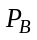, which is described in Section 5.2 of TS 36.213 [25] | See 3GPP TS 36.213[25]
pci | This holds the Physical Cell Identity (PCI) of the cell (for NM-Centralized, EM-Centralized and Distributed PCI assignment cases).  In the case of NM-Centralized PCI assignment, see TS 36.300, [11] subclause 22.3.5, IRPManager signals a specific value by writing this attribute. | See TS 36.211 [12] subclause 6.11 for legal values of pci.
pciList | This holds a list of physical cell identities that can be assigned to the pci attribute by eNB. The assignment algorithm is not specified.  This attribute shall be supported if and only if the EM-Centralized or Distributed PCI Assignment is supported. See TS 32.500, ref [15] subclause 6.1.6. | See TS 36.211 [12] subclause 6.11 for legal values of pci. The number of pci in the list is 1 to 504.
plmnIdList | List of unique identities for PLMN.  Note: A cell can broadcast up to 6 PLMN-id's. This is to support the case that one cell can be used by up to 6 operators’ core networks.  One member of plmnIdList is the primary PLMN Id.  See TS 36.331 [10] section 6.2.2: SystemInformationBlockType1/cellAccessRelatedInformation/plmn-IdentityList is a SEQUENCE (SIZE (1..6)) | A list of at most six entries of PLMN Identifiers. The PLMN Identifier is composed of a Mobile Country Code (MCC) and a Mobile Network Code (MNC).  See TS 23.003 [3] subclause 2.2 and 12.1.
relatedAntennaList | This is an attribute to list the DNs of AntennaFunction(s)(see TS 32.792[31]) that support the EUtranGenericCell. | See ‘relatedAntennaList’ in Ref. 3GPP TS 32.792 [31]
relatedTmaList | This is an attribute to list the DNs of TmaFunction(s) (see TS 32.792[31]) that support the EUtranGenericCell. | See ’relatedTmaList’ in Ref. 3GPP TS 32.792 [31].
relatedSectorEquipment | This is an attribute to the DN of SectorEquipmentFunction (see TS 32.792[31]) that support the EUtranGenericCell. | See ‘relatedSectorEquipment’ in Ref. 3GPP TS 32.792 [31].
qciDscpMappingList | It is a list of mapping between QCI and DSCP, each mapping is a structure including the element QCI and DSCP;  Wherein  - QCI represents the number of the QCI (Ref. 3GPP TS 23.203[33]);  - DSCP represents the DiffServ codepoint (Ref. 3GPP TS 23.207[34] and RFC 2474[35]). | For QCI, Ref. 3GPP TS 23.203[33];  For DSCP, Ref. RFC 2474[35]
servedRN | This attribute contains the DNs of one or more associated instances of RNFunction and ExternalRNFunction.
servingCell | This attribute contains the DN of one associated instance of EutranGenericCell or ExternalEutranGenericCell.
maxNbrRNAllowed | This is an integer indicating the maximum number of RNs allowed to be connected. It is a number which can be configured by the operator to control the node/network load.
sfAssignment | This is the uplink-downlink subframe configuration number of a TDD E-UTRAN cell. | See 3GPP TS 36.211[12].
specialSfPatterns | This is the special subframe configuration number of a TDD E-UTRAN cell. | See 3GPP TS 36.211[12].
tac | Common Tracking Area Code for the PLMNs. The identity used to identify tracking areas. | - It is the Tracking Area Code (TAC).  - A cell can only broadcast one TAC. See TS 36.300 [11], section 10.1.7 (PLMNID and TAC relation).  - TAC is defined in TS 23.003 [3], section 19.4.2.3.
tceIDMappingInfoList | This attribute includes a list of TCE ID and the corresponding TCE IP address. It is used in Logged MDT case to provide the information to the RNC to get the corresponding TCE IP address when there is an MDT log received from the UE. | See “Trace Collection Entity Address” and “Trace Collection Entity Id” in 3GPP TS 32.422 [30].
tCI | This is the Target Cell Identifier. It consists of E-UTRAN Cell Global Identifier (ECGI) and Physical Cell Identifier (PCI) of the target cell.  The EUtranRelation.tCI identifies the target cell from the perspective of the EUtranGenericCell, the name-containing instance of the subject EUtranRelation instance. | The Target Cell Identifier is defined in TS 36.300 [11]. See TS 36.211 [12] subclause 6.11 for legal values of the PCI.
x2BlackList | This is a list of DNs of ENBFunction and ExternalENBFunction. If the target node DN is a member of the source node’s ENBFunction.x2BlackList, the source node is:  - Prohibited from sending X2 connection request to target node;  - Forced to tear down established X2 connection to target node  - Not allowed to accept incoming X2 connection request from target node.  The same DN may appear here and in ENBFunction.x2WhiteList. In such case, the DN in x2WhiteList shall be treated as if it is absent.
x2IpAddressList | Represents one or more IP addresses used by ENBFunction for this ENBFunction’s X2 Interface | One or more IPv4 or IPv6 addresses
x2WhiteList | This is a list of DNs of ENBFunction and ExternalENBFunction. If the target node DN is a member of the source node’s ENBFunction.x2WhiteList, the source node :  - Is allowed to request the establishment of X2 connection with the target node;  - Is not allowed to initiate the tear down of established X2 connection to target node  The same DN may appear here and in ENBFunction.x2BlackList. In such case, the DN here shall be treated as if it is absent.
x2HOBlackList | This is a list of DNs of ENBFunction. The ENBFunction.x2HOBlackList identifies a list of neighbour ENBFunction with whom the subject ENBFunction is prohibited to use X2 interface for HOs even if the X2 interface exists between them.
allowedAccessClasses | This holds information for access classes (10-15) – [3GPP TS 22.011] that are allowed for the eUTRANCell .  The access classes are:  Class 10 – emergency call  Class 11 - For PLMN Use.  Class 12 - Security Services;  Class 13 - Public Utilities (e.g. water/gas suppliers);  Class 14 - Emergency Services;  Class 15 - PLMN Staff; | The default value is all access classes are allowed  See TS 22.011 [29] and 36.331 [10] for more details on the definition and SIB2 broadcast message definition

NOTE: Attributes isRemoveAllowed and isHOAllowed each has 2 legal values, allow (A) and prohibited (P). The two attributes are semantically equivalent to one attribute with 4 legal values such as:
hOAllow; hOProhibited; hOWhiteListed; hOBlackListed;
where
- hOAllow == isRemoveAllowed is A and isHOAllowed is A;
- hOProhibited == isRemoveAllowed is A and isHOAllowed is P;
- hOWhiteListed == isRemoveAllowed is P and isHOAllowed is A;
- hOBlackListed == isRemoveAllowed is P and isHOAllowed is P.
Therefore, the choice of an option is FFS.

6.5.2 Constraints
None.

6.6 Common Notifications

6.6.1 Alarm and configuration notifications
Name | Qualifier | Notes
notifyAckStateChanged | See Alarm IRP (3GPP TS 32.111-2 [11])
notifyAttributeValueChange | O
notifyChangedAlarm | See Alarm IRP (3GPP TS 32.111-2 [11])
notifyClearedAlarm | See Alarm IRP (3GPP TS 32.111-2 [11])
notifyNewAlarm | See Alarm IRP (3GPP TS 32.111-2 [11])
notifyObjectCreation | O
notifyObjectDeletion | O
notifyComments | See Alarm IRP (3GPP TS 32.111-2 [11])
notifyAlarmListRebuilt | See Alarm IRP (3GPP TS 32.111-2 [11])
notifyPotentialFaultyAlarmList | See Alarm IRP (3GPP TS 32.111-2 [11])

Note that these notifications are issued based on occurrences on the IRPAgent IOC and not on occurrences on other IOCs.

6.6.2 Configuration notifications
Name | Qualifier | Notes
notifyAttributeValueChange | O
notifyObjectCreation | O
notifyObjectDeletion | O

Note that these notifications are issued based on occurrences on the IRPAgent IOC and not on occurrences on other IOCs.

6.7 System State Model
None.

Annex A (informative):
Notifications during a Cell Outage Compensation
The following sequence diagrams and table show an example how notifications of IOC CellOutageCompensationInformation and other notifications are used to inform an IRPManager about the COC activities.
The sequence diagrams show the basic event flow, the table gives more details on selected, most relevant, content of the notifications.
Yes

state=cOCActivating
errorList is empty
OCI sends notification

Cell fails,
COC starts

Reconfigure other cell

Reconf successful?

No

Add other cell to errorList

cell sends notification

Outage compensated?

No

state=cOCActive
OCI sends notification

More reconfigurations?

No

Yes

Wait for end of Cell outage

OCI: OutageCompensationInformation

Yes

Figure A-1: Sequence diagram of COC, part 1

Yes

state=cOCDeactivating
errorList is empty
OCI sends notification

Cell outage of compensated cell ends

Reconfigure other cell

Reconf successful?

No

Add other cell to errorList

cell sends notification

Outage compensation removed?

No

state=cOCDeactive
OCI sends notification

More reconfigurations?

No

Yes

COC
ended

OCI: OutageCompensationInformation

Yes

Figure A-2: Sequence diagram of COC, part 2
Legend for the table:
Notifications in italic font are not directly triggered by COC activities, but help to give a full picture.:
Notification content in bold font indicates a changed attribute value.
Time | Event | Notification | Selected notification content *)
T1 | Outage of cell 1. COC is done for this cell. | notifyNewAlarm, originated by EUtranGenericCell instance representing cell 1  notifyAttributeValueChange of CellOutageCompensationInformation instance name contained in EUtranGenericCell instance representing cell 1. | notificationId=notiAlCell1  correlatedNotifications={ }  notificationId=COC1  correlatedNotifications={ notiAlCell1};  cOCStatus.state = cOCActivating  cOCStatus.errorList={}
T2 | COC reconfigures cell 2 | notifyAttributeValueChange of EUtranGenericCell instance representing cell 2 | notificationId=avcCell2comp  correlatedNotifications={COC1}
T3 | COC reconfigures cell 3 | notifyAttributeValueChange of EUtranGenericCell instance representing cell 3 | notificationId= avcCell3comp  correlatedNotifications={ COC1}
T4 | COC tries to reconfigure cell 4 without success | notifyAttributeValueChange of CellOutageCompensationInformation instance name contained in EUtranGenericCell instance representing cell 1 | notificationId=COC2  correlatedNotifications={COC1}  cOCStatus.state =  cOCActivating cOCStatus.errorList={cell4}
Case: COC successful
T5a | COC function decides, that no further actions are necessary. | notifyAttributeValueChange of CellOutageCompensationInformation instance contained in EUtranGenericCell instance representing cell 1 | notificationId=COC5a  correlatedNotifications={COC1}  cOCStatus.state = cOCActive  cOCStatus.errorList={cell4}
T6a | Outage of cell 1 ends | notifyClearedAlarm, originated by EUtranGenericCell instance representing cell 1  notifyAttributeValueChange of CellOutageCompensationInformation instance name contained in EUtranGenericCell instance representing cell 1 | notification Id= clearAlCell1  correlatedNotifications={ notiAlCell1, COC1}  Notification Id=COC6a  correlatedNotifications={COC1, COC5a, clearAlCell1}  cOCStatus.state = cOCDeactivating  cOCStatus.errorList={}
T7a | COC tries to reconfigure cell 2 without success | In case of unsuccessful reconfiguration:  notifyAttributeValueChange of CellOutageCompensationInformation instance name contained in EUtranGenericCell instance representing cell 1 | Notification Id=COC7a  correlatedNotifications={COC1, COC5a, COC6a, clearAlCell1}  cOCStatus.state=  cOCDeactivating;  cOCStatus.errorList ={cell2}
T8a | COC reconfigures cell 3 | notifyAttributeValueChange of EUtranGenericCell instance representing cell 3  notifyAttributeValueChange of CellOutageCompensationInformation instance name contained in EUtranGenericCell instance representing cell 1. | notification Id= avcCell3decomp  correlatedNotifications={ COC1, COC5a, avcCell3comp }  Notification Id=COC8a  correlatedNotifications={COC1, clearAlCell1}  cOCStatus.state= cOCDeactive  cOCStatus.errorList={cell2}
Case: COC not successful
T5b | COC function decides, that compensation was not successful | notifyAttributeValueChange of CellOutageCompensationInformation instance name contained in EUtranGenericCell instance representing cell 1 | Notification Id=COC5b  correlatedNotifications={COC1}  cOCStatus.state= cOCActive  cOCStatus.errorList={cell4}
T6b | Outage of cell 1 ends | notifyClearedAlarm, originated by EUtranGenericCell instance representing cell 1  notifyAttributeValueChange of CellOutageCompensationInformation instance name contained in EUtranGenericCell instance representing cell 1 | notification Id= clearAlCell1  correlatedNotifications={ notiAlCell1, COC1}  Notification Id=COC6b  correlatedNotifications={COC1, clearAlCell1}  cOCStatus.state= cOCDeactivating  cOCStatus.errorList={}
T7b | COC reconfigures cell 2 | notifyAttributeValueChange of EUtranGenericCell instance representing cell 2 | notification Id= avcCell2decomp  correlatedNotifications={COC1, COC5b, avcCell2comp }
T8b | COC reconfigures cell 3 | notifyAttributeValueChange of EUtranGenericCell instance representing cell 3  notifyAttributeValueChange of CellOutageCompensationInformation instance name contained in EUtranGenericCell instance representing cell 1. | notification Id= avcCell3decomp  correlatedNotifications={ COC1, COC5b, avcCell3comp }  Notification Id=COC8b  correlatedNotifications={COC1, clearAlCell1}  cOCStatus.state= cOCDeactive  cOCStatus.errorList={}
*) Remarks:
There may be some content of the correlatedNotifications and/or additionalInformation field, which is not related to COC. This additional content is not shown for better readability and must be kept unchanged by COC.
NotificationId’s are only examples.

Annex B (informative):
Change history
Change history
Date | TSG # | TSG Doc. | CR | Rev | Subject/Comment | Cat | Old | New
Dec 2008 |  |  |  |  | Presentation to SA for information |  | --- | 1.0.0
Mar 2009 | SP-43 | SP-090074 | -- | -- | Presentation to SA for approval |  | 2.0.0 | 8.0.0
Jun 2009 | SP-44 | SP-090408 | 001 | - | Cleanup, updated figures and improved definitions | F | 8.0.0 | 8.1.0
Jun 2009 | SP-44 | SP-090289 | 002 | - | Clarify x2Whitelist definition | F | 8.0.0 | 8.0.0
Jun 2009 | SP-44 | SP-090408 | 004 | - | Add the missing cellSize attribute in EUtranGenericCell IOC - align with 36.423 | F | 8.0.0 | 8.1.0
Jun 2009 | SP-44 | SP-090408 | 006 | - | IOC Relations and UML updates | F | 8.0.0 | 8.1.0
Jun 2009 | SP-44 | SP-090408 | 007 | - | Add missing IOCs in the Class Diagram | F | 8.0.0 | 8.1.0
Jun 2009 | SP-44 | SP-090408 | 008 | - | Add the missing downlink power related attributes for EUTRAN Cell - align with 36.213 and 36.331 | F | 8.0.0 | 8.1.0
Jun 2009 | SP-44 | SP-090289 | 003 | - | Add downlink power related attributes for EUTRAN Cell | F | 8.0.0 | 8.1.0
Jun 2009 | SP-44 | SP-090290 | 005 | - | Add ICIC management attribute in EUtranRelation | B | 8.1.0 | 9.0.0
Jun 2009 | SP-44 | SP-090408 | 009 | - | Add the missing downlink power related attributes for EUTRAN Cell - align with 36.213 and 36.331 | B | 8.1.0 | 9.0.0
Sep 2009 | SP-45 | SP-090542 | 011 | - | Add missing attribute ‘id’ | A | 9.0.0 | 9.1.0
Sep 2009 | SP-45 | SP-090534 | 012 | - | Removing changes introduced by S5-092094 | A | 9.0.0 | 9.1.0
Sep 2009 | SP-45 | SP-090542 | 014 | - | Correct Information relationship definitions | A | 9.0.0 | 9.1.0
Sep 2009 | SP-45 | SP-090542 | 017 | - | Cleanup and improvements | F | 9.0.0 | 9.1.0
Dec 2009 | SP-46 | SP-090719 | 018 | - | Add attributes to EUtranCellTDD and ExternalEUtranCellTDD | B | 9.1.0 | 9.2.0
Dec 2009 | SP-46 | SP-090719 | 019 | - | Add load balancing control | B | 9.1.0 | 9.2.0
Dec 2009 | SP-46 | SP-090719 | 020 | - | Remove the repeated definition of EP_RP_EPS | F | 9.1.0 | 9.2.0
Dec 2009 | SP-46 | SP-090719 | 021 | - | Import QCISet IOC to E-UTRAN NRM IRP | B | 9.1.0 | 9.2.0
Dec 2009 | SP-46 | SP-090719 | 022 | - | Indicate primary PLMN Id in plmnIdList attribute | C | 9.1.0 | 9.2.0
Jan 2010 | -- | -- | -- | -- | Editorial correction (highlighting in 6.3.3.2) | -- | 9.2.0 | 9.2.1
Mar 2010 | SP-47 | SP-100035 | 024 | -- | Delete the redundant Proxy Classes ProxyGsmCell and ProxyUtranCell | F | 9.2.1 | 9.3.0
Mar 2010 | SP-47 | SP-100035 | 025 | -- | Make tCI attribute of EUtranRelation IOC optional | F | 9.2.1 | 9.3.0
Mar 2010 | SP-47 | SP-100036 | 027 | -- | Add the missing IOC ExternalSGWFunction that Proxy_FarEndNE can represent | F | 9.2.1 | 9.3.0
Apr 2010 |  |  |  |  | Correction to history table (adds CR027) |  | 9.3.0 | 9.3.1
Jun 2010 | SP-48 | SP-100246 | 028 | -- | Remove superflous attribute farEndNeIpAddr | F | 9.3.1 | 10.0.0
Sep 2010 | SP-49 | SP-100489 | 029 | -- | Addition of eNBId and adjustment of cellIdentity | C | 10.0.0 | 10.1.0
Sep 2010 | SP-49 | SP-100489 | 030 | -- | Add IOC MCEFunction and MBSFNArea | B | 10.0.0 | 10.1.0
Sep 2010 | SP-49 | SP-100487 | 031 | -- | Remove cellType | A | 10.0.0 | 10.1.0
Sep 2010 | SP-49 | SP-100488 | 032 | -- | Add associations and roles for Radio Equipment view | A | 10.0.0 | 10.1.0
Dec 2010 | SP-50 | SP-100833 | 036 | -- | Correcting pci and pciList attributes definition - Align with 32.500 SON architecture definition | F | 10.1.0 | 10.2.0
Dec 2010 | SP-50 | SP-100866 | 038 | 1 | Introduction of attributes to reflect the status of Energy Savin | B | 10.1.0 | 10.2.0
Dec 2010 | SP-50 | SP-100833 | 041 | 1 | Adding Relay and Donor eNodeB NRM - Align with RAN2 TS 36.300 | B | 10.1.0 | 10.2.0
Dec 2010 | SP-50 | SP-100751 | 042 | 2 | Adding IOC for energy saving properties | B | 10.1.0 | 10.2.0
Dec 2010 | SP-50 | SP-100833 | 043 | -- | Add an attribute to IOC EUtranGenericCell to set allowed access class per cell | B | 10.1.0 | 10.2.0
Dec 2010 | SP-50 | SP-100751 | 044 | -- | Adding NRM for "candidate cells" in Energy Saving Management (ESM) | B | 10.1.0 | 10.2.0
Mar 2011 | SP-51 | SP-110095 | 45 | 2 | Add attributes to RNFunction in E-UTRAN Network Resource Model IRP Information Service | B | 10.2.0 | 10.3.0
Mar 2011 | SP-51 | SP-110095 | 46 | 1 | Add qciDscpMapping IOC | B | 10.2.0 | 10.3.0
Mar 2011 | SP-51 | SP-110095 | 47 | 1 | Add relay IOCs to be connected by the EP_RP_EPS by ENBFunction in E-UTRAN Network Resource Model IRP Information Service | B | 10.2.0 | 10.3.0
Mar 2011 | SP-51 | SP-110100 | 50 | 3 | Add a new attribute into EUtranGenericCell object class to define a cell as not changeable by Energy Saving Management - Align with 32.551 ESM Concepts and requirements | B | 10.2.0 | 10.3.0
Mar 2011 | SP-51 | SP-110095 | 53 | 2 | Correct Relay and Donor eNodeB model in E-UTRAN Network Resource Model IRP Information Service | F | 10.2.0 | 10.3.0
Mar 2011 | SP-51 | SP-110100 | 54 | 1 | Correct ambiguous value usage on energySavingState | F | 10.2.0 | 10.3.0
Mar 2011 | SP-51 | SP-110096 | 56 | 2 | Removing SectorEquipmentFunction from EUTRAN NRM | F | 10.2.0 | 10.3.0
Mar 2011 | SP-51 | SP-110102 | 62 | 1 | Adding TCE address and TCE ID mapping information to ENBFunction | B | 10.2.0 | 10.3.0
Mar 2011 | SP-51 | SP-110097 | 63 | 2 | Add a new object class to hold information about Cell Outage Compensation (COC) and report COC activities - Align with 32.541 | B | 10.2.0 | 10.3.0

