3GPP TS 32.732 V9.1.0 (2010-12)
Technical Specification
3rd Generation Partnership Project;
Technical Specification Group Services and System Aspects;
Telecommunication management;
IP Multimedia Subsystem (IMS)
Network Resource Model (NRM) Integration Reference Point (IRP): Information Service (IS)
(Release 9)


The present document has been developed within the 3rd Generation Partnership Project (3GPP TM) and may be further elaborated for the purposes of 3GPP.
The present document has not been subject to any approval process by the 3GPP Organizational Partners and shall not be implemented.
This Specification is provided for future development work within 3GPP only. The Organizational Partners accept no liability for any use of this Specification.
Specifications and reports for implementation of the 3GPP TM system should be obtained via the 3GPP Organizational Partners' Publications Offices.

Keywords
UMTS, management
3GPP
Postal address

3GPP support office address
650 Route des Lucioles - Sophia Antipolis
Valbonne - FRANCE
Tel.: +33 4 92 94 42 00 Fax: +33 4 93 65 47 16
Internet
http://www.3gpp.org
Copyright Notification
No part may be reproduced except as authorized by written permission.
The copyright and the foregoing restriction extend to reproduction in all media.

© 2010, 3GPP Organizational Partners (ARIB, ATIS, CCSA, ETSI, TTA, TTC).
All rights reserved.
UMTS™ is a Trade Mark of ETSI registered for the benefit of its members
3GPP™ is a Trade Mark of ETSI registered for the benefit of its Members and of the 3GPP Organizational Partners
LTE™ is a Trade Mark of ETSI currently being registered for the benefit of its Members and of the 3GPP Organizational Partners
GSM® and the GSM logo are registered and owned by the GSM Association
Contents
Foreword 6
Introduction 6
1 Scope 7
2 References 7
3 Definitions and abbreviations 8
3.1 Definitions 8
3.2 Abbreviations 8
4 System overview 10
4.1 Compliance rules 10
5 Modelling approach 10
6 Information Object Classes 10
6.1 Imported information entities and local labels 10
6.2 Class diagram 11
6.2.1 Attributes and relationships 11
6.2.2 Inheritance 15
6.3 Information object class definitions 19
6.3.1 ASFunction 19
6.3.1.1 Definition 19
6.3.1.2 Attributes 19
6.3.1.3 Notifications 19
6.3.2 BGCFFunction 19
6.3.2.1 Definition 19
6.3.2.2 Attributes 19
6.3.2.3 Notifications 19
6.3.3 CAMELIMSSFASFunction 19
6.3.3.1 Definition 19
6.3.3.2 Attributes 19
6.3.4 CSCFFunction 20
6.3.4.1 Definition 20
6.3.4.2 Attributes 20
6.3.4.3 Notifications 20
6.3.5 HSSFunction 20
6.3.5.1 Definition 20
6.3.5.2 Attributes 20
6.3.5.3 Notifications 20
6.3.6 ICSCFFunction 20
6.3.6.1 Definition 20
6.3.6.2 Attributes 20
6.3.6.3 Notifications 20
6.3.7 IMSMGWFunction 20
6.3.7.1 Definition 20
6.3.7.2 Attributes 21
6.3.7.3 Notifications 21
6.3.8 MGCFFunction 21
6.3.8.1 Definition 21
6.3.8.2 Attributes 21
6.3.8.3 Notifications 21
6.3.9 MRFCFunction 21
6.3.9.1 Definition 21
6.3.9.2 Attributes 21
6.3.9.3 Notifications 21
6.3.10 MRFPFunction 22
6.3.10.1 Definition 22
6.3.10.2 Attributes 22
6.3.10.3 Notifications 22
6.3.11 OSASCSASFunction 22
6.3.11.1 Definition 22
6.3.11.2 Attributes 22
6.3.12 PCSCFFunction 22
6.3.12.1 Definition 22
6.3.12.2 Attributes 22
6.3.12.3 Notifications 22
6.3.13 SCSFFunction 22
6.3.13.1 Definition 22
6.3.13.2 Attributes 22
6.3.13.3 Notifications 22
6.3.14 SIPASFunction 23
6.3.14.1 Definition 23
6.3.14.2 Attributes 23
6.3.15 SLFFunction 23
6.3.15.1 Definition 23
6.3.15.2 Attributes 23
6.3.15.3 Notifications 23
6.3.16 Reserved for Future Use 23
6.3.50 Reserved for Future Use 23
6.3.51 Void 24
6.3.52 Link_AS_ICSCF 24
6.3. 52.1 Definition 24
6.3.53 Link_AS_SCSCF 24
6.3.53.1 Definition 24
6.3.54 Link_AS_SLF 24
6.3.54.1 Definition 24
6.3.55 Link_BGCF_BGCF 24
6.3.55.1 Definition 24
6.3.57 Link_BGCF_MGCF 24
6.3.57.1 Definition 24
6.3.58 Link_BGCF_SCSCF 24
6.3.58.1 Definition 24
6.3.60 Link_HSS_ICSCF 24
6.3.60.1 Definition 24
6.3.61 Link_ICSCF_SCSCF 25
6.3.61.1 Definition 25
6.3.62 Link_ICSCF_MGCF 25
6.3.62.1 Definition 25
6.3.64 Link_ICSCF_PCSCF 25
6.3.64.1 Definition 25
6.3.65 Link_PCSCF_SCSCF 25
6.3.65.1 Definition 25
6.3.67 Link_CAMELIMSSFAS_HSS 25
6.3.67.1 Definition 25
6.3.68 Link_HSS_OSASCSAS 25
6.3.68.1 Definition 25
6.3.69 Link_HSS_SCSCF 25
6.3.69.1 Definition 25
6.3.70 Link_HSS_SIPAS 25
6.3.70.1 Definition 25
6.3.71 Link_ICSCF_SLF 26
6.3.71.1 Definition 26
6.3.72 Link_IMSMGW_MGCF 26
6.3.72.1 Definition 26
6.3.73 Link_MGCF_SCSCF 26
6.3.73.1 Definitions 26
6.3.74 Link_MRFC_MRFP 26
6.3.74.1 Definition 26
6.3.75 Link_MRFC_SCSCF 26
6.3.75.1 Definition 26
6.3.76 Link_SCSCF_SCSCF 26
6.3.76.1 Definition 26
6.3.77 Link_SCSCF_SLF 26
6.3.77.1 Definition 26
6.4 Information relationship definitions 26
6.5 Information attribute definitions 26
6.5.1 Definition and legal values 27
6.5.2 Constraints 27
6.6 Common notifications 28
6.7 Particular information configurations 28
Annex A (informative): Change history 29

Foreword
This Technical Specification has been produced by the 3rd Generation Partnership Project (3GPP).
The contents of the present document are subject to continuing work within the TSG and may change following formal TSG approval. Should the TSG modify the contents of the present document, it will be re-released by the TSG with an identifying change of release date and an increase in version number as follows:
Version x.y.z
where:
x the first digit:
1 presented to TSG for information;
2 presented to TSG for approval;
3 or greater indicates TSG approved document under change control.
y the second digit is incremented for all changes of substance, i.e. technical enhancements, corrections, updates, etc.
z the third digit is incremented when editorial only changes have been incorporated in the document.

Introduction
The present document is part of a TS-family covering the 3rd Generation Partnership Project Technical Specification Group Services and System Aspects, Telecommunication management; as identified below:
32.731: "IP Multimedia Subsystem (IMS) Network Resource Model (NRM) Integration Reference Point (IRP): Requirements".
32.732: "IP Multimedia Subsystem (IMS) Network Resource Model (NRM) Integration Reference Point (IRP): Information Service (IS)".
32.733: "IP Multimedia Subsystem (IMS) Network Resource Model (NRM) Integration Reference Point (IRP): Common Object Request Broker Architecture (CORBA) Solution Set (SS)".
32.735: "IP Multimedia Subsystem (IMS) Network Resource Model (NRM) Integration Reference Point (IRP): Bulk CM eXtensible Markup Language (XML) file format definition".

1 Scope
The present document is part of an Integration Reference Point (IRP) named IMS Network Resource Model (NRM) IRP, through which an IRPAgent can communicate configuration management information to one or several IRPManagers concerning IMS resources. The IMS NRM IRP comprises a set of specifications defining Requirements, a protocol neutral Information Service and one or more Solution Set(s).
The present document specifies the protocol neutral IMS NRM IRP: Information Service (IS). It reuses relevant parts of the Generic NRM IRP: IS in 3GPP TS 32.622 [9], either by direct reuse or sub-classing, and in addition to that defines IMS specific Information Object Classes.
Finally, in order to access the information defined by this NRM, an Interface IRP is needed, such as the Basic CM IRP in 3GPP TS 32.602 [10]. However, which Interface IRP that is applicable is outside the scope of the present document.

2 References
The following documents contain provisions which, through reference in this text, constitute provisions of the present document.
- References are either specific (identified by date of publication, edition number, version number, etc.) or non-specific.
- For a specific reference, subsequent revisions do not apply.
- For a non-specific reference, the latest version applies. In the case of a reference to a 3GPP document (including a GSM document), a non-specific reference implicitly refers to the latest version of that document in the same Release as the present document.
[1] 3GPP TS 32.101: "Telecommunication management; Principles and high level requirements".
[2] 3GPP TS 32.102: "Telecommunication management; Architecture".
[3] 3GPP TS 32.662: "Telecommunication management; Configuration Management (CM); Kernel CM IRP Information Service (IS)".
[4] 3GPP TS 32.150: "Telecommunication management; Integration Reference Point (IRP) Concept and definitions".
[5] 3GPP TS 32.111-2: "Telecommunication management; Fault Management; Part 2: Alarm Integration Reference Point: Information Service (IS)".
[6] 3GPP TS 32.300: "Telecommunication management; Configuration Management (CM); Name convention for Managed Objects".
[7] 3GPP TS 32.600: "Telecommunication management; Configuration Management (CM); Concept and high-level requirements".
[8] 3GPP TS 23.002: "Network architecture".
[9] 3GPP TS 32.622: "Telecommunication management; Configuration Management (CM); Generic network resources Integration Reference Point (IRP): Network Resource Model (NRM)".
[10] 3GPP TS 32.602: "Telecommunication management; Configuration Management (CM); Basic Configuration Management Integration Reference Point (IRP): Information Service (IS)".
[11] 3GPP TS 32.632: "Telecommunication management; Configuration Management (CM); Core network resources Integration Reference Point (IRP): Network Resource Model (NRM)".

3 Definitions and abbreviations

3.1 Definitions
For the purposes of the present document, the terms and definitions given in 3GPP TS 32.101 [1], 3GPP TS 32.102 [2], 3GPP TS 32.600 [7] and the following apply:
Association: In general it is used to model relationships between Managed Objects. Associations can be implemented in several ways, such as:
(1) name bindings;
(2) reference attributes; and
(3) association objects.
This IRP stipulates that containment associations shall be expressed through name bindings, but it does not stipulate the implementation for other types of associations as a general rule. These are specified as separate entities in the object models (UML diagrams).
Information Object Class (IOC): See 3GPP TS 32.150 [4].
Managed Element (ME): an instance of the Information Object Class ManagedElement defined in 3GPP TS 32.622 [9].
Managed Object (MO): in the context of the present document, a Managed Object (MO) is a software object that encapsulates the manageable characteristics and behaviour of a particular Network Resource. The MO is an instance of a MO class defined in an NRM. This class, called Information Object Class (IOC) has attributes that provide information used to characterize the objects that belong to the class (the term "attribute" is taken from TMN and corresponds to a "property" according to CIM). Furthermore, the IOC can have operations that represent the behaviour relevant for that class (the term "operation" is taken from TMN and corresponds to a "method" according to CIM). The IOC may support the emission of notifications that provide information about an event occurrence within a network resource.
Network Resource Model (NRM): a model representing the actual managed telecommunications network resources that a System is providing through the subject IRP
An NRM identifies and describes IOCs, their associations, attributes and operations.

3.2 Abbreviations
For the purposes of the present document, the following abbreviations apply:
AUC AUthentication Centre
AS Application Server
BG Border Gateway
BGCF Breakout Gateway Control Function
BS Billing System
CBC Cell Broadcast Center
CGF Charging Gateway Functionality
CN Core Network
DN Distinguished Name (see 3GPP TS 32.300 [6])
EIR Equipment Identity Register
EM Element Manager
FM Fault Management
FNR Flexible Number Register
GDMO Guidelines for the Definition of Managed Objects
GGSN Gateway GPRS Support Node
GMLC Gateway Mobile Location Center
GMSC Server Gateway MSC Server
GMSC Gateway MSC
GPRS General Packet Radio System
ICSCF Interrogating Call Session Control Function
IDL Interface Definition Language
IMS IP Multimedia Subsystem
IMSMGW IMS Media Gateway
IOC Information Object Class
IRP Integration Reference Point
ISO International Standards Organization
IWF InterWorking Function
ME Managed Element
MGCF Media Gateway Control Function
MGW Media GateWay
MNP-SRF Mobile Number Portability-Signalling Relay Function
MO Managed Object
MOI Managed Object Instance
MRFC Multimedia Resource Function Controller
MRFP Call Session Control Function Processor
MSC Server Mobile Services Switching Centre Server
MSC Mobile Services Switching Centre
NE Network Element
NM Network Manager
NPDB Number Portability DataBase
NR Network Resource
NRM Network Resource Model
OSI Open Systems Interconnection
PCSCF Proxy Call Session Control Function
PM Performance Management
RDN Relative Distinguished Name (see 3GPP TS 32.300 [6])
SCF Service Control Function
SCSCF Serving Call Session Control Function
SGSN Serving GPRS Support Node
SGW Signalling GateWay
SLF Subscription Locator Function
SMLC Serving Mobile Location Center
SMS Short Message Service
SMS-GMSC SMS Gateway MSC
SMS-IWMSC SMS InterWorking MSC
SRF Specialized Resource Function
SSF Service Switching Function
TMN Telecommunications Management Network
UML Unified Modelling Language
UMTS Universal Mobile Telecommunications System
UTRAN Universal Terrestrial Radio Access Network
VLR Visitor Location Register

4 System overview

4.1 Compliance rules
The following defines the meaning of Mandatory and Optional IOC attributes and associations between IOCs, in Solution Sets to the IRP defined by the present document:
- The IRPManager shall support all mandatory attributes/associations. The IRPManager shall be prepared to receive information related to mandatory as well as optional attributes/associations without failure; however the IRPManager does not have to support handling of the optional attributes/associations.
- The IRPAgent shall support all mandatory attributes/associations. It may support optional attributes/associations.
An IRPAgent that incorporates vendor-specific extensions shall support normal communication with a 3GPP SA5-compliant IRPManager with respect to all Mandatory and Optional information object classes, attributes and associations without requiring the IRPManager to have any knowledge of the extensions.
Given that:
- rules for vendor-specific extensions remain to be fully specified; and
- many scenarios under which IRPManager and IRPAgent interwork may exist;
it is recognized that the IRPManager, even though it is not required to have knowledge of vendor-specific extensions, may be required to be implemented with an awareness that extensions can exist and behave accordingly.

5 Modelling approach
The modelling approach is described in the Generic Network Resources IRP: NRM (3GPP TS 32.622 [9]).
It should be noted that this model allows for combined managed element functionality, where more than one ‘function IOCs' (inherited from ManagedFunction) modelling more specific managed element functionality may be contained in the ManagedElement IOC.

6 Information Object Classes

6.1 Imported information entities and local labels
Label reference | Local label
32.622 [9], information object class, Link | Link
32.622 [9], information object class, ManagedElement | ManagedElement

6.2 Class diagram

6.2.1 Attributes and relationships
This clause depicts the set of IOCs that encapsulate information relevant for this service. This clause provides the overview of all information object classes in UML. Subsequent clauses provide more detailed specification of various aspects of these information object classes.
The figures below show the containment/naming hierarchy and the associations of the information object classes defined in the present document.
NOTE: The listed cardinality numbers represent transient as well as steady-state numbers, and reflect all managed object creation and deletion scenarios in all figures.

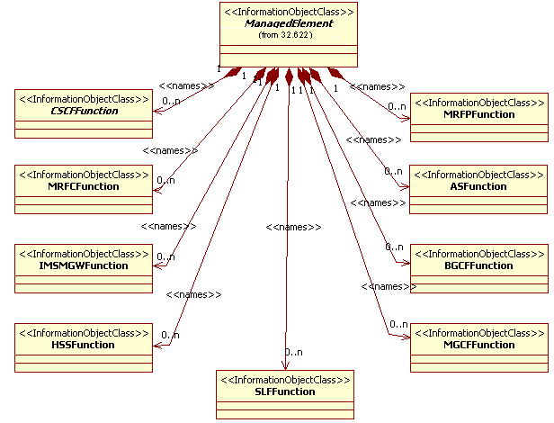
Figure 6.2.1: IMS NRM Containment/Naming relationships

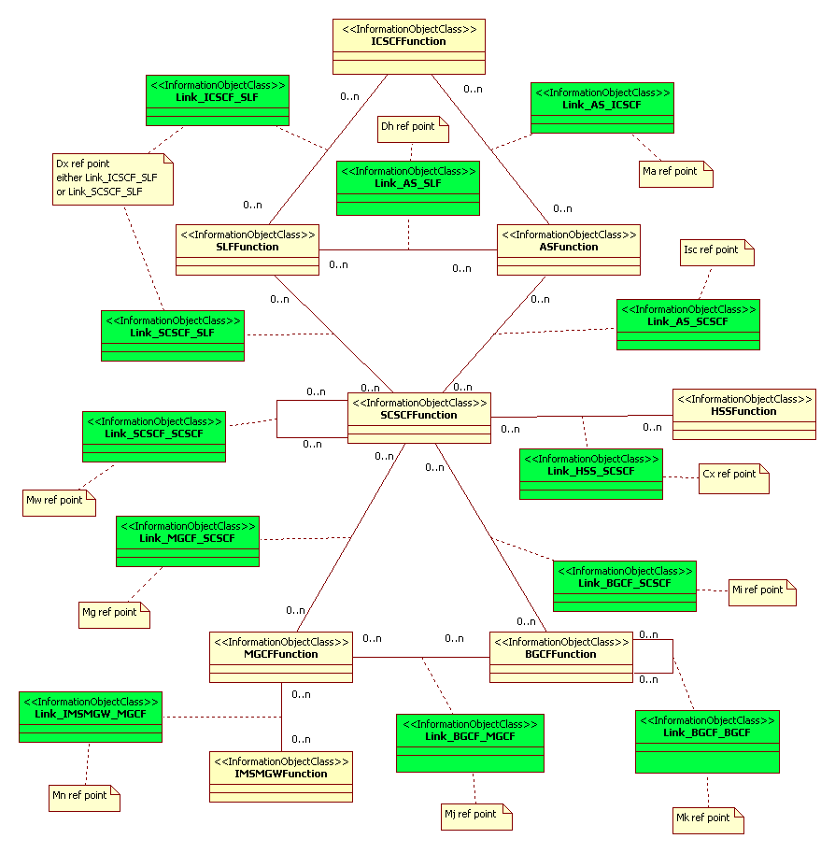
Note: If this NRM has interfaces (Link IOCs) modelled to IOCs in other NRM(s), the Link IOC definitions may be defined in the other NRM(s) and need to be considered in implementations. For example, see Link_Bgcf_Mgcf and Link_Cscf_Mgcf in CN NRM TS 32.632 [11].

Figure 6.2.1.1: IMS NRM Link Associations 1

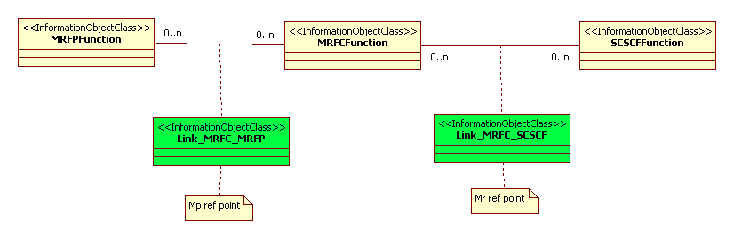

Figure 6.2.1.2: IMS NRM Link Associations 2

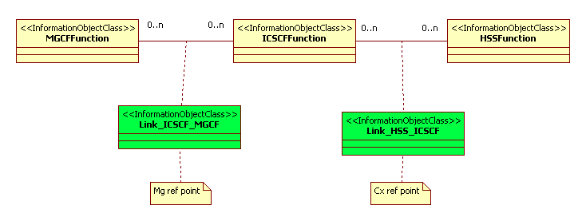
Figure 6.2.1.3: IMS NRM Link Associations 3

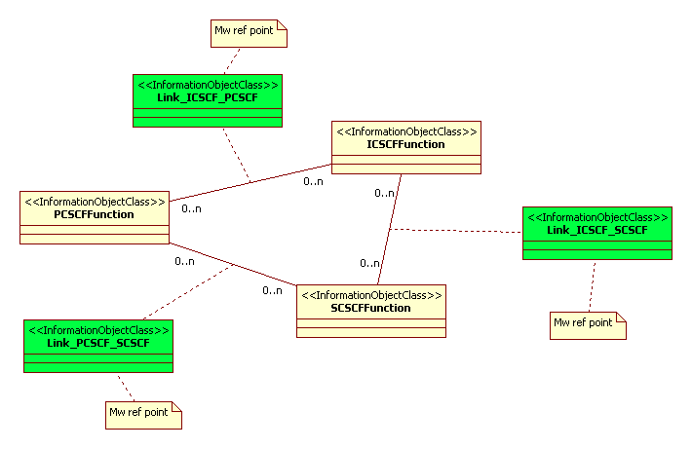
Figure 6.2.1.4: IMS NRM Link Associations 4

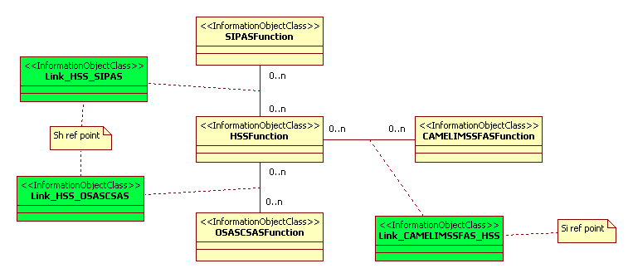
Figure 6.2.1.5: IMS NRM Link Associations 5

6.2.2 Inheritance
This clause depicts the inheritance relationships that exist between IOCs.
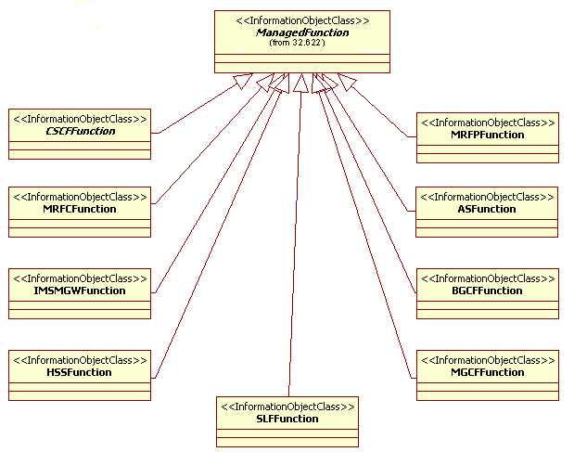
Figure 6.2.2.1: IMS NRM Inheritance Hierarchy 1

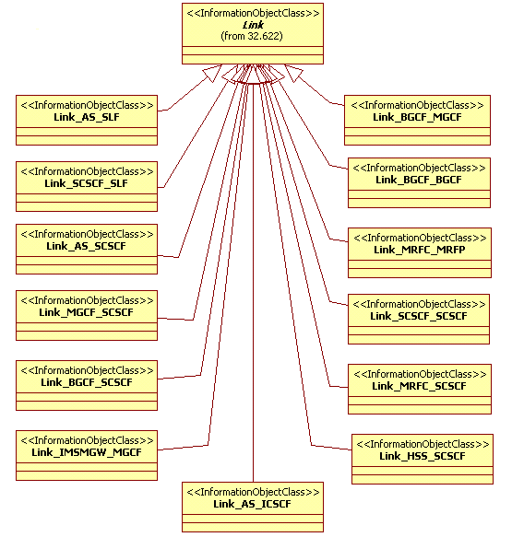
Figure 6.2.2.2: IMS NRM Inheritance Hierarchy 2

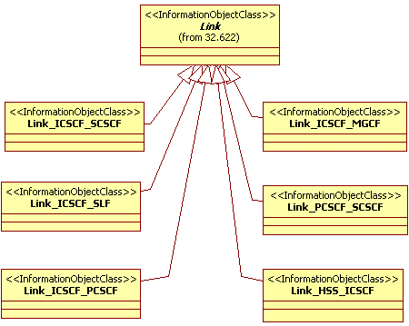
Figure 6.2.2.3: IMS NRM Inheritance Hierarchy 3

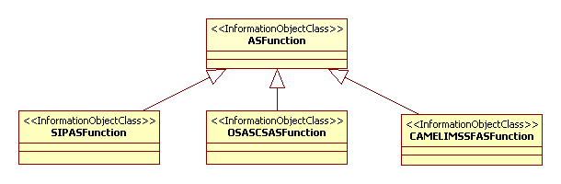
Figure 6.2.2.4: IMS NRM Inheritance Hierarchy 4

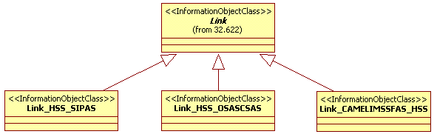
Figure 6.2.2.5: IMS NRM Inheritance Hierarchy 5

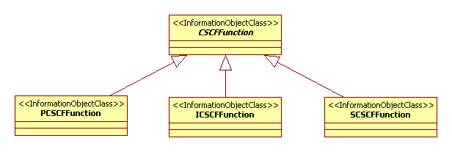
Figure 6.2.2.6: IMS NRM Inheritance Hierarchy 6

6.3 Information object class definitions

6.3.1 ASFunction

6.3.1.1 Definition
This IOC represents AS functionality. For more information about the AS, see 3GPP TS 23.002 [8]. AsFunction may be instantiated when a specific Application Server type is not already represented with an IOC subclassed from this IOC in this specification. If the Application Server type is already represented by an IOC in this specification, then it should instead be used. In the case a subclassed IOC is utilized, the AsFunction relationships (including link objects) are carried forward to the sub-classed IOC through inheritance.

6.3.1.2 Attributes
Attribute name | Visibility | Support Qualifier | Read Qualifier | Write Qualifier
asFunctionId | + | M | M | -
linkList | + | O | M | -

6.3.1.3 Notifications
The common notifications defined in subclause 6.6 are valid for this IOC, without exceptions or additions.

6.3.2 BGCFFunction

6.3.2.1 Definition
This IOC represents BGCF functionality. For more information about the BGCF, see 3GPP TS 23.002 [8].

6.3.2.2 Attributes
Attribute name | Visibility | Support Qualifier | Read Qualifier | Write Qualifier
bgcfFunctionId | + | M | M | -
linkList | + | O | M | -

6.3.2.3 Notifications
The common notifications defined in subclause 6.6 are valid for this IOC, without exceptions or additions.

6.3.3 CAMELIMSSFASFunction

6.3.3.1 Definition
This IOC represents CAMEL IM-SSF AS functionality. For more information about the CAMEL IM-SSF AS, see 3GPP TS 23.002 [8].

6.3.3.2 Attributes
Void.

6.3.4 CSCFFunction

6.3.4.1 Definition
This IOC represents CSCF functionality. For more information about the CSCF, see 3GPP TS 23.002 [8].
This IOC cannot be instantiated. It is defined for sub-classing purposes.

6.3.4.2 Attributes
Attribute name | Support Qualifier | Read Qualifier | Write Qualifier
cscfFunctionId | M | M | -
linkList | O | M | -

6.3.4.3 Notifications
The common notifications defined in subclause 6.6 are valid for this IOC, without exceptions or additions.

6.3.5 HSSFunction

6.3.5.1 Definition
This IOC represents HSS functionality. For more information about the HSS, see 3GPP TS 23.002 [8].

6.3.5.2 Attributes
Attribute name | Support Qualifier | Read Qualifier | Write Qualifier
hssFunctionId | M | M | -
linkList | O | M | -

6.3.5.3 Notifications
The common notifications defined in subclause 6.6 are valid for this IOC, without exceptions or additions.

6.3.6 ICSCFFunction

6.3.6.1 Definition
This IOC represents I-CSCF functionality. For more information about the I-CSCF, see 3GPP TS 23.002 [8].

6.3.6.2 Attributes
Void.

6.3.6.3 Notifications
The common notifications defined in subclause 6.6 are valid for this IOC, without exceptions or additions.

6.3.7 IMSMGWFunction

6.3.7.1 Definition
This IOC represents IMS-MGW functionality. For more information about IMS-MGW, see 3GPP TS 23.002 [8].

6.3.7.2 Attributes
Attribute name | Visibility | Support Qualifier | Read Qualifier | Write Qualifier
imsMgwFunctionId | + | M | M | -
linkList | + | O | M | -

6.3.7.3 Notifications
The common notifications defined in subclause 6.6 are valid for this IOC, without exceptions or additions.

6.3.8 MGCFFunction

6.3.8.1 Definition
This IOC represents MGCF functionality. For more information about the MGCF, see 3GPP TS 23.002 [8].

6.3.8.2 Attributes
Attribute name | Support Qualifier | Read Qualifier | Write Qualifier
mgcfFunctionId | M | M | -
linkList | O | M | -

6.3.8.3 Notifications
The common notifications defined in subclause 6.6 are valid for this IOC, without exceptions or additions.

6.3.9 MRFCFunction

6.3.9.1 Definition
This IOC represents MRFC functionality. For more information about the MRFC, see 3GPP TS 23.002 [8].

6.3.9.2 Attributes
Attribute name | Support Qualifier | Read Qualifier | Write Qualifier
mrfcFunctionId | M | M | -
linkList | O | M | -

6.3.9.3 Notifications
The common notifications defined in subclause 6.6 are valid for this IOC, without exceptions or additions.

6.3.10 MRFPFunction

6.3.10.1 Definition
This IOC represents MRFP functionality. For more information about the MRFP, see 3GPP TS 23.002 [8].

6.3.10.2 Attributes
Attribute name | Support Qualifier | Read Qualifier | Write Qualifier
mrfpFunctionId | M | M | -
linkList | O | M | -

6.3.10.3 Notifications
The common notifications defined in subclause 6.6 are valid for this IOC, without exceptions or additions.

6.3.11 OSASCSASFunction

6.3.11.1 Definition
This IOC represents OSA Application Server (Service Capability Server) functionality. For more information about the OSA Service Capability Server, see 3GPP TS 23.002 [8].

6.3.11.2 Attributes
Void.

6.3.12 PCSCFFunction

6.3.12.1 Definition
This IOC represents P-CSCF functionality. For more information about the P-CSCF, see 3GPP TS 23.002 [8].

6.3.12.2 Attributes
Void.

6.3.12.3 Notifications
The common notifications defined in subclause 6.6 are valid for this IOC, without exceptions or additions.

6.3.13 SCSFFunction

6.3.13.1 Definition
This IOC represents S-CSCF functionality. For more information about the S-CSCF, see 3GPP TS 23.002 [8].

6.3.13.2 Attributes
Void.

6.3.13.3 Notifications
The common notifications defined in subclause 6.6 are valid for this IOC, without exceptions or additions.

6.3.14 SIPASFunction

6.3.14.1 Definition
This IOC represents SIP AS functionality. For more information about the SIP AS, see 3GPP TS 23.002 [8].

6.3.14.2 Attributes
Void.

6.3.15 SLFFunction

6.3.15.1 Definition
This IOC represents SLF functionality. For more information about the SLF, see 3GPP TS 23.002 [8].

6.3.15.2 Attributes
Attribute name | Support Qualifier | Read Qualifier | Write Qualifier
slfFunctionId | M | M | -
linkList | O | M | -

6.3.15.3 Notifications
The common notifications defined in subclause 6.6 are valid for this IOC, without exceptions or additions.

6.3.16 Reserved for Future Use
...

6.3.50 Reserved for Future Use

6.3.51 Void
Void.

6.3.52 Link_AS_ICSCF

6.3. 52.1 Definition
This IOC models the Ma reference point as defined in TS 23.002 [8].

6.3.53 Link_AS_SCSCF

6.3.53.1 Definition
This IOC models the Isc reference point as defined in TS 23.002 [8].

6.3.54 Link_AS_SLF

6.3.54.1 Definition
This models the Dh reference point as defined in TS 23.002 [8].

6.3.55 Link_BGCF_BGCF

6.3.55.1 Definition
This models the Mk reference point as defined in TS 23.002 [8].
6.3.56 VoidVoid

6.3.57 Link_BGCF_MGCF

6.3.57.1 Definition
This models the Mj reference point as defined in TS 23.002 [8].

6.3.58 Link_BGCF_SCSCF

6.3.58.1 Definition
This models the Mi reference point as defined in TS 23.002 [8].
6.3.59 Void

6.3.60 Link_HSS_ICSCF

6.3.60.1 Definition
This IOC models the Cx reference point as defined in TS 23.002 [8].

6.3.61 Link_ICSCF_SCSCF

6.3.61.1 Definition
This models the Mw reference point as defined in TS 23.002 [8].

6.3.62 Link_ICSCF_MGCF

6.3.62.1 Definition
This IOC models the Mg reference point as defined in TS 23.002 [8].
6.3.63 VoidVoid

6.3.64 Link_ICSCF_PCSCF

6.3.64.1 Definition
This models the Mw reference point as defined in TS 23.002 [8].

6.3.65 Link_PCSCF_SCSCF

6.3.65.1 Definition
This models the Mw reference point as defined in TS 23.002 [8].
6.3.66 Void

6.3.67 Link_CAMELIMSSFAS_HSS

6.3.67.1 Definition
This IOC models the Si reference point between CAMEL Application Server (IM-SSF) and HSS as defined in TS 23.002 [8].

6.3.68 Link_HSS_OSASCSAS

6.3.68.1 Definition
This IOC models the Sh reference point between OSA Application Server (Service Capability Server) and HSS as defined in TS 23.002 [8].

6.3.69 Link_HSS_SCSCF

6.3.69.1 Definition
This IOC models the Cx reference point as defined in TS 23.002 [8].

6.3.70 Link_HSS_SIPAS

6.3.70.1 Definition
This IOC models the Sh reference point between SIP Application Server and HSS as defined in TS 23.002 [8].

6.3.71 Link_ICSCF_SLF

6.3.71.1 Definition
This models the Dx reference point as defined in TS 23.002 [8].

6.3.72 Link_IMSMGW_MGCF

6.3.72.1 Definition
This models the Mn reference point as defined in TS 23.002 [8].

6.3.73 Link_MGCF_SCSCF

6.3.73.1 Definitions
This models the Mg reference point as defined in TS 23.002 [8].

6.3.74 Link_MRFC_MRFP

6.3.74.1 Definition
This IOC models the Mp reference point as defined in TS 23.002 [8].

6.3.75 Link_MRFC_SCSCF

6.3.75.1 Definition
This IOC models the Mr reference point as defined in TS 23.002 [8].

6.3.76 Link_SCSCF_SCSCF

6.3.76.1 Definition
This models the Mw reference point as defined in TS 23.002 [8].

6.3.77 Link_SCSCF_SLF

6.3.77.1 Definition
This IOC models the Dx reference point as defined in TS 23.002 [8].

6.4 Information relationship definitions
In this version of the present document there are no information relationship definitions.

6.5 Information attribute definitions

6.5.1 Definition and legal values
Attribute Name | Definition | Legal Values
asFunctionId | An attribute whose ‘name+value’ can be used as an RDN when naming an instance of the IOC.  This RDN uniquely identifies the object instance within the scope of its containing (parent) object instance.
bgcfFunctionId | An attribute whose ‘name+value’ can be used as an RDN when naming an instance of the IOC.  This RDN uniquely identifies the object instance within the scope of its containing (parent) object instance.
cscfFunctionId | An attribute whose ‘name+value’ can be used as an RDN when naming an instance of the IOC.  This RDN uniquely identifies the object instance within the scope of its containing (parent) object instance.
icscfFunctionId | An attribute whose ‘name+value’ can be used as an RDN when naming an instance of the IOC.  This RDN uniquely identifies the object instance within the scope of its containing (parent) object instance.
imsMgwFunctionId | An attribute whose ‘name+value’ can be used as an RDN when naming an instance of the IOC.  This RDN uniquely identifies the object instance within the scope of its containing (parent) object instance.
linkList | An attribute containing all of the related link object Distinguished Names for the object instance, if any.
mgcfFunctionId | An attribute whose ‘name+value’ can be used as an RDN when naming an instance of the IOC.  This RDN uniquely identifies the object instance within the scope of its containing (parent) object instance.
mrfcFunctionId | An attribute whose ‘name+value’ can be used as an RDN when naming an instance of the IOC.  This RDN uniquely identifies the object instance within the scope of its containing (parent) object instance.
mrfpFunctionId | An attribute whose ‘name+value’ can be used as an RDN when naming an instance of the IOC.  This RDN uniquely identifies the object instance within the scope of its containing (parent) object instance.
pcscfFunctionId | An attribute whose ‘name+value’ can be used as an RDN when naming an instance of the IOC.  This RDN uniquely identifies the object instance within the scope of its containing (parent) object instance.
scscfFunctionId | An attribute whose ‘name+value’ can be used as an RDN when naming an instance of the IOC.  This RDN uniquely identifies the object instance within the scope of its containing (parent) object instance.
slfFunctionId | An attribute whose ‘name+value’ can be used as an RDN when naming an instance of the IOC.  This RDN uniquely identifies the object instance within the scope of its containing (parent) object instance.
hssFunctionId | An attribute whose ‘name+value’ can be used as an RDN when naming an instance of the IOC.  This RDN uniquely identifies the object instance within the scope of its containing (parent) object instance.

6.5.2 Constraints
Name | Definition
- | -

6.6 Common notifications
This subclause contains a list of notifications that can be referred to by any IOC defined by this IRP specification.
These notifications are only applicable to IOCs referring to this subclause.
Name | Qualifier | Notes
notifyAckStateChanged | See Alarm IRP (3GPP TS 32.111-2 [5])
notifyAlarmListRebuilt | See Alarm IRP (3GPP TS 32.111-2 [5])
notifyChangedAlarm | See Alarm IRP (3GPP TS 32.111-2 [5])
notifyClearedAlarm | See Alarm IRP (3GPP TS 32.111-2 [5])
notifyComments | See Alarm IRP (3GPP TS 32.111-2 [5])
notifyNewAlarm | See Alarm IRP (3GPP TS 32.111-2 [5])
notifyPotentialFaultyAlarmList | See Alarm IRP (3GPP TS 32.111-2 [5])
notifyObjectCreation | See Kernel CM IRP (3GPP TS 32.662 [3])
notifyObjectDeletion | See Kernel CM IRP (3GPP TS 32.662 [3])
notifyAttributeValueChange | See Kernel CM IRP (3GPP TS 32.662 [3])

6.7 Particular information configurations
Not applicable.

Annex A (informative):
Change history
Change history
Date | TSG # | TSG Doc. | CR | R | Subject/Comment | Cat | Old | New
Sep 2006 | SA_33 | SP-060563 | -- | -- | Submitted to TSG SA #33 for Information | -- | -- | 1.0.0
Dec 2006 | SA_34 | SP-060750 | -- | -- | Submitted to TSG SA #34 for Approval | -- | 2.0.0 | 7.0.0
Mar 2007 | SA_35 | SP-070047 | 0001 | -- | Add HssFunction to IMS NRM | F | 7.0.0 | 7.1.0
Jun 2007 | SA_36 | SP-070276 | 0002 | -- | Change in cardinalities of IMS managed functions | F | 7.1.0 | 7.2.0
Jun 2007 | SA_36 | SP-070276 | 0003 | -- | Correct definitions of AsFunctions - Align with 23.002 | F | 7.1.0 | 7.2.0
Jun 2007 | SA_36 | SP-070276 | 0004 | -- | Add missing Link_As_Icscf to IMS NRM - Align with 23.002 | F | 7.1.0 | 7.2.0
Sep 2007 | SA_37 | SP-070612 | 0006 | -- | Add missing link attributes to IMS NRM - Align with 3GPP2 | F | 7.2.0 | 7.3.0
Sep 2007 | SA_37 | SP-070610 | 0005 | -- | Correct description of common notifications - Align with Rel-8 32.151 IRP IS Template | F | 7.3.0 | 8.0.0
Jun 2008 | SA_40 | SP-080329 | 0007 | -- | Correction of the CamelImSsfAsFunction definition | F | 8.0.0 | 8.1.0
Dec 2009 | - | - | - | - | Update to Rel-9 version | -- | 8.1.0 | 9.0.0
Dec 2010 | SA_50 | SP-100758 | 0008 | 5 | Correcting CscfFunction definition of IMS NRM - Align with SA2 TS 23.002 | F | 9.0.0 | 9.1.0

