3GPP TS 32.535 V9.1.0 (2010-03)
Technical Specification
3rd Generation Partnership Project;
Technical Specification Group Services and System Aspects;
Telecommunication management;
Software Management Integration Reference Point (IRP);
eXtensible Markup Language (XML) definitions
(Release 9)


The present document has been developed within the 3rd Generation Partnership Project (3GPP TM) and may be further elaborated for the purposes of 3GPP.
The present document has not been subject to any approval process by the 3GPP Organizational Partners and shall not be implemented.
This Specification is provided for future development work within 3GPP only. The Organizational Partners accept no liability for any use of this Specification.
Specifications and reports for implementation of the 3GPP TM system should be obtained via the 3GPP Organizational Partners' Publications Offices.

Keywords
GSM, UMTS, Management
3GPP
Postal address

3GPP support office address
650 Route des Lucioles - Sophia Antipolis
Valbonne - FRANCE
Tel.: +33 4 92 94 42 00 Fax: +33 4 93 65 47 16
Internet
http://www.3gpp.org
Copyright Notification
No part may be reproduced except as authorized by written permission.
The copyright and the foregoing restriction extend to reproduction in all media.

©2010, 3GPP Organizational Partners (ARIB, ATIS, CCSA, ETSI, TTA, TTC).
All rights reserved.
UMTS™ is a Trade Mark of ETSI registered for the benefit of its members
3GPP™ is a Trade Mark of ETSI registered for the benefit of its Members and of the 3GPP Organizational Partners
LTE™ is a Trade Mark of ETSI currently being registered for the benefit of its Members and of the 3GPP Organizational Partners
GSM® and the GSM logo are registered and owned by the GSM Association
Contents
Introduction 4
1 Scope 5
2 References 5
3 Definitions and abbreviations 5
3.1 Definitions 5
3.2 Abbreviations 5
4 Software Management IRP XML Definitions 6
4.1 Software Management IRP XML Definitions 6
4.2 XML Schema for Software Management IRP Notifications (file name “swManagementIRPNotif.xsd”) 15
4.3 XML Schema for Software Management IRP IOCs (file name “swManagementIRPIOCs.xsd”) 21
Annex A (informative): Void 24
Annex B (informative): Change history 25

Foreword
This Technical Specification has been produced by the 3rd Generation Partnership Project (3GPP).
The contents of the present document are subject to continuing work within the TSG and may change following formal TSG approval. Should the TSG modify the contents of the present document, it will be re-released by the TSG with an identifying change of release date and an increase in version number as follows:
Version x.y.z
where:
x the first digit:
1 presented to TSG for information;
2 presented to TSG for approval;
3 or greater indicates TSG approved document under change control.
y the second digit is incremented for all changes of substance, i.e. technical enhancements, corrections, updates, etc.
z the third digit is incremented when editorial only changes have been incorporated in the document.

Introduction
The present document is part of a TS-family covering the 3rd Generation Partnership Project: Technical Specification Group Services and System Aspects; Telecommunication management; as identified below:
32.531 Telecommunication management; Software management; Concepts and Integration Reference Point (IRP) Requirements
32.532 Telecommunication management; Software management Integration Reference Point (IRP); Information Service (IS)
32.533 Telecommunication management; Software management Integration Reference Point (IRP); Common Object Request Broker Architecture (CORBA) Solution Set (SS)
32.535 Telecommunication management; Software management Integration Reference Point (IRP); eXtensible Markup Language (XML) definitions

Software Management, in general, provides the operator with the ability to manage effectively the software entities residing in the 3G network. Software Management function is useful especially when there is a need to manage a large number of software residing in the managed elements widely distributed geographically. The main focus is the management of new software releases and correction patches [1].
The software management operations are initiated by the operator or by functions in the Operations Systems (OSs) either on single NE or across several NEs of the 3G network.

1 Scope
The present document provides the XML file format definition for the Software Management Integration Reference Point (IRP) IS [3] V9.2.X.
The present document specifies the XML Definitions for the Software Management Integration Reference Point (IRP) as it applies to Itf-N, in accordance with Software Management IRP IS definitions [3] as well as Notification Log IRP XML Definitions [4].

2 References
The following documents contain provisions which, through reference in this text, constitute provisions of the present document.
- References are either specific (identified by date of publication, edition number, version number, etc.) or non-specific.
- For a specific reference, subsequent revisions do not apply.
- For a non-specific reference, the latest version applies. In the case of a reference to a 3GPP document (including a GSM document), a non-specific reference implicitly refers to the latest version of that document in the same Release as the present document.
[1] 3GPP TS 32.101: “Telecommunication management; Principles and high level requirements”.
[2] 3GPP TS 32.102: “Telecommunication management; Architecture”.
[3] 3GPP TS 32.532: “Telecommunication management; Software management Integration Reference Point (IRP); Information Service (IS)”
[4] 3GPP TS 32.335: “Telecommunication management; Notification Log (NL) Integration Reference Point (IRP): eXtensible Markup Language (XML) solution definitions”.
[5] 3GPP TS 32.331: “Telecommunication management; Notification Log (NL) Integration Reference Point (IRP): Requirements”.

3 Definitions and abbreviations

3.1 Definitions
For the purposes of the present document, the terms and definitions given in 3GPP TS 32.101 [1], 3GPP TS 32.102 [2], and 3GPP TS 32.331 [5] apply.

3.2 Abbreviations
For the purposes of the present document, the following abbreviations apply:
IRP Integration Reference Point
IS Information Service
NL Notification Log
NRM Network Resource Model
SwM Software Management
UML Unified Modelling Language
XML eXtensible Markup Language

4 Software Management IRP XML Definitions

4.1 Software Management IRP XML Definitions
This section provides XML definitions of Software Management IRP IOCs and notifications as defined in [3].
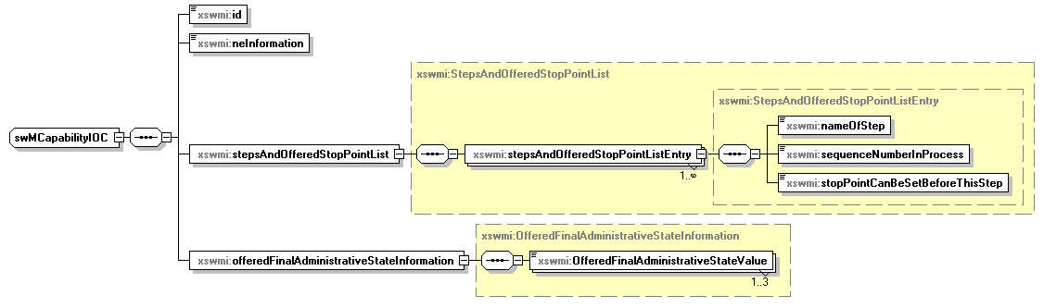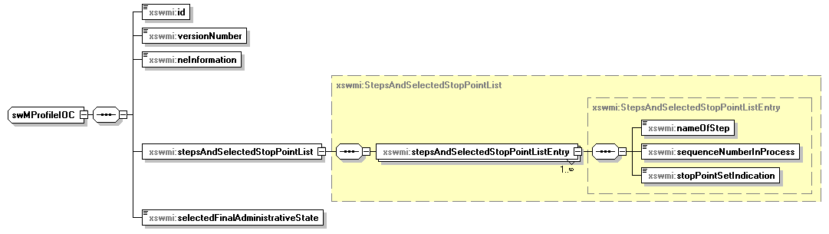
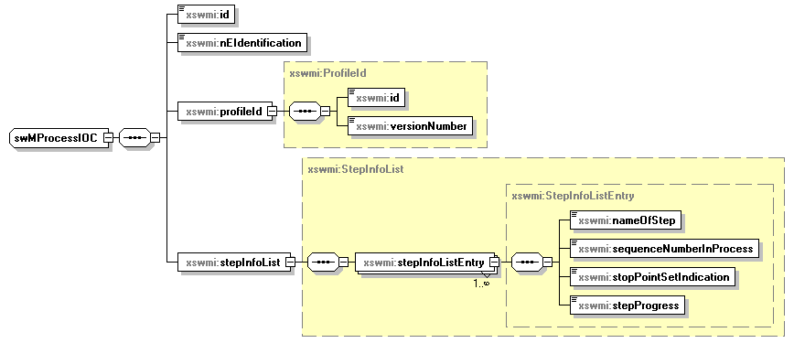
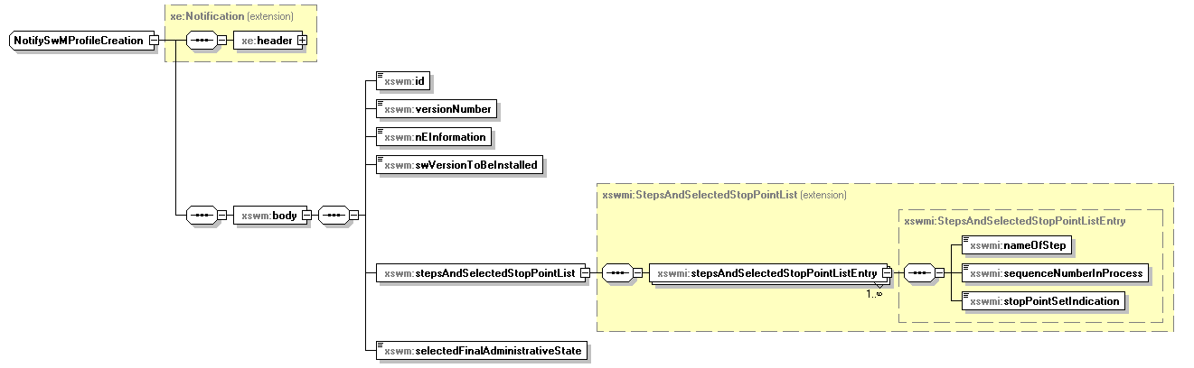

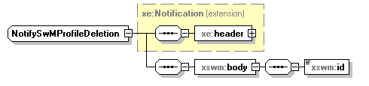
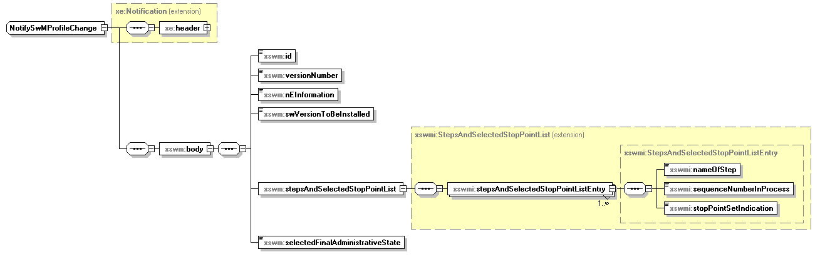
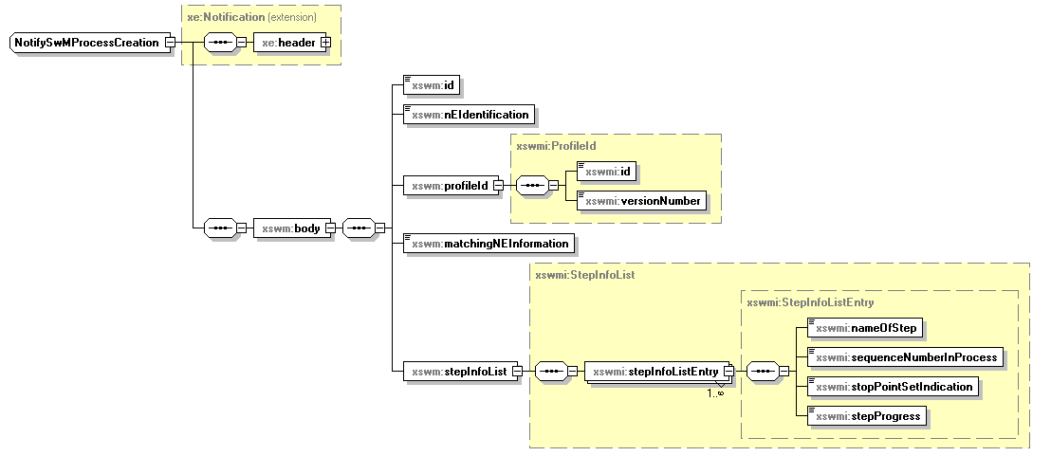
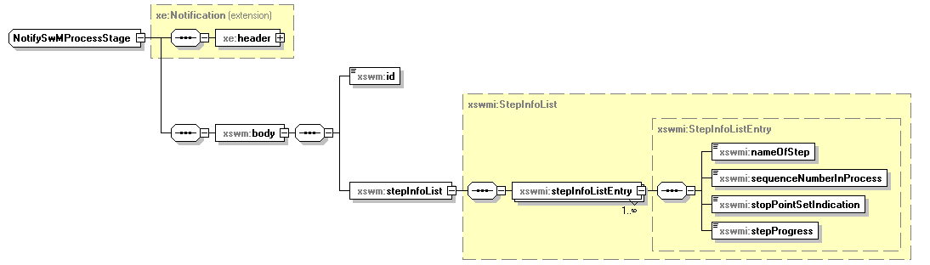
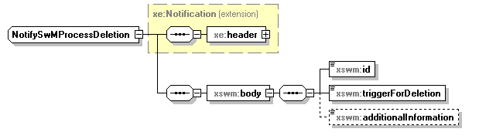
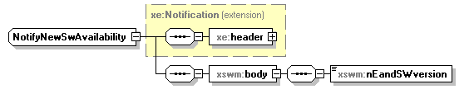
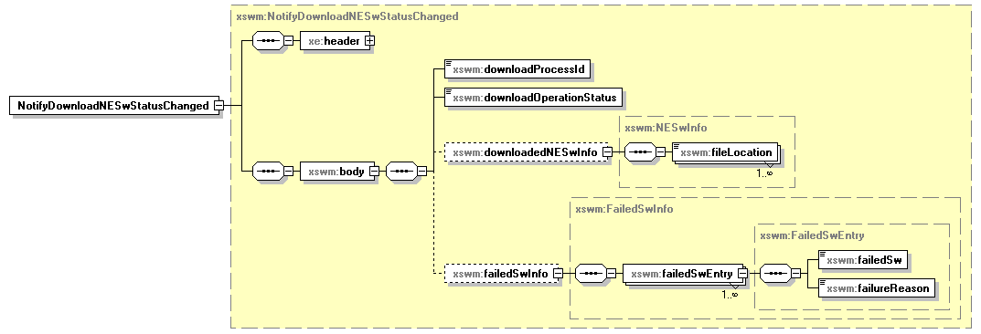
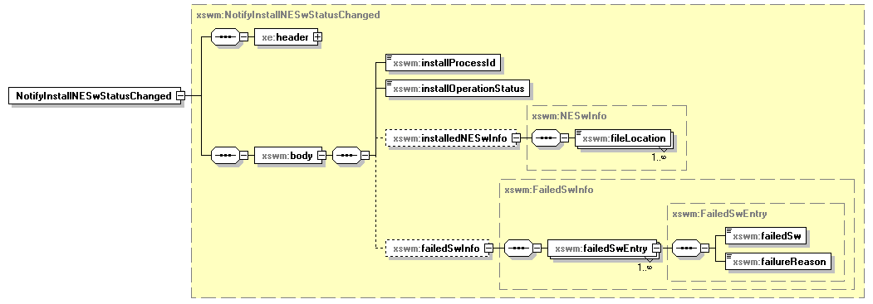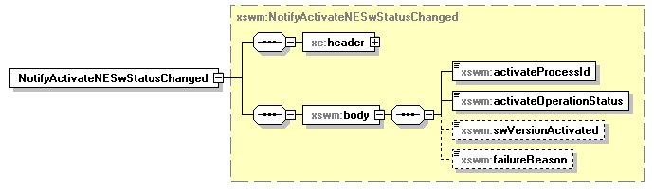

XML Schema for Software Management IRP Notifications (file name “swManagementIRPNotif.xsd”)
<?xml version="1.0" encoding="UTF-8"?>
<schema xmlns="http://www.w3.org/2001/XMLSchema" xmlns:xe="http://www.3gpp.org/ftp/specs/archive/32_series/32.305#notification" xmlns:xswm="http://www.3gpp.org/ftp/specs/archive/32_series/32.535#swManagementIRPNotif" xmlns:xswmi="http://www.3gpp.org/ftp/specs/archive/32_series/32.535#swManagementIRPIOCs" targetNamespace="http://www.3gpp.org/ftp/specs/archive/32_series/32.535#swManagementIRPNotif" elementFormDefault="qualified" attributeFormDefault="unqualified">
<import namespace="http://www.3gpp.org/ftp/specs/archive/32_series/32.305#notification"/>
<import namespace="http://www.3gpp.org/ftp/specs/archive/32_series/32.535#swManagementIRPIOCs"/>
<simpleType name="SwVersionToBeInstalledConditional">
<restriction base="string"/>
</simpleType>
<complexType name="OfferedFinalAdministrativeStateInformation">
<sequence>
<element name="OfferedFinalAdministrativeStateValue" type="xswmi:FinalAdministrativeStateValue" maxOccurs="3"/>
</sequence>
</complexType>
<simpleType name="TriggerForDeletion">
<restriction base="string">
<enumeration value="IRP_AGENT_TERMINATION"/>
<enumeration value="IRP_MANAGER_TERMINATION"/>
<enumeration value="AUTOMATED_SWM_SUCCESFULLY_CONCLUDED"/>
<enumeration value="SELF_CONFIGURATION_SUCCESFULLY_CONCLUDED"/>
</restriction>
</simpleType>
<simpleType name="RequestID">
<restriction base="unsignedLong"/>
</simpleType>
<simpleType name="DownloadNESwOperationStatus">
<restriction base="string">
<enumeration value="NE_SWDOWNLOAD_SUCCESSFUL"/>
<enumeration value="NE_SWDOWNLOAD_FAILED"/>
<enumeration value="NE_SWDOWNLOAD_PARTIALLY_SUCCESSFUL"/>
</restriction>
</simpleType>
<simpleType name="FileLocation">
<restriction base="string"/>
</simpleType>
<complexType name="NESwInfo">
<sequence>
<element name="fileLocation" type="xswm:FileLocation" maxOccurs="unbounded"/>
</sequence>
</complexType>
<complexType name="FailedSwEntry">
<sequence>
<element name="failedSw" type="xswm:FileLocation"/>
<element name="failureReason" type="xswm:FailureReason"/>
</sequence>
</complexType>
<complexType name="FailedSwInfo">
<sequence>
<element name="failedSwEntry" type="xswm:FailedSwEntry" maxOccurs="unbounded"/>
</sequence>
</complexType>
<simpleType name="FailureReason">
<restriction base="string"/>
</simpleType>
<simpleType name="InstallNESwOperationStatus">
<restriction base="string">
<enumeration value="NE_SW_INSTALLATION_SUCCESSFUL"/>
<enumeration value="NE_SW_INSTALLATION_FAILED"/>
<enumeration value="NE_SWINSTALLATION_PARTIALLY_SUCCESSFUL"/>
</restriction>
</simpleType>
<simpleType name="ActivateNESwOperationStatus">
<restriction base="string">
<enumeration value="NE_SW_ACTIVATION_SUCCESSFUL"/>
<enumeration value="NE_SW_ACTIVATION_FAILED"/>
<enumeration value="NE_SWACTIVATION_PARTIALLY_SUCCESSFUL"/>
</restriction>
</simpleType>
<complexType name="NotifySwMProfileChange">
<complexContent>
<extension base="xe:Notification">
<sequence>
<element name="body">
<complexType>
<sequence>
<element name="id" type="xswmi:Id"/>
<element name="versionNumber" type="xswmi:VersionNumber"/>
<element name="nEInformation" type="xswmi:NEInformation"/>
<element name="swVersionToBeInstalled" type="xswm:SwVersionToBeInstalledConditional"/>
<element name="stepsAndSelectedStopPointList">
<complexType>
<complexContent>
<extension base="xswmi:StepsAndSelectedStopPointList"/>
</complexContent>
</complexType>
</element>
<element name="selectedFinalAdministrativeState" type="xswmi:FinalAdministrativeStateValue"/>
</sequence>
</complexType>
</element>
</sequence>
</extension>
</complexContent>
</complexType>
<complexType name="NotifyNewSwAvailability">
<complexContent>
<extension base="xe:Notification">
<sequence>
<element name="body">
<complexType>
<sequence>
<element name="nEandSWversion" type="string"/>
</sequence>
</complexType>
</element>
</sequence>
</extension>
</complexContent>
</complexType>
<complexType name="NotifySwMProcessDeletion">
<complexContent>
<extension base="xe:Notification">
<sequence>
<element name="body">
<complexType>
<sequence>
<element name="id" type="xswmi:Id"/>
<element name="triggerForDeletion" type="xswm:TriggerForDeletion"/>
<element name="additionalInformation" type="string" minOccurs="0"/>
</sequence>
</complexType>
</element>
</sequence>
</extension>
</complexContent>
</complexType>
<complexType name="NotifySwMProcessStage">
<complexContent>
<extension base="xe:Notification">
<sequence>
<element name="body">
<complexType>
<sequence>
<element name="id" type="xswmi:Id"/>
<element name="stepInfoList" type="xswmi:StepInfoList"/>
</sequence>
</complexType>
</element>
</sequence>
</extension>
</complexContent>
</complexType>
<complexType name="NotifySwMProcessCreation">
<complexContent>
<extension base="xe:Notification">
<sequence>
<element name="body">
<complexType>
<sequence>
<element name="id" type="xswmi:Id"/>
<element name="nEIdentification" type="xswmi:Id"/>
<element name="profileId" type="xswmi:ProfileId"/>
<element name="matchingNEInformation" type="xswmi:NEInformation"/>
<element name="stepInfoList" type="xswmi:StepInfoList"/>
</sequence>
</complexType>
</element>
</sequence>
</extension>
</complexContent>
</complexType>
<complexType name="NotifySwMProfileDeletion">
<complexContent>
<extension base="xe:Notification">
<sequence>
<element name="body">
<complexType>
<sequence>
<element name="id" type="xswmi:Id"/>
</sequence>
</complexType>
</element>
</sequence>
</extension>
</complexContent>
</complexType>
<complexType name="NotifySwMProfileCreation">
<complexContent>
<extension base="xe:Notification">
<sequence>
<element name="body">
<complexType>
<sequence>
<element name="id" type="xswmi:Id"/>
<element name="versionNumber" type="xswmi:VersionNumber"/>
<element name="nEInformation" type="xswmi:NEInformation"/>
<element name="swVersionToBeInstalled" type="xswm:SwVersionToBeInstalledConditional"/>
<element name="stepsAndSelectedStopPointList">
<complexType>
<complexContent>
<extension base="xswmi:StepsAndSelectedStopPointList"/>
</complexContent>
</complexType>
</element>
<element name="selectedFinalAdministrativeState" type="xswmi:FinalAdministrativeStateValue"/>
</sequence>
</complexType>
</element>
</sequence>
</extension>
</complexContent>
</complexType>
<complexType name="NotifyDownloadNESwStatusChanged">
<complexContent>
<extension base="xe:Notification">
<sequence>
<element name="body">
<complexType>
<sequence>
<element name="downloadProcessId" type="xswm:RequestID"/>
<element name="downloadOperationStatus" type="xswm:DownloadNESwOperationStatus"/>
<element name="downloadedNESwInfo" type="xswm:NESwInfo" minOccurs="0"/>
<element name="failedSwInfo" type="xswm:FailedSwInfo" minOccurs="0"/>
</sequence>
</complexType>
</element>
</sequence>
</extension>
</complexContent>
</complexType>
<complexType name="NotifyInstallNESwStatusChanged">
<complexContent>
<extension base="xe:Notification">
<sequence>
<element name="body">
<complexType>
<sequence>
<element name="installProcessId" type="xswm:RequestID"/>
<element name="installOperationStatus" type="xswm:InstallNESwOperationStatus"/>
<element name="installedNESwInfo" type="xswm:NESwInfo" minOccurs="0"/>
<element name="failedSwInfo" type="xswm:FailedSwInfo" minOccurs="0"/>
</sequence>
</complexType>
</element>
</sequence>
</extension>
</complexContent>
</complexType>
<complexType name="NotifyActivateNESwStatusChanged">
<complexContent>
<extension base="xe:Notification">
<sequence>
<element name="body">
<complexType>
<sequence>
<element name="activateProcessId" type="xswm:RequestID"/>
<element name="activateOperationStatus" type="xswm:ActivateNESwOperationStatus"/>
<element name="swVersionActivated" type="string" minOccurs="0"/>
<element name="failureReason" type="xswm:FailureReason" minOccurs="0"/>
</sequence>
</complexType>
</element>
</sequence>
</extension>
</complexContent>
</complexType>
<element name="NotifySwMProfileCreation" type="xswm:NotifySwMProfileCreation"/>
<element name="NotifySwMProfileDeletion" type="xswm:NotifySwMProfileDeletion"/>
<element name="NotifySwMProcessCreation" type="xswm:NotifySwMProcessCreation"/>
<element name="NotifySwMProcessStage" type="xswm:NotifySwMProcessStage"/>
<element name="NotifySwMProcessDeletion" type="xswm:NotifySwMProcessDeletion"/>
<element name="NotifyNewSwAvailability" type="xswm:NotifyNewSwAvailability"/>
<element name="NotifySwMProfileChange" type="xswm:NotifySwMProfileChange"/>
<element name="NotifyDownloadNESwStatusChanged" type="xswm:NotifyDownloadNESwStatusChanged"/>
<element name="NotifyActivateNESwStatusChanged" type="xswm:NotifyActivateNESwStatusChanged"/>
<element name="NotifyInstallNESwStatusChanged" type="xswm:NotifyInstallNESwStatusChanged"/>
</schema>

XML Schema for Software Management IRP IOCs (file name “swManagementIRPIOCs.xsd”)
<?xml version="1.0" encoding="UTF-8"?>
<schema xmlns="http://www.w3.org/2001/XMLSchema" xmlns:xswmi="http://www.3gpp.org/ftp/specs/archive/32_series/32.535#swManagementIRPIOCs" xmlns:xn="http://www.3gpp.org/ftp/specs/archive/32_series/32.625#genericNrm" targetNamespace="http://www.3gpp.org/ftp/specs/archive/32_series/32.535#swManagementIRPIOCs" elementFormDefault="qualified" attributeFormDefault="unqualified">
<import namespace="http://www.3gpp.org/ftp/specs/archive/32_series/32.625#genericNrm" schemaLocation="genericNrm.xsd"/>
<simpleType name="NEInformation">
<restriction base="string"/>
</simpleType>
<simpleType name="Id">
<restriction base="xn:dn"/>
</simpleType>
<simpleType name="VersionNumber">
<restriction base="unsignedShort"/>
</simpleType>
<complexType name="ProfileId">
<sequence>
<element name="id" type="xswmi:Id"/>
<element name="versionNumber" type="xswmi:VersionNumber"/>
</sequence>
</complexType>
<simpleType name="FinalAdministrativeStateValue">
<restriction base="string">
<enumeration value="LOCKED"/>
<enumeration value="UNLOCKED"/>
<enumeration value="DETERMINED_BY_CONFIGURATION_DATA"/>
</restriction>
</simpleType>
<complexType name="OfferedFinalAdministrativeStateInformation">
<sequence>
<element name="OfferedFinalAdministrativeStateValue" type="xswmi:FinalAdministrativeStateValue" maxOccurs="3"/>
</sequence>
</complexType>
<complexType name="StepsAndOfferedStopPointListEntry">
<sequence>
<element name="nameOfStep" type="xswmi:NameOfStep"/>
<element name="sequenceNumberInProcess" type="xswmi:SequenceNumberInProcess"/>
<element name="stopPointCanBeSetBeforeThisStep" type="xswmi:StopPointCanBeSetBeforeThisStep"/>
</sequence>
</complexType>
<complexType name="StepsAndOfferedStopPointList">
<sequence>
<element name="stepsAndOfferedStopPointListEntry" type="xswmi:StepsAndOfferedStopPointListEntry" maxOccurs="unbounded"/>
</sequence>
</complexType>
<simpleType name="StopPointCanBeSetBeforeThisStep">
<restriction base="boolean"/>
</simpleType>
<complexType name="StepsAndSelectedStopPointListEntry">
<sequence>
<element name="nameOfStep" type="xswmi:NameOfStep"/>
<element name="sequenceNumberInProcess" type="xswmi:SequenceNumberInProcess"/>
<element name="stopPointSetIndication" type="xswmi:StopPointSetIndication"/>
</sequence>
</complexType>
<complexType name="StepsAndSelectedStopPointList">
<sequence>
<element name="stepsAndSelectedStopPointListEntry" type="xswmi:StepsAndSelectedStopPointListEntry" maxOccurs="unbounded"/>
</sequence>
</complexType>
<simpleType name="StopPointSetIndication">
<restriction base="string">
<enumeration value="STOP_POINT_IS_SET_BEFORE_THIS_STEP"/>
<enumeration value="STOP_POINT_IS_NOT_SET"/>
</restriction>
</simpleType>
<simpleType name="SequenceNumberInProcess">
<restriction base="unsignedShort"/>
</simpleType>
<simpleType name="NameOfStep">
<restriction base="string">
<enumeration value="SW_DOWNLOAD"/>
<enumeration value="SW_INSTALLATION"/>
<enumeration value="SW_ACTIVATION"/>
<enumeration value="PREPARE_BASIC_CONFIGURATION_AND_OAMLINK"/>
<enumeration value="RETRIEVE_CONFIGURATION_DATA"/>
<enumeration value="SETUP_PRECONFIGURED_SIGNALLING_LINKS"/>
<enumeration value="SET_FINAL_STATE_OF_NE "/>
</restriction>
</simpleType>
<simpleType name="StepProgress">
<restriction base="string">
<enumeration value="NOT_YET_STARTED"/>
<enumeration value="RUNNING"/>
<enumeration value="COMPLETED"/>
<enumeration value="AWAITING_RESUME"/>
<enumeration value="FAILURE"/>
<enumeration value="TERMINATED"/>
</restriction>
</simpleType>
<complexType name="StepInfoListEntry">
<sequence>
<element name="nameOfStep" type="xswmi:NameOfStep"/>
<element name="sequenceNumberInProcess" type="xswmi:SequenceNumberInProcess"/>
<element name="stopPointSetIndication" type="xswmi:StopPointSetIndication"/>
<element name="stepProgress" type="xswmi:StepProgress"/>
</sequence>
</complexType>
<complexType name="StepInfoList">
<sequence>
<element name="stepInfoListEntry" type="xswmi:StepInfoListEntry" maxOccurs="unbounded"/>
</sequence>
</complexType>
<complexType name="swMCapabilityIOC">
<sequence>
<element name="id" type="xswmi:Id"/>
<element name="neInformation" type="xswmi:NEInformation"/>
<element name="stepsAndOfferedStopPointList" type="xswmi:StepsAndOfferedStopPointList"/>
<element name="offeredFinalAdministrativeStateInformation" type="xswmi:OfferedFinalAdministrativeStateInformation"/>
</sequence>
</complexType>
<complexType name="swMProfileIOC">
<sequence>
<element name="id" type="xswmi:Id"/>
<element name="versionNumber" type="xswmi:VersionNumber"/>
<element name="neInformation" type="xswmi:NEInformation"/>
<element name="stepsAndSelectedStopPointList" type="xswmi:StepsAndSelectedStopPointList"/>
<element name="selectedFinalAdministrativeState" type="xswmi:FinalAdministrativeStateValue"/>
</sequence>
</complexType>
<complexType name="swMProcessIOC">
<sequence>
<element name="id" type="xswmi:Id"/>
<element name="nEIdentification" type="xswmi:NEInformation"/>
<element name="profileId" type="xswmi:ProfileId"/>
<element name="stepInfoList" type="xswmi:StepInfoList"/>
</sequence>
</complexType>
</schema>

Annex A (informative):
Void

Annex B (informative):
Change history
Change history
Date | TSG # | TSG Doc. | CR | R | Subject/Comment | Cat | Old | New
Dec 2009 | SA#46 | SP-090736 | -- | -- | Presentation to SA for Information and Approval | -- | -- | 1.0.0
Dec 2009 | -- | -- | -- | -- | Publication | -- | 1.0.0 | 8.0.0
Dec 2009 | - | - | - | - | Update to Rel-9 version | -- | 8.0.0 | 9.0.0
Mar 2010 | SA#47 | SP-100035 | 0001 | - | Discontinue from Rel-9 onwards the XML schema extraction and storage | F | 9.0.0 | 9.1.0
Mar 2010 | SA#47 | SP-100035 | 0002 | - | To add XML solution set for Non Automated Software Management notifications | F | 9.0.0 | 9.1.0

