3GPP TSG-SA5 Meeting #145-e S5-225724

Online, , Jun15 Aug 2022 – 24 Aug 2022
CR-Form-v12.1
CHANGE REQUEST
 | 32.240 | CR | -0446 | rev | - | Current version: | 17.6.0
For HELP on using this form: comprehensive instructions can be found at
http://www.3gpp.org/Change-Requests.

Proposed change affects: | UICC apps |  | ME |  | Radio Access Network |  | Core Network | X

Title: | Rel-18 CR 32.240 Adding New Consumer for MMS in Charging Architecture
Source to WG: | Amdocs, Ericsson LM, MATRIXX Software
Source to TSG: | S5
Work item code: | MMS_CH_SBI |  |  |  |  |  | Date:
Category: | B |  |  |  |  |  | Release: |  |  | Rel-18
 | Use one of the following categories:  F (correction)  A (mirror corresponding to a change in an earlier release)  B (addition of feature),  C (functional modification of feature)  D (editorial modification)  Detailed explanations of the above categories can  be found in 3GPP TR 21.900. |  |  |  |  |  |  |  | Use one of the following releases:  Rel-8 (Release 8)  Rel-9 (Release 9)  Rel-10 (Release 10)  Rel-11 (Release 11)  …  Rel-15 (Release 15)  Rel-16 (Release 16)  Rel-17 (Release 17)  Rel-18 (Release 18)
Reason for change: |  | Adding a new consumer for MMS in Charging Architecture.
Summary of change: |  | Add a new consumer and interface name to support converged charging for MMS
Consequences if not approved: |  | MMS charging cannot be supported by converged charging.
Clauses affected: |  | 4.2.3, 4.4.3
 |  | Y | N
Other specs |  |  | X | Other core specifications |  |  |  | TS/TR ... CR ...
affected: |  |  | X | Test specifications |  |  |  | TS/TR ... CR ...
(show related CRs) |  |  | X | O&M Specifications |  |  |  | TS/TR ... CR ...
Other comments:
This CR's revision history:

First change

4.2.3 Common architecture – service based interface
The following figures provide an overview of the logical ubiquitous charging architecture and the information flows for converged offline and online charging in service based interface variant for 5G systems and Edge Computing enabling sub-systems.
Figure 4.2.3.1 provides the overview in service based representation:

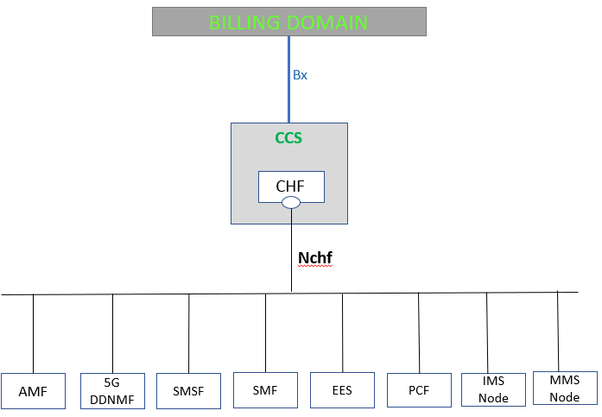
Figure 4.2.3.1: Logical ubiquitous charging architecture and information flows for 5G systems – service based interface

Figure 4.2.3.2 provides the overview in reference point representation:

Figure 4.2.3.1: Logical ubiquitous charging architecture and information flows for 5G systems – reference point representation
The reference points are defined in clause 4.4.3.
For the sake of simplicity, the SMF+PGW-C is not explicitly added in Figure 4.2.3.1 and Figure 4.2.3.2 and is represented by the SMF.The SMF+PGW-C uses Nchf for 5GS and EPC interworking as well as when enhanced to support GERAN/UTRAN.
The Nchf_SpendingLimitControl service exposed by CHF and consumed by the PCF is specified in TS 23.502 [214].

Second change

4.4.3 Charging services Reference Point
The common charging architectures are mapped into the specific domain/subsystem/service charging architectures in the respective middle tier TSs, which contain in their reference point representation, the following reference points:
N28: Reference point between PCF and CHF defined in TS 23.501[215].
N40: Reference point between SMF and the CHF in the same PLMN defined in clause 4.2 of TS 32.255 [15].
N41: Reference point between AMF and CHF in HPLMN defined in clause 4.2.2 of TS 32.256 [16].
N42: Reference point between AMF and CHF in VPLMN defined in clause 4.2.2 of TS 32.256 [16].
N44: Reference point between NEF and CHF defined in clause 4.4 of TS 32.254 [14].
N45: Reference point between IMS Node and CHF defined in clause 4.4 of TS 32.260 [20].
N46: Reference point between SMSF and CHF defined in clause 4.4 of TS 32.274 [34].
N47: Reference point between SMF and the CHF in different PLMNs defined in clause 4.2 of TS 32.255 [15].
N48: Reference point between MMS Node and CHF defined in clause 4.4 of TS 32.270 [30]

End of changes

