3GPP TSG-SA5 Meeting #145-e S5-225543rev1

Online, , 15th Aug 2022 - 24th Aug 2022
CR-Form-v12.2
CHANGE REQUEST
 | 28.554 | CR | 0100 | rev | - | Current version: | 17.7.0
For HELP on using this form: comprehensive instructions can be found at
http://www.3gpp.org/Change-Requests.

Proposed change affects: | UICC apps |  | ME |  | Radio Access Network | x | Core Network

Title: | Rel-18 CR TS 28.554 Updating Packet transmission reliability KPI in DL on N3
Source to WG: | Samsung Electronics Nordic AB
Source to TSG: | SA5
Work item code: | TEI17 |  |  |  |  |  | Date: |  |  | 2022-08-05
Category: | A |  |  |  |  |  | Release: |  |  | Rel-18
 | Use one of the following categories:  F (correction)  A (mirror corresponding to a change in an earlier release)  B (addition of feature),  C (functional modification of feature)  D (editorial modification)  Detailed explanations of the above categories can  be found in 3GPP TR 21.900. |  |  |  |  |  |  |  | Use one of the following releases:  Rel-8 (Release 8)  Rel-9 (Release 9)  Rel-10 (Release 10)  Rel-11 (Release 11)  …  Rel-16 (Release 16)  Rel-17 (Release 17)  Rel-18 (Release 18)  Rel-19 (Release 19)
Reason for change: |  | Subclause d) of 6.8.1.3 contains incorrect IOC name where the measurement is made
Summary of change: |  | Changing incorrect IOC name i.e. NRCellCU to GNBCUUPFunction because this is the correct IOC where the KPI is applicable and the measurement is made.
Consequences if not approved: |  | Incorrect IOC name stays where measurement is not made
Clauses affected: |  | 6.8.1.3
 |  | Y | N
Other specs |  |  | x | Other core specifications |  |  |  | TS/TR ... CR ...
affected: |  |  | x | Test specifications |  |  |  | TS/TR ... CR ...
(show related CRs) |  |  | X | O&M Specifications |  |  |  | TS/TR ... CR ...
Other comments: |  | This is to convert agreed draft CR S5-222613 of SA5 #142e meeting into CR.
This CR's revision history:

Start of change

6.8.1.3 Packet transmission reliability KPI in DL on N3
a) DLRelPSR_N3
b) This KPI describes the Reliability based on Packet Success Rate(PSR) Percentage between UPF and gNB. It is used to evaluate the N3 interface reliability contribution to the total network downlink reliability. It is the percentage of GTP data PDUs which are successfully received by gNB out of the total GTP data PDUs transmitted by UPF over N3 interface. It is a measure of the DL packet delivery success i.e. PSR% over N3 interface. It is a percentage value (%). This KPI can optionally be split into KPIs per QoS level (mapped 5QI or QCI in NR option 3) and per S-NSSAI.
c) DLRelPSR_N3 = 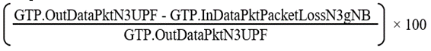

where GTP.OutDataPktN3UPF, GTP.InDataPktPacketLossN3gNB are as defined in TS 28.552
or optionally,
DLRelPSR_N3.QoS = 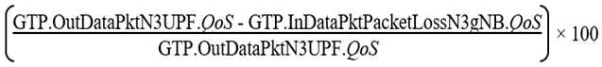

where QoS identifies the target QoS quality of service class.
or optionally,
DLRelPSR_N3.SNSSAI = 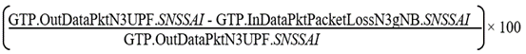

where SNSSAI identifies the S-NSSAI.
d) UPFFunction, GNBCUUPFunction

End of changes

