3GPP TSG-SA5 Meeting #145-e S5-225530

e-meeting, 15 August – 24 August 2022

Source: China Mobile

Title: pCR TR 28.833 Add procedure of management of the PDU session of FS_5GLAN_Mgt

Document for: Approval
Agenda Item: 6.8.4.3

Decision/action requested
The group is asked to discuss and endorse the proposal in section 4

2 References
[1] SP-220324 " New Study on Management Aspects of 5GLAN "
[2] 3GPP TS 23.501: "System Architecture for the 5G System; Stage 2".
[3] 3GPP TS 22.261: "Service requirements for next generation new services and markets; Stage 1".

3 Rationale
This contribution proposes to add potential solutions for TR 28.833.

4 Detailed proposal
It proposes to make the following changes.
1st Change

5 Topics

5.2 Topic 2: PDU Session management

5.2.1 Use case
The session management is applicable to 5G LAN-type services with clarification and enhancement. For example, SMF may support PDU Sessions for a 5G VN group, which offers a virtual data network capable of supporting 5G LAN-type service over the 5G system. The whole PDU sessions belong to the 5G VN group need to select the same SMF based on network configuration. But how to configure to select the same SMF based on network configuration has not defined yet. The 3GPP management system should have the capability to manage the PDU Session for providing 5G LAN-type services, including:
- A UE gets access to 5G LAN-type services via a PDU Session of IP PDU Session type or Ethernet PDU Session type.
- A PDU Session provides access to one and only one 5G VN group.
- A dedicated SMF is responsible for all the PDU Sessions for communication of a certain 5G VN group.
- A PDU Session provides unicast, broadcast and multicast communication for the DNN and S-NSSAI associated to a 5G VN group.

5.2.2 Potential requirements
REQ-LAN-PDU-01 The 3GPP management system should have the capability to manage the PDU Session for providing 5G LAN-type services.

5.2.3 Key Issues

5.2.3.1 Description

This key issue is for investigating how to support the 5G LAN-type service considering REQ-LAN-PDU-01. This investigation covers the following:
- which types of PDU session shall be supported for 5G LAN-type services by 5G network.
- identification and classification of the PDU sessions for communication of a certain 5G VN group;
- determination of which and how NF in the 5G system are suitable to perform and maintain the related information of the PDU session management to support 5G LAN-type service;
- How management configuration(s) can keep the same SMF selected during PDU session establishment for a 5G VN group.

5.2.4 Solutions

5.2.4.3 Procedure description
In order to support the 5G VN Group management configurated by OAM, the procedure of management of the PDU session of 5G VN Group configuration for network function is following.

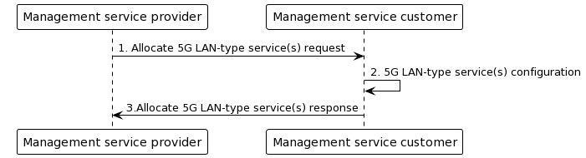
Figure 5.2.4.3 Procedure of management of the PDU session of 5G VN Group configuration for network functions
1. The management service provider after received the 5G LAN-type service requirements from customers can allocate the 5G LAN-type service request to the management service provider, which may be the management function of network functions, including External Group Id and 5G VN group configurations.
2. The management service customer allocates the 5G LAN-type service configuration to the specific network functions (e.g. AMF/SMF/NRF). The attributes of managedNFProfile in network functions’ IOC can include the information of 5G VN group related information and the correspondence between the 5G VN group ID and the supported SMFs.

3. The management service customer sends respond to the management service provider.

5.2.5 Evalution

5.2.6 Conclusion

End of Change

