3GPP TSG SA WG5 Meeting #145e S5-225407rev1

e-meeting, 15 - 19 August 2022

Source: Samsung, EUTC, EDF

Title: pCR TR 28.829 Clean up

Type: pCR

Document for: Approval, Information, Discussion
Agenda Item: 6.9.13.6 (FS_NSOEU: Study on Network and Service Operations for Energy Utilities)

1 Decision/action requested
SA5 is asked to approve this pCR.

2 References
None

3 Rationalei
This pCR removes some editors notes and makes some small changes to justify these changes.
For the following editor's note " Editor's Note: The term 'MNO' will be reviewed, as it may need to be aligned with terminology in TS 28.530" there appeared to be no changes needed to this TR after examining TS 28.530.

4 Detailed proposal
Please see the proposal below.

BEGIN CHANGE

2 References
The following documents contain provisions which, through reference in this text, constitute provisions of the present document.
- References are either specific (identified by date of publication, edition number, version number, etc.) or non-specific.
- For a specific reference, subsequent revisions do not apply.
- For a non-specific reference, the latest version applies. In the case of a reference to a 3GPP document (including a GSM document), a non-specific reference implicitly refers to the latest version of that document in the same Release as the present document.
[1] 3GPP TR 21.905: "Vocabulary for 3GPP Specifications".
[2] 3GPP TS 22.104: "Service requirements for cyber-physical control applications in vertical domains".
[3] 3GPP TS 22.261: "Service requirements for the 5G system".
[4] 3GPP TR 28.824: " Study on network slice management capability exposure"
[5] IT Process Wiki – The ITIL Wiki:. https://wiki.en.it-processmaps.com/index.php/ITIL_Service_Operation Content is available according to Creative Commons Attribution-NonCommercial-ShareAlike 3.0 Germany License. Access 08.12.21.
[6] 3GPP TR 22.867: "Study on 5G smart energy and infrastructure"
[7] Connected Nations 2020, UK Report, Ofcom. https://www.ofcom.org.uk/__data/assets/pdf_file/0024/209373/connected-nations-2020.pdf Access 20.4.22.
[8] Telecom Services Security Incidents 2019 Annual Analysis Report, ENISA European Agency for Cybersecurity, July 23, 2020. https://www.enisa.europa.eu/publications/annual-report-telecom-security-incidents-2019 This publication is intended for information purposes only and is accessible free of charge. Reproduction is authorised provided the source is acknowledged. Access 20.4.22.
[9] DIRECTIVE (EU) 2019/ 944 OF THE EUROPEAN PARLIAMENT AND OF THE COUNCIL - of 5 June 2019 - on common rules for the internal market for electricity and amending Directive 2012/ 27/ EU (europa.eu)
https://eur-lex.europa.eu/legal-content/EN/TXT/PDF/?uri=CELEX:32019L0944&from=EN
[10] IEC TC 57 https://www.iec.ch/ords/f?p=103:7:511571509228708::::FSP_ORG_ID,FSP_LANG_ID:1273,25
[11] 3GPP TR 22.867: "Study on 5G smart energy and infrastructure".
[y] 3GPP TS 22.104, " Service requirements for cyber-physical control applications in vertical domains ".

NEXT CHANGE

3.1 Terms
For the purposes of the present document, the terms given in 3GPP TR 21.905 [1] and the following apply. A term defined in the present document takes precedence over the definition of the same term, if any, in 3GPP TR 21.905 [1].
Distribution System Operator: a natural or legal person who is responsible for operating, ensuring the maintenance of and, if necessary, developing the distribution system in a given area and, where applicable, its interconnections with other systems, and for ensuring the long-term ability of the system to meet reasonable demands for the distribution of electricity, see Article 2, definitions in DIRECTIVE (EU) 2019/ 944 [9].
SCADA: the operating system in energy company. This is for controlling the power grid. The management system of power grid is standardized by IEC TC 57, see Dashboard, scope [10].
Distribution Automation: Distribution Automation (DA) is the family of technologies, systems and processes (including sensors, actuators, processors, communication networks, switches, etc.) that enable the remote, real-time monitoring, operation, and optimization of utility distribution systems on the field.

NEXT CHANGE

3.3 Abbreviations
For the purposes of the present document, the abbreviations given in 3GPP TR 21.905 [1] and the following apply. An abbreviation defined in the present document takes precedence over the definition of the same abbreviation, if any, in 3GPP TR 21.905 [1].
DSO Distribution System Operator
SCADA Supervisory Control And Data Acquisition
DA Distribution Automation

NEXT CHANGE

6.1.1 Description
Motivation
When there is an electrical outage, the electrical service operator strives to restore service as quickly as possible. There are several reasons for the need for rapid recovery from an interruption of electrical service:
- In some countries, regulations require rapid recovery and penalize an Energy Utility service provider for any time in which services does not operate. For example, at the least, in many countries customers do not have to pay for electrical service when it is not available.
- Interruptions in electrical service can be expensive, as businesses often require electricity for operations, manufacturing and to properly store valuable products. Thus, electrical outages can translate directly into business losses (of productivity or inventory.)
- Power outages for hospitals and care facilities can result in harm or even death to patients.
NOTE 1: Regulations identify 'critical' electricity customers which are obliged to install and maintain secure sources (e.g. local generators.) Public mobile network operators in some cases are not covered by these regulations. Further, public mobile network operators are generally not considered 'critical' electricity customers by regulation, so Energy Utility service providers cannot prioritize service to these customers.
- Electrical service outages affect many customers, so failure of service is not comparable in terms of business consequences to outages of mobile telecommunication service to a single customer.

For this reason, there are regulations that make energy service availability the highest priority. In order to achieve this, Smart Energy services such as protection, SCADA and Distribution Automation are used to monitor and adjust distribution equipment to avoid incidents that would reduce energy service availability.
As a point of comparison, a fiber optic access service is often offered with an availiability of at least 99.999%. Telecommunication systems may not achieve this level of service availability. Since telecommunications offers an alternative to fixed fiber optic access, additional means to achieve high degrees of availability are essential to the DSO.

Background
To achieve extreme telecommunication serivce availability, it is currently not feasible to rely on a single telecommunication network. Instead, DSOs networks employ communication access equipment that have multiple USIMs. If one telecommunication service provider is not available, the second can be used. However, this arrangement ('failover') is insufficient, as it requires in practice 2 minutes or more to bring up a secondary USIM and register with a back up network.
NOTE 2: An electrical service operator is a more general term than a DSO. For the purpose for the purpose of the use case, the term DSO is more appropriate, while the more general term is applicable to the motivation above.
To prevent an outage that will last an hour or more, Distribution Automation must be used to intervene in the first minutes, ideally in the first seconds, in which an outage occurs. The following examples show two outages and can be considered characteristic of the prospects of resolution in most situations.

In Figure 1, an incident affecting an underground Medium Voltage (MV) line eliminated service to 4223 customers. The existence of DA in secondary substations along the line allowed the fault to be isolated quickly and then resolved. This dramatically reduced the service outage duration for a substantial number of customers. A few customers that were along a line without DA access required local operation that took more than one hour. (The time scale on the X axis is not to scale. The data points track the number of clients affected by service outage incidents over time.)

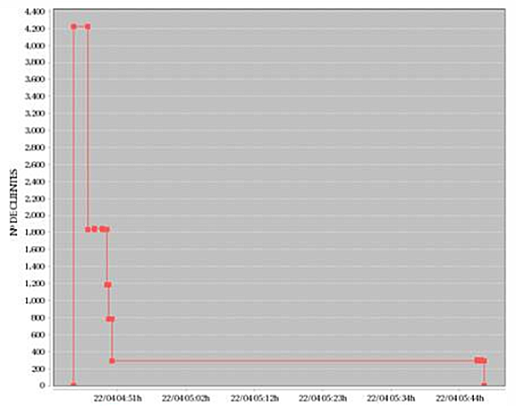
Figure 1: Incident Example
Over 50% of the customers could have their service restored in 3 minutes. Another 40% of the customers had their service restored in under 10 minutes. The remaining roughly 10% of the customers required manual intervention in order to have their service restored. The rapid service restoration saved EUR 1000s in saved penalties as well as needing only one service truck to roll.
In Figure 2, another example, another MV line was damaged, again showing a complication of a line that did not offer the possibility of DA intervention.
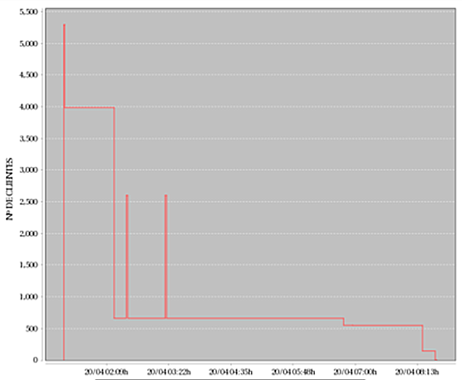
Figure 2: Incident Example featuring a time consuming recovery for a minority of customers
This incident affected 5292 customers. The outage lasted 7 hours but it can be observed that most of the customers could have their service restored within the first minutes due to remote access to primary and secondary substations and intervention using DA. In this incident, EUR 10000s could be saved.
Considering the importance of rapid response during a power outage, it is important that the communication facility is available at the time of an outage. If communication failure only is ascertained during an incident, the outage duration can be extended significantly for most of the affected customers.
In order to improve availability, some DSOs use dual USIM UE deployments. In practice, it takes on the order of 2 minutes to bring up service on an alternate mobile network. These minutes, if they coincide with an outage, are expensive both in terms of penalties and in terms of problems faced by customers during the outage. This also uses up roughly half of the ‘downtime budget’ of 99.999% availability (5 minutes per year unscheduled downtime maximum.)
Communication links are tested, e.g. every minute by means of ping messages end to end, to identify availability and latency. The effective availability of 3GPP telecommunications networks observed in practice can be more like 98.5% (where availability means ability to achieve communication with the expectations of performance according to the service level agreement. While this is far below the levels we expect from 5G and that we cite in stage 1 requirements, the fact is that observations of performance of past generations indicate that in order to achieve the target availability, information is needed. Please see TS 22.104 [y], Annex A.4.
NOTE 3: The actual availability of mobile network services is not exposed to energy utility service provider (customers), nor is the cause of the availability limit, e.g. limited capacity, radio quality issues, etc. This makes it difficult for energy utilities to perform risk assessment and network planning for communication services to carry their smart energy services.

Communication performance failure, based on extensive field experience, can be correlated with network performance events. Network performance can be compared to historic information indicating failures. In this case when communication with a ‘primary’ PLMN shows signs of declining performance, an ‘alternate’ communication channel can be employed, e.g. registration with another PLMN for a multi-USIM device. This action can be performed proactively, so that in the event that the ‘primary’ communication session does fail to deliver required performance, recovery can occur quickly (within seconds) to the ‘alternative’ communication session.
NEXT CHANGE

6.3.3 Use case actors
DSO response team member: A representative of the DSO's incident response team who is responsible for communication with service providers, officials and key customers during power cuts.
MNO service desk team member: A representative of a mobile network operator's incident response team who can be reached by 'enterprise customers.'

END OF CHANGE

