3GPP TSG-SA5 Meeting #145-e S5-225391

e-meeting, 15 - 24 August 2022

Source: Huawei

Title: pCR TR 28.908 Add possible solutions on AI/ML model update

Document for: Approval
Agenda Item: 6.7.5.7

1 Decision/action requested
In this box give a very clear / short /concise statement of what is wanted.

References
[1] 3GPP TR 28.908-030 Management and orchestration; Study on Artificial Intelligence/Machine Learning (AI/ML) management
[2] 3GPP TS 28.105 Management and orchestration; Artificial Intelligence / Machine Learning (AI/ML) management

3 Rationale
TR 28.908 [1] discussed the use cases and requirements of AI/ML update management. This contribution proposes the potential solutions on AI/ML update.

4 Detailed proposal
It is proposed to add the following chapter in TR 28.908 [1].
1st modified section

5.9 AI/ML update management

5.9.1 Description
Due to the complexity and time-varying nature of network, the AI/ML entities previously deployed may no longer be applicable to the current network after running for a period of time. Typically, the performance of a trained model may degrades over time. The AI/ML entitie needs to be updated timely to ensure the performance of inference and analysis.

5.9.2 Use cases

5.9.2.1 AI/ML entities updating initiated by producer
The AI/ML entity updating may be initiated by the AI/ML MnS producer. In order to keep the model at a requested level, the AI/ML MnS producer may periodically conduct AI/ML retraining with new available training data. Once a new version AI/ML entity is obtained after the training is finished, it can be used to update the current AI/ML entity with this new version. In another condition, the AI/ML MnS producer may initiate AI/ML entity updating based on the running model performance. For example, if the performance of the running AI/ML model is decreased under a predefined threshold, the AI/ML MnS producer may decide to start ratraining and then update the AI/ML entity to a new version which performs better.

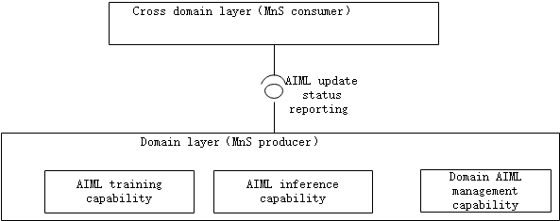
5.9.2.1-1: Potential requirements

REQ-AIML_UPD-CON-1: The AI/ML MnS producer should have a capability to update the AI/ML entities and inform an authorized consumer about the update status.

5.9.4 Possible solutions

5.9.4.1 Possible solution#1
Following is the proposed solution based on information model defined in TS 28.105 [2].
- Extend the AIMLEntity <<dataType>> with an attribute "updatedTime", which indicates the time that the AI/ML entity is updated. For a trained AIMLEntity, the value of "aIMLEntityVersion" indicates the version number of the AI/ML entity. When the AI/ML entities updating is initiated and successfully excuted, the value of "aIMLEntityVersion" is modified to be the new version number, and the value of "updatedTime" is the time that the updating is finished. Then AI/ML MnS producer can use the "notifyMOIAttributeValueChange" operation to inform the authorized MnS consumer about the AIML update Status including the updated AIMLEntity version number and the corresponding updating time.

End of modified section

