3GPP TSG-SA5 Meeting #145-e S5-225390

e-meeting, 15 - 24 August 2022

Source: Huawei, Deutsche Telekom

Title: pCR TR 28.908 Add use case on AI/ML configuration

Document for: Approval
Agenda Item: 6.7.5.8

1 Decision/action requested
In this box give a very clear / short /concise statement of what is wanted.

References
[1] SP-211443 New Study on AI/ ML management
[2] 3GPP TR 28.908 Management and orchestration; Study on Artificial Intelligence/Machine Learning (AI/ML) management
[3] 3GPP TS 28.813 Management and orchestration; Study on new aspects of Energy Efficiency (EE) for 5G

3 Rationale
The approved new SI [1] proposed to study the AI/ML management capabilities and management services to support/coordinate AI/ML in 5GS (3GPP management system, 5GC and NG-RAN). At the beginning of the phase, AI/ML configuration need to be considered so as to making an AI/MLenabled function available in the operational environments.
As described in clause 4.7.3 in TR 28.813[3], to provide centralized ES for RAN domain area, 3GPP management system performs the functionalities as monitoring, analysis, decision, execution and evaluation. With AI technology, 3GPP management system can provide more efficient ES for RAN domain area while keeping basic KPIs stable for SLA assurance. In order to support RAN domain Energy saving management scenario, the AI/ML configuration for RAN domain ES need to be studied.
This contribution proposes to add a use case on AI/ML configuration.

4 Detailed proposal
It is proposed to add the following chapter in TR 28.908 [2].
1st modified section

5.X AI/ML configuration management for RAN domain ES

5.X.1 Description
At the beginning of the AI/ML enabled function operation, enabling the AI/ML entities should be controlled by AI/ML management. As described in clause 4.7 in TR 28.813[3], RAN domain ES can use AI to formulate energy saving solutions. Therefore, the AI/ML entities which enabled RAN domain ES function should be controlled by AI/ML management. The AI/ML entity configuration need to be triggered to enable RAN domain ES function. The AI/ML entity configuration can be initiated by the AI/ML MnS consumer or initiated by the AI/ML MnS producer.

5.X.2.1 AI/ML entity configuration initiated by consumer
The AI/ML entity configuration may be initiated by the AI/ML MnS consumer of Cross domain management. AI/ML MnS Consumer monitor network performance and determine whether to trigger the AI/ML entity configuration. For example, for ES purpose, AI/ML MnS Consumer collects the information of the capacity booster cells and coverage cells inside the RAN domain area, then makes the decision for activation AI/ML entity, e.g. for enabled RAN domain ES function, consumer can configure the training/retraining activation at training phase, policy, target and activation for inference phase etc. In this case, the consumer can trigger the AI/ML entities so as to get better network performance.

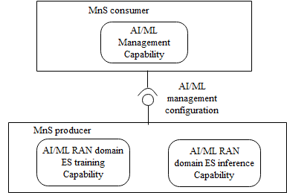
Figure 5.X.2.1-1: AI/ML entity configuration initiated by consumer

5.X.2.2 AI/ML entity configuration initiated by producer
The AI/ML entity configuration may be initiated by the AI/ML MnS producer. AI/ML MnS producer can determines whether to trigger AI/ML entity configuration based on network performan and service requirements. For example, after receiving an RAN domain ES requirement, the AI/ML MnS producer can decide to trigger training of the AI/ML entity, e.g. RAN domain ES function. In this case, the AI/ML MnS producer responsible for AI/ML management shall have a capability to trigger the AI/ML entities and inform an authorized consumer about the AI/ML entity status.

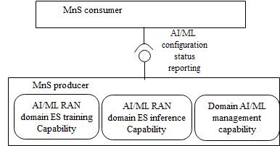
Figure 5.X.2.2-1: AI/ML entity configuration initiated by producer

5.X.3 Potential requirements
REQ-AIML_Config-CON-1: The AI/ML MnS producer should have a capability to allow the authorized consumer to trigger AI/ML training capability and inference capability configuration.
REQ-AIML_Config-CON-2: The AI/ML MnS producer responsible for AI/ML management shall have a capability to configure the AI/ML training capability and inference capabilityand inform an authorized consumer about the AI/ML configuration status.

5.X.4 Possible solutions
TBD

End of modified section

