3GPP TSG-SA5 Meeting #145-e S5-225348

e-meeting, 15 Aug – 24 Aug 2022

Source: Amdocs

Title: Adding potential solution for locating a cancel failed event

Document for: Approval
Agenda Item: 7.5.2

1 Decision/action requested
Include the proposed changes in TR 28.826.

2 References
[1] 3GPP TR 28.826: " Study on Nchf charging services phase 2 improvements and optimizations"

3 Rationale
Adding a potential solution for key issue #4a, addressing how to locate the event that should be cancelled.

4 Detailed proposal
First change

5.4.5.x Solutions #4.x: Cancelling using a reference identifier for Charging Event
A possible solution for key issues 4a, covering requirements REQ-3GPPCH-ESC-01, cancelling of event would be to add a reference identifier (e.g. refundInformation) in Charging Data Response -> multipleUnitInformation for IEC, that can later be sent back in Charging Data Request -> multipleUnitUsage, to identify the event to be cancelled or refunded

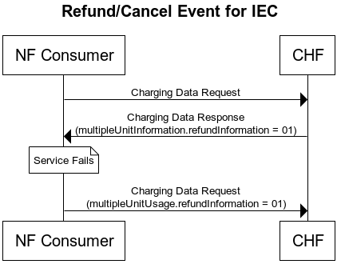

End of changes

