3GPP TSG SA WG5 Meeting #145-e S5-225343

August 15 – 24, 2022, e-Meeting revision of S5-2abcde

Source: Intel

Title: pCR 28.838 add solution

Document for: Approval
Agenda Item: 6.7.8.1

1 Decision/action requested
The group is asked to discuss and approve the proposals.

2 References
[1] TR 28.838 “Study on measurement data collection to support RAN intelligence”

3 Rationale
This contribution proposes to add the solution to TR28.838 [1].

4 Detailed proposal

1st modified section

2 References
The following documents contain provisions which, through reference in this text, constitute provisions of the present document.
- References are either specific (identified by date of publication, edition number, version number, etc.) or non-specific.
- For a specific reference, subsequent revisions do not apply.
- For a non-specific reference, the latest version applies. In the case of a reference to a 3GPP document (including a GSM document), a non-specific reference implicitly refers to the latest version of that document in the same Release as the present document.
[1] 3GPP TR 21.905: "Vocabulary for 3GPP Specifications".
[2] 3GPP TR 37.817 “Study on enhancement for Data Collection for NR and EN-DC”.
[x] 3GPP TS 28.541: "Management and orchestration; 5G Network Resource Model (NRM); Stage 2 and stage 3".
[y] 3GPP TS 38.331: “NR; Radio Resource Control (RRC) protocol specification”.
[z] 3GPP TS 28.550: “Management and orchestration; Performance assurance”.
[w] 3GPP TS 28.532: “Management and orchestration; Generic management services”.
[v] 3GPP TS 28.622: “Generic Network Resource Model (NRM) Integration Reference Point (IRP); Information Service (IS)”.
[u] 3GPP TS 28.622: “Management and orchestration; Architecture framework”.

Next section

5 Use cases, requirements and potential solutions

5.x Potential solutions
This clause contains the potential solutions to support the requirements listed in clause 5.1, 5.2, and 5.3.
NOTE: The solutions will only result in new measurements to support RAN3 defined data in the normative work.

5.x.1 Measurement data collected from NG-RAN neighboring nodes
RAN intelligence use cases defined in TR 37.817 [2] require input data and feedbacks from the neighboring nodes. Figure 5.x.1-1 shows that MnF of performance assurance (see clause 4.5 in TS 28.533 [u]) can be used by consumers to collect the measurement data from NG-RAN neighboring nodes.

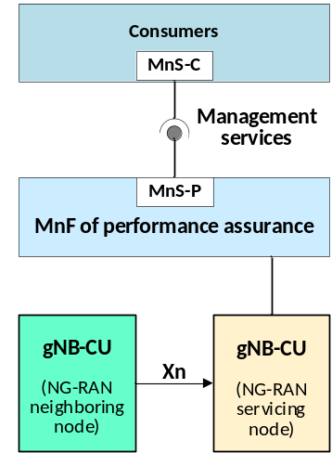
Figure 5.x.1-1 Measurement data collected from NG-RAN neighboring nodes

5.x.1.1 Measurement collection via performance job control
Figure 5.x.1.1-1 depicts a solution to describe how a consumer can utilize the MnS produced by MnF of performance assurance to collect the measurement data from neighboring nodes via the performance job control.
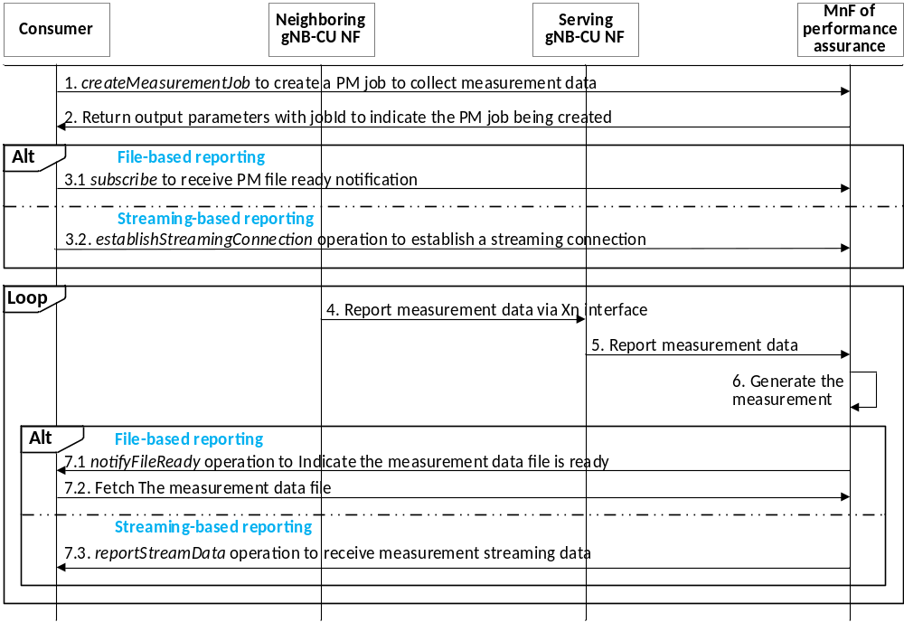
Figure 5.x.1.1-1 Measurement data collection via performance job control
1. A consumer invokes the createMeasurementJob operation (see TS 28.550 [z]) provided by the MnF of performance assurance to create a measurement job for collecting measurement data. The operation includes the following, but not limited to, attributes:
- iOCInstanceList: the DN(s) of NRCellRelation MOI (see TS 28.541 [x]).
- measurementCategoryList: the measurement type(s) (see TS 28.550 [z]) that include new measurements for RAN3 defined data, such as Current/predicted resource status, historical successful and unsuccessful UE handovers from neighboring nodes (see clause 5.3.2.4 in TR 38.817 [2]).
- reportingMethod: file or streaming based reporting.
2. MnF of Performance assurance returns the output parameter with jobId to indicate the measurement job been created.
3. If the measurement job is based on performance file reporting service, then
3.1 The consumer invokes the subscribe operation (see clause 12.6.1.1.1 in TS 28.532 [w]) to subscribe to receive notifications when the measurement data is ready for collection.
Otherwise, (performance data streaming service)
3.2 The consumer invokes the establishStreamingConnection operation to establish a streaming connection for sending the streaming data.
4. Neighboring gNB-CU NF reports the measurement data to serving gNB-CU NF via the Xn interface.
5. Serving gNB-CU NF reports the measurement data to the MnF of performance assurance (NOTE).
6. MnF of performance assurance generates the measurement.
7. If the measurement job is based on performance file reporting service, then
7.1 MnF of performance assurance sends a notifyFileReady notification (see clause 11.6.1.1 in TS 28.532 [w]) to the consumer to indicate the performance data file is ready.
7.2. The consumer fetches the measurement data from the MnF of performance assurance.
Otherwise, (performance data streaming service)
7.3 MnF of performance assurance invokes the reportStreamData operation to send the streaming measurement data to the consumer.

NOTE: The interface between performance assurance MnS for NF and serving gNB CU is not subject to standardization.

5.x.1.2 Measurement collection via configurable measurement control
Figure 5.x.1.2-1 depicts a solution to describe how a consumer can utilize the MnS produced by MnF of performance assurance to collect the measurement data via the configuration measurement control.
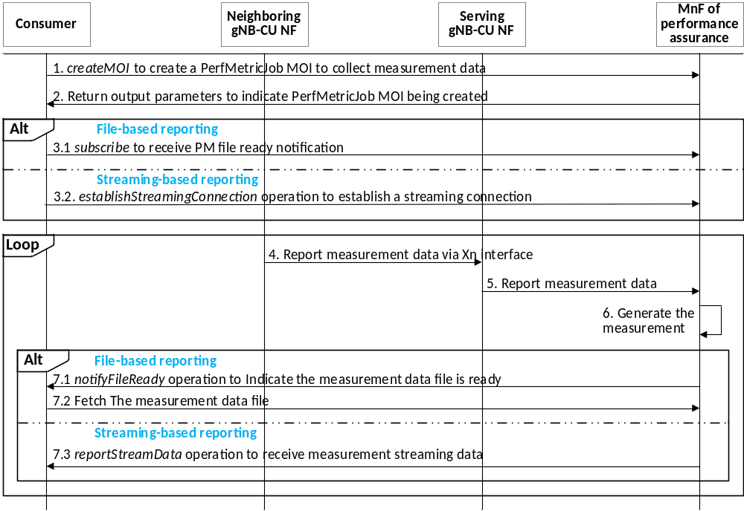
Figure 5.x.1.2-1 Measurement data collection via configurable measurement control
1. A consumer invokes the createMOI operation (see TS 28.532 [w]) for PerfMetricJob IOC (see clause 4.3.31 in TS 28.622 [v]) to request the MnF of performance assurance to create a measurement job for collecting measurement data from the neighboring node. The operation includes the following, but not limited to, attributes:
- objectInstances: the DN(s) of NRCellRelation MOI(s) indicating the NR cell CU of the neighboring node.
- performanceMetrics: the list of performance metrics.
- reportingCtrl: file or streaming based reporting.
2. MnF of performance assurance returns the output parameter with the status of PerfMetricJob MOI creation.
3. If the measurement job is based on performance file reporting service, then
3.1 The consumer invokes the subscribe operation to subscribe to receive notifications when the measurement data is ready for collection.
Otherwise, (performance data streaming service)
3.2 The consumer invokes the establishStreamingConnection operation to establish a streaming connection for sending the streaming data.
4. Neighboring gNB-CU NF reports the measurement data to serving gNB-CU NF via the Xn interface.
5. Serving gNB-CU NF reports the measurement data to the MnF of performance assurance (NOTE).
6. MnF of performance assurance generates the measurement for the object instance of NRCellRelation MOI(s) referring to the neighboring gNB CU NF.
7. If the measurement job is based on performance file reporting service, then
7.1 MnF of performance assurance sends a notifyFileReady notification to the consumer to indicate the performance data file is ready.
7.2. The consumer fetches the measurement data from the MnF of performance assurance.
Otherwise, (performance data streaming service)
7.3 The consumer collects the measurement data and invokes the reportStreamData operation to send the 5GC NF streaming data to the consumer.
NOTE: The interface between performance assurance MnS for NF and serving gNB CU is not subject to standardization.

5.x.2 Measurement data collected from NG-RAN local node
The existing performance assurance MnS can be reused to collect the measurement data, including feedbacks from actors, from the NG-RAN local node. The actors are distributed SON functions that are modeled as DMROFunction, DLBOFunction, and DESManagementFunction IOCs (see TS 28.541 [x]).

5.x.2.1 Measurement collection via performance job control
Figure 5.x.2.1-1 depicts a solution to describe how a consumer can utilize the MnS produced by MnF of performance assurance to collect the measurement data (e.g., feedbacks from the actors) via the performance job control.
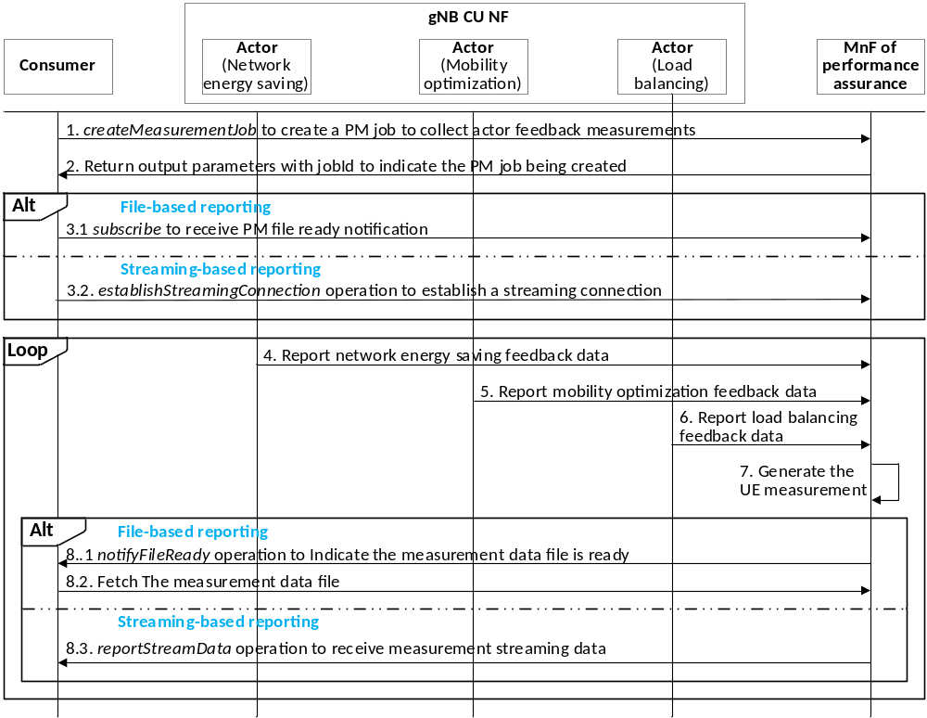
Figure 5.x.2.1-1 Measurement data collection via performance job control
1. A consumer invokes the createMeasurementJob operation provided by the MnF of performance assurance to create a measurement job for the collection of measurement data to create a measurement job for collecting the feedback data from the actors. The operation includes the following, but not limited to, attributes:
- iOCInstanceList: the DN(s) of DMROFunction, DLBOFunction, and DESManagementFunction MOI.
- measurementCategoryList: the measurement type(s) that include new measurements for RAN3 defined data, such as UE trajectory prediction, current/predicted UE traffic from local nodes (see clause 5.3.2.4 in TR 38.817 [2]).
- reportingMethod: file or streaming based reporting.
2. MnF of performance assurance returns the output parameter with jobId to indicate the measurement job been created.
3. If the measurement job is based on performance file reporting service, then
3.1 The consumer invokes the subscribe operation to subscribe to receive notifications when the measurement data is ready for collection.
Otherwise, (performance data streaming service)
3.2 The consumer invokes the establishStreamingConnection operation to establish a streaming connection for sending the streaming data.
4. The actor of network energy saving reports the measurement data to the performance assurance MnS-P for NF (NOTE).
5. The actor of mobility optimization reports the measurement data to the performance assurance MnS-P for NF (NOTE).
6. The actor of load balancing reports the measurement data to the performance assurance MnS-P for NF (NOTE).
7. MnF of performance assurance generates the measurement for the object instance of NRCellRelation MOI(s) referring to the neighboring gNB CU NF.
8. If the measurement job is based on performance file reporting service, then
8.1 MnF of performance assurance sends a notifyFileReady notification to the consumer to indicate the performance data file is ready.
8.2. The consumer fetches the measurement data from the MnF of performance assurance.
Otherwise, (performance data streaming service)
8.3 The consumer collects the measurement data and invokes the reportStreamData operation to send the 5GC NF streaming data to the consumer.
NOTE: The interface between performance assurance MnS for NF and serving gNB CU is not subject to standardization.

5.x.2.2 Measurement collection via configurable measurement control
Figure 5.x.1.2-1 depicts a solution to describe how a consumer can utilize the MnS produced by MnF of performance assurance to collect the measurement data (e.g., feedbacks from the actors) via the configuration measurement control.
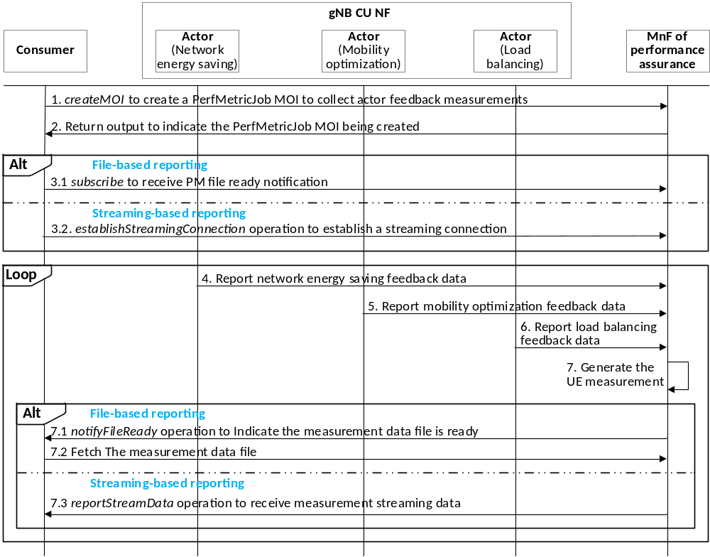
Figure 5.x.1.2-1 Measurement data collection via configurable measurement control
1. A consumer invokes the createMOI operation for PerfMetricJob IOC to request the MnF of performance assurance to create a measurement job for collecting measurement data from the actors. It includes the following, but not limited to, attributes:
- objectInstances: the DN(s) of DMROFunction, DLBOFunction, and DESManagementFunction MOI(s).
- performanceMetrics: the list of performance metrics.
- reportingCtrl: file or streaming based reporting.
2. MnF of performance assurance returns the output parameter with the status of PerfMetricJob MOI creation.
3. If the measurement job is based on performance file reporting service, then
3.1 The consumer invokes the subscribe operation to subscribe to receive notifications when the measurement data is ready for collection.
Otherwise, (performance data streaming service)
3.2 The consumer invokes the establishStreamingConnection operation to establish a streaming connection for sending the streaming data.
4. The actor of network energy saving reports the measurement data to the performance assurance MnS-P for NF (NOTE).
5. The actor of mobility optimization reports the measurement data to the performance assurance MnS-P for NF (NOTE).
6. The actor of load balancing reports the measurement data to the performance assurance MnS-P for NF (NOTE).
7. MnF of performance assurance generates the measurement.
8. If the measurement job is based on performance file reporting service, then
8.1 MnF of performance assurance sends a notifyFileReady notification to the consumer to indicate the performance data file is ready.
8.2. The consumer fetches the measurement data from the MnF of performance assurance.
Otherwise, (performance data streaming service)
8.3 MnF of performance assurance invokes the reportStreamData operation to send the streaming measurement data to the consumer.
NOTE: The interface between performance assurance MnS for NF and serving gNB CU is not subject to standardization.

5.x.3 Measurement data collected from UEs
Figure 5.x.3-1 depicts that the gNB may configure the RRC_CONNECTED UE to report NR measurements, inter-RAT measurements of E-UTRA frequencies, inter-RAT measurements of UTRA-FDD frequencies, and NR sidelink measurements of L2 U2N Relay UEs (see clause 5.5.1 in TS 38.331 [y]) that are neded to support handover, carrier aggregation, or dual connectivity. The gNB sends the RRCReconfiguration message with measConfig IE to determine the type of measurements to be collected by UE. UE returns the measurement in the MeasurementReport message.
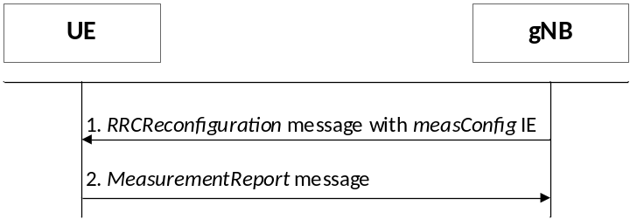
Figure 5.x.3-1 UE measurement report configuration
Therefore, gNB already receives UE measurement report (e.g., RSRP, RSRQ, SINR, etc) that can be used as input data for the model training without any additional trigger.
Figure 5.x.3-2 shows that MnF of performance assurance management can be used to collect the UE measurements. A measurement can be created when one or more UE measurement reports are received. The measurement should refer to NRCellCU IOC with subcounter for each UE measurements. The subcounder index should be based on C-RNTI that is associated with the RRC Connection.
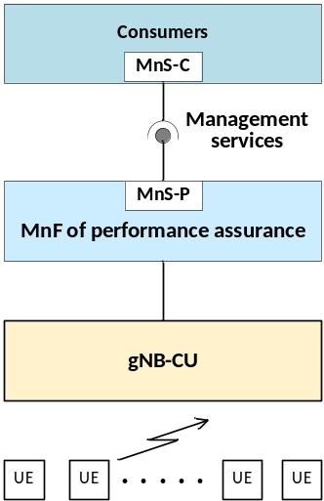
Figure 5.x.3-2 UE measurement data collection

5.x.3.1 Measurement collection via performance job control
Figure 5.x.3.1-1 depicts a solution to describe how a consumer can utilize the MnS produced by MnF of performance assurance to collect the UE measurement data via the performance job control.
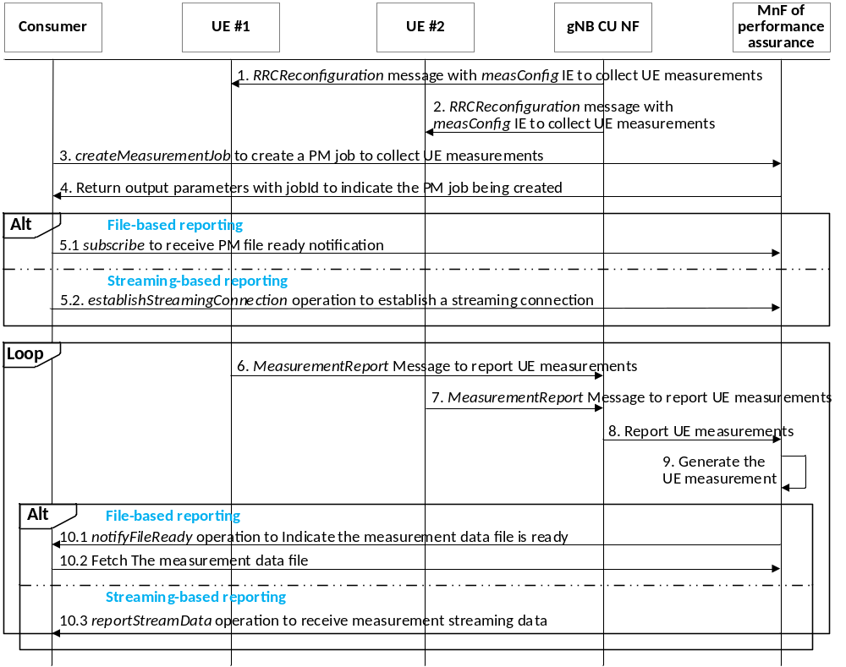
Figure 5.x.3.1-1 Measurement data collection via performance job control
1. gNB CU sends a RRC message RRCReconfiguration message with measConfig IE to request UE #1 to report UE measurements.
2. gNB CU sends a RRC message RRCReconfiguration message with measConfig IE to request UE #2 to report UE measurements.
3. A consumer invokes the createMeasurementJob operation provided by the MnF of performance assurance to create a measurement job for collecting UE measurements. It includes the following, but not limited to, attributes:
- iOCInstanceList: the DN(s) of NRCellCU MOI.
- measurementCategoryList: the measurement type(s) that include new measurements for RAN3 defined data, such as UE location information, UE Mobility History Information from UEs (see clause 5.3.2.4 in TR 38.817 [2]).
- reportingMethod: file or streaming based reporting.
4. MnF of performance assurance returns the output parameter with jobId to indicate the measurement job been created.
5. If the measurement job is based on performance file reporting service, then
5.1 The consumer invokes the subscribe operation to subscribe to receive notifications when the measurement data is ready for collection.
Otherwise, (performance data streaming service)
5.2 The consumer invokes the establishStreamingConnection operation to establish a streaming connection for sending the streaming data.
6. UE #1 returns a RRC message MeasurementReport to report the UE measurements.
7. UE #2 returns a RRC message MeasurementReport to report the UE measurements.
8. gNB-CU NF reports the UE measurements to the MnF of performance assurance (NOTE).
9. MnF of performance assurance generates the measurement with subcounter identified by C-RNTI for each UE measurements.
10. If the measurement job is based on performance file reporting service, then
10.1 MnF of performance assurance sends a notifyFileReady notification (see clause 11.6.1.1 in TS 28.532 [w]) to the consumer to indicate the performance data file is ready.
10.2. The consumer fetches the measurement data from the MnF of performance assurance.
Otherwise, (performance data streaming service)
10.3 The consumer collects the measurement data and invokes the reportStreamData operation to send the 5GC NF streaming data to the consumer.
NOTE: The interface between performance assurance MnS for NF and serving gNB CU is not subject to standardization.

5.x.3.2 Measurement collection via configurable measurement control
Figure 5.x.3.2-1 depicts a solution describing how a consumer can can utilize the MnS produced by MnF of performance assurance to collect the UE measurements via the configuration measurement control.
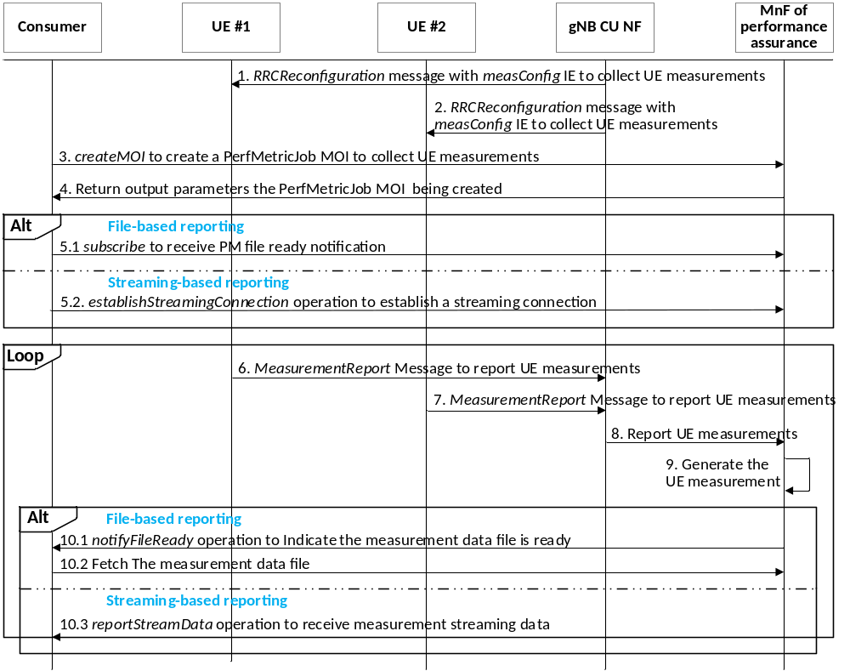
Figure 5.x.3.2-1 Measurement data collection via configurable measurement control
1. gNB CU sends a RRC message RRCReconfiguration message with measConfig IE to request UE #1 to report UE measurements.
2. gNB CU sends a RRC message RRCReconfiguration message with measConfig IE to request UE #2 to report UE measurements.
3. A consumer invokes the createMOI operation for PerfMetricJob IOC to request the MnF of performance assuranc to create a measurement job for collecting UE measurements. It includes the following, but not limited to, attributes:
- objectInstances: the DN(s) of NRCellCU MOI(s).
- performanceMetrics: the list of performance metrics.
- reportingMethod: file or streaming based measurements.
4. MnF of performance assurance returns the output parameter with the status of PerfMetricJob MOI creation.
5. If the measurement job is based on performance file reporting service, then
5.1 The consumer invokes the subscribe operation to subscribe to receive notifications when the measurement data is ready for collection.
Otherwise, (performance data streaming service)
5.2 The consumer invokes the establishStreamingConnection operation to establish a streaming connection for sending the streaming data.
6. UE #1 returns a RRC message MeasurementReport to report the UE measurements.
7. UE #2 returns a RRC message MeasurementReport to report the UE measurements.
8. gNB-CU NF reports the UE measurements to the MnF of performance assurance (NOTE).
9. MnF of performance assurance generates the measurement with subcounter identified by C-RNTI for each UE measurements.
10. If the measurement job is based on performance file reporting service, then
10.1 MnF of performance assurance sends a notifyFileReady notification (see clause 11.6.1.1 in TS 28.532 [w]) to the consumer to indicate the performance data file is ready.
10.2. The consumer fetches the measurement data from the MnF of performance assurance.
Otherwise, (performance data streaming service)
10.3 MnF of performance assurance invokes the reportStreamData operation to send the streaming measurement data to the consumer.
NOTE: The interface between performance assurance MnS for NF and serving gNB CU is not subject to standardization.

End of modified section

