**3GPP TSG-SA5 Meeting #145-e *S5-225214***

**e-meeting, 15 - 24 August 2022**

**Source: ChinaMobile, HUAWEI**

**Title: Usecase and requirement for Self-configuration Management**

**Document for: Approval**

**Agenda Item: 6.4.1**

# 1 Decision/action requested

***In this box give a very clear / short /concise statement of what is wanted.***

# 2 References

[1] SP-211431 New WID on Self-Configuration of RAN Nes

[2] S5-222726 TS 28.317 v0.1.0

# 3 Rationale

This document is going to provide proposals on use cases and requirements for Self-configuration management.

# 4 Detailed proposal

This document proposes the following updates for TS 28.317.

|  |
| --- |
| **1st Change** |

# Management capabilities

### 5.x Self-configuration process management

#### 5.x.1 Use cases

Self-configuration refers to the procedure of taking RAN NE to a state ready to to carry traffic in an automated manner, which may include following activities: generate the RAN NE initial configuration data, download and activate software, download and active configuration data, self-test, and update network resource model, etc.

Self-configuration monitor and control process is performed by MnS producer for RANSC (e.g. SCS),So MnS producer for RANSC needs to expose self-configuration management capabilities to authorized MnS consumer for RANSC to monitor and control the self-configuration processes for certain RAN NE(s). The authorized MnS consumer for RANSC can be the entity who wants to monitor and control self-configuration process (e.g. operator’s management system).

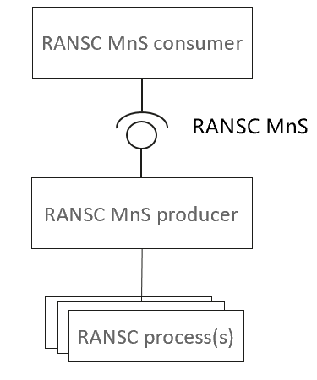

Figure 5.x.1 Framework for RANSC process management

The authorized MnS consumer for RANSC can request MnS producer for RANSC to create and activate an self-configuration process for certain RAN NE in the case of the authorized MnS consumer for RANSC trigger the self-configuration process. Besides, MnS producer for RANSC also can create and activate a self-configuration process triggered by itself based on the Self-configuration management profile (representing the decision of authorized MnS consumer for RANSC ) configured by the authorized MnS consumer for RANSC.

As the self-configuration process is complex and time-consuming, the authorized MnS consumer for RANSC needs to obtain the progress of the self-configuration process. Self-configuration process includes several steps (each step can represent one or several of activities) according to the self-configuration capabilities. So the authorized MnS consumer for RANSC may want to be informed the important events for step transition (e.g. start to execute a new step) and abnormal events during the self-configuration process. The authorized MnS consumer for RANSC also wants to be informed the reasons when abnormal event (e.g. failure) occurred.

The authorized MnS consumer for RANSC may want to request to set the stop point(s) for certain step of the self-configuration process based on self-configuration capability. When a stop point is reached, the self-configuration process is paused and the MnS consumer for RANSC is informed with the pause information (incl. corresponding step information). When the MnS consumer for RANSC sends a resuming request, the self-configuration process will continue to execute to the next step.

During the self-configuration, the authorized MnS consumers for RANSC can send request to MnS producer for RANSC to query the list of ongoing self-configuration process or the progress for certain self-configuration process.

When the last step of the self-configuration process is completed, MnS producer for RANSC needs to send the result of this process to the authorized MnS consumers for RANSC. The authorized MnS consumers for RANSC can terminate an ongoing self-configuration process for failure analysis and solving. When the last step of the self configuration process is completed successfully, the MnS producer for RANSC can delete the self-configuration process automatically.

#### 5.x.2 Requirements

**REQ-SCM -1:** MnS producer for RANSC shall have the capability to allow the authorized MnS consumers for RANSC to create and activate a self-configuration process.

**REQ-SCM -2:**  MnS producer for RANSC shall have the capability to allow the authorized MnS consumers for RANSC to query the list of ongoing Self-configuration processes.

**REQ-SCM -3：**MnS producer for RANSC shall have the capability to report the step information of a self-configuration process to the authorized MnS consumers for RANSC.

**REQ-SCM -4:** MnS producer for RANSC shall have the capability to report abnormal information to the authorized MnS consumers for RANSC when detected.

**REQ-SCM -5:** MnS producer for RANSC shall have the capability to inform the authorized MnS consumers for RANSC the result (success or failure) of the self-configuration process when the process is finished.

**REQ-SCM -6:** MnS producer for RANSC shall have the capability to allow the authorized MnS consumers for RANSC to query the progress of the self-configuration process when needed.

**REQ-SCM -7：**MnS producer for RANSC shall have the capability to allow the authorized MnS consumers for RANSC to terminate an ongoing self-configuration process.

**REQ-SCM -8:** MnS producer for RANSC shall have the capability to inform the authorized MnS consumers for RANSC the information that it has deleted the self-configuration process automatically.

Editor’s Note: the term “MnS producer/consumer for RANSC” is FFS.

|  |
| --- |
| **End of change** |