3GPP TSG-SA5 Meeting #145-e S5-225214

e-meeting, 15 - 24 August 2022

Source: ChinaMobile, HUAWEI

Title: Usecase and requirement for Self-configuration Management

Document for: Approval
Agenda Item: 6.4.1

1 Decision/action requested
In this box give a very clear / short /concise statement of what is wanted.

2 References
[1] SP-211431 New WID on Self-Configuration of RAN Nes
[2] S5-222726 TS 28.317 v0.1.0

3 Rationale
This document is going to provide proposals on use cases and requirements for Self-configuration management.

4 Detailed proposal
This document proposes the following updates for TS 28.317.
1st Change

Management capabilities

5.x Self-configuration process management

5.x.1 Use cases
Self-configuration refers to the procedure of taking RAN NE to a state ready to to carry traffic in an automated manner, which may include following activities: generate the RAN NE initial configuration data, download and activate software, download and active configuration data, self-test, and update network resource model, etc.
Self-configuration process is performed in RAN NE, but it is also important for operators to control and monitor the self-configuration process. So RANSC MnS producer needs to expose self-configuration management capabilities to authorized RANSC MnS consumer to monitor and control the self-configuration processes for certain RAN NE(s). The authorized RANSC MnS consumer can be the entity who wants to monitor and control self-configuration process.
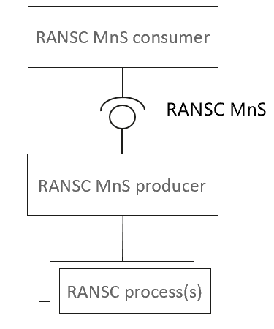
Figure 5.x.1 Framework for RANSC process management
The authorized RANSC MnS consumer can request RANSC MnS producer to create and activate an self-configuration process for certain RAN NE in the case of the authorized RANSC MnS consumer trigger the self-configuration process. Besides, RANSC MnS producer also can create and activate a self-configuration process triggered by itself based on the Self-configuration management profile (representing authorized RANSC MnS consumer's decision) configured by the authorized RANSC MnS consumer.
As the self-configuration process is complex and time-consuming, the authorized RANSC MnS consumer needs to obtain the progress of the self-configuration process. Self-configuration process includes several steps (each step can represent one or several of activities) according to the self-configuration capabilities. So the authorized RANSC MnS consumer may want to be informed the important events for step transition (e.g. start to execute a new step) and abnormal events during the self-configuration process. The authorized RANSC MnS consumer also wants to be informed the reasons when abnormal event (e.g. failure) occurred.
The authorized RANSC MnS consumer may want to request to set the stop point(s) for certain step of the self-configuration process based on self-configuration capability. When a stop point is reached, the self-configuration process is paused and the RANSC MnS consumer is informed with the pause information (incl. corresponding step information). When the RANSC MnS consumer sends a resuming request, the self-configuration process will continue to execute to the next step.
During the self-configuration, the authorized RANSC MnS consumers can send request to RANSC MnS producer to query the list of ongoing self-configuration process or the progress for certain self-configuration process.
When the last step of the self-configuration process is completed, RANSC MnS producer needs to send the result of this process to the authorized RANSC MnS consumers. The authorized RANSC MnS consumers can terminate an ongoing self-configuration process for failure analysis and solving. When the last step of the self configuration process is completed successfully, the RANSC MnS producer can delete the self-configuration process automatically.

5.x.2 Requirements
REQ-SCM -1: RANSC MnS producer shall have the capability to allow the authorized RANSC MnS consumers to create and activate a self-configuration process.
REQ-SCM -2: RANSC MnS producer shall have the capability to allow the authorized RANSC MnS consumers to query the list of ongoing Self-configuration processes.
REQ-SCM -3：RANSC MnS producer shall have the capability to report the step information of a self-configuration process to the authorized consumers.
REQ-SCM -4: RANSC MnS producer shall have the capability to report abnormal information to the authorized RANSC MnS consumers when detected.
REQ-SCM -5: RANSC MnS producer shall have the capability to inform the authorized RANSC MnS consumers the result (success or failure) of the self-configuration process when the process is finished.
REQ-SCM -6: RANSC MnS producer shall have the capability to allow the authorized RANSC MnS consumers to query the progress of the self-configuration process when needed.
REQ-SCM -7：RANSC MnS producer shall have the capability to allow the authorized RANSC MnS consumers to terminate an ongoing self-configuration process.
REQ-SCM -8: RANSC MnS producer shall have the capability to inform the authorized RANSC MnS consumers the information that it has deleted the self-configuration process automatically.

End of change

