3GPP TSG-SA5 Meeting #145-e S5-225163rev1

e-meeting, 15 - 24 August 2022

Source: Huawei

Title: Concepts of filtering and encapsulation in exposure governance

Document for: Approval
Agenda Item: 6.9.6.3

1 Decision/action requested
For approval

2 References
[1] 3GPP TR 28.824 V0.8.0 Study on network slice management capability exposure
[2] 3GPP TS 28.533 Management and orchestration; Architecture framework

3 Rationale
As described in TS 28.533 [2] clause 4.4, the exposure governance of management services achieves the exposure control for the basic components (e.g. management services component type A, B, C) of one management service.
The figure 4.4.1 below comes from TS 28.533 clause 4.4, showing the exposure governance applied on exposed management service. Exposure governance plays an important role during the process of management capability exposure. For instance, if the capability offered by management service A’ is a subset of that offered by management service A, without the exposure governance, the management service A’ consumer may have the access to consume all capability provided by management service A which will cause the illegal/improper management capabilities consumption.
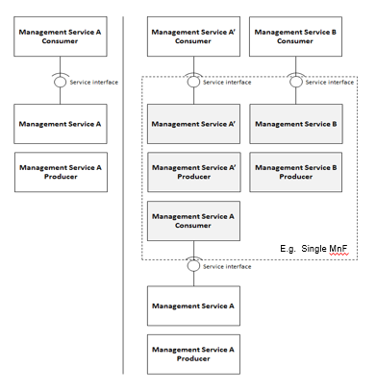
Figure 4.4.1: Management capability exposure governance applied on exposed Management Service A

According to TS 28.533 [2] clause A.2, Exposure governance management function (EGMF) shown in Figure A.2.1 is management function in network function model with the role of management service exposure governance (i.e. abstraction, simplification, filtering, etc.) as below.
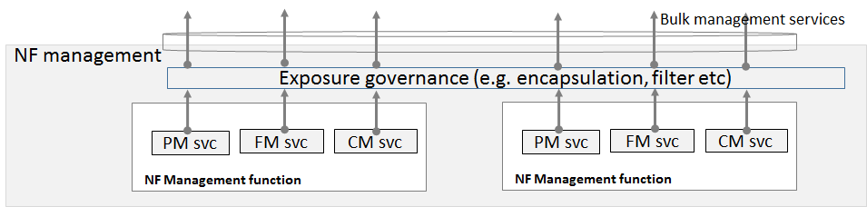
Figure A.2.1: Example NF management function layer structure
However, details of EGMF management capability exposure governance is FFS in TS 28.533 [2], i.e., what exactly does the exposure governance mean hasn’t been specified in [2]. This contribution is proposed to give definitions of filtering and encapsulation.

4 Detailed proposal
This contribution proposes to make the following changes in [1].

1st change

4.1.1.x Exposure Governance
To avoid unauthorised management capability consumption, management services should be applied with exposure governance before being exposed to different types of MnS consumers. As introduced in TS 28.533[11], management capability exposure governance provides exposure governance on basic elements of management function service based interface:
1) Management service component type A
2) Management service component type B
3) Management service component type C
The Figure 4.1.1.x below illustrates the filtering and encapsulation of management services.
Figure 4.1.1.x: exposure governance on management service A and management service B
The management functions (i.e. MnF 1, MnF 2 and MnF 3 shown in Figure 4.1.1.x) can be regarded as EGMFs. Definitions and examples are given in next clauses to show what the filtering and encapsulation are.

4.1.1.x.1 Filtering
Definition: The exposure access control on MnS component Type A, Type B and/or Type C.
Typical case 1: Assuming the management service A is Provisioning MnS with operations createMOI, getMOIAttributes, modifyMOIAttributes and deleteMOI as MnS component Type A, the filtering on management service A could be that only operation getMOIAttributes is available to management service A' consumer. Management service A' is Provisioning MnS with operation getMOIAttributes as filtered subset of MnS component Type A of management service A.
Typical case 2: Assuming the management service A is Provisioning MnS with NRM MOIs as the component Type B, the filtering on management service A could be that only part of the attributes of the NRM MOI, as the component Type B of management service A, will be exposed to management service A'' consumer. Management service A'' is Provisioning MnS with only part of the attributes of the aforementioned NRM MOIs as filtered subset of MnS component Type B of management service A.
To implement the filtering on MnS, attribute mnsScope of IOC MnsInfo, see further details in TS 28.622 [17], may be used to provide information about the management scope of a Management Service. The management scope is defined as the set of managed object instances that can be accessed (as filtering) using the Management Service.

4.1.1.x.2 Encapsulation
Definition: The exposure encapsulation of management services provided by different management service producers.

Typical case 1: According to the sub-use case introduced in clause 5.6.1.2, assuming the management service A is the provisioning management on 5GC subnetwork provided by company-A, the management service B is the provisioning management on RAN subnetwork provided by company-B with RAN coverage in Spain, the encapsulation of management service A and management service B is the management services AB which provides the exposed provisioning management on an end to end network slice exposed to company-V.
Typical case 2: According to the sub-use case in clause 5.6.1.2, assuming the management service A is the provisioning management on RAN subnetwork provided by company-B with RAN coverage in Spain, the management service B is the provisioning management on RAN subnetwork provided by company-C with RAN coverage in USA, the encapsulation of management service A and management service B is the management service AB which provides the exposed provisioning management on RAN coverage for all areas in Spain and USA requested by company-V.

End of changes

