3GPP TSG-SA5 Meeting #145-e S5-225162rev1

e-meeting, 15 - 24 August 2022

Source: Huawei

Title: Potential solution for satisfying resource isolation demand for Smart Grid Utilities

Document for: Approval
Agenda Item: 6.9.1.1

1 Decision/action requested
Approval

2 References
[1] 3GPP TR 28.907: "Study on enhancement of management of non-public networks"

3 Rationale
This contribution is proposed to provide potential solution for issue resource isolation demand described in TR 28.907[1] clause 5.3.

4 Detailed proposal
This contribution proposes to make the following changes in [1].
1st change

5.3.2 Potential solutions

5.3.2.1 Introduction
This clause provides a potential solution to satisfy the resource isolation demand described in clause 5.3.1.

5.3.2.2 Description
A resource isolation-sharing policy, which contains the logical and physical isolation policies among different safety zones, can be sent to NPN-OP.
The logical resource isolation-sharing policy includes several groups of safety zones. Energy applications belonging to the safety zones within the same group use the shared logical resources (e.g. a network slice), while energy applications categorized into different safety zones across different groups use isolated logical resources. An example of the division of safety zones into groups is shown in Figure 5.3.2.2-1.
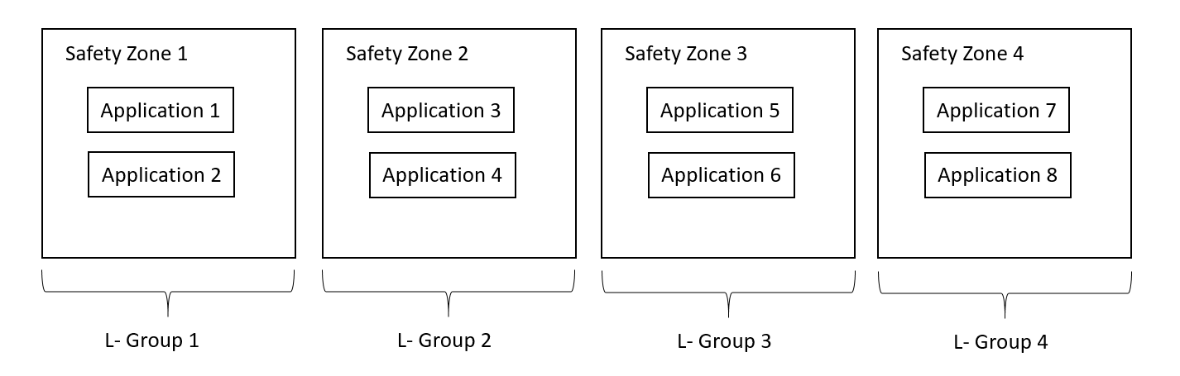
Figure 5.3.2.2-1: Example of logical isolation-sharing policy – groups cross multiple safety zones
In case that the applications belonging to the same safety zone require to be logically isolated with each other, the groups can reflect the resource isolation-sharing policy at a more granular level, such as specifying the applications. An example of the division of applications into groups is shown in Figure 5.3.2.2-2. Application 1-1 and Application 2-1 are further divided into different subgroups as they cannot share same logical network resources event though they are both categorized into safety zone 1.
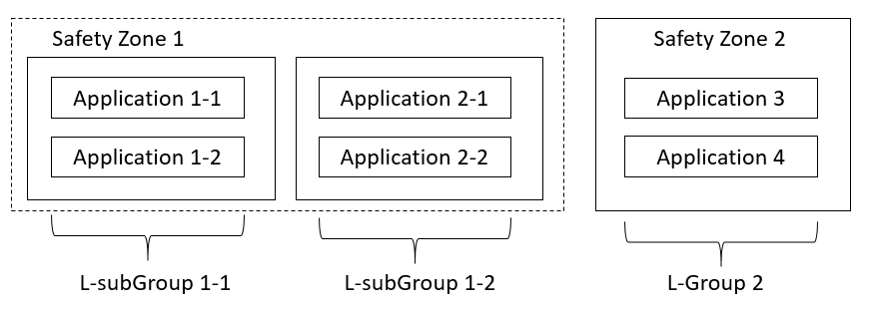
Figure 5.3.2.2-2: Example of logical isolation-sharing policy – subgroups within one safety zone
Similarly, the physical resource isolation-sharing policy includes several groups of safety zones. Energy applications belonging to the safety zones within the same group use the shared physical resources, while energy applications categorized into different safety zones across different groups use isolated physical resources. An example of the division of safety zones into groups is shown in Figure 5.3.2.2-3.
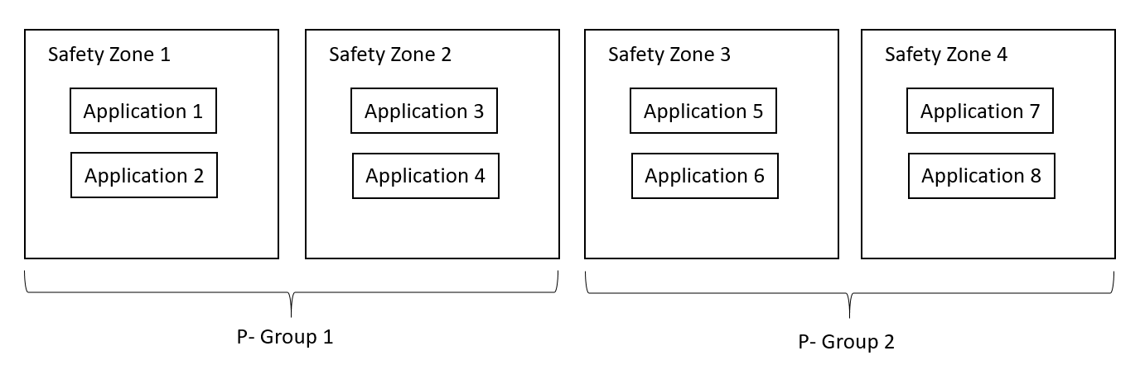
Figure 5.3.2.2-3: Example of physical isolation-sharing policy
All logical and physical isolation-sharing relations (i.e. shared or isolated) between every two safety zones could be figured out with the resource isolation policy, and the NPN-OP should take it into consideration when allocating network resources for each safety zone. When Smart Grid Utilities requests the network resources allocation for energy applications, the safety zone type and the related logical and/or physical resource isolation lists could be attached in the request to show the logical and/or physical resource isolation-sharing relations between one safety zone and other safety zones, so that the network resources allocation for energy applications belonging to certain safety zones satisfies the resource isolation demand. Detailed explanation of the safety zone type, logical and physical resource isolation lists are as following:
- The safety zone type is used to identify which safety zones the energy applications are categorized into.
- The subgroup identifier is used to identify the subgroups of energy applications within one safety zone. It is only applicable when applications belonging to a same safety zone requires to be logically isolated each other.
- The logical resource isolation list is derived from the logical isolation-sharing policy and contains safety zones that are required to be logical isolated with the current safety zone. Safety zones which are out of this list are ones that sharing the same logical network resources with the current safety zone. When the subgroup identifier is specified, the other subgroups of the current safety zone should also be included in the logical resource isolation lists.
- The physical resource isolation list is derived from the physical isolation-sharing policy and contains safety zones that are required to be physical isolated with the current safety zone. Safety zones which are out of this list are ones that sharing the same physical network resources with the current safety zone.

