3GPP TSG-SA5 Meeting #145-e S5-225143

e-meeting, 15 - 24 August 2022
CR-Form-v12.1
CHANGE REQUEST
 | 28.531 | CR | 0125 | rev | 1 | Current version: | 17.4.0
For HELP on using this form: comprehensive instructions can be found at
http://www.3gpp.org/Change-Requests.

Proposed change affects: | UICC apps |  | ME |  | Radio Access Network | X | Core Network | X

Title: | Update feasibility check procedure to align with FeasibilityCheckAndReservationJob
Source to WG: | Huawei
Source to TSG: | S5
Work item code: | TEI17 |  |  |  |  |  | Date: |  |  | 2022-07-21
Category: | F |  |  |  |  |  | Release: |  |  | Rel-17
 | Use one of the following categories:  F (correction)  A (mirror corresponding to a change in an earlier release)  B (addition of feature),  C (functional modification of feature)  D (editorial modification)  Detailed explanations of the above categories can  be found in 3GPP TR 21.900. |  |  |  |  |  |  |  | Use one of the following releases:  Rel-8 (Release 8)  Rel-9 (Release 9)  Rel-10 (Release 10)  Rel-11 (Release 11)  …  Rel-15 (Release 15)  Rel-16 (Release 16)  Rel-17 (Release 17)  Rel-18 (Release 18)
Reason for change: |  | - Several misalignment for the feasibility check procedure and FeasibilityCheckAndReservationJob IOC, for example,  - The term " feasibilityCheckResult " is used in the procedure, while the term "feasibilityResult" is used in FeasibilityCheckandReservastionJob IOC  - The term " feasibility check and reservation status" is used in the procedure, while the terms " feasibilityResult, inFeasibleReason, resourceReservationStatus, reservationFailureReason, reservationExpiration and recommendedRequirements " are used in FeasibilityCheckAndReservationJob IOC.  - The title of clause 7.13 and 7.14 is not align with title of Figure 7.13-1 and Figure 7.14-1.
Summary of change: |  | - Update the procedure description to align with FeasibilityCheckAndReservationJob IOC definition.  - Align the title of clause 7.13 and 7.14 with title of Figure 7.13-1 and Figure 7.14-1
Consequences if not approved: |  | Some misalignments exists for the feasibility check feature.
Clauses affected: |  | 7.13, 7.14
 |  | Y | N
Other specs |  |  | X | Other core specifications |  |  |  | TS/TR ... CR ...
affected: |  |  | X | Test specifications |  |  |  | TS/TR ... CR ...
(show related CRs) |  |  | X | O&M Specifications |  |  |  | TS/TR ... CR ...
Other comments:
This CR's revision history:

1st Change

7.13 Procedure of feasibility check and reservation of NSI
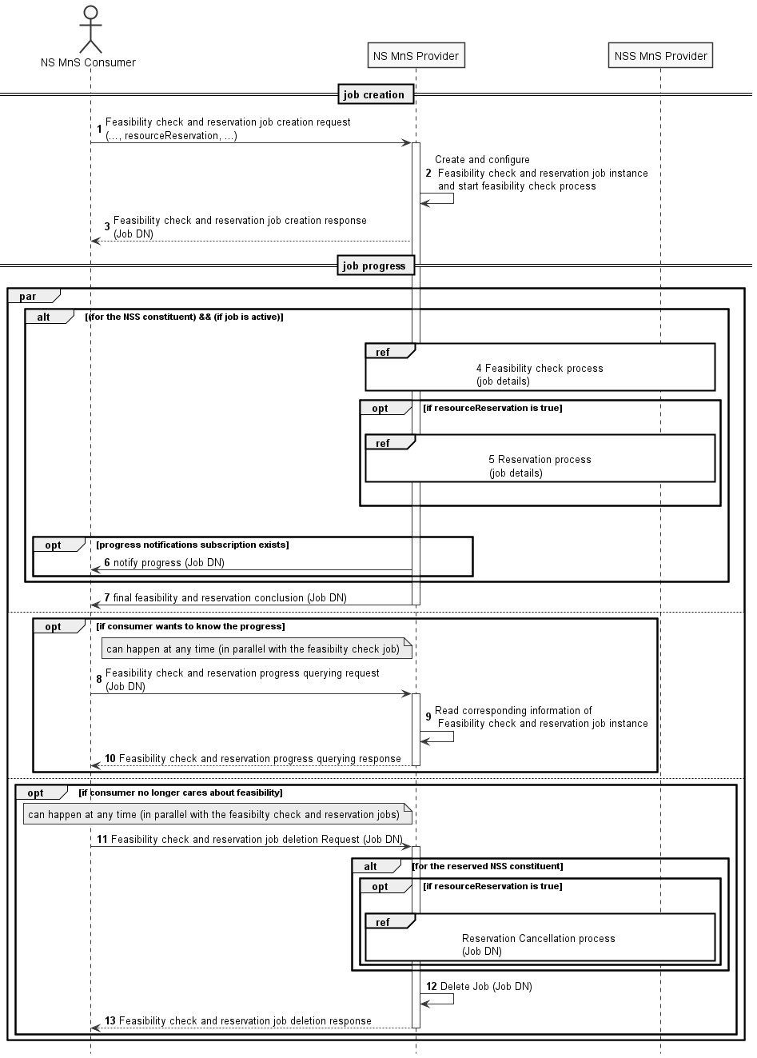
Figure 7.13-1 Network slice feasibility check and reservation procedure
1) Network Slice Management Service Provider (NS MnS Provider) receives a feasibility check with or without reservation job creation request (see createMOI operation defined in TS 28.532 [8]) from Network Slice Management Service Consumer (NS MnS Consumer) with feasibility check and reservation requirements (including serviceProfile, resourceReservation and requestedReservationExpiration of FeasibilityCheckAndReservationJob IOC defined in TS 28.541 [6]). The request is to check whether the network slice related requirements (i.e., ServiceProfile) can be satisfied and optionally be requested to be reserved. The resourceReservation attribute in the request may indicate whether reservation is also requested or not.
2) NS MnS Provider creates the FeasibilityCheckAndReservationJob instance and configures the attribute "ServiceProfile" and other attributes received from the request and NS MnS Provider starts the executing the feasibility check process.
3) NS MnS Provider sends the feasibility check and reservation job creation response with the DN of the FeasibilityCheckAndReservationJob instance (see createMOI operation defined in TS 28.532 [8]) to NS MnS Consumer.
4) NS MnS Provider performs feasibility check locally on whether the resources are available.
NS MnS Provider may invoke the feasibility check and reservation procedure for the constituent network slice subnet as described in clause 7.14
5) NS MnS Provider performs resource reservation process when resourceReservation is True and feasibilityResult is feasible.
6) The NS MnS Consumer may subscribe for the attribute value change notifications for this specific job or for any of the job(s) created by it to receive any asynchronous job progress notifications for those job(s). NS MnS Provider then sends the asynchronous job progress notification for feasibility check and reservation process with processMonitor attributes.
7) NS MnS Provider sends the final notification with the feasibility check and reservation status (including feasibilityResult, inFeasibleReason, resourceReservationStatus, reservationFailureReason, reservationExpiration and recommendedRequirements of FeasibilityCheckAndReservationJob IOC in TS 28.541 [6]).
8-10) Once after step 3, NS MnS Consumer can send query request to NS MnS Provider any time, to know the feasibility check and reservation job status and receive the feasibility check and reservation job status.
11-13) NS MnS consumer can request to delete the feasibility check and reservation job any time and the NS MnS Provider deletes the Job and sends the Job deletion response. NS MnS Provider will cancel the resource reservation when the feasibility check and reservation job is deleted.

7.14 Procedure of feasibility check and reservation of network slice subnet
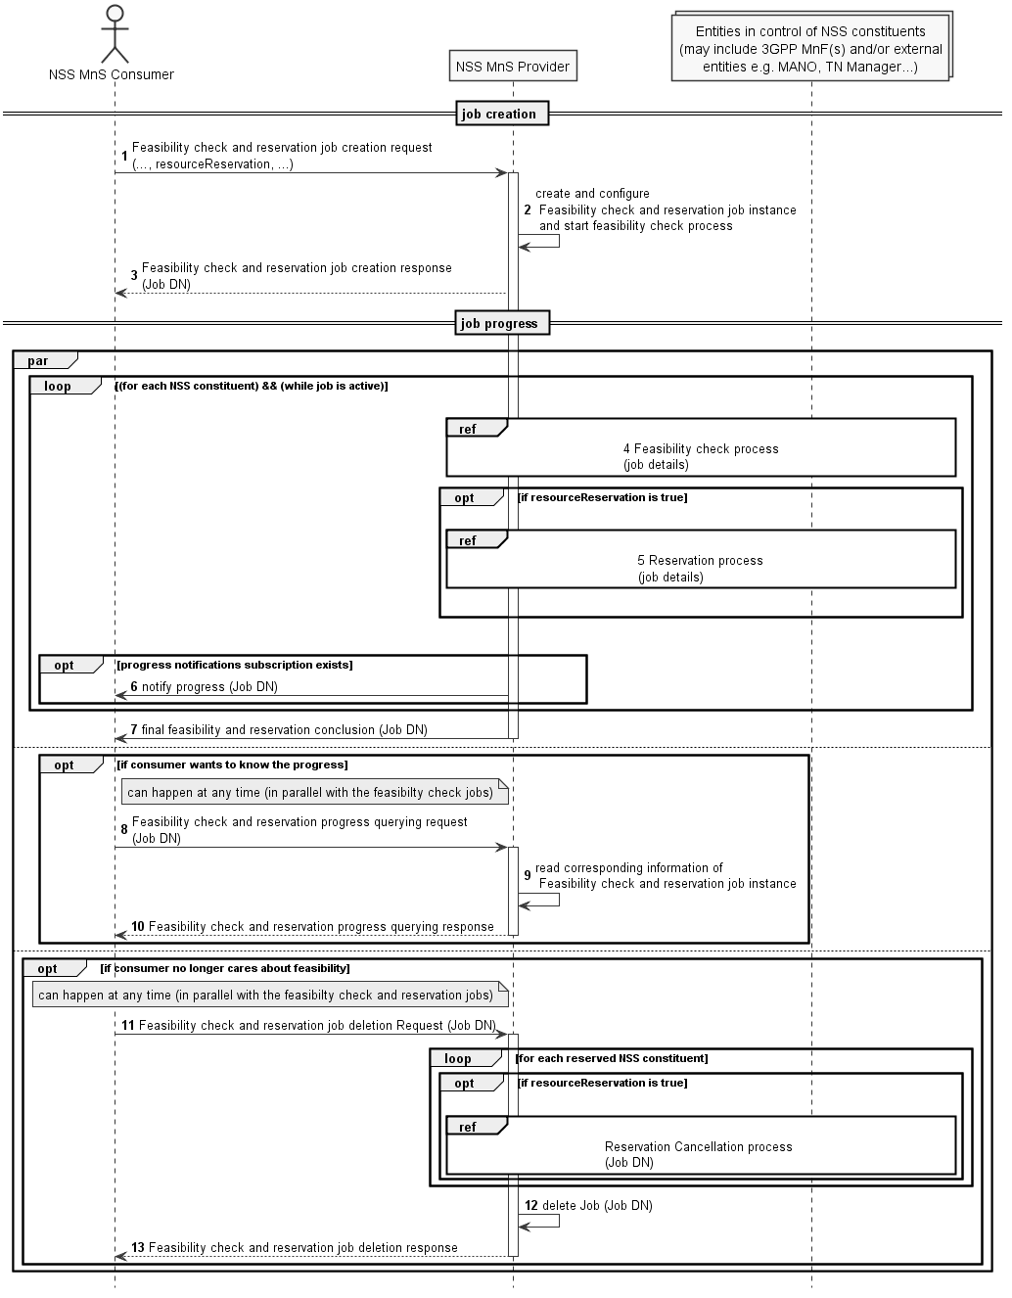
Figure 7.14-2 Network slice subnet feasibility check and reservation procedure
1) Network Slice Subnet Management Service Provider (NSS MnS Provider) receives a feasibility check with or without reservation job creation request (see createMOI operation defined in TS 28.532 [8]) from Network Slice Subnet Management Service Consumer (NSS MnS Consumer) with feasibility check and reservation requirements (including sliceProfile, resourceReservation and requestedReservationExpiration defined in FeasibilityCheckAndReservationJob IOC defined in TS 28.541 [6]). The request is to check whether the network slice subnet related requirements (i.e. SliceProfile) can be satisfied and optionally be requested to be reserved. The resourceReservation attribute in the request may indicate whether reservation is also requested or not.
2) NSS MnS Provider creates the FeasibilityCheckAndReservationJob instance and configures the attribute "SliceProfile" and other attributes received from the request and NSS MnS Provider starts the executing the feasibility check process.
3) NSS MnS Provider sends the feasibility check and reservation job creation response for the received DN of the FeasibilityCheckAndReservationJob (see createMOI operation defined in TS 28.532 [8]) requests to NSS MnS Consumer.
4) NSS MnS Provider performs feasibility check locally (e.g 3GPP MnFs) on whether the resources are available.
NSS MnS Provider may optionally perform feasibility check with other entities in control of the network slice subnet constituents (e.g., MANO, TN Manager) of the network slice subnet.
5) NSS MnS Provider performs resource reservation process when resourceReservation is True and feasibilityResult is feasible.
6) The NSS MnS Consumer may subscribe for the attribute value change notifications for this specific job or for any of the job(s) created by it to receive any asynchronous job progress notifications for those job(s). NSS MnS Provider then sends the asynchronous job progress notification for feasibility check and reservation process with processMonitor attributes
7) NSS MnS Provider sends the final notification with the feasibility check and reservation status (including feasibilityResult, inFeasibleReason, resourceReservationStatus, reservationFailureReason, reservationExpiration and recommendedRequirements defined in FeasibilityCheckAndReservationJob IOC in TS 28.541 [6]).
8-10) Once after step 3, NSS MnS Consumer can send query request to NSS MnS Provider any time, to know the feasibility check and reservation job status and receive the feasibility check and reservation job status.
11-13) NSS MnS consumer can request to delete the feasibility check and reservation job any time and the NSS MnS Provider deletes the Job and sends the Job deletion response. NSS MnS Provider will cancel the resource reservation when the feasibility check and reservation job is deleted.

End of Change

