3GPP TSG-SA5 Meeting #145-e S5-225086

e-meeting, 15 - 24 August 2022
CR-Form-v12.1
CHANGE REQUEST
 | 28.531 | CR | 0118 | rev | 1 | Current version: | 17.4.0
For HELP on using this form: comprehensive instructions can be found at
http://www.3gpp.org/Change-Requests.

Proposed change affects: | UICC apps |  | ME |  | Radio Access Network | x | Core Network | x

Title: | Update procedures for modification of Network Slice and Network Slice Subnet MOIs
Source to WG: | Nokia, Nokia Shanghai Bell
Source to TSG: | S5
Work item code: | eNETSLICE_PRO |  |  |  |  |  | Date: |  |  | 2022-08-04
Category: | F |  |  |  |  |  | Release: |  |  | Rel-18
 | Use one of the following categories:  F (correction)  A (mirror corresponding to a change in an earlier release)  B (addition of feature),  C (functional modification of feature)  D (editorial modification)  Detailed explanations of the above categories can  be found in 3GPP TR 21.900. |  |  |  |  |  |  |  | Use one of the following releases:  Rel-8 (Release 8)  Rel-9 (Release 9)  Rel-10 (Release 10)  Rel-11 (Release 11)  …  Rel-15 (Release 15)  Rel-16 (Release 16)  Rel-17 (Release 17)  Rel-18 (Release 18)
Reason for change: |  | The sequence diagrams for Network Slice Instance Modification and Network Slice Subnet Instance Modification are incorrect.
Summary of change: |  | The sequence diagrams in figure 7.6-1 and figure 7.7-1 are corrected to reflect the correct APIs.  Abbreviations for Network Slice Subnet Management Service Provider and Network Slice Subnet Management Service Consumer corrected in clause 7.7
Consequences if not approved: |  | Incorrect specification leads to confusion and incorrect implementation.
Clauses affected: |  | 7.6, 7.7
 |  | Y | N
Other specs |  |  | X | Other core specifications |  |  |  | TS/TR ... CR ...
affected: |  |  | X | Test specifications |  |  |  | TS/TR ... CR ...
(show related CRs) |  |  | x | O&M Specifications |  |  |  | TS/TR ... CR ...
Other comments: |  | - S5-225086 is CR converted from draftCR S5-224279 that was approved in #144e meeting.
This CR's revision history: |  | - Cover page updated to correct the category of the CR and to reflect in other comments that the CR is converted from draftCR from #144e to CR in #145e.

1st Change

7.6 Procedure of Network Slice Instance Modification
The Figure 7.6-1 illustrates the procedure of modifying an existing NSI.

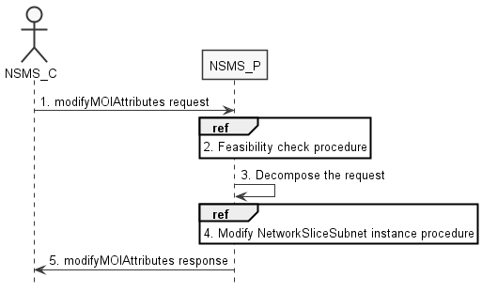
Figure 7.6-1: Network Slice Instance Modification Request procedure
1) Network Slice Management Service Provider (NSMS_P) receives a modifyMOIAttributes operation defined in TS 28.532 [8] from Network Slice Management Service Consumer (NSMS_C) with the DN of NetworkSlice MOI and the new network slice related requirements (see ServiceProfile defined in clause 6.3.3 in TS 28.541[6]).
2) Based on the new network slice related requirements, NSMS_P invokes the feasibility check procedure. If the modification requirements can be satisfied, go to step 3), else go to step 5).
3) NSMS_P decomposes the NetworkSlice MOI modification request into NSSI modification request(s), i.e., generating the new network slice subnet related requirements for each NSSI if needed.
4) NSMS_P, as the role of Network Slice Subnet Management Service Consumer (NSSMS_C), invokes the NSSI modification procedure.
5) NSMS_P sends NSI modification result (see modifyMOIAttributes operation defined in TS 28.532 [8]) to NSMS_C.

7.7 Procedure of Network Slice Subnet Instance Modification
The Figure 7.7-1 illustrates the procedure of modifying an existing NSSI.

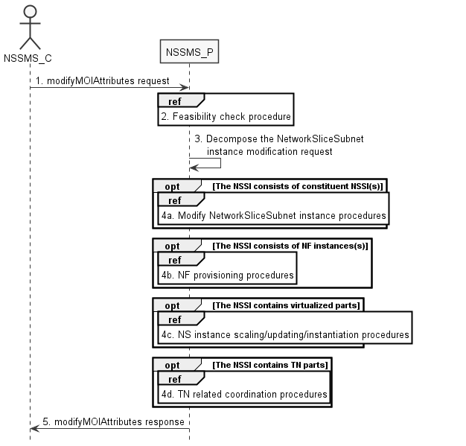
Figure 7.7-1: Network Slice Subnet Instance Modification Request procedure
1) Network Slice Subnet Management Service Provider (NSSMS_P) receives a modifyMOIAttributes operation defined in TS 28.532 [8] from Network Slice Subnet Management Service Consumer (NSSMS_C) with the DN of NetworkSliceSubnet MOI and the new network slice subnet related requirements (see SliceProfile defined in clause 6.3.3 in TS 28.541[6]).
2) Based on the new network slice subnet related requirements, NSSMS_P invokes the feasibility check procedure. If the modification requirements can be satisfied, go to step 3), else go to step 5).
3) NSSMS_P decomposes the NetworkSliceSubnet MOI modification request into modification requests for each NSSI constituent.
4a) If the requested NSSI constituent is constituent NSSI, NSSMS_P invokes NSSI modification procedure as described in clause 7.7.
4b) If the requested NSSI constituent is NF instance, NSSMS_P invokes NF creation procedure as described in clause 7.10 or NF modification procedure as described in clause 7.11.
4c) If the NSSI contains the virtualized part, NSSMS_P invokes the NS instance scaling and/or NS instance updating and/or NS instance instantiation procedure as described in TS 28.526 [7].
4d) If the NSSI contains the TN part, NSSMS_P invokes the TN related coordination procedure as described in clause 7.9.
5) NSSMS_P sends NSSI modification results (see modifyMOIAttributes operation defined in TS 28.532 [8]) to NSSMS_C.

End of change

