3GPP TSG-SA5 Meeting #145e S5-225058

August 2022, E-meeting

Source: Nokia

Title: pCR 28. 912 use case on Intent to AIML Capability Mapping

Document for: Approval

Agenda Item: 6.7.3.2

1 Decision/action requested
The group is asked to discuss and agree on the proposal.

2 References
[1] 3GPP draft TR28.912: “Study on enhanced intent driven management services for mobile networks”.

3 Rationale
This pCR is to add the UC and potential requirements on use case on Intent to AIML Capability Mapping.

4 Detailed proposal
Start of modification

5 Use cases, potential requirements and possible solutions

4.n Key Issue#4.n: Enablers for Intent Fulfilment

5.A.1 Description

5.A.2 Use cases

5.A.2.1 Mapping of Intents to AI/MLEntities capabilities
To rely on AI/ML for execution, a consumer my need to request the intent driven management service producer to return which AI/ML capabilities can be applied to specific intent management requirements (e.g. the enablers for satisfying the type of intent target). For this, the intent driven management service producer should be able to inform the consumer of the set of AI/MLEntities that together achieve the consumer's intent management requirements.

For intents specifically, the complexity of the stated intents may significantly vary - from simple intents which may be fulfilled with a call to a single AI/MLEntity to complex intents that may require an intricate orchestration of multiple AI/MLEntities. For simple intents, it may be easy to employ the one or multiple AI/MLEntities. For complex intents, it may be required to employ multiple AI/MLEntities along with a corresponding functionality that manages their inter-related execution. The usage of the the AI/MLEntities requires the awareness of the AI/ML capabilities and interrelations to each other and to the desired intent management requirements.

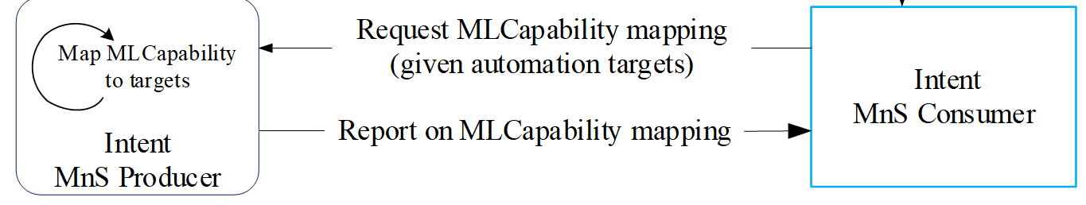
Figure 5.A.2.1-1: Mapping intent management requirmemts to AI/ML Capabilities
Given the knowledge of available AI/ML capabilities and their relation to automation requirements, the consumer may wish to request an intent to be fulfilled using specific AI/ML capabilities. The Intent driven management should enable allow the cosumer to make such a request and to fulfill the intent for the consumer as requested.

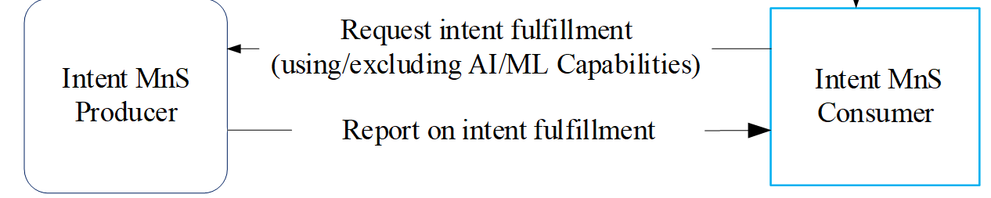
Figure 5.A.2.1-2Request intent fulfimment within information for using/excluding AI/ML capabilities

5.A.3 Potential requirements
REQ-MLCAPTEST-1 The 3GPP Management system should have a capability to enable an authorized consumer to request the Producer of Intent driven MnS to return capabilities of one or more AI/MLEntities to support specified intent management requirments.
REQ-MLCAPTEST-2 The 3GPP Management system should have a capability to enable an authorized consumer to request the Producer of Intent-driven Management MnS to fulfil an intent by usingor excuding specific AI/ML capabilities

5.A.4 Possible solutions

TBD

End of modifications

