GPP TSG-SA5 Meeting #144-e S5-224297rev2

e-meeting, 27 June - 1 July 2022

Source: Ericsson

Title: Intent driven management for network slicing

Document for: Discussion
Agenda Item: 6.7.4

1 Decision/action requested
The group is asked to endorse this discussion paper

References
[1] GSMA NG.116 Generic Network Slice Template Version 6.0 25 November 2021
[2] TS 28.312 Management and orchestration; Intent driven management services for mobile networks
[3] TS 28.541 Management and orchestration; 5G Network Resource Model (NRM); Stage 2 and stage 3
[4] TS 28.531 Management and orchestration; Provisioning
[5] TMF921A Intent Management API Profile v1.1.0
[6] TM Forum IG1253 Intent in Autonomous Networks v1.2.0
[7] TM Forum IG1253C Intent Lifecycle Management Interface v1.1.0
[8] TS 28.533 Management and orchestration; Architecture framework
[9] TS 28.532 Management and orchestration; Generic management services
[10] TS 28.552 Management and orchestration; 5G performance measurements

1 Introduction
This discussion paper describes and discusses topics for the study on intent driven management for network slicing.

2 Overview

2.1 GSMA
The original CSP requirements for network slicing were documented by GSMA in NG.116 [1]. The requirements are expressed as attributes that describe both the characteristics and the scalability/capacity of a network slice. The characteristics are further divided into performance related characteristics supported by a network slice (for example KPI’s on throughput and latency) and functionality provided by a network slice (for example positioning, capacity and QoS), both are applicable before a network slice is instantiated and control and management related attributes which are relevant after a network slice is instantiated
The Generic network Slice Template (GST) can be said to give a template that an NSP can use to get both service fulfilment and service assurance requirements for certain services from an NSC.

2.2 TM Forum
TM Forum have specified a framework for intent driven management which is documented in IG1253, see reference [6] allowing an intent (requirement) owner to convey the intent to an intent handler. The information captured in an intent provides the intent handler with sufficient information to realize the intent and provide intent reports to the owner of the intent. The intent owner can invoke an intent handler using a standard set of procedures, see reference [6].
TM Forum developed their solution based on the lifecycle stages of an intent. The lifecycle stages are show in Figure 2.2.1.
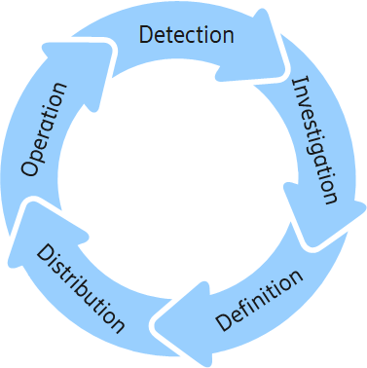
Figure 2.2.1: The lifecycle stages of an intent documented by TM Forum in IG1253 [6].
The functional areas that describe what is supported by an intent driven management interface are:
- Intent Setting
- Intent Reporting
- Intent Negotiation
- Intent Manager Registration and discovery
To support the functional areas a set of standard procedures are available to an intent owner to interact with an intent handler, this interaction is shown in Figure 2.2.1. Various procedures are supported on the intent interface, which is the interface between an intent owner and intent handler. The intent owner is represented by an MnS Consumer and the intent handler is represented by an MnS Producer.
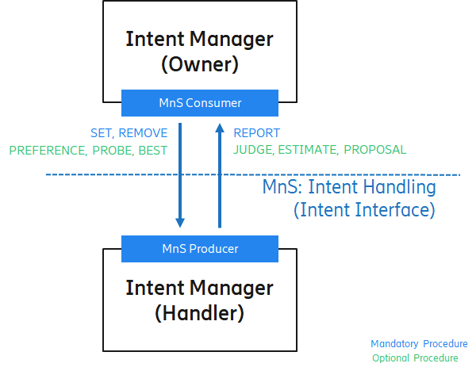
Figure 2.2.1: The procedures for intent driven management [6]
The supported procedures across the intent interface documented in IG1253C, see reference [7] are:
- Mandatory procedure for intent lifecycle management, SET/REMOVE/REPORT, see further details clause 3 reference [7],
- Optional procedure for collaborative evaluation, JUDGE/PREFERENCE, , see further details in clause 4 reference [7],
- Optional procedure for intent probing, PROBE/ESTIMATE, see further details in clause 4.2 reference [7],
- Optional procedure for intent best options, BEST/PROPOSAL see further details in clause 4.3 reference [7].
Through the interface the intent management functions manage the life cycle of intent objects. An intent owner role is implemented through an Intent Management Function (Intent Manager in Figure 2.2.1) and the intent handler role is implemented through another Intent Management Function. An Intent Management Function can play/implement the role of an Intent Owner and Intent Handler in the same implementation.
The Intent Management Function (IMF or Intent Manager) can be both intent Owner and intent Handler as the same time allowing to build hierarchies of IMFs, examples of these hierarchies are shown section 2.5.

2.3 3GPP SA5

2.3.1 Slice Management
The 3GPP network slice management use cases, requirements and solutions are specified in TS 28.531 [4] and TS 28.541 [3]. The solution specifies interaction between an MnS consumer and an MnS producer on how to allocate and manage a network slice or network slice subnet based on the input provided by the consumer in as a list of ServiceProfile and SliceProfile attributes. The network slice information model is documented in UML and can be found in TS 28.541 [3]. The network slice provisioning procedures are documented in TS 28.531 [4] are shown in the list below.
- Network Slice Instance Allocation
- Network Slice Subnet Instance Allocation
- Network Slice Instance Deallocation
- Network slice subnet instance deallocation
- Network Slice Instance Modification
- Network Slice Subnet Instance Modification
- Obtaining Network Slice Subnet Capability
- Resource reservation and checking feasibility of NSI
- Resource reservation and checking feasibility of network slice subnet.
- TN coordination supporting network slicing
These procedures in are supported by the network slicing operations; AllocateNsi, DeallocateNsi, AllocateNssi, DeallocateNssi specified in TS 28.531 [2] and by multiple operations from the generic provisioning MnS specified in TS 28.532 [9], for example getMOIAttributes is used for obtaining capability of MnS producer, createMOI and deleteMOI is used for feasibility check and resource reservation. For the procedure of TN co-ordination, the 3GPP Management system interacts with TN management through requirements derived from the ServiceProfile, see TS 28.541 Annex L.2 [3].

2.3.2 Intent Management
TS 28.312 [2] defines the procedures for an intent driven management function (IDMF):
- Create intent
- Modify intent
- Delete intent
- Query intent
These procedures define the life cycle management of intents in 3GPP. The procedures allow an MnS consumer to convey intent(Expectation) including requirements, goals and contexts (constraints and conditions) to an MnS producer. The information conveyed through intent(Expectation) is specific to 3GPP domain and contained by a subnetwork.
The procedures can be used to operate on a 3GPP defined intent information model, see TS 28.312 [2].

2.4 Observations

2.4.1 Procedures and operations
For the management of network slicing the network slice management interface and the intent management interface of TM Forum [5] support equivalent functionality. The mapping of the TM Fourm intent procedures to 3GPP network slicing is shown in Table 2.4.1.
Intent procedures TMF |  | Intetn procedures TS 28.312 |  | Network slicing procedure
MnS consumer | MnS producer | MnS consumer | MnS producer | MnS consumer | MnS producer
SET/REMOVE | REPORT | Create  Modify  Delete | Create/Modify/delete response on action  Notification on fulfilment status for Create/Modify | ALLOCATENSI/ DEALLOCATENSI REQUEST  ALLOCATENSSI/ DEALLOCATENSSI REQUEST  modifyMOIAttributes* REQUEST  *MOI can be an Nsi or Nssi | ALLOCATENSI/ DEALLOCATENSI RESPONSE  ALLOCATENSSI/ DEALLOCATENSSI RESPONSE  Each modifyMOIAttributes has a corresponding response, see TS 28.532 [9]
Retrieve | Return Itent object | Query | Response (intent object) | getMOIAttributes* REQUEST | getMOIAttributes has a corresponding response, see TS 28.532 [9]
JUDGE | PREFERENCE |  |  | No equivalent procedure | No equivalent procedure
BEST | PROPOSAL |  |  | No equivalent procedure | No equivalent procedure
PROBE | ESTIMATE |  |  | REQUEST “CREATION of FeasibilityCheckandResourceReservationJob IOC” | FeasibilityResult is FEASIBLE or InFEASIBLE  Each operation has a corresponding response, see TS 28.532 [9]

Table 2.4.1: Mapping of Intent manager procedures to Network slicing procedures

Note that resource reservation capability is not explicit in the TM Forum specification for intent.
From Table 2.4.1 the following observation can be made:
- Observation A1. The intent management procedures have more semantics than in network slicing procedures as it allows for negotiation between a consumer and producer.
- Observation A2. The intent management procedures allow consumer to set a reporting expectation as part of the intent, this capability is not specified for network slicing.
- Observation A3. The resource reservation capability provided by network slicing procedures is not explicit in the intent management procedures.
- Observation A4. For modification of an existing Intent the SET operation maps to the generic operation modifyMOIAttributes.

2.4.2 Topology and responsibilities
Figure 2.4.2.1 shows the mapping of the intent interfaces to the 3GPP management topology for network slicing. A generic informative model for 3GPP topology for network slicing can be found in TS 28.533 [8] Annex A.8.
The requirements or expectation for network slice are conveyed to the NSMF which owns the requirements or expectation for the cross domain NSSMF. The cross domain NSSMF conveys the requirements or expectation towards the domain NSSMFs. The different domains handle intent independently and co-ordination between the domains is responsibility of the cross domain NSSMF.
In the scenario where intent is received by the NSMF it will be transferred to the cross domain NSSMF.
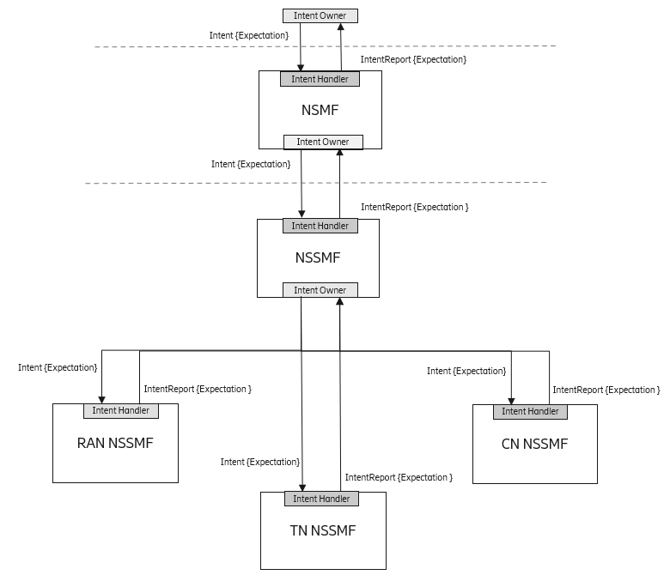
Figure 2.4.2.1 : Network slice management functions providing intent interfaces

An intent is conveyed as intent(Expectation) from and intent owner to an intent handler. An expectation captures delivery expectation, property expectation and reporting expectation. An intent report conveys amongst other the information on fulfilment and assurance of the expectation. Reporting expectation report provides information that the intent owner needs to have to decide if the intent has been fulfilled.
The mapping of Figure 2.4.2.1 to Intent Management Functions is shown in Figure 2.4.2.2.
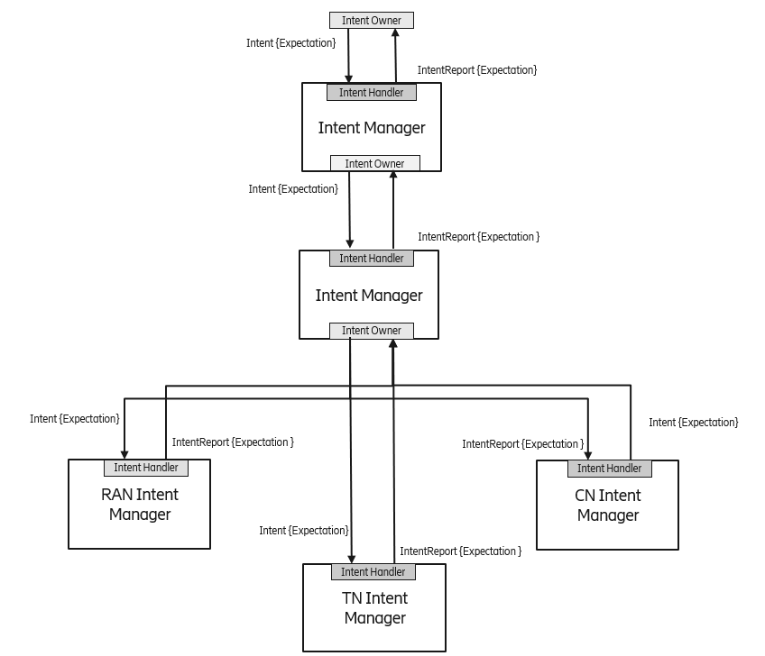
Figure 2.4.2.2 Network slice management functions mapped to Intent Managers

In the network slicing model a network slice has a 1:1 relation to a network slice subnet. A network slice is managed by an NSMF, and a network slice subnet is managed by a cross-domain NSSMF.
- Observation B1. In an Intent Management architecture both the NSMF and cross-domain NSSMF could be collapsed into a single Intent Management Function, see Figure 2.4.2.2. This can be done since the intent received by the first Intent Manager will transparently be sent to the second Intent Manager
- Observation B2. . The Intent Manager shown in Figure 2.4.2.2 may handle other intents that are not applicable to network slicing and the RAN, TN and CN Intent Managers may handle intents that are not applicable to the respective network slice subnets.
In a network slice management scenario the intent(Expectation) for a network slice would carry the requirements provided by a service profile, and intent(Expectation) for network slice subnet would carry the requirements provided by a slice profile.
NOTE: Exactly how the network slice related requirements and network slice subnet related requirements would be captured depends on the model used for intents and expectations, to what extent profile datatypes are re-used is FFS.
While service profile and slice profile have all information for an intent handler to process the request, i.e. the intent(Expectation), the expectation on the reporting is not sufficiently specified in the ServiceProfile and not specified in the SliceProfile.
Observation B3. There is no definition for a report that a network slice producer can provide based on the ServiceProfile or SliceProfile in the 3GPP Network Slice NRM.
In Figure 2.4.2.2 a cross-domain Intent Manager receives intent from an Intent Owner, the Intent Manager process the intent and creates new intent for each domain that can be understood by the domain Intent Managers, i.e. RAN Intent Manager, TN Intent Manager and CN Intent Manager. The cross-domain Intent Manager is responsible for the co-ordination of the Intent between the different domains. Based on the IntentReports received from the domain Intent Managers the Intent Manager may modify the existing expectation(s) or convey new expectations to the domain Intent Managers. The figure 2.4.2.2 shows that the first Intent Manager owns the transport related intents and interacts with the TN Intent Manager.
- Observation B4: This implies a split responsibility between the cross-domain Intent Manager and the domain Intent Managers for intents that relates to transport requirements within each domain.
The cross domain Intetn Manager conveys the requirements or expectation towards the domain Intetn Managers. In Figure 2.4.2.3 the RAN Intent Manager interacts with the TN Intetn Manager using intent driven MnS, the same applies for the CN Intetn Manager. In 2.4.2.3 the TN Intent Manager does not interact with the cross domain as it receives the transport expectation directly from the RAN management domain and CN management domain. The transport expectation (e.g. roundtrip delay) between the UPF in CN and RAN is measured in the CN, the TN Intent Manager can decide if the intent(Expectation) for TN has been met. The same applies for RAN measurements for transport inside the RAN, measurement for RAN and CN can be found in TS 28.552, see reference [10].
- Observation B5: RAN and CN Intent Managers can handle transport related expectations within their domain by interacting with the TN Intent Manager
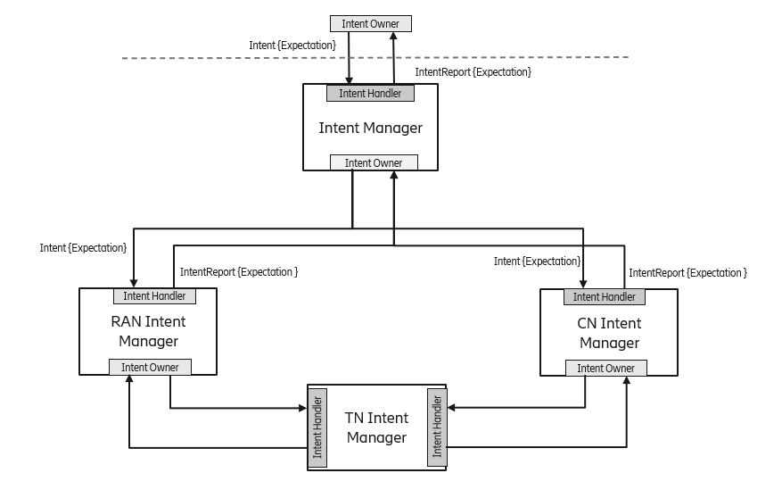
Figure 2.4.2.3: Cross-domain Intent Manager interact with RAN and CN domain Intent Managers

- Observation B6: In 3GPP an Intent Manager or Intent Management Function corresponds with an Intent Driven Management Function (IDMF).

2.5 Summary of observations

2.5.1 Procedures and operations
- Observation A1. The intent management procedures have more semantics than in network slicing procedures as it allows for negotiation between a consumer and producer.
- Observation A2. The intent management procedures allow consumer to set a reporting expectation as part of the intent, this capability is not specified for network slicing.
- Observation A3. The resource reservation capability provided by network slicing procedures is not explicit in the intent management procedures.
- Observation A4. For modification of an existing Intent the SET operation maps to the generic operation modifyMOIAttributes.

2.5.2 Topology and responsibility
- Observation B1. In an Intent Management architecture both the NSMF and cross-domain NSSMF could be collapsed into a single Intent Management Function, see Figure 2.4.2.2.
- Observation B2. . The Intent Manager shown in Figure 2.4.2.2 may handle other intents that are not applicable to network slicing and the RAN, TN and CN Intent Managers may handle intents that are not applicable to the respective network slice subnets.
- Observation B3. There is no definition for a report that a network slice producer can provide based on the ServiceProfile or SliceProfile in the 3GPP Network Slice NRM.
- Observation B4. This implies a split responsibility between the cross-domain Intent Manager and the domain Intent Managers for intents that relates to transport requirements within each domain.
- Observation B5. RAN and CN Intent Managers can handle transport related expectations within their domain by interacting with the TN Intent Manager
- Observation B6: In 3GPP an Intent Manager or Intent Management Function corresponds with an Intent Driven Management Function (IDMF).
NOTE: TN Intent Manager is out of scope of SA5 and whether any TN Intent Manager is specified by other SDOs is FFS

3 Discussion
Conclusion 1
From the procedures and operations observation A1 we can draw the conclusion that intent management encompasses network slice management capabilities (network slice management is a subset of intent management), except intent does not handle resource reservation at the moment.
Conclusion 2:
From the topology and responsibility observation B1 we can draw the conclusion that the NSMF and cross domain NSSMF are collapsed into a single cross domain Intent Manager.
Conclusion 3:
From the topology and responsibility observation 2 we can note that an Intent Manager may also handle intents that are not related to network slicing (for example energy efficiency related intents). It is proposed to keep that assumption in the study
Proposal 1
From the procedures and operations observation A1 we can draw the conclusion that there is a gap between network slicing capabilities and intent capabilities. It is proposed to study how this gap should be addressed
Proposal 2
From the procedures and operations observation A2 we can draw the conclusion that there is a gap for reporting expectation reports. It is proposed to study how this gap should be addressed
Proposal 3
From the procedures and operations observation A3 we can draw the conclusion that the resource reservation capability for network slicing is not explicitly defined for intent management. It is proposed to study how this gap should be addressed
Proposal 4
From the topology and responsibility observation B3 there is no definition for a report that a network slice producer can provide based on the ServiceProfile or SliceProfile in the 3GPP Network Slice NRM. It is proposed to study the definition of such a report.
Proposal 5
From the topology and responsibility observation B5 we conclude that the RAN and CN Intent Managers could interact with a TN Intent Manager to handle transport related expectations. It is proposed to study this division of responsibility.
Proposal 6
From the topology and responsibility observation B6 we conclude that in 3GPP an Intent Manager or Intent Management Function corresponds with an Intent Driven Management Function (IDMF).

4 Detailed proposal
The group is asked to endorse conclusions 1, 2 and 3 and to endorse proposals 1, 2, 3, 4, and 5.

