3GPP TSG-SA5 Meeting #144-e S5-224291

e-meeting, 27 June - 1 July 2022

Source: Ericsson, Deutsche Telekom

Title: Update solution description for CAPIF alternative 2 and 3

Document for: Approval
Agenda Item: 6.9.6.3

1 Decision/action requested
The group is asked to approve the proposal

2 References
[1] 3GPP TR 28.824: "Management and orchestration; Study on network slice management capability exposure"

3 Rationale
The study report, see reference [1] includes a gap analysis on the CAPIF alternatives 2 and 3. The following updates are needed:
- The gap analysis for CAPIF alternative 2 and 3 includes statements on extension of CAPIF 3/4 while the Editor’s Note states it is still FFS. It is proposed to place the Editor’s Note in the correct place in the table and remove the text on extension.
- The gap analysis for CAPIF alternative 2 and 3 includes statements on extension of CAPIF 1/1e while no details are provided as why the current CAPIF API cannot support the use cases. It is proposed to remove the text until it has been clarified there is an issue and gap in the CAPIF specification.
- The gap analysis for CAPIF alternative 2 and 3 for CAPIF 5 is left open. It is proposed to add “CAPIF 5 can be used without any modification”.

4 Detailed proposal
First change

7.9.2 Exposure via CAPIF alternative 2
This clause describes a potential solution where network slice management capability exposure is used in conjunction with a CAPIF core function (see TS 23.222 [14]) to expose management services to MnS consumers.
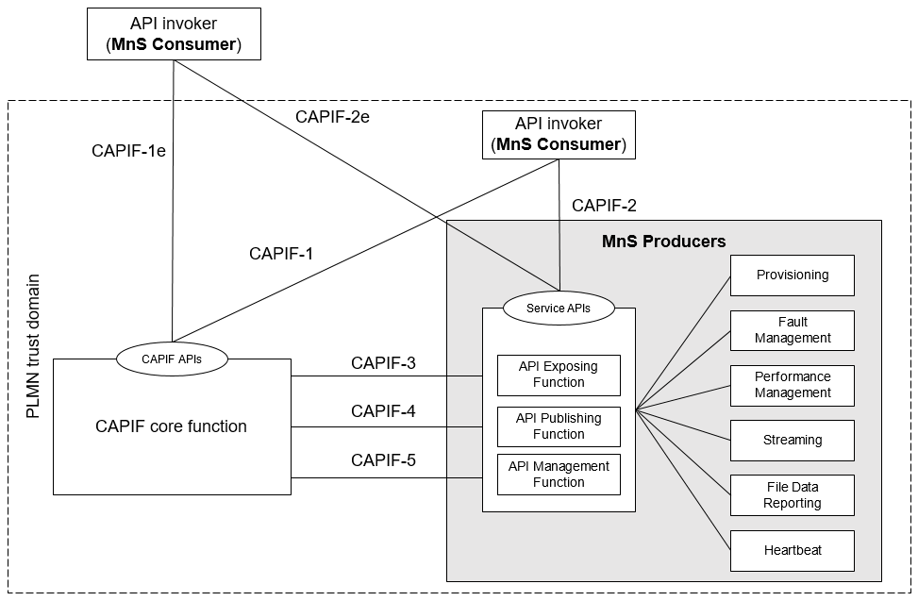
Figure 7.9.2-1: Exposure via CAPIF alternative 2
In this alternative, network slice management capability exposure consumes the interfaces at reference points CAPIF-3, CAPIF-4, and CAPIF-5 as defined in TS 23.222 [14]. It may be necessary to extend CAPIF-3/4/5 as defined in TS 23.222 [14] to support exposure of network slice management services.
Editor’s note: Whether it is necessary to extend CAPIF-3/4/5 for alternative 2 is FFS.
In this alternative, network slice management capability exposure provides the interfaces at reference point CAPIF-2/2e. It may be necessary to extend CAPIF-2/2e as defined in TS 23.222 [14] to support network slice management capability exposure and authentication of MnS consumers.
In this alternative, MnS Consumers utilize the interfaces at reference point CAPIF-1/1e. It may be necessary to extend CAPIF-1/1e as defined in TS 23.222 [14] to support network slice management capability exposure and authorization/authentication of MnS consumers.
Editor’s note: Whether network slice management capability exposure is affected by transforming the management service API to another service API is FFS.
Table7.9.2-1 shows the CAPIF interface and the potential MnS that can be implemented within the interface for alternative 2. In addition, extension of CAPIF interface may be needed to achieve certain functionalities in the context of network slice management capability expousre.
Table 7.9.2-1 Interface description
Interface | Related MnS | Gap analysis
CAPIF 1/1e | - Discovery of MnS(s) from MnS registry using ProvMnS  Specified in TS 28.622 [17], TS 28.623 [16], and TS 28.532 [15] | .  - Management of MnS consumers includes the management of MnS consumer type and identity. The management of MnS consumer type and identity is for differentiating different access permission for different MnS consumer.
CAPIF 2/2e | - Authentication and authorization of MnS consumers is specified in TS 28.533 [11] clause 4.9.  - Service APIs (MnS): faultMnS, fileDataReportingMnS, heartbeatNtf, perfMnS, provMnS, and streamingDataMnS  Specified in in TS 28.532 [15]
CAPIF 3 | - Nchf_ConvergedCharging  Specified in TS 28.201 [18] and TS 28.202 [6] | Editor’s Note: Access control for an MnS consumer, which is enforced by MnS producers is FFS.  Editor’s Note: Whether the extension of CAPIF-3 regarding routing information is needed for alternative 2 is FFS.
CAPIF 4 | - MnS Registry  Specified in TS 28.622 [17] and TS 28.623 [16]. | Editor’s Note: Whether the extension of CAPIF-4 regarding ServiceAPIDescription is needed for alternative 2 is FFS.  -
CAPIF 5 | - Auditing of the MnS producer is not specified

Second change

7.9.3 Exposure via CAPIF alternative 3
This clause describes a potential solution where network slice management capability exposure implements a Common API Framework for 3GPP Northbound APIs (see TS 23.222 [14]) to expose management services to MnS consumers.
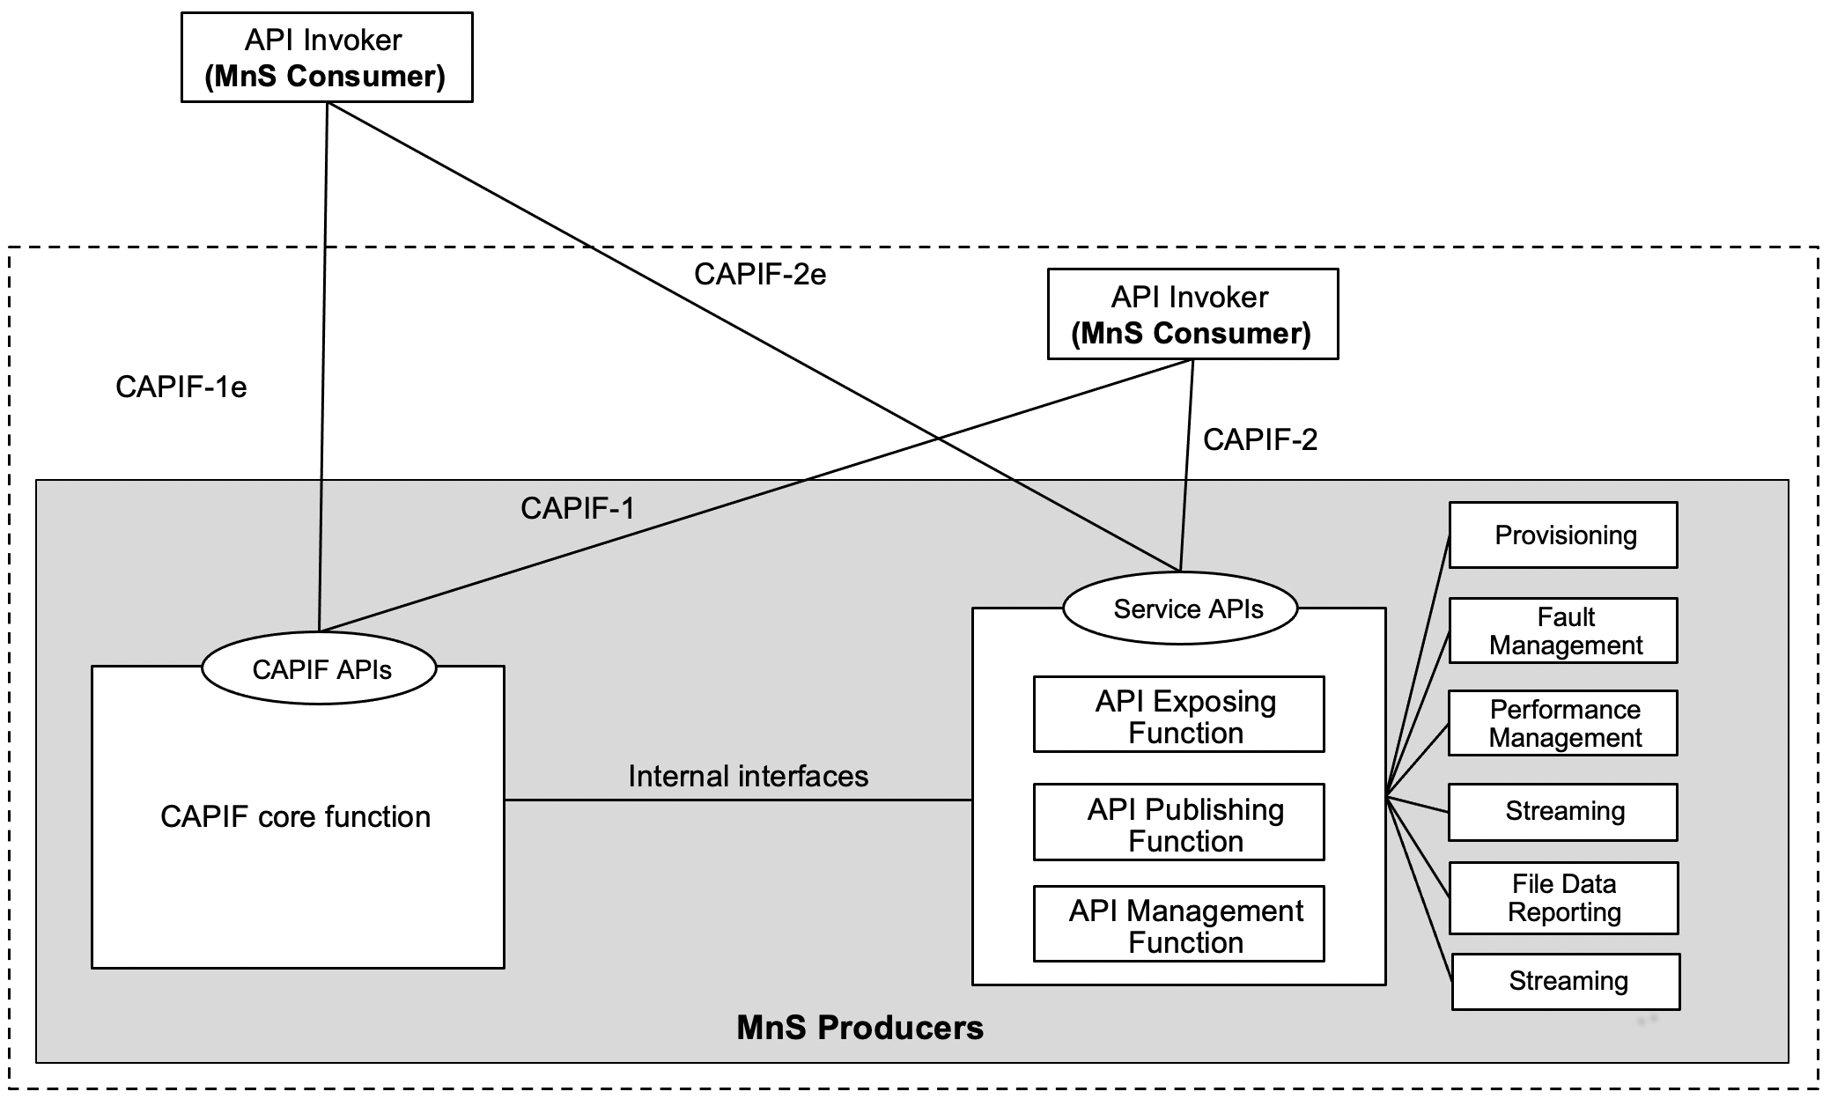
Figure 7.9.3-1: Exposure via CAPIF alternative 3
In this alternative, network slice management capability exposure may internally implement the internal interfaces using reference points CAPIF-3, CAPIF-4, and CAPIF-5 as defined in TS 23.222 [14] or may use non-standardized interfaces.
Editor’s Note: Whether it is necessary to extend CAPIF-3/4/5 for alternative 3 is FFS.
In this alternative, network slice management capability exposure provides the interfaces at reference point CAPIF-1/1e. It may be necessary to extend CAPIF-1/1e as defined in TS 23.222 [14] to support authorization/authentication of MnS consumers and discovery of MnS producers.
In this alternative, network slice management capability exposure provides the interfaces at reference point CAPIF-2/2e. It may be necessary to extend CAPIF-2/2e as defined in TS 23.222 [14] to support network slice management capability exposure and authentication of MnS consumers.
Editor’s Note: Whether network slice management capability exposure is affected by transforming the management service API to another service API is FFS.
Table7.9.3-1 shows the CAPIF interface and the potential MnS that can be implemented within the interface for alternative 2. In addition, extension of CAPIF interface may be needed to achieve certain functionalities in the context of network slice management capability exposure. Note that in CAPF alternative 3, 4, 5 in alternative 3 are internal interface. However, since external interface may bring impacts on the internal interface. The gap analysis for these interfaces is needed.
Table 7.9.3-1 Interface description
Interface | Related MnS | Gap analysis
CAPIF 1/1e | - Discovery of MnS(s) from MnS registry using ProvMnS  Specified in TS 28.622 [17], TS 28.623 [16], and TS 28.532 [15] | -  - Management of MnS consumers includes the management of MnS consumer type and identity. The management of MnS consumer type and identity is for differentiating different access permission for different MnS consumer.
CAPIF 2/2e | - Authentication and authorization of MnS consumers is specified in TS 28.533 [11] clause 4.9  - Service APIs (MnS): faultMnS, fileDataReportingMnS, heartbeatNtf, perfMnS, provMnS, and streamingDataMnS  Specified in in TS 28.532 [15]

