3GPP TSG-SA5 Meeting #144-e S5-224287

e-meeting, 27 June - 1 July 2022

Source: Ericsson, Deutsche Telekom

Title: Potential solution for management capability exposure alternative 1

Document for: Approval
Agenda Item: 6.9.6.3

1 Decision/action requested
The group is asked to approve the proposal

2 References
[1] 3GPP TR 28.824: "Management and orchestration; Study on network slice management capability exposure"
[2] S5-223744 Discussion paper on filtering, enrichment and converting of management information.docx

3 Rationale
The study report, see reference [1] identifies 3 scenarios for management capability exposure using the CAPIF framework. The 3 alternatives are documented in clause 7.9 as alternative 1, 2 and 3.
Potential solutions have been identified for alternative 2 and alternative 3, these are documented in clause 7.10. The potential solution for alternative 1 is missing. This contribution proposes to add potential solution for alternative 1. The solution is based on the procedure which was discussed at the #143e meeting and can be found in reference [2].

4 Detailed proposal
First change

7.x Potential solution for management capability exposure alternative 1
This solution supports exposure via CAPIF alternative 1 as defined in 7.9.1.
The procedure described in Figure 7.x.1 would allow for handling of the exposed APIs to be completely separated from the MnS(s) and be more adaptable to the NSC Application needs
The procedure described in 7.x.1 would also allow for invocation of other services than MnS(s) that may be required to fulfil the need of an NSC Application.
NOTE: Filtering, enrichment and converting represents an optional translation of MnS APIs into service APIs, for the case where 3rd party consumption requires them. The decision on whether this translation is needed, and how to apply it (translation internals) is out of scope of SA5

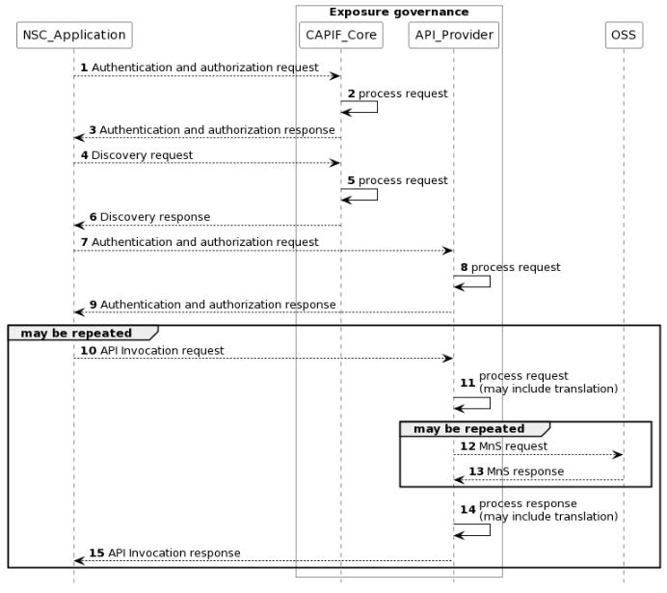
Figure 7.x.1 Procedure for consumption of exposed MnS after service order is completed
NOTE: For simplicity reasons the CAPIF Core Function and API Provider defined in TS 23.222 are combined into Exposure governance and any communication between them is also not included.
1) The CAPIF_Core receives an authenticating and authorization request from the NSC_Application based on the identity and other information required for authentication and authorization of the NSC_Application.
2) The CAPIF_Core processes the authentication and authorization request.
3) The CAPIF_Core provides the appropriate response to the NSC_Application.
4) The CAPIF_Core receives a request for the discovery of service APIs information.
5) The CAPIF_Core processes the discovery.request.
6) The CAPIF_Core provides the appropriate response to the NSC_Application.
7) The API_Provider receives an authorization request from the NSC_Application based on the identity and other information required for authorization of the NSC_Application.
8) The API_Provider processes the authorization request.
9) The API_Provider provides the appropriate response to the NSC_Application
10) The API_Provider receives a request for the invocation of the service API(s) from the NSC_Application.
11) The API_Provider processes (and optionally may filter, enrich and/or convert) the invocation request.
12) The OSS receives request from API_Provider for MnS.
13) The OSS provides the appropriate response to the API_Provider.
14) The API_Provider processes (and optionally may filter, enrich and/or convert) the response from the OSS
15) The API_Provider provides the appropriate response to the NSC_Application.
Once the NSC_Application has been authenticated and authorized the NSC_Application can start to send API_Invocation requests (step 10). Each request is processed by the API_Provider where the API_Provider may optionally translate into several MnS requests (step 11). Translation means filtering, enrichment and/or conversion of the request to MnS request(s) (step 12). As part of the processing of the request the API_Provider may also invoke other services e.g. charging.
When all MnS reponses have been received (step 13 and step 14) the API_Provider may optionally translate this into a single API_Invocation reponse (step 15).
Second change

A.X UML code for Figure 7.x.1
@startuml
skinparam sequence {
ArrowColor Black
ActorBorderColor Black
ActorBackgroundColor White
ParticipantBorderColor Black
ParticipantBackgroundColor White
LifeLineBorderColor Black
}
skinparam NoteBackgroundColor White
skinparam NoteBorderColor White
skinparam NoteColor White
skinparam shadowing false
hide footbox
autonumber
participant NSC_Application
box "Exposure governance" #white
participant CAPIF_Core
participant API_Provider
end box
participant OSS

NSC_Application --> CAPIF_Core : Authentication and authorization request
CAPIF_Core -> CAPIF_Core: process request
NSC_Application <-- CAPIF_Core : Authentication and authorization response

NSC_Application --> CAPIF_Core : Discovery request
CAPIF_Core -> CAPIF_Core: process request
NSC_Application <-- CAPIF_Core : Discovery response

NSC_Application --> API_Provider : Authentication and authorization request
API_Provider -> API_Provider: process request
NSC_Application <-- API_Provider : Authentication and authorization response

group may be repeated
NSC_Application --> API_Provider : API Invocation request
API_Provider -> API_Provider: process request\n(may include translation)
group may be repeated
API_Provider --> OSS: MnS request
API_Provider <-- OSS: MnS response
end
API_Provider -> API_Provider: process response\n(may include translation)
NSC_Application <-- API_Provider : API Invocation response
end
@enduml
.
End of changes

