3GPP TSG-SA5 Meeting #144e S5-22xxx

Electronic meeting, 27 June – 01 July 2022

Source: Huawei

Title: pCR TR 28.863 Issue #2 Remote controlling description

Document for: Approval
Agenda Item: 6.9.4.1

1 Decision/action requested
This contribution is proposed to be approved.

2 References
[1] 3GPP TS 28.863v0.2.0: "Study on Key Quality Indicators (KQIs) for 5G service experience"

3 Rationale
The document gives the detailed description of the scenarios of remote controlling.

4 Detailed proposal
It is proposed to apply the following changes as below in TR 28.863 [1].
Start of the first change

4.4 Issue # 4: KQIs for Remote Controlling

4.4.1 Description

The scenario of remote controlling in this TR means PLC (Programmable Logic Controller) controlling. The description of the scenario is in Figure 2. Through the operating of control equipment in the control center, the user can remotely control the PLC controller on the site by means of the network.
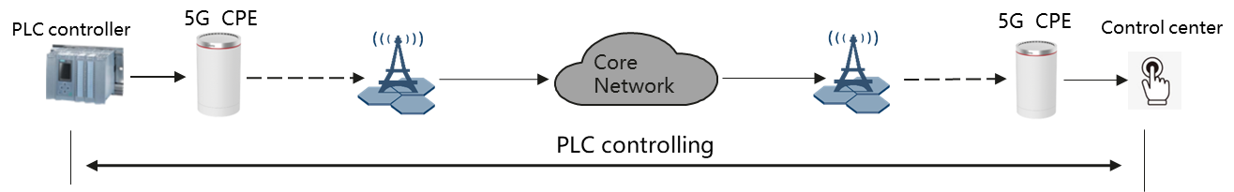
Figure2 Remote controlling scenario
In remote controlling scenario, especially for PLC controlling, real-time interactions are involved. URLLC slicing is used in 5G SA networking to meet ultra-low latency requirements. Real-time interactive services are mainly small-packet transmission services, which do not require network bandwidth but require ultra-low latency. For industrial-grade URLLC services, unqualified delay may cause service failures instead of performance problems. Therefore, it is important to analyze the delay and the delay fulfillment boundary. The network side needs to ensure that the delay is lower than the boundary instead of the absolute value of the delay. For example, if the SLA requirement is 10 ms, the evaluation focuses on ensuring that most service measurements are within the 10 ms boundary, or the proportion that exceed the delay boundary is as low as possible.
Furthermore, the packet loss is also an important factor to be considered in PLC controlling. If the packet loss rate is too high in PLC controlling, the control instruction fails. Therefore, the packet loss rate is also a key factor to measure the control quality and needs to be considered when defining the quality indicator for the service.
End of the first change

