3GPP TSG-SA5 Meeting #144-e S5-224133

e-meeting, 27 June - 1 July 2022

Source: China Unicom

Title: Discussion on URLLC performance measurements related to resource load of URLLC services

Document for: Approval and Endorsement
Agenda Item: 6.8.3

1 Decision/action requested
It proposes to discuss and endorse

2 References
[1] 3GPP TS 28.552 “Management and orchestration 5G performance measurements”
[2] 3GPP TS 38.824 “Study on physical layer enhancements for NR ultra-reliable and low latency case (URLLC)”
[3] 3GPP TS 38.213 “NR; Physical layer procedures for control”

3 Rationale
Observation#1: It exists URLLC and eMBB coexistence scenarios
Under the new definition of 5G application scenarios, there are coexistence scenarios of URLLC and eMBB services, and 3GPP protocol also contains related contents of eMBB and URLLC multiplexing mechanisms.
Taking the uplink service scenario as an example, TS 38.824 evaluates the performance of URLLC and eMBB services under enhanced UL inter UE Tx prioritization/multiplexing mechanisms, and proposes potential enhancements for UL inter UE Tx prioritization/multiplexing, which includes UE UL cancelation mechanisms and enhanced UL power control.
Corresponding to the UE UL cancelation mechanisms, there is a definition of Cancellation Indication (CI) in TS 38.213. The Cancellation Indication instructs other UE services to cancel their transmissions, which can realize resource preemption for different services in the uplink transmissions. Corresponding to enhanced UL power control, there is a related definition of power boosting (PB). By increasing the uplink transmission power of the UE, it can resist the interference caused by the transmission of other UEs.
At the same time, preemption indication (PI) is also defined for resource preemption of different services in the downlink transmission, and PI can be used to indicate to other UEs that their resources are preempted.
The contents of the above protocols confirm the existence of URLLC and eMBB coexistence scenarios.
Observation#2: The existing PRB usage rate related measurements for evaluating network resource load cannot effectively evaluate the resource load of URLLC services in eMBB and URLLC multiplexing scenarios.
At present, the network resource load is mainly evaluated through resource usage-related measurements. Refering to TS 28.552, the evaluation measurements are mainly PRB usage rate-related measurements, which measures usage (in percentage) of physical resource blocks (PRBs). Although these measurements can evaluate the overall resource load of the cell, they cannot effectively evaluate the resource load of the URLLC service under the eMBB and URLLC multiplexing scenarios.
For example, in a statistical time period, the PRB usage rate of the network is low. Because the URLLC service has high requirements for delay sensitivity, it needs to be transmitted immediately. At this time, on the small number of scheduled resources of the overall network resources, the URLLC service has data transmission requirements. But on these few scheduled resources, the resource requirements of URLLC services cannot be meet, so the EMBB service resources are preempted. In this case, since the PRB usage rate only reflects the overall resource load of the cell, it cannot reflect the situation that the resources of the URLLC service are insufficient at this time.
Assuming that there is a resource scheduled situation as shown in the figure below, in the coexistence scenario of eMBB and URLLC services, there are 10 sample occasions in a statistical period, and each sample occasions has 10 PRBs available. 10 PRBs are used at the 1st sample occasion, 10 PRBs are used at the 2nd sample occasion, 10 PRBs are used at the 3rd sample occasion, and 5 PRBs are used at the 4th sample occasion, no PRBs are used on the remaining sample occasions (ie, the 5th to 10th sample occasions).
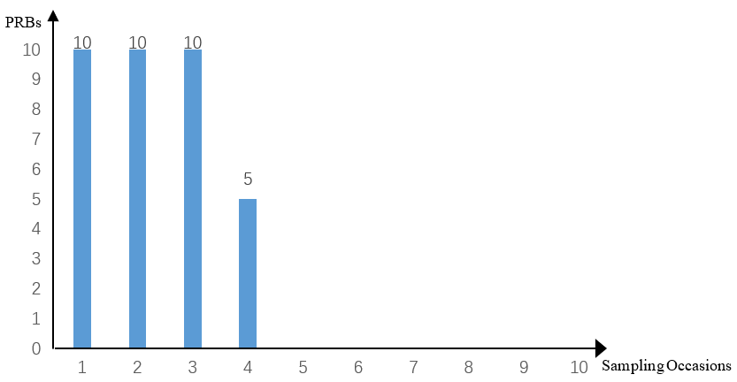
For the above resource scheduling situation, there are the following two scenarios:
Scenario 1: No resource preemption occurs for eMBB and URLLC services on sample occasions with data scheduled (ie, the first to fourth sample occasions). The total number of PRBs available for these 10 sample occasions is 100 (10 sample occasions*10 PRBs), and the number of PRBs used is 35 (10+10+10+5=35 PRBs), so PRB usage rate of the 10 Sample occasions is 35% (35/100=35%).
Scenario 2: On the first, second and third sample occasions, there are URLLC services that require instant transmission newly initiated, then preempted the resources of the eMBB service. But no resource preemption occurred on the 4th sample occasion. At this time, the PRB usage rate is still 35%, but on these 4 sample occasions with data scheduled, URLLC resource preemption occurs in 3 sample occasions, that is, the proportion of resource preemption is 75% (3sample occasions/ 4 sample occasions=75%).
In the above two scenarios, although the PRB usage rate is the same, the resource requirements of the URLLC services cannot be met on the scheduled resources in scenario 2, so preemption of the eMBB service resources occurs. At this time, the PRB usage rate cannot fully reflect the URLLC service resource load under eMBB and URLLC multiplexing scenarios which is like Scenario 2.
Therefore, the existing PRB usage rate related measurements for evaluating network resource load cannot effectively evaluate the resource load of URLLC services under eMBB and URLLC multiplexing scenarios.

4 Detailed proposal
Proposal# It is necessary to add measurements that can measure resource multiplexing and preemption under multi-service coexistence scenarios to reflect resource load and resource allocation rationality. Detailed proposal is elaborated in pCR S5-224135, S5-224136, S5-224137.

