3GPP TSG-SA5 Meeting #144-e S5-224105

e-meeting, 27 June - 1 July 2022

Source: Huawei

Title: Add use case for VNFC failover

Document for: Approval
Agenda Item: 6.8.5.1

1 Decision/action requested
For approval

2 References
[1] 3GPP TR 28.834 V0.1.0 Study on Management of Cloud Native Virtualized Network Functions

3 Rationale
This contribution adds a use case to describe how failure of a cloud-native VNFC may cause information to be passed over the 3GPP Management System interfaces.

4 Detailed proposal
This contribution proposes to make the following changes in [1].

1st change

2 References
The following documents contain provisions which, through reference in this text, constitute provisions of the present document.
- References are either specific (identified by date of publication, edition number, version number, etc.) or non-specific.
- For a specific reference, subsequent revisions do not apply.
- For a non-specific reference, the latest version applies. In the case of a reference to a 3GPP document (including a GSM document), a non-specific reference implicitly refers to the latest version of that document in the same Release as the present document.
[1] 3GPP TR 21.905: "Vocabulary for 3GPP Specifications".
[x] ETSI GR NFV-IFA 029: "Report on the Enhancements of the NFV architecture towards
Cloud-native and PaaS".

2nd change

5.X Use cases# X: Failure of VNFC within cloud-native VNF

5.X.1 Description
Figure 5.X-1 (copied from ETSI GR NFV-IFA 029[x] clause 5.2.2.1) shows a cloud-native VNF which is composed of multiple VNFCs. Load balancing is done over several VNFC instances. In the case of a failing VNFC instance, fail-over can happen to another VNFC instance.
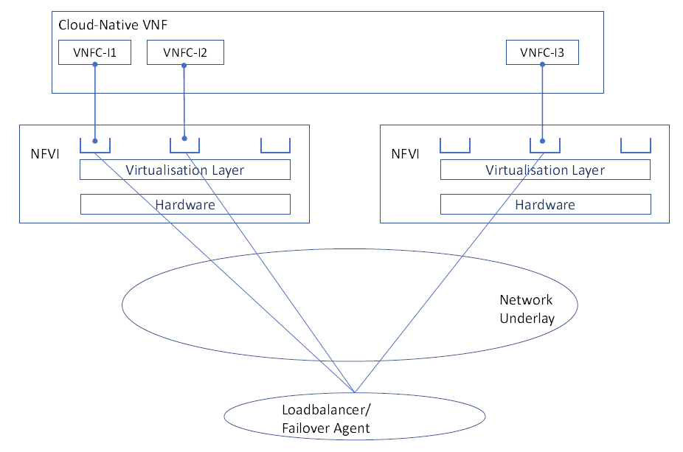
Figure 5.X-1: Cloud-native VNF load balancing and failover
As a pre-condition to this use case, the network is running normally. The 3GPP management system has initiated collection of measurements from the cloud-native VNF.
The use case begins when a VNFC instance (for example VNFC-1) fails.
VNFM detects the failed VNFC instance. If the VNFC instance is in standby mode (not in scope of this use case), VNFM triggers removal and replacement of the VNFC instance. If the VNFC instance is in active mode (in the scope of this use case), VNFM triggers the failover agent to trigger failover.
Failover agent selects a standby VNFC instance and makes it active. Failover agent changes the traffic forwarding pattern to include the newly active VNFC instance. Failover agent changes the traffic forwarding pattern to remove the failed VNFC instance. Failover agent triggers the load balancer to rebalance the load.
In case the failover is too slow or the failover is unsuccessful, the VNF may experience an overload situation. This overload situation will result in abnormal values in the performance measurements which are collected by the 3GPP management system. In some cases, this may result in notifications from the 3GPP management system if pre-defined thresholds are crossed. Depending on the impact to the VNF functionality, the 3GPP management system may issue alarms to indicate that functionality is lost or impaired.
The end result is that the 3GPP management system may issue alarms or performance data indicating a VNF overload situation if the failover is too slow or if the failover is unsuccessful.

5.X.2 Requirements
None.

End of changes

