3GPP TSG-SA5 Meeting #144-e S5-224085rev2

e-meeting, 27 June - 1 July 2022

Source: Alibaba group

Title: pCR 28.824 Update of solution 7.9

Document for: Approval
Agenda Item: 6.9.6.3

1 Decision/action requested
For approval

2 References
[1] 3GPP TR 28.824 V0.5.0 Study on network slice management capability exposure

3 Rationale
This contribution is to resolve the Editor’s note in solution 7.9 and to update the alternative 2&3 with some extensions on CAPIF interfaces.
Solution 7.9 was captured in TR 28.824 with the following Editor’s Note:
Editor’s note: Whether it is necessary to extend CAPIF-3/4/5 for alternative 2 is FFS.
Editor’s note: Whether the extension of CAPIF-3 regarding routing information is needed for alternative 2 is FFS.
Editor’s note: Whether the extension of CAPIF-4 regarding ServiceAPIDescription is needed for alternative 2 is FFS.
In SA5#143e, gap analysis has been conducted in order to justify the need for the extension of CAPIF-3/4/5. Solution 7.4 suggests that in order to ensure the security when exposing MnS to the NSC, a dedicated MnS producer can control the exposure governace as a proxy for exposing MnS.
The routing information in CAPIF architecture is to maintain the connection information of API exposing functions in the PLMN trust domain. Similar to this, in order to act as the proxy for exposing MnS, this dedicated MnS producer needs to maintain the respective MnS producer information which contains the address of MnS producers that produce the proper MnS (e.g. faultMnS, PerfMnS, etc) in order to obtain the MnS for the NSC based on request. Therefore, the respective MnS producer information needs to be extended if using CAPIF-3 interface in the context of network slice management capability exposure.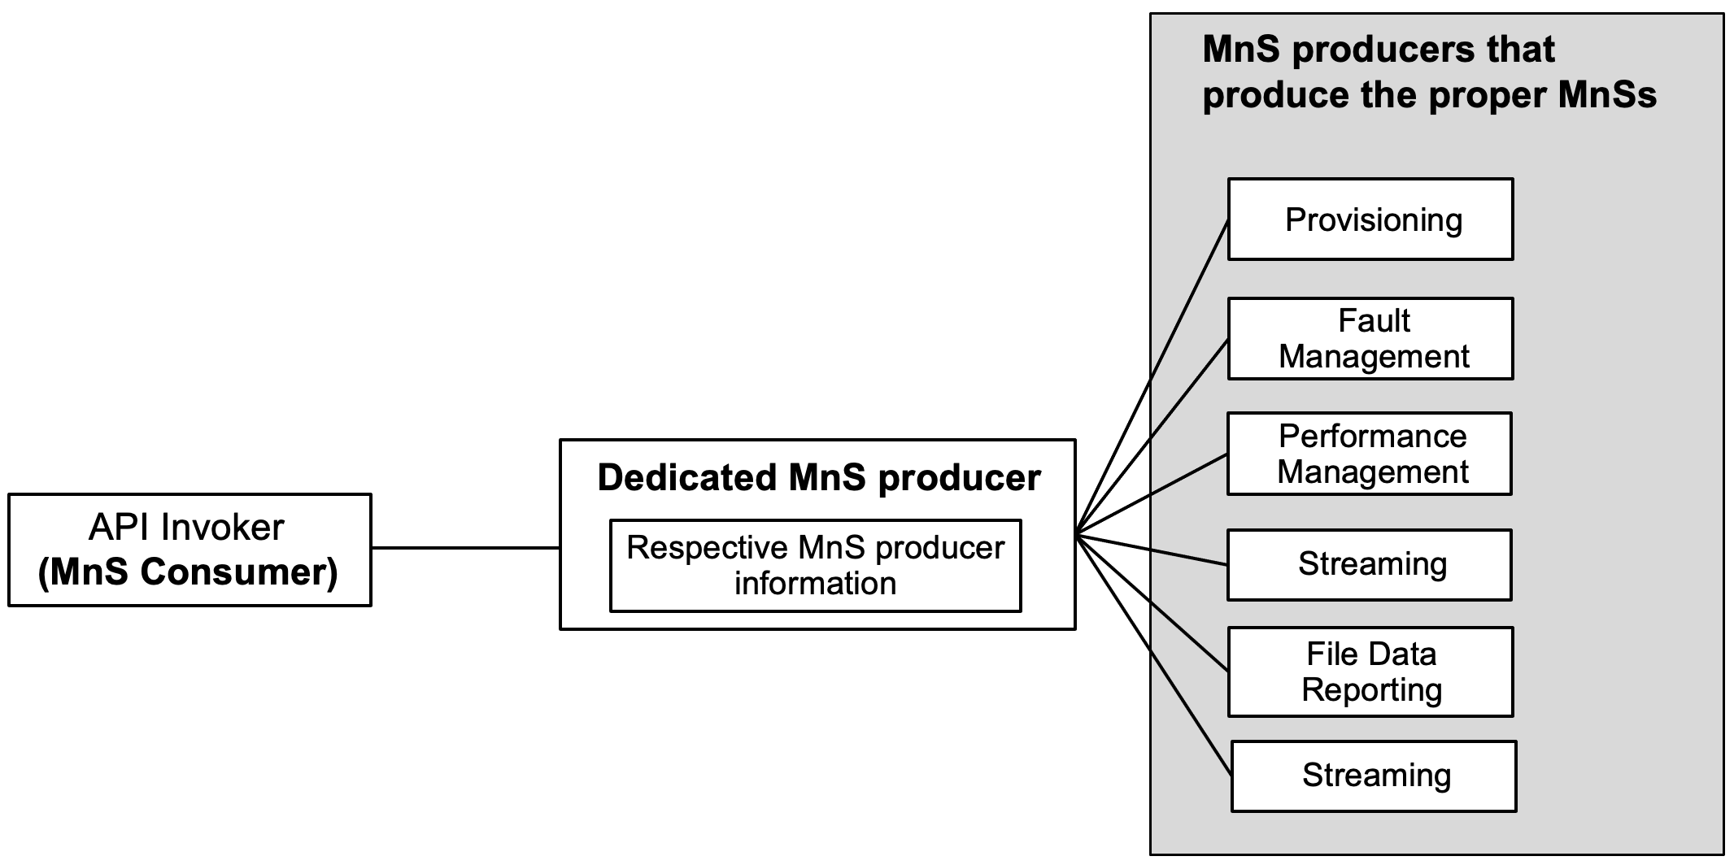

Figure 1: Exposure via CAPIF alterMnS exposure via dedicated MnS producer as a proxy

After the completion of authentication and authorization with the NSC, the CAPIF core function needs to help the NSC to discover the address of the dedicated MnS producer that controls the exposure governance so that the NSC can request for MnS consumption via the dedidated MnS producer. In order to provide the discovery service to the NSC, the MnS data that contains the address of the dedicated MnS producer needs to be pulished to the CAPIF core function. This request for the extension of CAPIF-4 interface to make sure that the ServiceAPIDescription for CAPIF_Publish_Service_API can carry the MnS data in order to support the discovery service for NSC.

Proposal: Remove the above Editor’s Notes regarding CAPIF-3/4.
Editor’s note: Whether it is necessary to extend CAPIF-3/4/5 for alternative 3 is FFS.
Editor’s note: Whether the extension of CAPIF-3 regarding routing information is needed for alternative 3 is FFS.
Editor’s note: Whether the extension of CAPIF-4 regarding ServiceAPIDescription is needed for alternative 3 is FFS.
In alternative 3, the internal interface may still use CAPIF-3, CAPIF-4 and CAPIF-5 interface. In this case, the internal interface needs to be extended in order to support the exposure capabilities. Similar with the alternative 2, CAPIF-3 interface needs to be extended with respective MnS producer information in order to allow the dedicated MnS producer to identify the proper MnS producer. Also, the Service APIDescription need to be extended for achieving discovery service for external customer.
Proposal: Remove the above Editor’s Notes regarding CAPIF-3/4.
Editor’s note: Whether network slice management capability exposure is affected by transforming the management service API to another service API is FFS.
From the discussion in SA5#142e, the group tends to agree that the translation function is not in the scope of SA5. However, how to reflect the translation function in the context of CAPIF is not solved yet. The translation function can be located within the API provider domain from where it can interact with the internal MnS producer. Since both the MnS and potential translated MnS need to be exposed via the CAPIF-2e and CAPIF-1e interfaces, The translated MnS can reuse the CAPIF interface (e.g. CAPIF-2e and CAPIF-1e) and related extension for exposure without any further enhancement.
Proposal: Add a NOTE to mention that the translation function can be located within the API provider domain from where it can interact with the internal MnS producer. The translated MnS can reuse the CAPIF interface (e.g. CAPIF-2e and CAPIF-1e) and related extension. How to translate MnS is not in the scope of SA5.
Editor’s note: Access control for an MnS consumer, which is enforced by MnS producers is FFS.
Access control capability is specified in TS 28.533 [11] clause . Therefore, it is suggested to remove the EN and add description about the defined access control capability.

4 Detailed proposal
This contribution proposes to make the following changes in [1].

1st change

7.9 Potential solutions for network slice management capability exposure via CAPIF

7.9.1 Exposure via CAPIF alternative 1
This clause describes a potential solution where network slice management capability is exposed via the Common API Framework for 3GPP Northbound APIs, see TS 23.222 [14].
4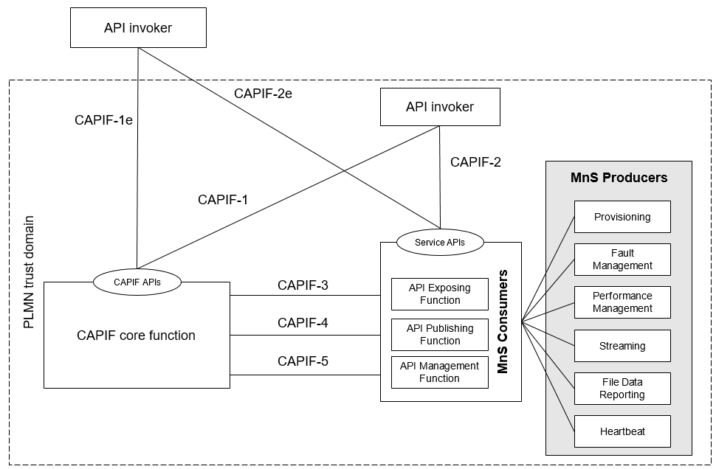
Figure 7.9.1-1: Exposure via CAPIF alternative 1
In this alternative, network slice management capability exposure provides faultMnS, fileDataReportingMnS, heartbeatNtf, perfMnS, provMnS, and streamingDataMnS as specified in in TS 28.532 [15].
NOTE: The translation function can be located within the API provider domain from where it can interact with the internal MnS producer. The translated MnS can reuse the CAPIF interface (e.g. CAPIF-2e and CAPIF-1e) for exposure. How to translate MnS is not in the scope of SA5.

7.9.2 Exposure via CAPIF alternative 2
This clause describes a potential solution where network slice management capability exposure is used in conjunction with a CAPIF core function (see TS 23.222 [14]) to expose management services to MnS consumers.
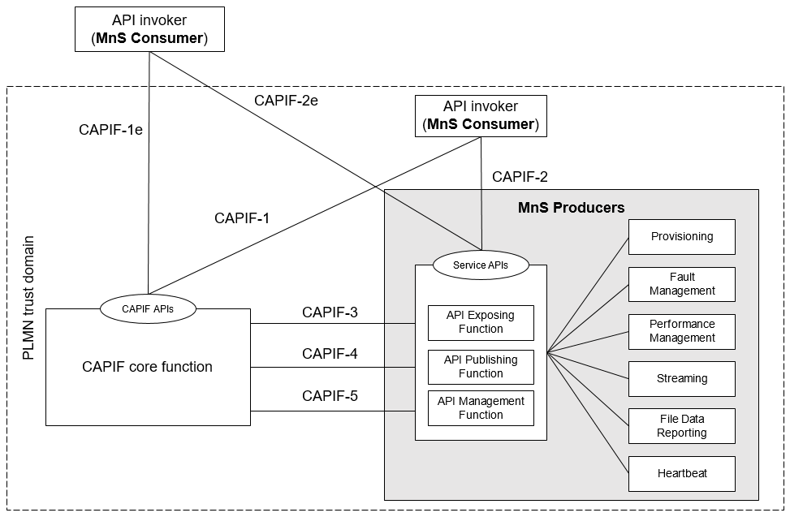
Figure 7.9.2-1: Exposure via CAPIF alternative 2
In this alternative, network slice management capability exposure consumes the interfaces at reference points CAPIF-3, CAPIF-4, and CAPIF-5 as defined in TS 23.222 [14]. It may be necessary to extend CAPIF-3/4/5 as defined in TS 23.222 [14] to support exposure of network slice management services.
Editor’s note: Whether it is necessary to extend CAPIF-5 for alternative 2 is FFS.
In this alternative, network slice management capability exposure provides the interfaces at reference point CAPIF-2/2e. It may be necessary to extend CAPIF-2/2e as defined in TS 23.222 [14] to support network slice management capability exposure and authentication of MnS consumers.
In this alternative, MnS Consumers utilize the interfaces at reference point CAPIF-1/1e. It may be necessary to extend CAPIF-1/1e as defined in TS 23.222 [14] to support network slice management capability exposure and authorization/authentication of MnS consumers.
NOTE: The translation function can be located within the API provider domain from where it can interact with the internal MnS producer. The translated MnS can reuse th e CAPIF interface (e.g. CAPIF-2e and CAPIF-1e) and related extension for exposure. How to translate MnS is not in the scope of SA5.
Table7.9.2-1 shows the CAPIF interface and the potential MnS that can be implemented within the interface for alternative 2. In addition, extension of CAPIF interface may be needed to achieve certain functionalities in the context of network slice management capability expousre.
Table 7.9.2-1 Interface description
Interface | Related MnS | Gap analysis
CAPIF 1/1e | - Discovery of MnS(s) from MnS registry using ProvMnS  Specified in TS 28.622 [17], TS 28.623 [16], and TS 28.532 [15] | - The ServiceAPIDescription for CAPIF_Discover_Service_API needs to be extended in the context of network slice management capability exposure. The MnS address within the MnS data can indicate a dedicated producer for exposing exposed MnS after authentication and authorization.  - Management of MnS consumers includes the management of MnS consumer type and identity. The management of MnS consumer type and identity is for differentiating different access permission for different MnS consumer.
CAPIF 2/2e | - Authentication and authorization of MnS consumers is specified in TS 28.533 [11] clause 4.9.  - Service APIs (MnS): faultMnS, fileDataReportingMnS, heartbeatNtf, perfMnS, provMnS, and streamingDataMnS  Specified in in TS 28.532 [15]
CAPIF 3 | - Nchf_ConvergedCharging  Specified in TS 28.201 [18] and TS 28.202 [6]  - Access control capability specified in TS 28.533 [11] | - Respective MnS producer information in CAPIF needs to be extended in the context of network slice management capability exposure. A dedicated producer obtains information of respective MnS producer, the respective MnS producer information contains the address of MnS producers that produce the proper MnS (e.g. faultMnS, PerfMnS, etc).
CAPIF 4 | - MnS Registry  Specified in TS 28.622 [17] and TS 28.623 [16]. | - The ServiceAPIDescription for CAPIF_Publish_Service_API needs to be extended in the context of network slice management capability exposure. The MnS address within the MnS data can indicate a dedicated producer for exposing exposed MnS after authentication and authorization.
CAPIF 5 | - Auditing of the MnS producer is not specified

To ensure the security when exposing MnS to the NSC, a dedicated MnS producer can control the exposure governace as a proxy for exposing MnS. Acting as the proxy for exposing MnS, this dedicated MnS producer needs to maintain the respective MnS producer information which contains the address of MnS producers that produce the proper MnS (e.g. faultMnS, PerfMnS, etc) in order to obtain the MnS for the NSC based on request. The respective MnS producer information may be requested by the CAPIF core function for providing discovery service for the MnS consumer within the PLMN trust domain.
The respective MnS producer information can be described as below:
Table 7.9.2-2 Respective MnS producer information
Attributes | Support | Cardinality | Description
Respective MnS producer information | O | 1…N | The respective MnS producer information contains the address of MnS producers that produce the proper MnS (e.g. faultMnS, PerfMnS, etc).

After the completion of authentication and authorization with the NSC, the CAPIF core function needs to help the NSC to discover the address of the dedicated MnS producer that controls the exposure governance so that the NSC can request for MnS consumption via the dedidated MnS producer. In order to provide the discovery service to the NSC, the MnS data that contains the address of the dedicated MnS producer needs to be pulished to the CAPIF core function. This request for the extension of CAPIF-4 interface to make sure that the ServiceAPIDescription for CAPIF_Publish_Service_API can carry the MnS data in order to support the discovery service for NSC.
The mnsAddress of MnsInfo within CAPIF-1e and 4 can be extended as below:
Table 7.9.2-3 mnsaddress information within MnsInfo
Attributes | Support | Cardinality | Description
mnsAddress | M | 1 | The MnS address for external MnS consumer indicates a dedicated producer for exposing exposed MnS after authentication and authorization. The dedicated producer obtains the MnS from corresponding MnS producer based on the respective MnS producer information and exposes the MnS to the MnS consumer.

The MnS consumer management information is needed for differentiating the MnS consumer in term of consumer type and different access permission. The MnS consumer type is for differentiate the MnS consumer inside and outside the PLMN trust domain.
API invoker ID is defined in CAPIF architecture. However, the format of API invoker ID is not studied yet. Since API invoker ID can be mapped into the MnS consumer ID in the context of exposure, the format of MnS consumer ID has to be studied.
The MnS consumer management information within CAPIF-1e can be extended as below:
Table 7.9.2-4 MnS consumer management information
Attributes | Support | Cardinality | Description
MnSConsumerType | O | 1…N | It indicates the type of MnS consumer that requests for the exposure of the MnSs provided by MnS producer. The type of MnS consumer is external if the MnS consumer is outside the PLMN trust domain. The type of MnS consumer is internal if the MnS consumer is inside the PLMN trust domain.  allowedValue: EXTERNAL,  INTERNAL
MnSConsumerID | O | 1…N | It indicates the Identifier of the MnS consumer that requests MnSs from the MnS producer.  The identifier of the MnS consumer can be associated to its access token. The access token can represents a set of MnSs that are allowed to be exposed to MnS consumer.  The format of the MnS consumer ID can use FQDN (See TS 21.003 clause 19.4.2.1).

7.9.3 Exposure via CAPIF alternative 3
This clause describes a potential solution where network slice management capability exposure implements a Common API Framework for 3GPP Northbound APIs (see TS 23.222 [14]) to expose management services to MnS consumers.
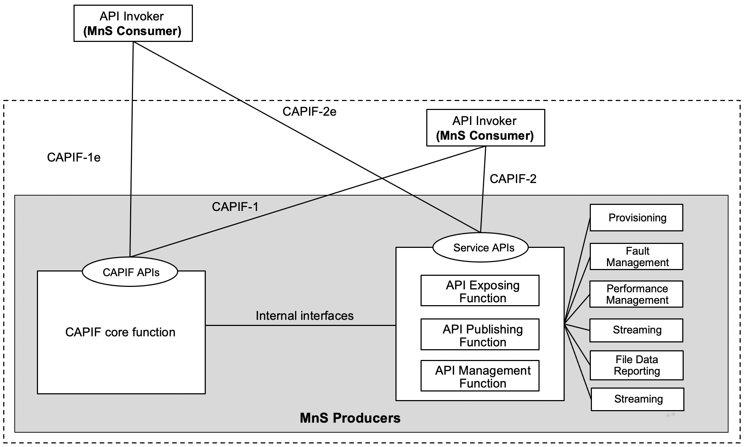
Figure 7.9.3-1: Exposure via CAPIF alternative 3
In this alternative, network slice management capability exposure may internally implement the internal interfaces using reference points CAPIF-3, CAPIF-4, and CAPIF-5 as defined in TS 23.222 [14] or may use non-standardized interfaces.

Editor’s note: Whether it is necessary to extend CAPIF-5 for alternative 3 is FFS.
In this alternative, network slice management capability exposure provides the interfaces at reference point CAPIF-1/1e. It may be necessary to extend CAPIF-1/1e as defined in TS 23.222 [14] to support authorization/authentication of MnS consumers and discovery of MnS producers.
In this alternative, network slice management capability exposure provides the interfaces at reference point CAPIF-2/2e. It may be necessary to extend CAPIF-2/2e as defined in TS 23.222 [14] to support network slice management capability exposure and authentication of MnS consumers.
NOTE: The translation function can be located within the API provider domain from where it can interact with the internal MnS producer. The translated MnS can reuse the CAPIF interface (e.g. CAPIF-2e and CAPIF-1e) and related extension. How to translate MnS is not in the scope of SA5.
Table7.9.3-1 shows the CAPIF interface and the potential MnS that can be implemented within the interface for alternative 2. In addition, extension of CAPIF interface may be needed to achieve certain functionalities in the context of network slice management capability exposure. Note that in CAPF alternative 3, 4, 5 in alternative 3 are internal interface. However, since external interface may bring impacts on the internal interface. The gap analysis for these interfaces is needed.
Table 7.9.3-1 Interface description
Interface | Related MnS | Gap analysis
CAPIF 1/1e | - Discovery of MnS(s) from MnS registry using ProvMnS  Specified in TS 28.622 [17], TS 28.623 [16], and TS 28.532 [15] | - The ServiceAPIDescription for CAPIF_Discover_Service_API needs to be extended in the context of network slice management capability exposure. The MnS address within the MnS data can indicate a dedicated producer for exposing exposed MnS after authentication and authorization.  - Management of MnS consumers includes the the management of MnS consumer type and identity. The management of MnS consumer type and identity is for differentiating different access permission for different MnS consumer.
CAPIF 2/2e | - Authentication and authorization of MnS consumers is specified in TS 28.533 [11] clause 4.9  - Service APIs (MnS): faultMnS, fileDataReportingMnS, heartbeatNtf, perfMnS, provMnS, and streamingDataMnS  Specified in in TS 28.532 [15]
CAPIF 3 | - Nchf_ConvergedCharging  Specified in TS 28.201 [18] and TS 28.202 [6]  - Access control capability specified in TS 28.533 [11] | - Respective MnS producer information in CAPIF needs to be extended in the context of network slice management capability exposure. A dedicated producer obtains information of respective MnS producer, the respective MnS producer information contains the address of MnS producers that produce the proper MnS (e.g. faultMnS, PerfMnS, etc).
CAPIF 4 | - MnS Registry  Specified in TS 28.622 [17] and TS 28.623 [16] | - The ServiceAPIDescription for CAPIF_Publish_Service_API in CAPIF-4 needs to be extended in the context of network slice management capability exposure. The MnS address within the MnS data can indicate a dedicated producer for exposing exposed MnS after authentication and authorization.
CAPIF 5 | - Auditing of the MnS producer is not specified

To ensure the security when exposing MnS to the NSC, a dedicated MnS producer can control the exposure governace as a proxy for exposing MnS. Acting as the proxy for exposing MnS, this dedicated MnS producer needs to maintain the respective MnS producer information which contains the address of MnS producers that produce the proper MnS (e.g. faultMnS, PerfMnS, etc) in order to obtain the MnS for the NSC based on request. The respective MnS producer information can be collected by the CAPIF core function using internal interface. The dedicated MnS producer request for respective MnS producer information from CAPIF core function if the related information is not available.
An alternative way is that the respective MnS producer information can be acquired and maintained by the dedicated MnS pr, which is similar with alternative 2. The respective MnS producer information may be requested by the CAPIF core function for providing discovery service for the MnS consumer within the PLMN trust domain.
The respective MnS producer information can be described as below:
Table 7.9.2-2 Respective MnS producer information
Attributes | Support | Cardinality | Description
Respective MnS producer information | O | 1…N | The respective MnS producer information contains the address of MnS producers that produce the proper MnS (e.g. faultMnS, PerfMnS, etc).

After the completion of authentication and authorization with the NSC, the CAPIF core function needs to help the NSC to discover the address of the dedicated MnS producer that controls the exposure governance so that the NSC can request for MnS consumption via the dedidated MnS producer. In order to provide the discovery service to the NSC, the MnS data that contains the address of the dedicated MnS producer needs to be pulished to the CAPIF core function. This request for the extension of CAPIF-4 interface to make sure that the ServiceAPIDescription for CAPIF_Publish_Service_API can carry the MnS data in order to support the discovery service for NSC.

The mnsAddress of MnsInfo within CAPIF-1e and 4 can be extended as below:
Table 7.9.2-3 mnsaddress information within MnsInfo
Attributes | Support | Cardinality | Description
mnsAddress | M | 1 | The MnS address for external MnS consumer indicates a dedicated producer for exposing exposed MnS after authentication and authorization. The dedicated producer obtains the MnS from corresponding MnS producer based on the respective MnS producer information and exposes the MnS to the MnS consumer.

The MnS consumer management information is needed for differentiating the MnS consumer in term of consumer type and different access permission. The MnS consumer type is for differentiate the MnS consumer inside and outside the PLMN trust domain.
API invoker ID is defined in CAPIF architecture. However, the format of API invoker ID is not studied yet. Since API invoker ID can be mapped into the MnS consumer ID in the context of exposure, the format of MnS consumer ID has to be studied.
The MnS consumer management information within CAPIF-1e can be extended as below:
Table 7.9.2-4 MnS consumer management information
Attributes | Support | Cardinality | Description
MnSConsumerType | O | 1…N | It indicates the type of MnS consumer that requests for the exposure of the MnSs provided by MnS producer. The type of MnS consumer is external if the MnS consumer is outside the PLMN trust domain. The type of MnS consumer is internal if the MnS consumer is inside the PLMN trust domain.  allowedValue: EXTERNAL,  INTERNAL
MnSConsumerID | O | 1…N | It indicates the Identifier of the MnS consumer that requests MnSs from the MnS producer.  The identifier of the MnS consumer can be associated to its access token. The access token can represents a set of MnSs that are allowed to be exposed to MnS consumer.  The format of the MnS consumer ID can use FQDN (See TS 21.003 clause 19.4.2.1).

End of changes

