3GPP TSG-SA5 Meeting #144-e S5-224082rev1

e-meeting, 27 June - 1 July 2022

Source: Huawei

Title: Possible solutions for CAPIF functional entities implementation on management domain

Document for: Approval
Agenda Item: 6.9.6.3

1 Decision/action requested
For approval

2 References
[1] 3GPP TR 28.824 V0.7.0 Study on network slice management capability exposure
[2] 3GPP TS 28.533 Management and orchestration; Architecture framework

3 Rationale
In TR 28.824 [1] clause 7.9, three exposure scenarios which are compliant with CAPIF are introduced. The problem is that the CAPIF function entities (e.g. CAPIF Core Function, API provider domain functions) are placeholders representing a set of functionalities related to common northbound API exposure framework. Therefore, this contribution will further fill the gap between the common CAPIF function entities with specific MnS producer to fulfil CAPIF function entities implementation on management domain.
For CAPIF alternative 1, no CAPIF function entity is placed in the scope of MnS Producer, which means that there is no need to apply a specific MnS producer to implement CAPIF function entity in SA5. But the exposure governance for management capability is needed since the exposure governance on management domain helps to prevent illegal or improper access to management capability for any OAM-external consumer as described in TS 28.533 [2] clause 4.4. Therefore, this contribution proposes that EGMF will implement the exposure governance as the exposure gateway to management domain.
For CAPIF alternative 2, API provider domain functions are within the scope of MnS producers, yet it doesn’t specify which MnS producer will implement the functions defined in API provider domain. Therefore, this contribution proposes that EGMF will play the role as the service API provider function and fulfil all functionalities defined for API provider domain functions.
For CAPIF alternative 3, CAPIF core function and API provider domain functions are within the scope of MnS producers, yet it doesn’t specify which MnS producer will implement the functions defined in CAPIF core function and API provider domain functions. Therefore, this contribution proposes that EGMF will play the role as the combination of CAPIF core function and service API provider function to fulfil all functionalities defined for CAPIF core function and API provider domain functions.
In this proposal, concrete examples are given to show the what the exposure governance does to management services (i.e. simplification, filtering and abstraction) as specified in TS 28.533 [2] clause A.2.

4 Detailed proposal
This contribution proposes to make the following changes in [1].

1st change

2 References
The following documents contain provisions which, through reference in this text, constitute provisions of the present document.
- References are either specific (identified by date of publication, edition number, version number, etc.) or non-specific.
- For a specific reference, subsequent revisions do not apply.
- For a non-specific reference, the latest version applies. In the case of a reference to a 3GPP document (including a GSM document), a non-specific reference implicitly refers to the latest version of that document in the same Release as the present document.
[1] 3GPP TR 21.905: "Vocabulary for 3GPP Specifications".
[2] TM Forum TMF622 Product Order API REST Specification
[3] TM Forum TMF641 Service Ordering API
[4] TM Forum TMF652 Resource Order Management API
[5] 3GPP TS 28.531: "Management and orchestration; Concepts, use cases and requirements"
[6] 3GPP TS 28.202: "Charging management; Network slice management charging in the 5G System (5GS); Stage 2"
[7] 3GPP TR23.700-99 “Study on Network Slice Capability Exposure for Application Layer Enablement (NSCALE)”
[8] 3GPP TS23.434 “Service Enabler Architecture Layer for Verticals (SEAL); Functional architecture and information flows.”
[9] 3GPP TS 28.541: "Management and orchestration; 5G Network Resource Model (NRM); Stage 2 and stage 3"
[10] 3GPP TS 28.537: "Management and orchestration; Management capabilities"
[11] 3GPP TS 28.533: "Management and orchestration; Architecture framework"
[12] TM Forum TMF633 Service Catalogue Management API
[13] TM Forum TMF620 Product Catalogue Management API
[14] 3GPP TS 23.222: "Functional architecture and information flows to support Common API Framework for 3GPP Northbound APIs; Stage 2"
[15] 3GPP TS 28.532: "Management and orchestration; Generic Management Service"
[16] 3GPP TS 28.623: "Telecommunication management; Generic Network Resource Model (NRM) Integration Reference Point (IRP); Solution Set (SS) definitions"
[17] 3GPP TS 28.622: " Telecommunication management; Generic Network Resource Model (NRM) Integration Reference Point (IRP) Information Service (IS)"
[18] 3GPP TS 28.201: "Charging management; Network slice performance and analytics charging in the 5G System (5GS); Stage 2"
[19] 3GPP TS 29.222: “Common API Framework for 3GPP Northbound APIs”.
[20] 3GPP TS 31.222: “Security aspects of Common API Framework (CAPIF) for 3GPP northbound APIs”.
[21] CAMARA: https://github.com/camaraproject

2st change

7.x Possible solutions for CAPIF functional entities implementation on management domain

7.x.1 EGMF supports the exposure governance
This clause describes how the exposure governance is implemented by EGMF and the corresponding EGMF functionalities compliant with clause 7.9.1 Exposure via CAPIF alternative 1.
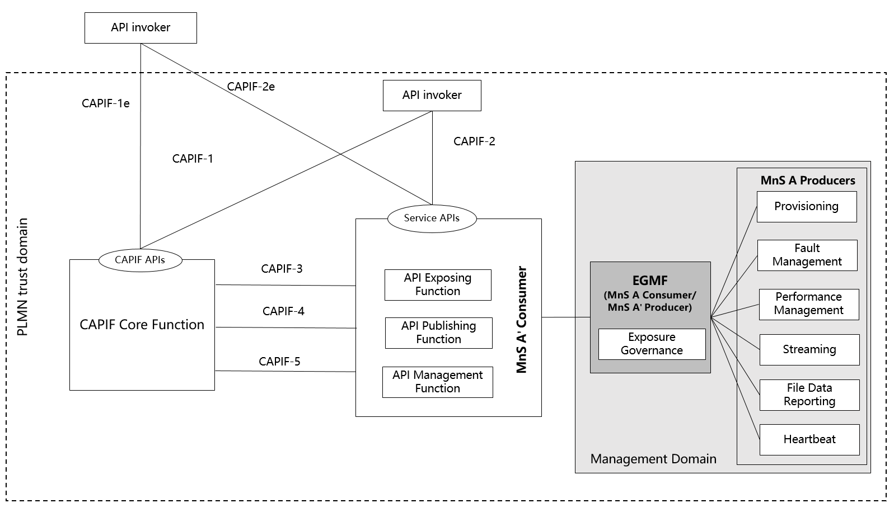
Figure 7.x.1-1: EGMF implements the exposure governance
Figure 7.x.1-1 conforms to Figure 7.9.1-1: Exposure via CAPIF alternative 1 in clause 7.9.1. EGMF implements Exposure Governance as described in TS 28.533 clause 4.4 [11].
To implement exposure governance, EGMF should implement the following functionalities:
- Provide the governance on management services to control the management capabilities exposed to MnS consumers. The exposed MnS can be provided as service APIs as is to API invoker by API Exposing Function. The governance could be the simplification, filtering and abstraction as specified in TS 28.533 clause A.2 [11].
The Figure 7.x.1-2 illustrates the simplification, filtering and abstraction of management services.
Figure 7.x.1-2: exposure governance on management service A and management service B
The management services provided by MnF 1, MnF 2 and MnF 3 can be regarded as EGMFs. Examples are given showing what the simplification, filtering and abstraction are.
- Simplification example: Assuming the management service A is Provisioning MnS with supported HTTP operations PUT, GET, PATCH, DELETE, the simplification on management service A could be that only HTTP operation GET is available to management service A' consumer.
- Filtering example: Assuming the management service A is Provisioning MnS, the filtering on management service A could be that only part of the attributes of the NRM MOI which constitute the component Type B of management service A'' will be exposed to management service A'' consumer.
- Abstraction example: Assuming the management service A producer is for the provisioning management on RAN subnetwork, while the management service B producer is for provisioning management on 5GC subnetwork. The abstraction on management service A and management service B could be the combination of these two management services to achieve the provisioning management on an end to end network slice for exposure purpose.

7.x.2 EGMF implements the API provider domain functions
This clause describes how the API provider domain functions are implemented by EGMF and the corresponding EGMF functionalities compliant with clause 7.9.2 Exposure via CAPIF alternative 2.
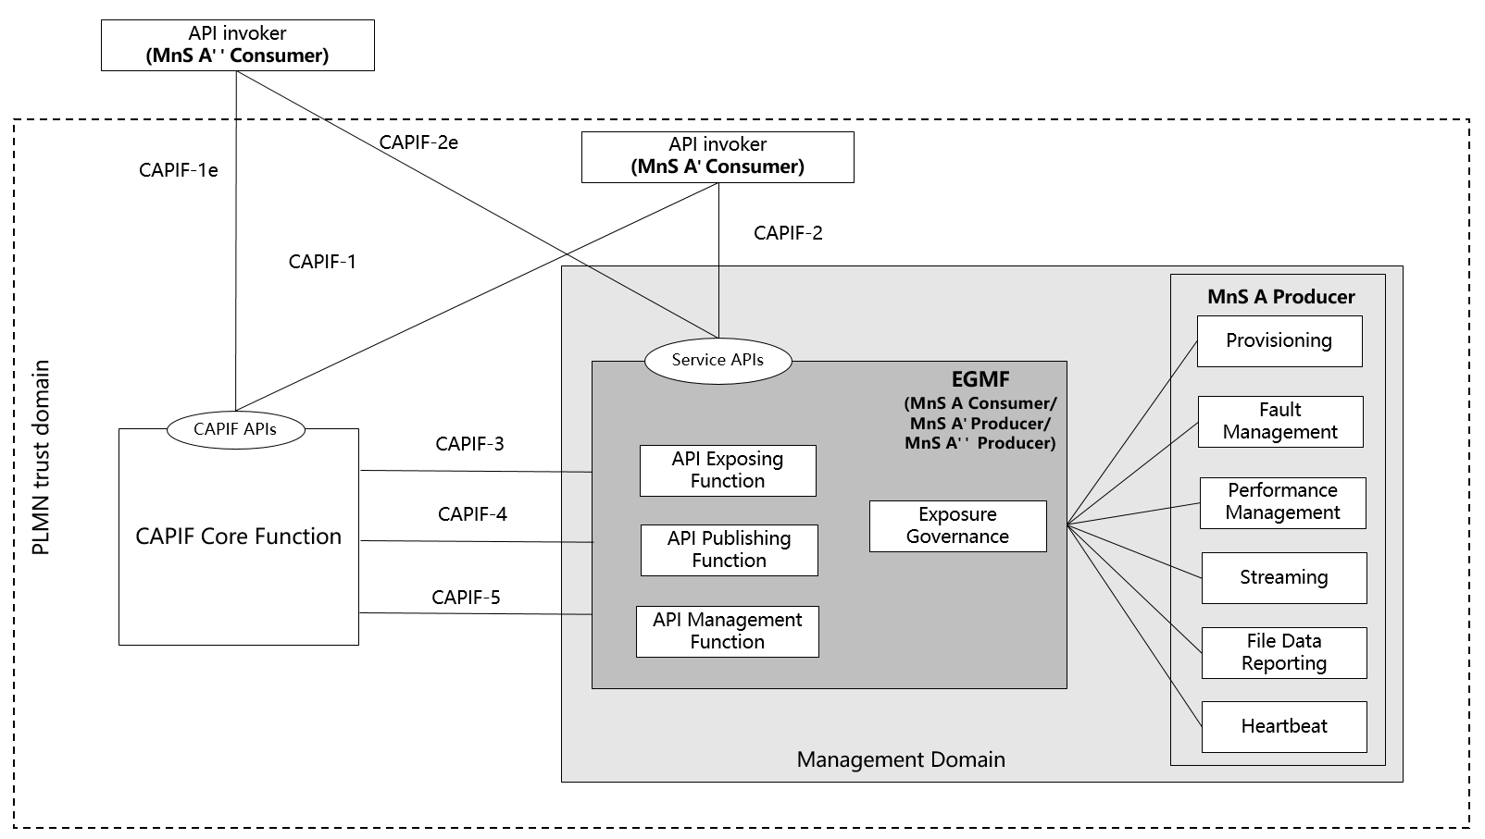
Figure 7.x.2: EGMF implements the API provider domain functions
Figure 7.x.2 conforms to Figure 7.9.2-1: Exposure via CAPIF alternative 2 in clause 7.9.2. EGMF implements API Exposing Function, API Publishing Function, API Management Function as specified in TS 23.222 [14] and Exposure Governance as described in TS 28.533 clause 4.4 [11].
To implement exposure governance, EGMF should implement the following functionalities:
- Provide the governance on management services to control the management capabilities exposed to MnS consumers. The governance could be the simplification, filtering and abstraction on the dimension of MnS components Type A, B, and C respectively. For the simplification, filtering and abstraction, see clause 7.x.1-2 for further details.
To implement API Exposing Function, EGMF should implement the following functionalities, see further details in TS 23.222 clause 6.3.4 [14]
- Authenticate the API invoker based on the identity and other information required for authentication of the API invoker provided by the CAPIF core function.
- Validate the authorization provided by the CAPIF core function.
- Log the service API invocations at the CAPIF core function.
- Invocation of Service APIs. The exposed MnS can be provided to API invoker as service APIs as is.
To implement API Publishing Function, EGMF should implement the following functionalities, see further details in TS 23.222 clause 6.3.5 [14]
- Publish the service API information of the API provider to the CAPIF core function.
To implement API Management Function, EGMF should implement the following functionalities, see further details in TS 23.222 clause 6.3.6 [14]
- Audit the service API invocation logs received from the CAPIF core function.
- Monitor the events reported by the CAPIF core function.
- Configure the API provider policies to the CAPIF core function.
- Monitor the status of the service APIs.
- Onboard the new API invokers and offboard API invokers.
- Register and maintain registration information of the API provider domain functions on the CAPIF core function.

7.x.3 EGMF implements the CAPIF Core Function and API provider domain functions
This clause describes how the CAPIF Core Function and API provider domain functions are implemented by EGMF and the corresponding EGMF functionalities compliant with clause 7.9.3 Exposure via CAPIF alternative 3.
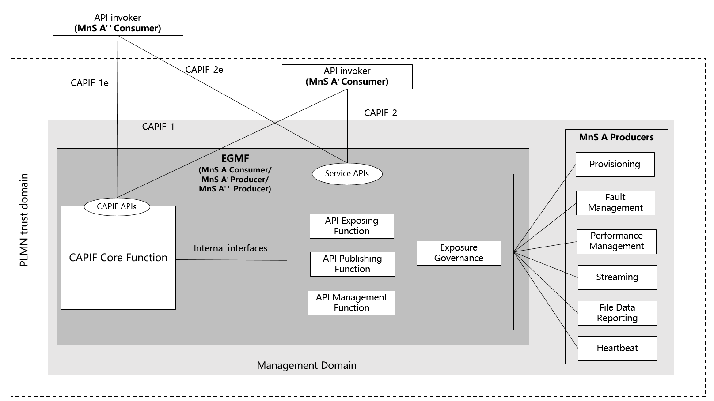
Figure 7.x.3: EGMF implements the CAPIF Core Function and API provider domain functions
Figure 7.x.3 conforms to Figure 7.9.3-1: Exposure via CAPIF alternative 3 in clause 7.9.3. EGMF implements CAPIF Core function, API Exposing Function, API Publishing Function, API Management Function as specified in TS 23.222 [14] and Exposure Governance as described in TS 28.533 clause 4.4 [11].
To implement exposure governance, EGMF should implement the following functionalities:
- Provide the governance on management services to control the management capabilities exposed to MnS consumers. The governance could be the simplification, filtering and abstraction on the dimension of MnS components Type A, B, and C respectively. For the simplification, filtering and abstraction, see clause 7.x.1-2 for further details.
To implement API Exposing Function, EGMF should implement the following functionalities, see further details in TS 23.222 clause 6.3.4 [14]
- Authenticate the API invoker based on the identity and other information required for authentication of the API invoker provided by the CAPIF core function.
- Validate the authorization provided by the CAPIF core function.
- Log the service API invocations at the CAPIF core function.
- Invocation of Service APIs. The exposed MnS can be provided to API invoker as service APIs as is.
To implement API Publishing Function, EGMF should implement the following functionalities, see further details in TS 23.222 clause 6.3.5 [14]
- Publish the service API information of the API provider to the CAPIF core function.
To implement API Management Function, EGMF should implement the following functionalities, see further details in TS 23.222 clause 6.3.6 [14]
- Audit the service API invocation logs received from the CAPIF core function.
- Monitor the events reported by the CAPIF core function.
- Configure the API provider policies to the CAPIF core function.
- Monitor the status of the service APIs.
- Onboard the new API invokers and offboard API invokers.
- Register and maintain registration information of the API provider domain functions on the CAPIF core function.
To implement CAPIF Core Function, EGMF should implement the following functionalities, see further details in TS 23.222 clause 6.3.3 [14]
- Authenticate the API invoker based on the identity and other information required for authentication of the API invoker.
- Support mutual authentication with the API invoker.
- Provide authorization for the API invoker prior to accessing the service API.
- Publish, storing and supporting the discovery of service APIs information.
- Control the service API access based on PLMN operator configured policies.
- Store the logs for the service API invocations and providing the service API invocation logs to authorized entities.

- Monitor the service API invocations;
- Onboard a new API invoker and offboard an API invoker;
- Store policy configurations related to CAPIF and service APIs;
- Support accessing the logs for auditing (e.g. detecting abuse); and
- Support publishing, discovery of service APIs information with another CAPIF core function in CAPIF interconnection

End of changes

