3GPP TSG-SA5 Meeting #142-e S5-222725d1

e-meeting, 17 - 26 January 2022

Source: Alibaba, AsiaInfo

Title: Solution on exposure architecture and related API

Document for: Approval
Agenda Item: 6.5.22

1 Decision/action requested
The group is asked to agree the text in detailed proposal.

2 References
Not applicable

3 Rationale
So far, there is an ongoing discussion on how to expose the MnS to the external customer in the case that the external customer can consume exposed MnS directly from OSS. Two possible options are listed below:
1) Exposed MnS is exposed directly via MnS producer for exposed MnS, for example NSMF, NSSMF, etc
2) Exposed MnS is exposed via a dedicated proxy (e.g. EGMF)
In order to address this issue, the exposure function defined in SA2 can be a good reference. In SA2, a dedicated function named Network Exposure Function is used for exposing any information from 5GC to AF that is external to the Network Operator. NEF has the following functionalities:
- Exposure of capabilities and events:
- NF capabilities and events may be securely exposed by NEF for e.g. 3rd party, Application Functions, Edge Computing as described in clause 5.13.
- Secure provision of information from external application to 3GPP network:
- It provides a means for the Application Functions to securely provide information to 3GPP network, e.g. time synchronization service information and service specific information. In that case the NEF may authenticate and authorize and assist in throttling the Application Functions.
- Translation of internal-external information:
- It translates between information exchanged with the AF and information exchanged with the internal network function. For example, it translates between an AF-Service-Identifier and internal 5G Core information such as DNN, S-NSSAI.
SA5 may leverage the same design principle and specifies MnS producers for managing the NF capability exposure, secure provision of information from external application to 3GPP management system, and also translation of internal-external information.
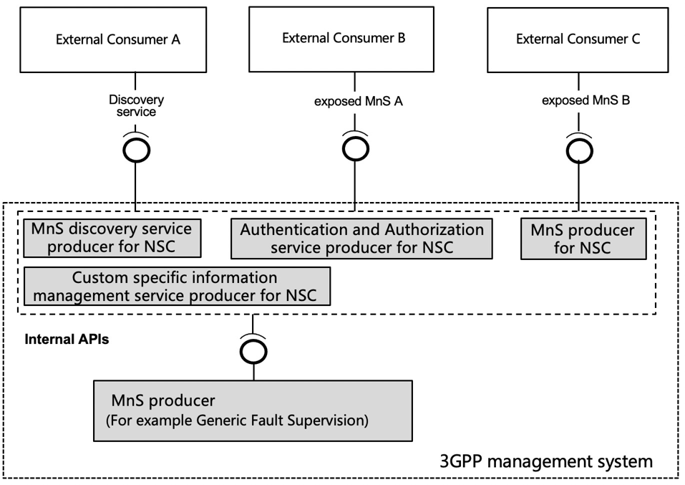
Figure 1 Exposure via MnS producers serving NSC
Figure 1 shows an architecture where the exposure goes through several MnS producers in the context that the external customer can consume exposed MnS directly via OSS.
The external API is used for external customer to discovery and consumer exposed MnS from exposure function, exposure function collects the MnS from MnS producer within the 3GPP management system and expose to external customer.
External customer can reuse the operation from generic management service (defined in TS 28.532) to request for exposed MnS from exposure function.
Apart from the generic operation, enhancement is needed, for example, the external customer needs to carry the authorization information (e.g. token) for consuming the MnS discovery service for NSC or exposed MnS.
The internal API is used for MnS producer to offer service (e.g. MnS, discovery related information) to exposure function based on the request from external customer.
Internal API can reuse the operation from generic management service.
This contribution proposes exposure architecture and related API.

4 Detailed proposal

1st change

2 References
The following documents contain provisions which, through reference in this text, constitute provisions of the present document.
- References are either specific (identified by date of publication, edition number, version number, etc.) or non-specific.
- For a specific reference, subsequent revisions do not apply.
- For a non-specific reference, the latest version applies. In the case of a reference to a 3GPP document (including a GSM document), a non-specific reference implicitly refers to the latest version of that document in the same Release as the present document.
[1] 3GPP TR 21.905: "Vocabulary for 3GPP Specifications".
[2] TM Forum TMF622 Product Order API REST Specification
[3] TM Forum TMF641 Service Ordering API
[4] TM Forum TMF652 Resource Order Management API
[5] 3GPP TS 28.531: "Management and orchestration; Concepts, use cases and requirements"
[6] 3GPP TS 28.532: "Management and orchestration; Generic management services"
[7] 3GPP TS 28.202: "Charging management; Network slice management charging in the 5G System (5GS); Stage 2"
[8] 3GPP TR23.700-99 “Study on Network Slice Capability Exposure for Application Layer Enablement (NSCALE)”

[9] 3GPP TS23.434 “Service Enabler Architecture Layer for Verticals (SEAL); Functional architecture and information flows.”
[10] 3GPP TS 28.541: "Management and orchestration; 5G Network Resource Model (NRM); Stage 2 and stage 3"
[11] 3GPP TS 28.537: "Management and orchestration; Management capabilities"
[12] 3GPP TS 28.533: "Management and orchestration; Architecture framework"
[13] 3GPP TS 28.622: "Generic Network Resource Model (NRM) Integration Reference Point (IRP); Information Service (IS)"
[14] TM Forum TMF633 Service Catalogue Management API
[15] TM Forum TMF620 Product Catalogue Management API

2nd changes

7.X Solution for exposure interface via OSS
This clause describes a solution for the procedure described in clause 7.4.
The NSC has to consume several MnSs e.g., for authentication, authorization, and MnS discovery. When the NSC consumes an MnS, the MnS may rely on other MnSs to be able to produce the service.
Step | Description in step | Interface | Reference | Description in reference
1 | product order | External | TM Forum TMF622 [2] | Product Order
2 |  | None | - | -
3 | service order | Internal | TM Forum TMF641 [3] | Service Order
4 |  | None | - | -
5 | service order completed | Internal | TM Forum TMF641 [3] | Service Order State Change Event with the address of MnS producer
6 | product order completed | External | TM Forum TMF622 [2] | Product Order State Change Event with the address of MnS producer
7 | Authentication and Authorization | External | - | Authentication and authorization of the NSC’s MnS consumers. Dedicated operation for Authentication and Authorization is missing in current specification.
8 | MnS discovery | External | 3GPP TS 28.532 [6], TS 28.622 [13] | MnS discovery of MnS producers may require enhancement of TS 28.532 and TS 28.622 for registry.
9 | MnS consumption | External | 3GPP TS 28.532 [6], 3GPP TS 28.531 [5] | Consumption of MnS may need enhancement to TS 28.532 and TS 28.531, for authorization.
Figure 7.X.1 Exposed MnS consumption via OSS interface

End of changes

