3GPP TSG SA WG5 Meeting 142-e S5-222509

electronic meeting, online, 4– 12th Apr 2022
CR-Form-v12.0
CHANGE REQUEST
 | 28.405 | CR |  | rev | - | Current version: | 17.0.0
For HELP on using this form: comprehensive instructions can be found at
http://www.3gpp.org/Change-Requests.

Proposed change affects: | UICC apps |  | ME |  | Radio Access Network | X | Core Network | X

Title: | Input to DraftCR Handling of QoE measurement collection at handover in NR
Source to WG: | Ericsson
Source to TSG: | S5
Work item code: | eQoE |  |  |  |  |  | Date: |  |  | 2021-03-21
Category: | B |  |  |  |  |  | Release: |  |  | Rel-17
 | Use one of the following categories:  F (correction)  A (mirror corresponding to a change in an earlier release)  B (addition of feature),  C (functional modification of feature)  D (editorial modification)  Detailed explanations of the above categories can  be found in 3GPP TR 21.900. |  |  |  |  |  |  |  | Use one of the following releases:  Rel-8 (Release 8)  Rel-9 (Release 9)  Rel-10 (Release 10)  Rel-11 (Release 11)  …  Rel-15 (Release 15)  Rel-16 (Release 16)  Rel-17 (Release 17)  Rel-18 (Release 18)
Reason for change: |  | The features are missing in the specification
Summary of change: |  | Adding Handling of measurement collection at handover in NR.
Consequences if not approved: |  | Functionality is missing resulting in interoperability problem
Clauses affected: |  | 2, 4.z.2 (new), 4.z.2.1 (new), 4.z.2.2 (new), 4.z.2.3 (new)
 |  | Y | N
Other specs |  |  | x | Other core specifications |  |  |  | TS/TR ... CR ...
affected: |  |  | x | Test specifications |  |  |  | TS/TR ... CR ...
(show related CRs) |  |  | x | O&M Specifications |  |  |  | TS/TR ... CR ...
Other comments:
This CR's revision history: |  | Input to draft CR

First change
2 References
[x] 3GPP TS 38.331: " NR; Radio Resource Control (RRC); Protocol specification".

Next change

4.z.2 Handling of measurement collection at handover in NR

4.z.2.1 Handover between cells within an gNB
When handover is made the measurement area is checked.
If the mobile is inside the measurement area after the handover, the gNB sends the RRCReconfiguration message [x] to the UE. The UE send the +CAPPLEVMCNR AT command [5] to the application, if there is no ongoing QoE measurements, to inform that recording shall start if the application becomes active.

4.z.2.2 NG Based Handover
The figure 4.z.2.2-1 and the text below describes the handling at NG Based handover between gNBs for Signalling Based Activation case.
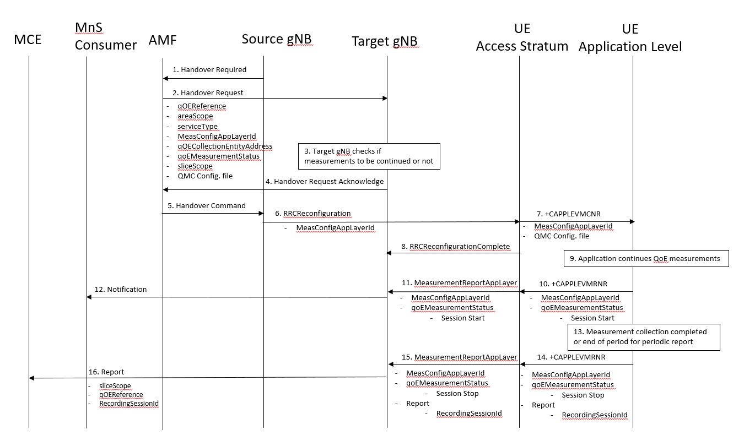
Figure 4.z.2.2-1: Handling of QMC activation in case of NG Based handover in NR for Signalling Based Activation
- Source gNB sends the message HANDOVER REQUIRED to AMF
- AMF sends the message HANDOVER REQUEST to the Target gNB and includes qOEReference, areaScope,serviceType, MeasConfigAppLayerId, qOECollectionEntityAddress, qoEMeasurementStatus, sliceScope and QMC Configuration file.
- The target gNB checks if the measurements to be continued or not.
- The target gNB sends the message HandoverRequestAcknowledge to the AMF.
- The AMF sends the message HANDOVER COMMAND to the source gNB.
- The source gNB sends the message RRCReconfiguration to the UE.
- The access stratum in the UE sends the AT command +CAPPLEVMCNR to application level, only when there is a new configuration.
- The UE sends the message RRCReconfigurationComplete to the gNB.
- The application continues QoE measurements.
- The application layer sends the AT command +CAPPLEVMRNR including MeasConfigAppLayerId and that a session has started to the access stratum.
- The UE sends the message MeasurementReportAppLayer including MeasReportAppLayerId and qoEMeasurementStatus to the gNB.
- The gNB sends a notification including the recording session indication to the MnS Consumer.
- When the QMC is completed or end of periodic reporting is reached, the recorded information is collected in a QMC report [6], [7].. The qOEReference, Client Id [6] and [7] in the reporting container (that represent the UE request session) and recordingSessionId are needed in the QoE collection entity for post processing purposes.
- The application layer sends the AT command +CAPPLEVMRNR including MeasConfigAppLayerId and the QMC report to the access stratum.
- The UE sends the message MeasurementReportAppLayer including MeasConfigAppLayerId and the QMC report to the gNB.
- The gNB sends the QMC report to the MCE associated to the qOEReference and sliceScope.

4.z.2.3 NG Based Handover
The figure 4.z.2.2-2 shows the handling at handover between gNBs for Management Based Activation case.
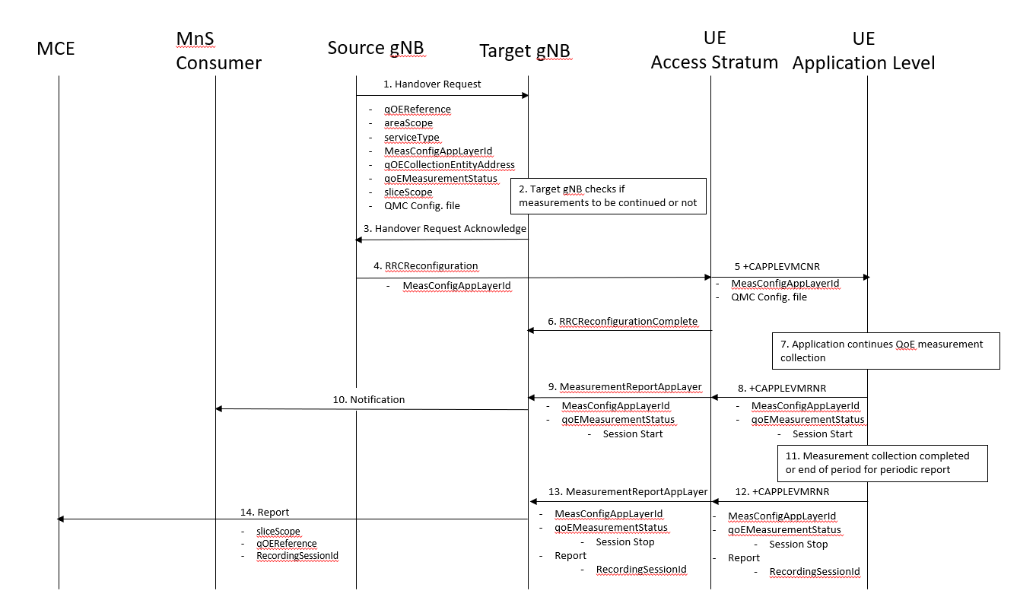
Figure 4.z.2.2-2: Handling of QMC activation in case of handover in NR for Management Based Activation

End change

