**3GPP TSG-SA5 Meeting #142-eS5-222506rev2**

**e-meeting, 17 - 26 January 2022**

**Source: Alibaba, AsiaInfo**

**Title: Solution on exposure architecture and related API**

**Document for: Approval**

**Agenda Item: 6.5.22**

# 1 Decision/action requested

***The group is asked to agree the text in detailed proposal.***

# 2 References

Not applicable

# 3 Rationale

So far, there is an ongoing discussion on how to expose the MnS to the external customer in the case that the external customer can consume exposed MnS directly from OSS. Two possible options are listed below:

1) Exposed MnS is exposed directly via MnS producer for exposed MnS, for example NSMF, NSSMF, etc

2) Exposed MnS is exposed via a dedicated proxy (e.g. EGMF)

In order to address this issue, the exposure function defined in SA2 can be a good reference. In SA2, a dedicated function named Network Exposure Function is used for exposing any information from 5GC to AF that is external to the Network Operator. NEF has the following functionalities:

* Exposure of capabilities and events:

- NF capabilities and events may be securely exposed by NEF for e.g. 3rd party, Application Functions, Edge Computing as described in clause 5.13.

* Secure provision of information from external application to 3GPP network:

- It provides a means for the Application Functions to securely provide information to 3GPP network, e.g. time synchronization service information and service specific information. In that case the NEF may authenticate and authorize and assist in throttling the Application Functions.

* Translation of internal-external information:

- It translates between information exchanged with the AF and information exchanged with the internal network function. For example, it translates between an AF-Service-Identifier and internal 5G Core information such as DNN, S-NSSAI.

SA5 may leverage the same design principle and specifies a group of MnS producers for managing the NF capability exposure, secure provision of information from external application to 3GPP management system, and also translation of internal-external information.

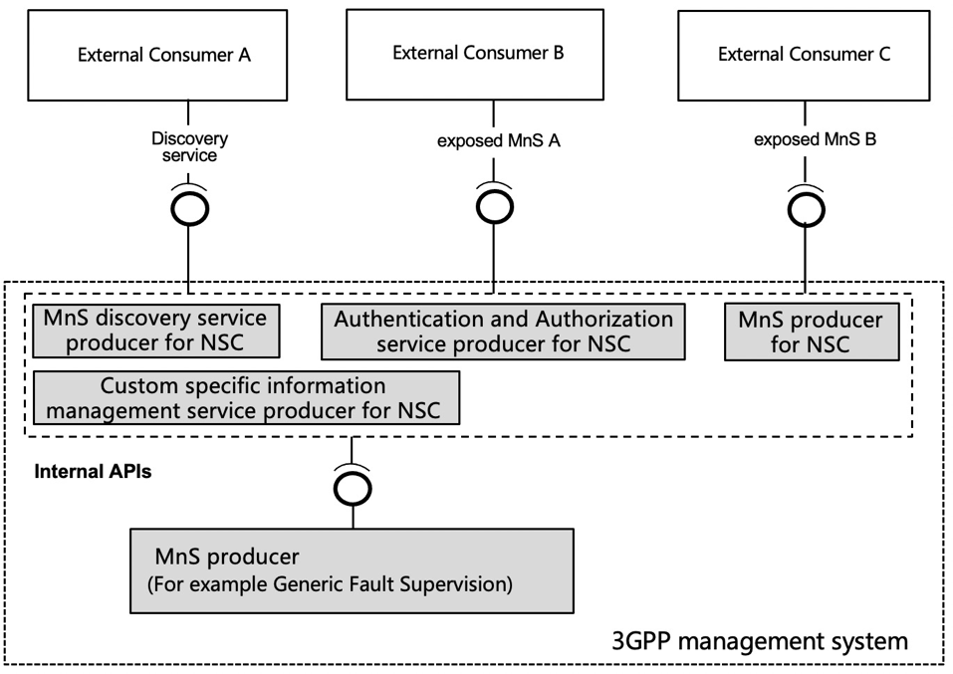

**Figure 1 Exposure via a group of MnS producers**

Figure 1 shows an architecture where the exposure goes through a group of MnS producers in the context that the external customer can consume exposed MnS directly via OSS.

The external API is used for external customer to discovery and consumer exposed MnS from exposure function, exposure function collects the MnS from MnS producer within the 3GPP management system and expose to external customer.

External customer can reuse the operation from generic management service (defined in TS 28.532) to request for exposed MnS from exposure function.

Apart from the generic operation, enhancement is needed, for example, the external customer needs to carry the authorization information (e.g. token) for consuming the MnS discovery service for NSC or exposed MnS.

The internal API is used for MnS producer to offer service (e.g. MnS, discovery related information) to exposure function based on the request from external customer.

Internal API can reuse the operation from generic management service.

This contribution proposes exposure architecture and related API.

# 4 Detailed proposal

|  |
| --- |
| **1st change** |

# 2 References

The following documents contain provisions which, through reference in this text, constitute provisions of the present document.

- References are either specific (identified by date of publication, edition number, version number, etc.) or non‑specific.

- For a specific reference, subsequent revisions do not apply.

- For a non-specific reference, the latest version applies. In the case of a reference to a 3GPP document (including a GSM document), a non-specific reference implicitly refers to the latest version of that document *in the same Release as the present document*.

[1] 3GPP TR 21.905: "Vocabulary for 3GPP Specifications".

[2] TM Forum TMF622 Product Order API REST Specification

[3] TM Forum TMF641 Service Ordering API

[4] TM Forum TMF652 Resource Order Management API

[5] 3GPP TS 28.531: "Management and orchestration; Concepts, use cases and requirements"

[6] 3GPP TS 28.532: "Management and orchestration; Generic management services"

[7] 3GPP TS 28.202: "Charging management; Network slice management charging in the 5G System (5GS); Stage 2"

[8] 3GPP TR23.700-99 “Study on Network Slice Capability Exposure for Application Layer Enablement (NSCALE)”

[9] 3GPP TS23.434 “Service Enabler Architecture Layer for Verticals (SEAL); Functional architecture and information flows.”

[10] 3GPP TS 28.541: "Management and orchestration; 5G Network Resource Model (NRM); Stage 2 and stage 3"

[11] 3GPP TS 28.537: "Management and orchestration; Management capabilities"

[12] 3GPP TS 28.533: "Management and orchestration; Architecture framework"

[13] 3GPP TS 28.622: "Generic Network Resource Model (NRM) Integration Reference Point (IRP); Information Service (IS)"

[14] TM Forum TMF633 Service Catalogue Management API

[15] TM Forum TMF620 Product Catalogue Management API

|  |
| --- |
| **2nd changes** |

7.X Solution for exposure interface via OSS

This clause describes a solution for the procedure described in clause 7.4. For each step in the procedure Table 7.X.1 identify the following:

- NSC has to interact with a group of MnS producers for the authentication, authorization, MnS discovery, and also the MnS consumption. Upon the receipt of the request from NSC, the group of MnS producers interacts with the internal MnS producer and provide the relevant exposed MnS to the NSC.

|  |  |  |  |  |
| --- | --- | --- | --- | --- |
| **Step** | **Description in step** | **Interface** | **Reference** | **Description in reference** |
| 1 | product order | External | TM Forum TMF622 [2] | Product Order |
| 2 |  | None | - | - |
| 3 | service order | Internal | TM Forum TMF641 [3] | Service Order |
| 4 |  | None | - | - |
| 5 | service order completed | Internal | TM Forum TMF641 [3] | Service Order State Change Event with the address of MnS producer for NSC |
| 6 | product order completed | External | TM Forum TMF622 [2] | Product Order State Change Event with the address of MnS producer for NSC |
| 7 | Authentication and Authorization | External | 3GPP TS 28.532 [6] | The NSC need to interacts with an authentication and authorization service producer within the OSS before consuming the MnS from OSS. Dedicated operation for Authentication and Authorization is missing in current specification. |
| 8 | MnS discovery for NSC | External | 3GPP TS 28.532 [6], TS 28.622 [13] | The NSC need to interacts with MnS discovery service producer within the OSS after the authentication and authorization. MnsRegistry and potential enhancement of MnsRegistry for NSC to achieve MnS discovery service for NSC are needed. |
| 9 | MnS consumption | External | 3GPP TS 28.532 [6], 3GPP TS 28.531 [5] | After discovering the MnS producer, the NSC can interact with the MnS producer for NSC in order to consume the exposed MnS. Potential enhancement based on access control and Operations in TS 28.532 and TS 28.531, such as NotifyMOIAttributeValueChanges are needed. |

Figure 7.X.1 Exposed MnS consumption via OSS interface

|  |
| --- |
| **End of changes** |