3GPP TSG SA WG5 Meeting 142-e S5-222483

**e-meeting, 4 -12 April 2022**

**Source: Nokia**

**Title: Adding domain observation data as input in cross-domain MDA**

**Document for: Approval**

**Agenda Item: 6.6.5**

# 1 Decision/action requested

This contribution is for approval.

# 2 References

[x] TR 28.809 Study on enhancement of management data analytics

# 3 Rationale

This contribution introduces the notion of including additionally or alternatively input from single-domain or multiple single-domain observation sources for cross-domain MDA and service assurance. In other words, this contribution states that cross-domain MDA may not explicitly rely on single-domain analytics but may additionally or alternatively use domain observation data directly.

# 4 Detailed proposal

|  |
| --- |
| **1st Modified Section** |

6.3 MDA role in cross-domain service assurance

Cross-domain MDA may base its analysis on the outputs from one or multiple single-domain MDA including analytics output and raw inputs (e.g., PM, alarm notifications, etc.). To facilitate service assurance the cross-domain MDA may adopt output from one or multiple single-domain MDA. Figure 6.3-1 shows the simplest case, where a cross-domain MDA incorporates the results of single-domain MDA(s).

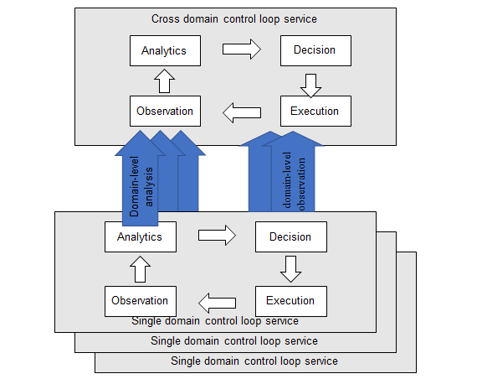

**Figure 6.3-1 Cross-domain MDA based on single-domain MDA**

Figure 6.3-2 shows the case where a cross-domain MDA incorporates the results of single-domain MDA(s) which are embedded within single-domain control loop service(s). Service assurance control loop may be conducted at single-domain bases where MDA role is assumed by analytics. The cross-domain MDA may further leverage the output from one or multiple single-domain control loops for its analytics for the e2e service assurance.

Cross domain MDA

Analytics

Single domain control loop service

Single domain control loop service

Single domain control loop service

Analytics

Execution

Observation

Decision

Domain-level analysis

**Figure 6.3-2 Cross-domain MDA based on single-domain control loop service**

Figure 6.3-3 shows the case where a cross-domain MDA is part of a cross-domain control loop service. Also in this case, cross-domain MDA incorporates the results of single-domain MDA(s). Service assurance control loop may be conducted at the cross-domain level in which the MDA role is assumed by analytics. The cross-domain control loop may adopt output from one or multiple single-domain MDA(s) for the e2e service assurance.

Cross domain control service

Analytics

Execution

Observation

Decision

Single domain MDA

Single domain MDA

Single domain MDA

Analytics

Domain-level analysis

**Figure 6.3-3 Cross-domain control loop service based on single-domain MDA(s)**

Figure 6.3-4 shows another case where a cross-domain MDA is part of a cross-domain control service. In this case, cross-domain MDA incorporates the results of single-domain MDA(s) which are embedded within single-domain control loop service(s). Service assurance control loop may be conducted at both levels where MDA role is assumed by analytics, i.e., at the cross-domain and single-domain. The cross-domain MDA may adopt output from one or multiple single-domain MDA(s) for the e2e service assurance.

Cross domain control loop service

Analytics

Execution

Observation

Decision

Single domain control loop service

Single domain control loop service

Single domain control loop service

Analytics

Execution

Observation

Decision

Domain-level analysis

**Figure 6.3-4 Cross-domain control loop service based on single-domain control loop service(s)**

|  |
| --- |
| **End of Modified Section** |