3GPP TSG-SA5 Meeting #142-e S5-222468Rev1

e-meeting, 4 - 12 April 2022

Source: AsiaInfo，Alibaba

Title: Update potential solution for MnS discovery service for exposure

Document for: Approval

Agenda Item: 6.5.22

1 Decision/action requested
The group is asked to discuss and approval.

2 References
Not applicable

3 Rationale
This contribution proposes to update potential solution for MnS discovery service for exposure.

4 Detailed proposal
1st Change

7.3 Potential solution for MnS discovery service for exposure
The MnS data can be accessed by different kinds of discovery service consumers based on different use cases.
In some use cases, the exposure usually goes through BSS. The BSS can obtain MnS data from the MnS discovery service on behalf of the NSC.
There are different scenarios where the NSC could directly interact with the MnS producer exposure interface via OSS.

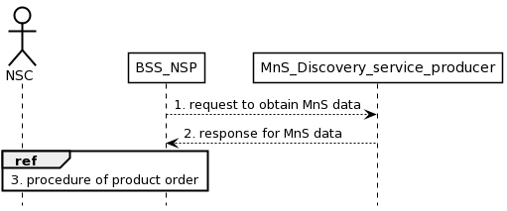
Figure 7.3.1 Procedure for MnS discovery service for exposure via BSS
- The BSS requests for MnS data from the MnS discovery service for NSC on behalf of the NSC. The MnS data may contain the address of the exposed producer.
- MnS discovery service producer for NSC provides discovery service to NSC. The MnS discovery service producer returns the MnS data to BSS. The BSS may provide discovery service to NSC based on MnS data.
- The NSC completes the product order via the interaction with BSS_NSP.

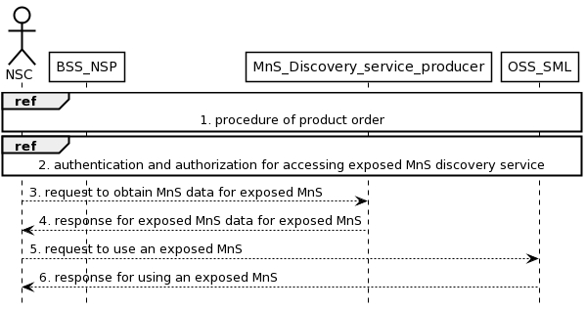
Figure 7.3.2 Procedure for MnS discovery service for exposure via OSS
- The NSC completes a product order via the interaction with BSS_NSP. As a result of the product ordering, the NSC obtains the address of the MnS discovery service producer for exposure.
NOTE: MnS discovery service producer providing discovery service for the exposed MnS to external.
- The NSC executes authentication and authorization for accessing MnS discovery service.
- The NSC requests for MnS data for exposed MnS from the MnS discovery service. The exposed MnS data for exposed MnS may contain the information of the exposed MnS instance and the address of the exposed MnS producer. The MnS data for exposed MnS is the data for authorized NSC to identify proper MnS producer which produces the exposed MnS.
- The MnS discovery service returns the MnS data for exposed MnS to the NSC.
- The NSC requests the services from the target exposed MnS producer.
- The target exposed MnS producer returns the responses.
MnsResitger operation defined in 3GPP TS 28.622[X] can be used in the step3. The MnsInfo name-contained by MnsRegistry is used by the NSC to discover the producers of specific Management Services and to derive the addresses of the exposed MnS producer. mnsaddress of MnsInfo attributes may contain two addresses which are the address for exposure function (e.g. EGMF) and the addresses of MnS producer. The NSC identifies the exposure function (e.g. EGMF) via the information of mnsaddress, which contains the addresses information of the exposure MnS. The addresses information of exposure MnS can be carried by the exposed MnS request from NSC. Upon receiving the exposed MnS request, the exposure function (e.g. EGMF) retrieves the addresses of the MnS producer for exposed MnS and make request for that exposed MnS for the NSC.
End of changes

