3GPP TSG-SA5 Meeting #142-e S5-222938

e-meeting, 4 -26 April 2022
CR-Form-v12.1
CHANGE REQUEST
 | 28.531 | CR | 0070 | rev | - | Current version: | 17.3.0
For HELP on using this form: comprehensive instructions can be found at
http://www.3gpp.org/Change-Requests.

Proposed change affects: | UICC apps |  |  | ME |  | Radio Access Network | X | Core Network | X

Title: | Rel-17 CR TS 28.531 Update procedure of reservation and checking feasibility of network slice subnet
Source to WG: | Nokia, Nokia Shanghai Bell, Huawei
Source to TSG: | S5
Work item code: | eNETSLICE_PRO |  |  |  |  |  | Date: |  |  | 2022-03-25
Category: | B |  |  |  |  |  | Release: |  |  | Rel-17
 | Use one of the following categories:  F (correction)  A (mirror corresponding to a change in an earlier release)  B (addition of feature),  C (functional modification of feature)  D (editorial modification)  Detailed explanations of the above categories can  be found in 3GPP TR 21.900. |  |  |  |  |  |  |  | Use one of the following releases:  Rel-8 (Release 8)  Rel-9 (Release 9)  Rel-10 (Release 10)  Rel-11 (Release 11)  …  Rel-15 (Release 15)  Rel-16 (Release 16)  Rel-17 (Release 17)  Rel-18 (Release 18)
Reason for change: |  | The procedure of reservation and checking feasibility of network slice subnet defined in Section 7.14 in TS 28.531 is not detailed and missing some important steps.
Summary of change: |  | Update the procedure of reservation and checking feasibility of network slice subnet.
Consequences if not approved: |  | Resource reservation procedure is not clear in the current 7.14 procedure and hence it can not be implemented in a uniform way across the consumers/producers of different vendors.
Clauses affected: |  | 7.14
 |  | Y | N
Other specs |  |  | X | Other core specifications |  |  |  | TS/TR ... CR ...
affected: |  |  | X | Test specifications |  |  |  | TS/TR ... CR ...
(show related CRs) |  |  | X | O&M Specifications |  |  |  | TS/TR ... CR ...
Other comments:
This CR's revision history: |  | - S5-222938 is the revision of S5-221246

1st Change

7.14 Procedure of reservation and checking feasibility of network slice subnet

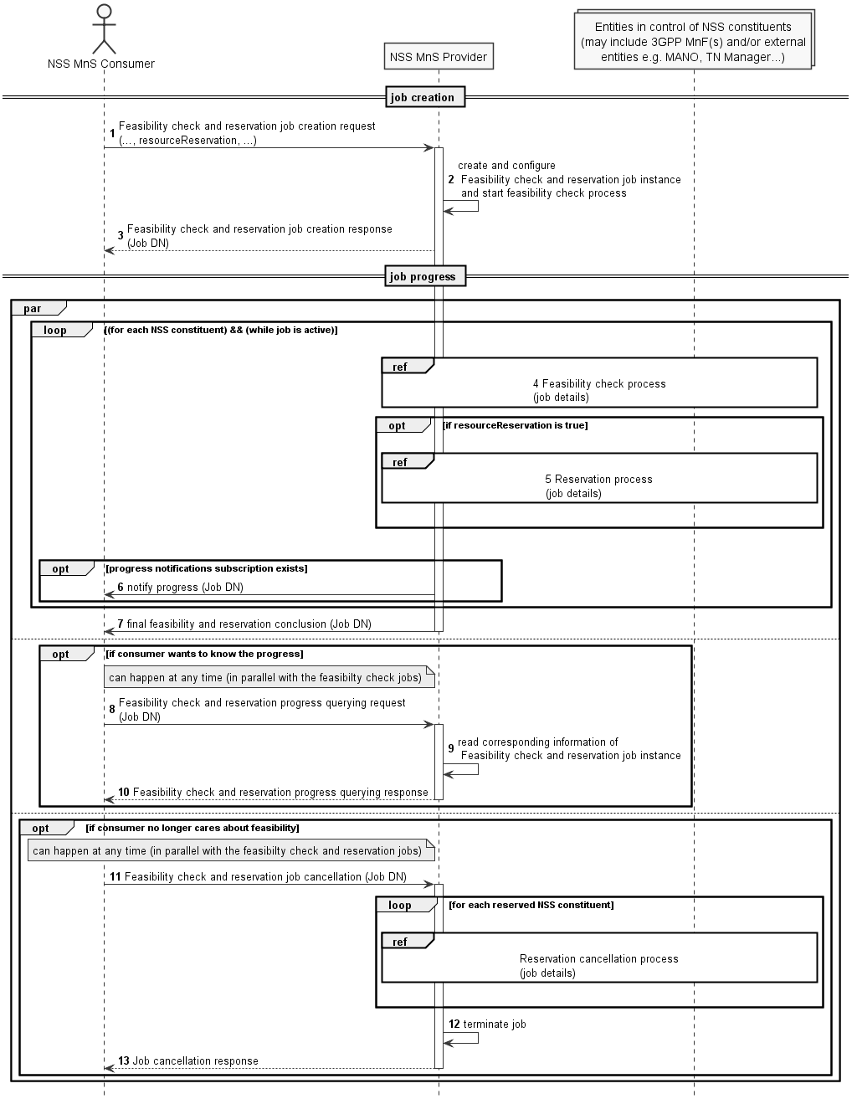

Figure 7.14-2 Network slice subnet feasibility check procedure

- Network Slice Subnet Management Service Provider (NSS MnS Provider) receives a feasibility check with or without reservation job creation request (see createMOI operation defined in TS 28.532 [8]) from Network Slice Subnet Management Service Consumer (NSS MnS Consumer) with feasibility check and reservation requirements (see FeasibilityCheckAndReservationJob IOC defined in TS 28.541 [6]). The request is to check whether the network slice subnet related requirements (i.e. SliceProfile) can be satisfied and optionally be requested to be reserved. The resourceReservation attribute in the request may indicate whether reservation is also requested or not.
- NSS MnS Provider creates the FeasibilityCheckAndReservationJob instance and configures the attribute "SliceProfile" and other attributes received from the request and NSS MnS Provider starts the executing the feasibility check process.
- NSS MnS Provider sends the feasibility check and reservation job creation response for the received Job DN. FeasibilityCheckAndReservation job DN (see createMOI operation defined in TS 28.532 [8]) requests to NSS MnS Consumer.
- NSS MnS Provider performs feasibility check locally (e.g 3GPP MnFs) on whether the resources are available.
NSS MnS Provider may optionally perform feasibility check with other entities in control of the network slice subnet constituents (eg., MANO, TN Manager) of the network slice subnet.
- NSS MnS Provider performs resource reservation process when resourceReservation is True and feasibilityCheckResult is feasible.
- The NSS MnS Consumer may subscribe for the attribute value change notifications for this specific Job DN or for any of the job(s) created by it to receive any asynchronous job progress notifications for those Job(s). NSS MnS Provider then sends the asynchronous job progress notification for feasibility check and reservation process.
- NSS MnS Provider sends the final notification with the feasibility check and reservation status.
  - Once after step 4, NSS MnS Consumer can query NSS MnS Provider any time, to know the feasibility check and reservation job status and receive the feasibility check and reservation job status.
  - NSS MnS consumer can cancel the feasibility check and reservation job any time and the NSS MnS Consumer terminates the Job and sends the Job cancellation response.
nd of Change

