3GPP TSG-SA5 Meeting #142e S5-222346rev1

e-meeting, 04 - 12 Apr. 2022

Source: CMCC，Lenovo, Motorola Mobility

Title: pCR - 28.819 Proposed overall process

Document for: Approval,
Agenda Item: 6.5.14

1 Decision/action requested
The group is asked to discuss and approve.

2 References
[1] 3GPP SA5 TR 28.819 v0.5.0（2022-02）: ” Technical Specification Group Services and System Aspects; Management and Orchestration; Study on continuous integration continuous delivery support for 3GPP NFs”

3 Rationale
Add process based on the scenarios and solutions approved.

4 Detailed proposal
It proposes to make the following changes to TR 28.819[1].
Start of changes

7. Proposed Process for Multi-Vendor CI-CD
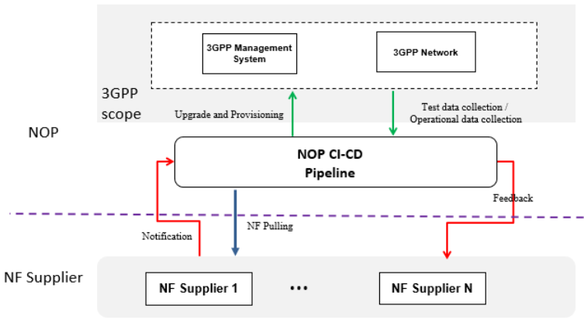
Figure 7.1 High level NF CICD process
The above figure describes the high level NF CICD process between NOP and the NF supplier. There may include the following stages and process:
-The new NF software is notified from the NF supplier to the NOP.
- The NOP Pipeline pulls the new NF software.
-The NOP Pipeline will inform 3GPP management system to do upgrade and provisioning after necesary CICD procedures (e.g. testing in the testing environment).
-The 3GPP management system will deploy and configure 3GPP network to support operational testing or operations.
-The 3GPP management system will keep monitor and collect test or operational datas.
- If there is a problem in any process of CICD, the NOP may need to give a feedback to NF supplier after necessary data handling.
In above high level processes, only upgrade and provisioning, test data collection & operational data (two green lines) will have requirements and normative works related to 3GPP.
End of changes

