3GPP TSG-SA5 Meeting #142-e S5-222327

e-meeting, 4 - 12 April 2022

Source: Huawei, Orange, Ericsson

Title: pCR 28.824 Describe possible solution for EGMF

Document for: Approval
Agenda Item: 6.5.22

1 Decision/action requested
For approval

2 References
[1] 3GPP TR 28.824 V0.5.0 Study on network slice management capability exposure

3 Rationale
This contribution describes potential solutions where network slice management capability is exposed via the Common API Framework for 3GPP Northbound APIs.
TS 23.222 Annex B.0 describes how a service API provider may use the Common API Framework (CAPIF).
Figure 3-1: Functional model for the CAPIF

4 Detailed proposal
This contribution proposes to make the following changes in [1].

1st change

2 References
The following documents contain provisions which, through reference in this text, constitute provisions of the present document.
- References are either specific (identified by date of publication, edition number, version number, etc.) or non-specific.
- For a specific reference, subsequent revisions do not apply.
- For a non-specific reference, the latest version applies. In the case of a reference to a 3GPP document (including a GSM document), a non-specific reference implicitly refers to the latest version of that document in the same Release as the present document.
[1] 3GPP TR 21.905: "Vocabulary for 3GPP Specifications".
[2] TM Forum TMF622 Product Order API REST Specification
[3] TM Forum TMF641 Service Ordering API
[4] TM Forum TMF652 Resource Order Management API
[5] 3GPP TS 28.531: "Management and orchestration; Concepts, use cases and requirements"
[6] 3GPP TS 28.202: "Charging management; Network slice management charging in the 5G System (5GS); Stage 2"
[7] 3GPP TR23.700-99 “Study on Network Slice Capability Exposure for Application Layer Enablement (NSCALE)”

[8] 3GPP TS23.434 “Service Enabler Architecture Layer for Verticals (SEAL); Functional architecture and information flows.”
[9] 3GPP TS 28.541: "Management and orchestration; 5G Network Resource Model (NRM); Stage 2 and stage 3"
[10] 3GPP TS 28.537: "Management and orchestration; Management capabilities"
[11] 3GPP TS 28.533: "Management and orchestration; Architecture framework"
[12] TM Forum TMF633 Service Catalogue Management API
[13] TM Forum TMF620 Product Catalogue Management API
[x1] 3GPP TS 23.222: "Functional architecture and information flows to support Common API Framework for 3GPP Northbound APIs; Stage 2"
[x2] 3GPP TS 28.532: "Management and orchestration; Generic Management Service"
[x3] 3GPP TS 28.623: "Telecommunication management; Generic Network Resource Model (NRM) Integration Reference Point (IRP); Solution Set (SS) definitions"
[x4] 3GPP TS 28.622: " Telecommunication management; Generic Network Resource Model (NRM) Integration Reference Point (IRP) Information Service (IS)"
[x5] 3GPP TS 28.201: "Charging management; Network slice performance and analytics charging in the 5G System (5GS); Stage 2"

2nd change

7.x Potential solutions for network slice management capability exposure via CAPIF

7.x.1 Exposure via CAPIF alternative 1
This clause describes a potential solution where network slice management capability is exposed via the Common API Framework for 3GPP Northbound APIs, see TS 23.222[x1].
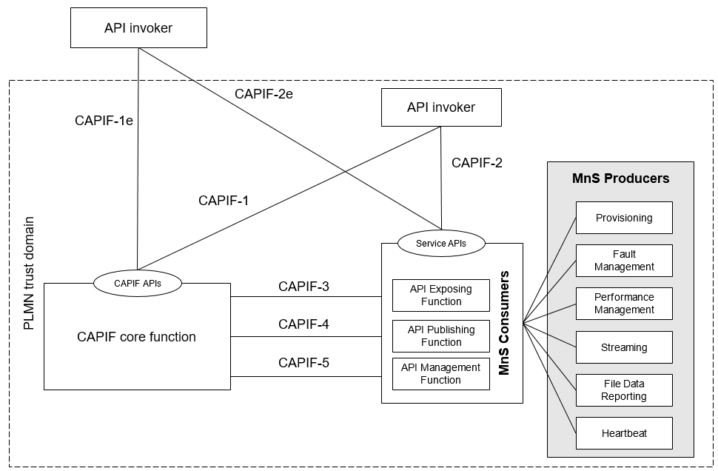
Figure 7.x.1-1: Exposure via CAPIF alternative 1

In this alternative, network slice management capability provides faultMnS, fileDataReportingMnS, heartbeatNtf, perfMnS, provMnS, and streamingDataMnS as specified in in TS 28.532 [x2].
Editor’s note: Whether it is necessary to transform the management service API to another service API is FFS.

7.x.2 Exposure via CAPIF alternative 2
This clause describes a potential solution where network slice management capability is used in conjunction with a CAPIF core function (see TS 23.222[x1]) to expose management services to MnS consumers.
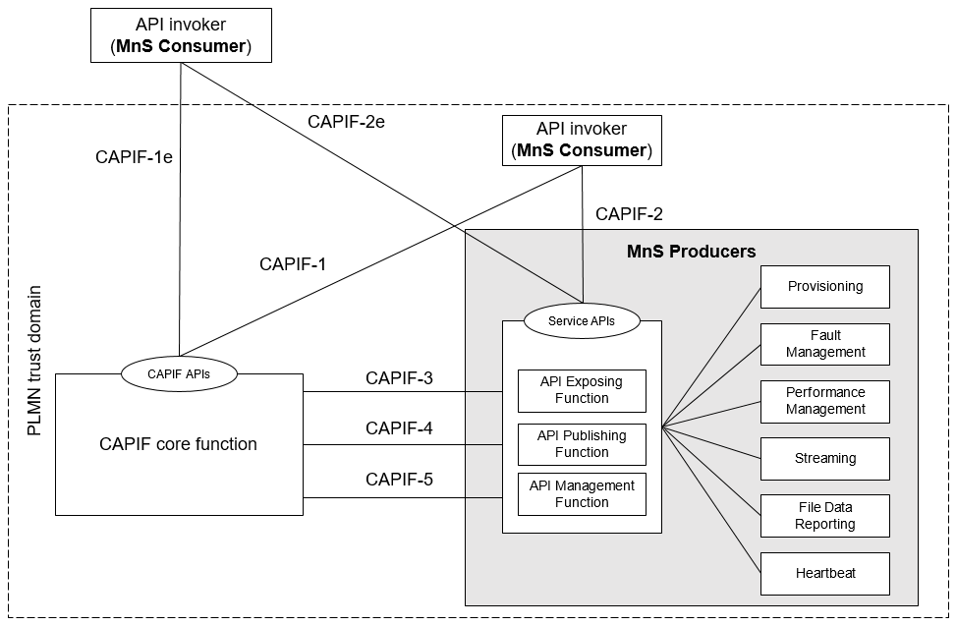
Figure 7.x.2-1: Exposure via CAPIF alternative 2

In this alternative, network slice management capability consumes the interfaces at reference points CAPIF-3, CAPIF-4, and CAPIF-5 as defined in TS 23.222[x1].
In this alternative, network slice management capability provides the interfaces at reference point CAPIF-2/2e. It may be necessary to extend CAPIF-2/2e as defined in TS 23.222[x1] to support network slice management services and authentication of MnS consumers.
In this alternative, MnS Consumers utilize the interfaces at reference point CAPIF-1/1e. It may be necessary to extend CAPIF-1/1e as defined in TS 23.222[x1] to support network slice management services and authorization/authentication of MnS consumers.
Editor’s note: Whether it is necessary to transform the management service API to another service API is FFS.

7.x.3 Exposure via CAPIF alternative 3
This clause describes a potential solution where network slice management capability implements a Common API Framework for 3GPP Northbound APIs (see TS 23.222[x1]) to expose management services to MnS consumers.
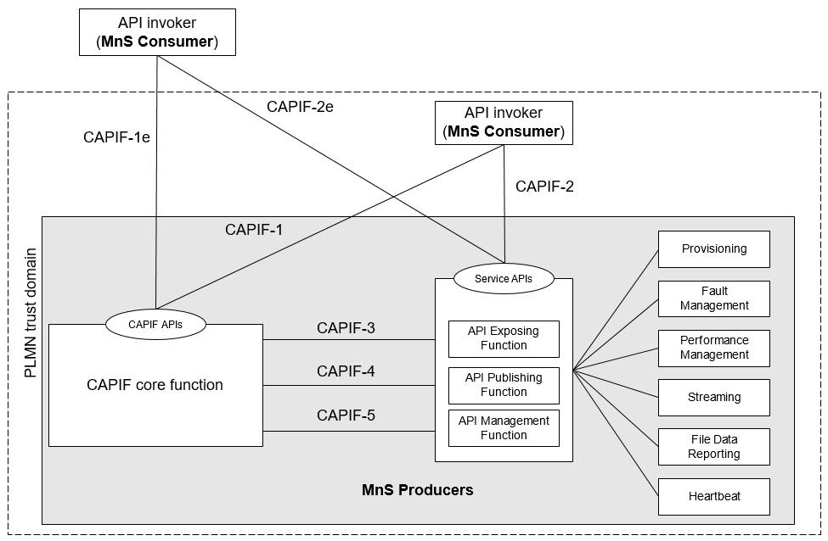
Figure 7.x.3-1: Exposure via CAPIF alternative 3

In this alternative, network slice management capability may internally implement the interfaces at reference points CAPIF-3, CAPIF-4, and CAPIF-5 as defined in TS 23.222[x1] or may use non-standardized interfaces.
In this alternative, network slice management capability provides the interfaces at reference point CAPIF-1/1e. It may be necessary to extend CAPIF-1/1e as defined in TS 23.222[x1] to support authorization/authentication of MnS consumers and discovery of MnS producers.
In this alternative, network slice management capability provides the interfaces at reference point CAPIF-2/2e. It may be necessary to extend CAPIF-2/2e as defined in TS 23.222[x1] to support network slice management services and authentication of MnS consumers.
Editor’s note: Whether it is necessary to transform the management service API to another service API is FFS.

End of changes

