3GPP TSG-SA5 Meeting #142-e S5-222325rev3

e-meeting, 4 - 12 April 2022

Source: Huawei

Title: Add desptiption of deployment options

Document for: Approval
Agenda Item: 6.5.14

1 Decision/action requested
This document is to request approval of the proposed text.

2 Rational
The current Draft TR 28.819 describes the concepts and steps in a charin. But, the multiple vendor relation and the deployment for this multiple vendor relation is not described in current Draft TR. This document is to propose some description of relation in multiple vendor relations in context of CICD.

3 Proposed changes

The start of the change

5.2 Single and Multiple NF Suppliers CI-CD

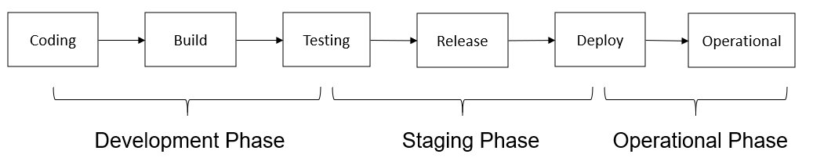
Figure 5.2-1: Typical CI-CD Chain
A typical CI-CD chain consists of several stages as shown in Figure 5.2-1: Development Phase, Staging Phase and Operational Phase. Starting from the Development Phase, the developers write the software of the NF, and the test code used to test the NF. When the software is finished and committed, the CI-CD tool will automatically trigger the building and testing. At the step of testing, the integrity of software artifacts is checked and the functional/non-functional acceptance testing are performed. At the staging phase, the software which passes all the tests will be release to the operational environment. At the Operational phase, the software is deployed in the production environment with the real traffic/user load. The software delivered in such typical CI-CD chain is usually provided by a single supplier.
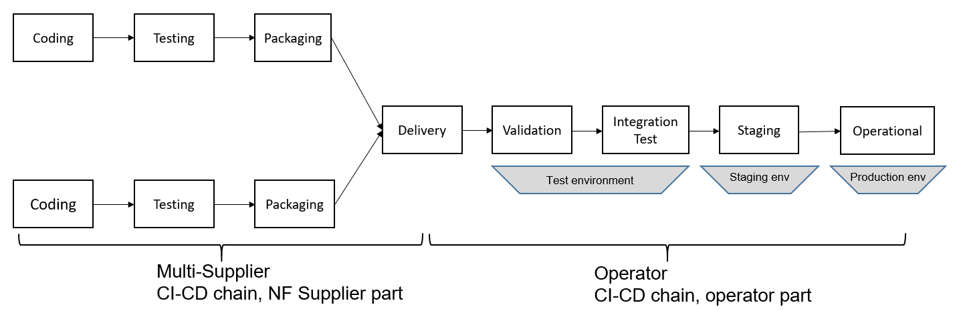
Figure 5.2-2: Multiple NF supplier to single operator
In telco environments (see Figure 5.2-2), the coding, initial testing and package part of the CI-CD chain is typically at the vendor premises, and the validation, integration testing and deployment part is at the operator part. The CI-CD tools used in the operator part is responsible for fetching delivered artifacts, triggering tests, collecting test results and data, deploying software to staging/production environment, collecting operational data and sending feedback to the vendor.

Figure 5.2-3: Vendor and Operator internal processes
As shown in Figure 5.2-3, as one deployment option, the vendor internal CI-CD process can be vender specific work flows, which may include developing, testing, packaging, health status monitoring androllback.

As shown in Figure 5.2-3, as another deployment option, the vendor internal CI-CD process can be vender specific pipeline, which may include developing, validation and testing, packaging, and may support the capability ofnew NF release notification, deployment of new NF and the health status monitoring and rollback.
Additionally, an operator receives software artifacts (for 3GPP NFs) from multiple vendors, and then follows its own internal CI-CD processes (see Figure 5.2-3) as a part of the CI-CD chain before deploying the NF to an operational platform. The internal CI-CD processes are not in scope of this SID. However, there are scenarios in which the CI-CD process interacts with the operators 3GPP Management system. This is the key focus of this study.

End of change

