3GPP TSG-SA5 Meeting #142-e S5-222194rev1

e-meeting, 4 - 12 April 2022

Source: MATRIXX Software

Title: pCR TR 28.827 Add a SMS use case and solution for 7.1

Document for: Apgreement
Agenda Item: 7.5.3

1 Decision/action requested
This pCR is to introduce a new use case (SMS) with potential requirements, key issues and one solution for 7.1

2 References
[1] 3GPP TR 28.827 "Study on 5G charging for additional roaming scenarios and actors"

3 Rationale
This pCR is to introduce a new use case (SMS) with potential requirements, key issues and one solution for 7.1

4 Detailed proposal
The following changes are proposed to be incorporated into TR 28.827 [1]
First change

2 References
The following documents contain provisions which, through reference in this text, constitute provisions of the present document.
- References are either specific (identified by date of publication, edition number, version number, etc.) or non-specific.
- For a specific reference, subsequent revisions do not apply.
- For a non-specific reference, the latest version applies. In the case of a reference to a 3GPP document (including a GSM document), a non-specific reference implicitly refers to the latest version of that document in the same Release as the present document.
[1] 3GPP TR 21.905: "Vocabulary for 3GPP Specifications".
[2] 3GPP TS 23.501:"System Architecture for the 5G System".
[3] GSMA TD.201: "Common Billing and Charging Processes ".
[4] 3GPP TS 32.255:" Charging management;5G Data connectivity domain charging; stage 2".
[5] 3GPP TS 32.256:" Charging management; 5G connection and mobility domain charging; Stage 2".
[6] 3GPP TS 23.502: "Procedures for the 5G System (5GS)".
[x] 3GPP TS 32.274: "Telecommunication management; Charging management; Short Message Service (SMS) charging".

Next change

7.1.1.x Use case #1x: Visited MNO charging home MNO for SMS provided to the home MNO’s subscribers
This use case focuses on visited MNO and home MNO business roles.
A CCS (UE) has a subscription with the home MNO which allows usage of SMS over NAS in 5GS.
The visited MNO to home MNO charging could be based on number of SMS sent or received by the home MNO UEs served by the visited MNO’s network considering of the following aspects:
- RAT type;
- Location

Next change

7.1.2 Potential charging requirements
REQ-CH_VMNO-01: The charging mechanism in visited MNO should support charging based on the 5G data connectivity usage for each home MNO.
REQ-CH_VMNO-02: The charging mechanism in visited MNO should support collecting charging information related to 5G data connectivity usage for each home MNO.
REQ-CH_VMNO-03: The charging mechanism in visited MNO should support charging based on the 5G connection and mobility usage for each home MNO.
REQ-CH_VMNO-04: The charging mechanism in visited MNO should support collecting charging information related to 5G connection and mobility usage for each home MNO.
REQ-CH_VMNO-05: The charging mechanism in visited MNO may support roaming charging profile negotiation related to 5G data connectivity charging with each home MNO for Home Routed roaming case.
REQ-CH_VMNO-xx: The charging mechanism in visited MNO should support charging based on SMS usage for each home MNO.
REQ-CH_VMNO-yy: The charging mechanism in visited MNO should support collecting charging information related to SMS usage for each home MNO.

Next change

7.1.3 Key issues
The following key issues are identified:
- Key Issue #1a: Aggregation of charging information in visited MNO for 5G data connectivity usage per home MNO.
- Key Issue #1b: Aggregation of charging information in visited MNO for 5G connection and mobility usage per home MNO.
- Key Issue #1x: Aggregation of charging information in visited MNO for SMS usage per home MNO.

Next change

7.1.4.x Solution #1.x: CDR in VPLMN for wholesale of SMS

7.1.4.x.1 General
A possible solution for key issue 1x, wholesale charging for SMS provided to the home MNO by the visited MNO.

7.1.4.x.2 Reference architecture

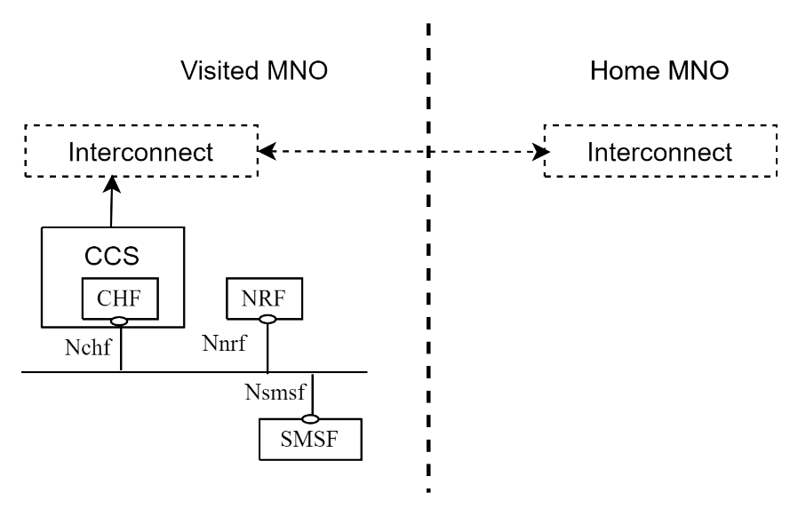
Figure 7.1.4.x.2-1: Roaming SMS in service-based interface representation

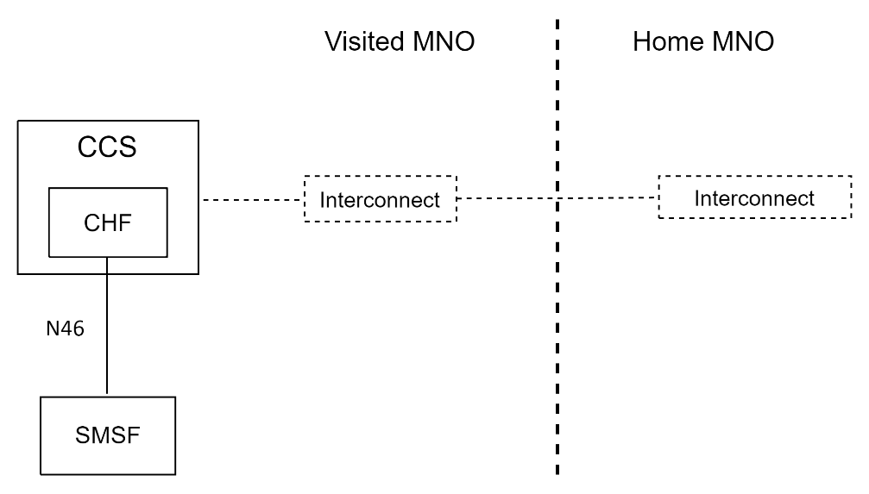
Figure 7.1.4.x.2-2: Roaming SMS in reference point representation
The SMSF with CTF interact with CHF using Nchf interface. The CDRs produced by CHF may be sent for interconnect charging (shown as dashed in the figures), which then can be used to aggregate and calculate the amount of SMSs per home MNO, the interconnect part is only included for completeness and is currently outside the scope of 3GPP SA5.

7.1.4.x.3 Message flows
Figure 7.1.4.x.3-1 shows a scenario for Home MNO UE SMS submission in visited MNO SMSF for PEC mode, based on clause 5.4.2.5 of TS 32.274 [x]
The CDRs generated in the CHF in VPLMN are used as input for wholesale charging of the HPLMN.

Figure 7.1.4.x.3-1: Roaming SMS submission to SMSF – PEC in VPLMN

1- 3. Initial procedures as per clause 5.4.2.5 of TS 32.274 [x].
4. The SMSF in VPLMN sends Charging Data Request [Event] to CHF in VPLMN for the SMS indicating "roamer in".
5. The CHF in VPLMN creates a CDR for this SMS.
6. The CHF in VPLMN acknowledges by sending Charging Data Response [Event] to the SMSF in VPLMN.
7. Forward SMS as per clause 5.4.2.5 of TS 32.274 [x].

End of changes

