3GPP TSG-SA5 Meeting #142-e S5-222179

e-meeting, 4 - 12 April 2022

Source: Apple

Title: Introduction of a solution for KI#6

Document for: Approval
Agenda Item: 7.5.1

1 Decision/action requested
This pCR is to introduce a solution for Key Issue #6: UE Converged Charging based on network slice charging

2 References
[1] 3GPP TR 32.847 "Charging management; Study on Charging Aspects for Network Slicing Phase 2".

3 Rationale
This pCR is to introduce a solution for Key Issue #6: UE Converged Charging based on network slice charging.
This pCR is for the case that Network Operator (NOP) charges NS tenants according to clause 4.3 and clause 4.4, while NOP charges individual UE independent of NS tenants. The support of differentiated individual UE converged charging based on UE served by different Network Slice could be achieved by NS tenants charging individual UE, e.g., according to the SLA between the NS tenant and the UE it served.
A typical example is that NOP provides both network services and network slices to the application provider which is the NS tenant, while the application provider provides different level of service to the UE. Meanwhile, NOP provides network services to the UE without considering which NS serving the UE. According to the models defined in clause 4.1 in TR 32.847 [1], NOP plays the roles of Communication Service Provider (CSP) for the UE and Network Slice Provider (NSP) for the application provider, the application provider plays the role of Network Slice Customer (NSC) and CSP for the UE, UE plays the role of Communication Service Customer (CSC). NOP charges the application provider for providing network slices, while NOP charges UE for providing UE the communication service. NOP charges UE independent of NS tenant can save cost of adjusting CSC payment habit. It is specific implementation that how the application provider charges UE according to the differentiated service level provided to UE by the application providers.

4 Detailed proposal
Propose to incorporate the followings change into the TR 32.847 [1].
First change

6.6.1 General Description
This key issue is for investigating how to support UE Converged Charging influenced by network slice converged charging of the network slice serving the UE.
UE Converged Charging is based on criteria related to the Network Slice serving a UE. For example, the tenant has paid for a Network Slice allowing a large number of UEs and when the load level of network slice is low, wants some UE to be allowed with a lower tariff for using Network resources.
UE Converged Charging can be handled by NOP independently with NOP charging the NS tenant which serving the UE. The support of differentiated individual UE converged charging based on UE served by different Network Slice could be achieved by NS tenants charging individual UE, e.g., according to the SLA between the NS tenant and the UE it served.
This investigation covers the following:
- determination of which entity/entities is/are suitable to provide the network slice level of charging information for UE Converged Charging.
- determination of the main interactions for UE Converged Charging to be influenced by network slice converged charging.
- identification of the main charging information.

Second change

6.6.x Solution#6.x CCS for independent charging of NS tenant and UE

6.6.x.1 General description
This solution addresses the Key Issue#6 for REQ-NSCH-01, and REQ-NSCH-11 potential requirements.
According to the models defined in clause 4.1 NOP plays NSP for NS tenant and CSP for individual UE, and NS tenant plays the role of NSC and CSP for individual UE, and individual UE plays the role of CSC.
The Converged Charging System (CCS) handles NS tenant charging and individual UE charging independently by CHF generating separate CDR files for NS tenant and individual UE.
The CCS performs charging functionalities for individual UEs, and includes in particular:
- CHF exposing Nchf services associated to individual UEs.
- ABMF hosting individual UE account balance, provisioned with all necessary information related to subscribed-to services the UE has paid for.
The CCS performs charging functionalities for NS tenant, and includes in particular:
- CHF exposing Charging service(s) associated to NS-tenant.
- ABMF contains NS-tenant account balance, provisioned with all necessary information related to the Network Slice matching SLS requirements the NS-tenant has paid for,
- The subscription description includes in particular. the list of service profiles subscribed-to by the NS-tenant, each service profile with assigned group of S-NSSAI(s).
The UE 5G data connectivity converged charging from SMF is specified in 3GPP TS 32.255 [9] and uses Nchf_ConvergedCharging service exposed by UE CCS for individual UE PDU session charging.
The Registration management converged charging from AMF is specified in 3GPP TS 32.256 [10] and uses Nchf_ConvergedCharging service exposed by UE CCS for individual UE registration.

6.6.x.2 Architecture description

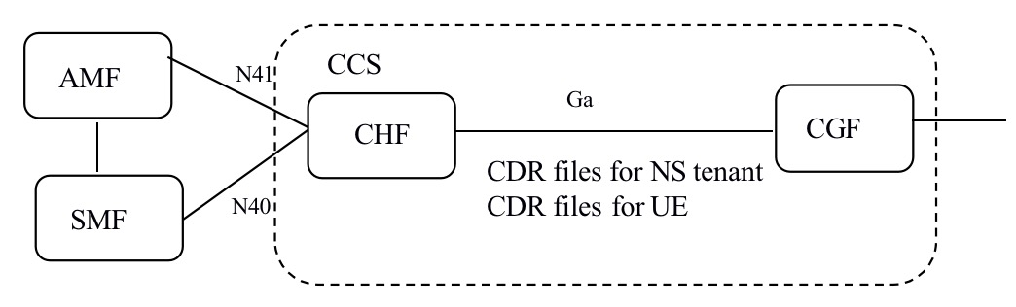
Figure 6.6.x.2-1: Charging architecture for independent charging of NS tenant and UE
CHF supports generating CDR files for NS tenant and individual UE separately.
Ga supports CDR files for NS tenant and CDR files for individual UE independent transmission to CGF.

6.6.x.3 Flow description
The procedure for NS tenant converged charging refers to the solutions of dedicated NS tenant CCS.
The procedure for UE 5G data connectivity converged charging from SMF refers to specification in 3GPP TS 32.255 [9] and the Registration management converged charging from AMF in 3GPP TS 32.256 [10].

End of changes

