**3GPP TSG-SA5 Meeting #142-e *S5-222119***

**e-meeting, 4 - 12 April 2022**

|  |  |  |  |  |  |  |  |  |
| --- | --- | --- | --- | --- | --- | --- | --- | --- |
| *CR-Form-v12.1* | | | | | | | | |
| **CHANGE REQUEST** | | | | | | | | |
|  | | | | | | | | |
|  |  | **CR** |  | **rev** |  | **Current version:** |  |  |
|  | | | | | | | | |
| *For* [***HE******LP***](http://www.3gpp.org/3G_Specs/CRs.htm#_blank)*on using this form: comprehensive instructions can be found at* [*http://www.3gpp.org/Change-Requests*](http://www.3gpp.org/Change-Requests)*.* | | | | | | | | |
|  | | | | | | | | |

|  |  |  |  |  |  |  |  |  |
| --- | --- | --- | --- | --- | --- | --- | --- | --- |
| ***Proposed change affects:*** | UICC apps |  | ME |  | Radio Access Network | **X** | Core Network |  |

|  |  |  |  |  |  |  |  |  |  |  |
| --- | --- | --- | --- | --- | --- | --- | --- | --- | --- | --- |
|  | | | | | | | | | | |
| ***Title:*** | Rel-16 CR 28.541 Diagram fix for NRM fragment for RRM policies | | | | | | | | | |
|  |  | | | | | | | | | |
| ***Source to WG:*** | Nokia, Nokia Shanghai Bell | | | | | | | | | |
| ***Source to TSG:*** | S5 | | | | | | | | | |
|  |  | | | | | | | | | |
| ***Work item code:*** | TEI16 | | | | |  | ***Date:*** | | | 2022-03-22 |
|  |  | | | |  | |  | | |  |
| ***Category:*** |  |  | | | | | ***Release:*** | | | Rel-16 |
|  | *Use one of the following categories:* ***F*** *(correction)* ***A*** *(mirror corresponding to a change in an earlier release)* ***B*** *(addition of feature),* ***C*** *(functional modification of feature)* ***D*** *(editorial modification)*  Detailed explanations of the above categories can be found in 3GPP [TR 21.900](http://www.3gpp.org/ftp/Specs/html-info/21900.htm). | | | | | | | | *Use one of the following releases: Rel-8 (Release 8) Rel-9 (Release 9) Rel-10 (Release 10) Rel-11 (Release 11) … Rel-15 (Release 15) Rel-16 (Release 16) Rel-17 (Release 17) Rel-18 (Release 18)* | |
|  |  | | | | | | | | | |
| ***Reason for change:*** | | NRM fragment for RRM policies is incomplete | | | | | | | | |
|  | |  | | | | | | | | |
| ***Summary of change:*** | | * Renaming the current NRM fragment to indicate that this is for abstract RRM Policies * Explicitly represent the NRM fragment of one specific implementation of abstract RRM policy (RRMPolicyRatio)   Figure 4.2.1.1-6 has been modified and new figure 4.2.1.1-x has been added to reflect the above two points. | | | | | | | | |
|  | |  | | | | | | | | |
| ***Consequences if not approved:*** | | Incomplete standards leads to confusion | | | | | | | | |
|  | |  | | | | | | | | |
| ***Clauses affected:*** | | 4.2.1.1 | | | | | | | | |
|  | |  | | | | | | | | |
|  | | **Y** | **N** |  | | | |  | | |
| ***Other specs*** | |  | **X** | Other core specifications | | | | TS/TR ... CR ... | | |
| ***affected:*** | |  | **X** | Test specifications | | | | TS/TR ... CR ... | | |
| ***(show related CRs)*** | |  | **X** | O&M Specifications | | | | TS/TR ... CR ... | | |
|  | |  | | | | | | | | |
| ***Other comments:*** | |  | | | | | | | | |
|  | |  | | | | | | | | |
| ***This CR's revision history:*** | |  | | | | | | | | |

***First changes***

4.2.1.1 Relationships

This clause depicts the set of classes (e.g. IOCs) that encapsulates the information relevant for this gNB and en-gNB. For the UML semantics, see 3GPP TS 32.156 [43]. Subsequent clauses provide more detailed specification of various aspects of these classes.

The model fragments are for management representation of gNB and en-gNB for all NG-RAN deployment scenario as listed below:

- Non-split NG-RAN deployment scenario, represents the gNB defined in 3GPP TS 38.401[4]. In this scenario, a gNB is represented by a combination of a GNBCUCPFunction, one or more GNBCUUPFunctions and one or more GNBDUFunctions.

- 2-split NG-RAN deployment scenario, represents the gNB consist of gNB-CU and gNB-DU defined in 3GPP TS 38.401[4] clause 6.1.1. In this scenario, a gNB-CU is represented by a combination of a GNBCUCPFunction and one or more GNBCUUPFunctions, whereas a gNB-DU is represented by a GNBDUFunction.

- 3-split NG-RAN deployment scenario, represents the gNB consist of gNB-CU-CP, gNB-CU-UP and gNB-DU defined in 3GPP TS 38.401[4] clause 6.1.2. In this scenario, a gNB-CU-CP is represented by a GNBCUCPFunction, a gNB-CU-UP is represented by a GNBCUUPFunction, and a gNB-DU is represented by a GNBDUFunction.

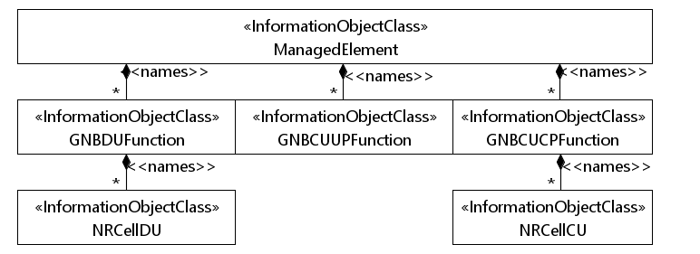

**Figure 4.2.1.1-1: NRM for all deployment scenarios**

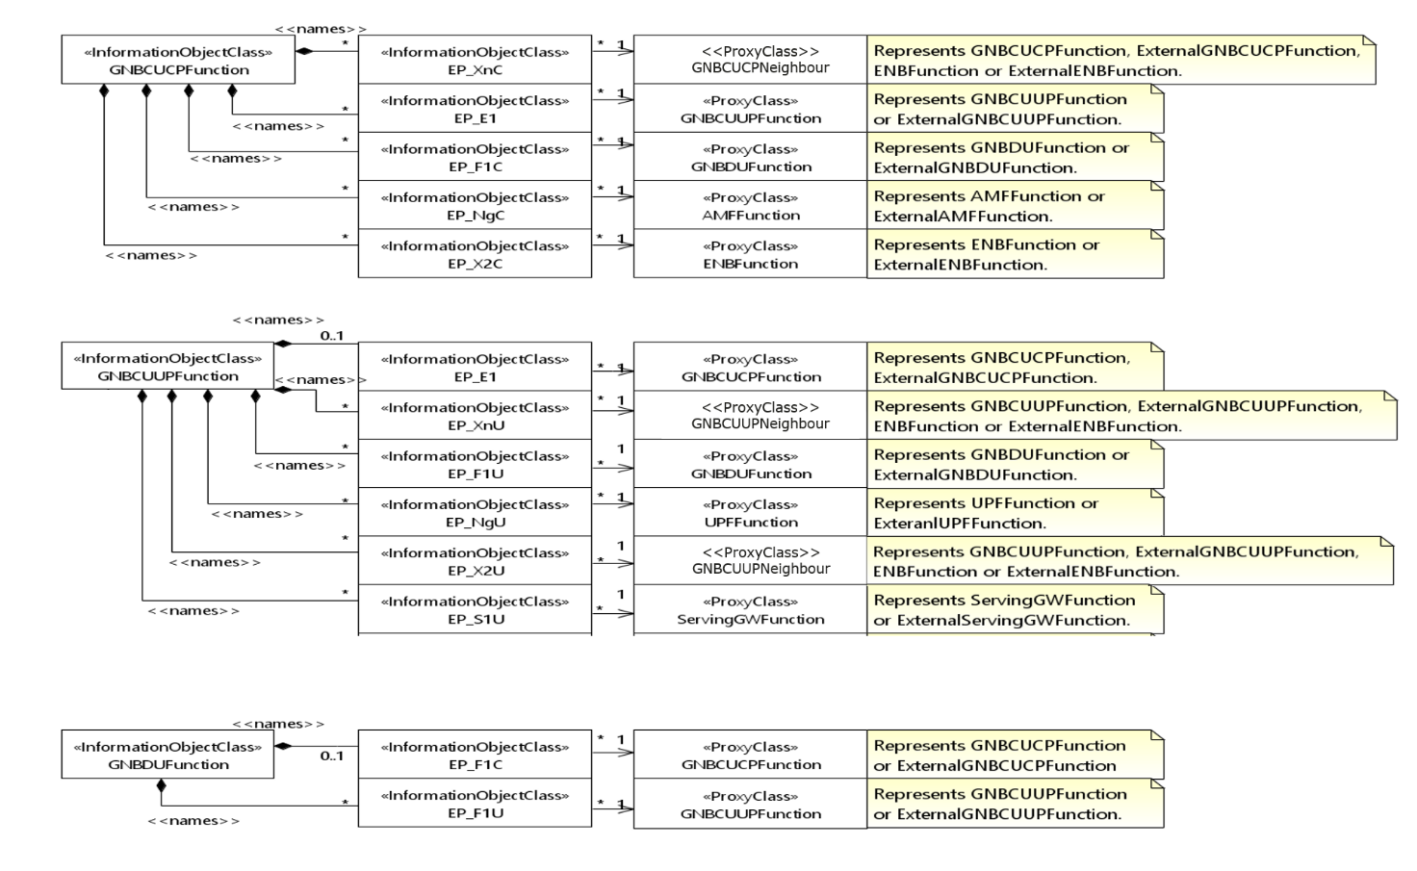

**Figure 4.2.1.1-2: NRM for EPs for all deployment scenarios**

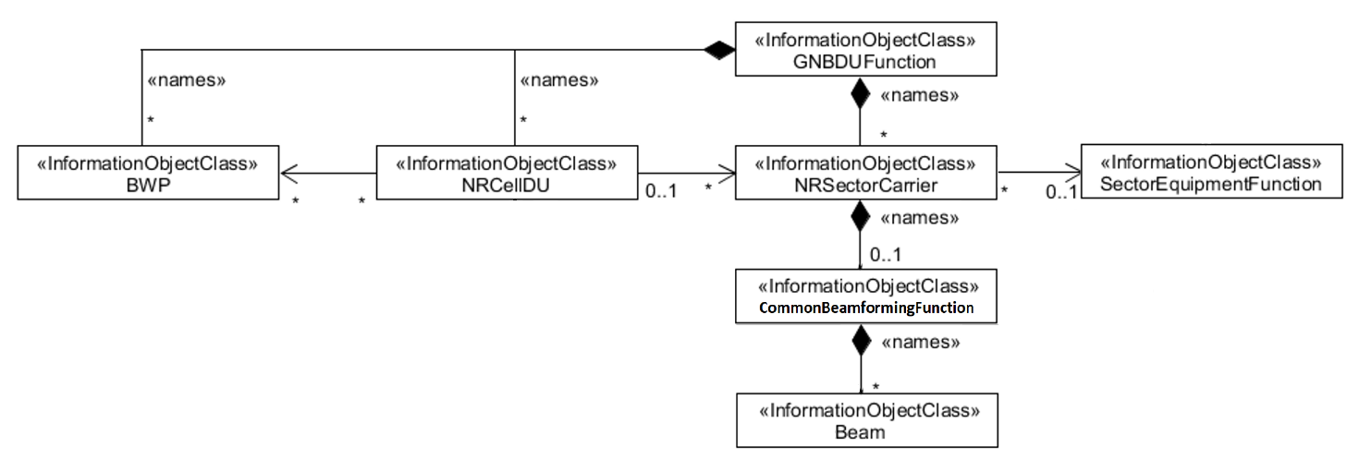

**Figure 4.2.1.1-3: NRM for <<IOC>>NRSectorCarrier and <<IOC>>BWP for all deployment scenarios**

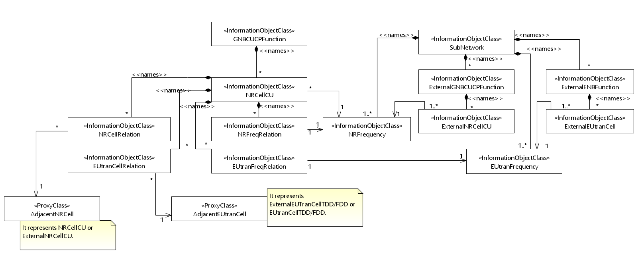

**Figure 4.2.1.1-4: Cell Relation view for all deployment scenarios**

NOTE 1: The above NRM fragment uses SubNetwork to hold both NR and LTE external entities and frequencies.

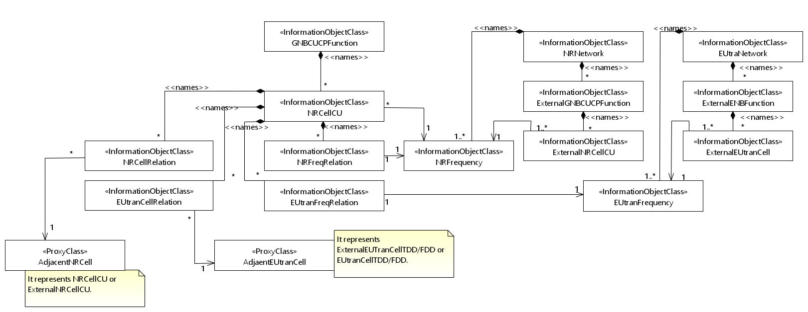

**Figure 4.2.1.1-5: Cell Relation view for all deployment scenarios**

NOTE 2: The above NRM fragment uses NRNetwork to hold NR external entities and frequency and using EUtraNetwork to hold LTE external entities and frequency. The NRNetwork and EUtraNetwork are subclasses of SubNetwork (defined in 3GPP TS 28.622 [30]) with no additional attributes. The reason using NRNetwork and EUtraNetwork is for a clean separation of NR external entities and frequency and LTE external entities and frequency.



**Figure 4.2.1.1-6: NRM fragment for abstract RRM Policies**

**Figure 4.2.1.1-x: NRM fragment for RRMPolicyRatio**

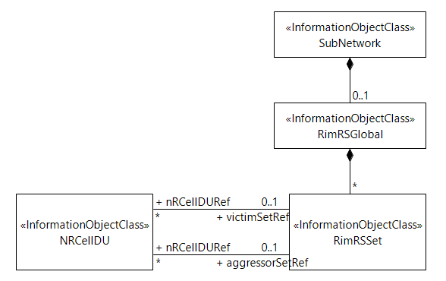

**Figure 4.2.1.1-7: NRM fragment to support RIM**

Figure 4.2.1.1-8 shows the NRM fragment for pre-configured 5QIs in NG-RAN.



**Figure 4.2.1.1-8: NRM fragment for pre-configured 5QIs in NG-RAN**

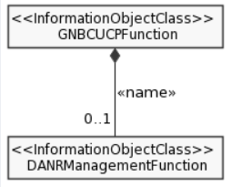

**Figure 4.2.1.1-9: NRM fragment for DANR Management**

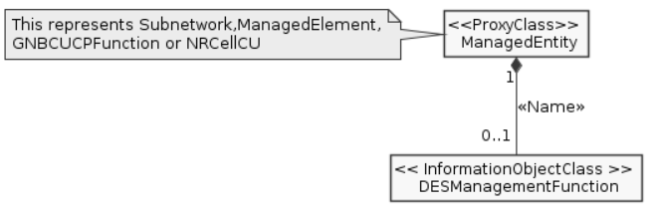

**Figure 4.2.1.1-10: NRM fragment for DES Management**



**Figure 4.2.1.1-11: NRM fragment for DRACH Management**



**Figure 4.2.1.1-12: NRM fragment for DMRO Management**



**Figure 4.2.1.1-13: NRM fragment for DPCI Management**

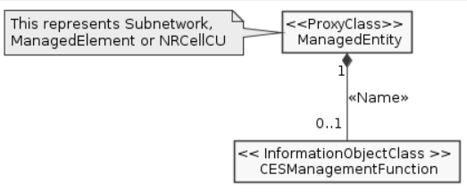

**Figure 4.2.1.1-14: NRM fragment for CES Management**

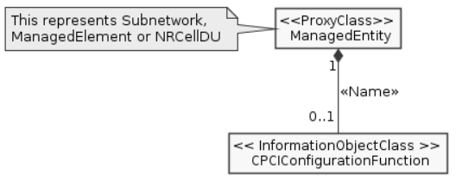

**Figure 4.2.1.1-15: NRM fragment for CPCI Management**

Figure 4.2.1.1-16 shows the NRM fragment for dynamically assigned 5QIs in NG-RAN.



**Figure 4.2.1.1-16: NRM fragment for dynamically assigned 5QIs in NG-RAN**

***End of changes***