3GPP TSG-SA5 Meeting #141-e S5-221714d8

e-meeting, 17 - 26 January 2022

Source: Alibaba

Title: Key issue and solution on exposure interface via OSS

Document for: Approval
Agenda Item: 6.5.2

1 Decision/action requested
The group is asked to agree the text in detailed proposal.

2 References
Not applicable

3 Rationale
This contribution proposes key issue and solution on exposure interface via OSS.

4 Detailed proposal

First change

2 References
The following documents contain provisions which, through reference in this text, constitute provisions of the present document.
- References are either specific (identified by date of publication, edition number, version number, etc.) or non-specific.
- For a specific reference, subsequent revisions do not apply.
- For a non-specific reference, the latest version applies. In the case of a reference to a 3GPP document (including a GSM document), a non-specific reference implicitly refers to the latest version of that document in the same Release as the present document.
[1] 3GPP TR 21.905: "Vocabulary for 3GPP Specifications".
[2] TM Forum TMF622 Product Order API REST Specification
[3] TM Forum TMF641 Service Ordering API
[4] TM Forum TMF652 Resource Order Management API
[5] 3GPP TS 28.531: "Management and orchestration; Concepts, use cases and requirements"
[6] 3GPP TS 28.202: "Charging management; Network slice management charging in the 5G System (5GS); Stage 2"
[7] 3GPP TR23.700-99 “Study on Network Slice Capability Exposure for Application Layer Enablement (NSCALE)”

[8] 3GPP TS23.434 “Service Enabler Architecture Layer for Verticals (SEAL); Functional architecture and information flows.”
[9] 3GPP TS 28.541: "Management and orchestration; 5G Network Resource Model (NRM); Stage 2 and stage 3"
[10] 3GPP TS 28.533: "Management and orchestration; Architecture framework"
2nd change

4.2.6 Issue #6: Network slice management capability exposure interface via OSS

Use cases regarding exposure interface via OSS has been introduced in Section 6. NSC can make contract with the NSP or CSP regarding exposure via BSS. Upon the completion of the contact, the NSC can directly get access to the OSS within the NSP or CSP for access the exposed MnS. Several key issues exist for the use cases. For example, how does the NSC identifies the address of MnS producer for the exposed MnS within the OSS and how to consume the exposed MnS directly from OSS needs to be addressed.

3rd change

7.X Possible solutions for exposed MnS consumption via OSS interface

This clause introduces the solution for the use case described in clause 5.6, where the NSC can directly interact with OSS for the consumption of exposed MnS.
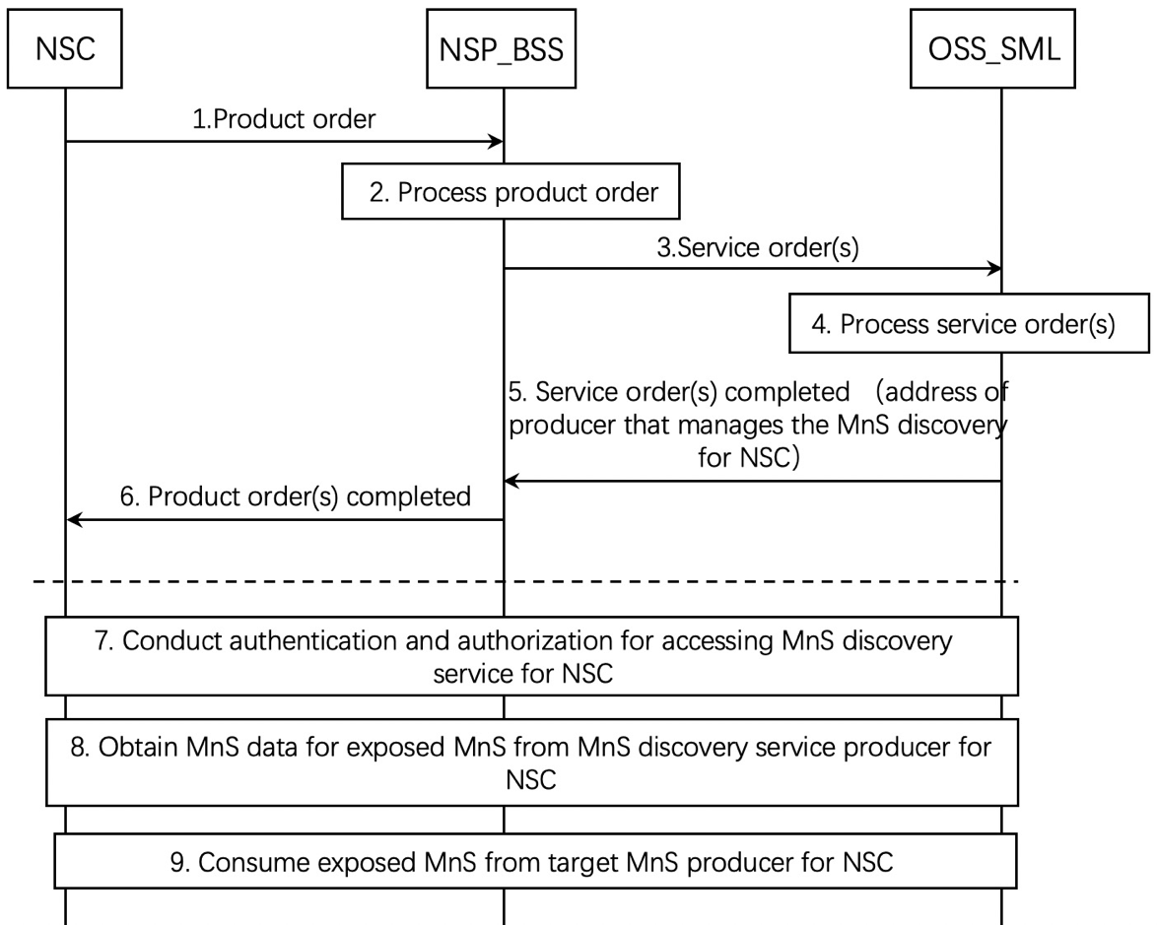

Figure 5.11.2.1-1 Exposed MnS consumption via OSS interface
1. The NSP receives a product order from the NSC through BSS. The interface used towards the BSS is specified by TM Forum specifications [2].
2. The BSS processes the product order and when applicable converts it to appropriate service order(s) for the OSS Service Management Layer. This is internal to BSS and there are no interface requirements.
3. The OSS Service Management Layer receives a service order from the BSS. The interface used is specified by TM Forum specifications [3].
4. The MnS producer for NSC (e.g. NSMF) on the OSS Service Management Layer processes the service order and when applicable converts it to appropriate request(s) for the OSS Network Management Layer as requests for management and orchestration of resources. In addition, MnS producer on the OSS Service Management Layer can decides to expose MnS directly from OSS_SML and prepares the address of MnS discovery service producer for NSC that can be accessed by the NSC and related authorization information (e.g. token) for accessing the MnS discovery service for NSC. The service order may trigger a procedure of resource order with OSS_NML.

5. The MnS producer for NSC on OSS Service Management Layer notifies the BSS that the service order has been completed. In addition, the notification may contain the address of producer that manages the MnS discovery service for NSC to access and also identities of the related MOIs which is related to the exposed MnSs that the NSC requests. The interface used is specified by TM Forum specifications [3].

NOTE 1: The MnS discovery service producer for NSC can be within the OSS or outside the OSS.
6. The BSS notifies the NSC that the product order has been completed. In addition, the address of MnS discovery producer for NSC and the related authorization information (e.g. token) for accessing the MnS discovery service for NSC are sent to the NSC by the product order completed message. The interface used the interface towards the BSS is specified by TM Forum specifications [2].
7. If the notification in step 6 contains the address of MnS discovery service producer for NSC, the NSC conducts authentication and authorization for accessing exposed MnS discovery service.
8. After the authentication and authorization, the NSC obtains the MnS data for exposed MnS, which contains the information of the exposed MnS instance and the address of target MnS producer for NSC. The MnS data for exposed MnS is the data for authorized MSC to identify proper MnS producer which produces the exposed MnS.

9. After obtaining the information of the MnS data for exposed MnS, the NSC identifies the target MnS producer for NSC and consumes the exposed MnS. To consider the security, the MnS producer may leverage a dedicated MnF which controls the exposure governance as a proxy for exposing MnS.

4th change

6 Potential requirements for network management capability exposure

6.2 Potential requirements related to exposure interface via OSS
- REQ-NSCE-03 The 3GPP management system may provide capabilities to authenticate and authorize NSC to consume exposed MnS directly from 3GPP management system.

End of changes

