3GPP TSG-SA5 Meeting #141-e S5-221073

January 17 – 26, 2022, e-Meeting Revision of s5-abvde
CR-Form-v11.4
CHANGE REQUEST
 | 28.541 | CR | 0650 | rev | - | Current version: | 17.5.0
For HELP on using this form: comprehensive instructions can be found at
http://www.3gpp.org/Change-Requests.

Proposed change affects: | UICC apps |  | ME |  | Radio Access Network |  | Core Network | X

Title: | Add Stage 2 solutions to support ECM
Source to WG: | Intel
Source to TSG: | S5
Work item code: | ECM |  |  |  |  |  | Date: |  |  | 2022-01-07
Category: | B |  |  |  |  |  | Release: |  |  | Rel-17
 | Use one of the following categories:  F (correction)  A (mirror corresponding to a change in an earlier release)  B (addition of feature),  C (functional modification of feature)  D (editorial modification)  Detailed explanations of the above categories can  be found in 3GPP TR 21.900. |  |  |  |  |  |  |  | Use one of the following releases:  Rel-8 (Release 8)  Rel-9 (Release 9)  Rel-10 (Release 10)  Rel-11 (Release 11)  Rel-12 (Release 12)  Rel-13 (Release 13)  Rel-14 (Release 14)  Rel-15 (Release 15)  Rel-16 (Release 16)
Reason for change: |  | Stage 2 solutions are needed to support ECM NRM defined in TS 28.538. .
Summary of change: |  | Add Stage 2 solutions to support ECM.
Consequences if not approved: |  | ECM NRM is not complete.
Clauses affected: |  | Clause 2, clause 5.1, Figure 5.2.1.1-25 (new), Figure 5.2.1.1-26 (new), Figure 5.2.1.2-9 (new), Figure 5.2.1.2-10 (new), clause 5.3.x, 5.3.y, 5.3.z, 5.3.v (new), clause 4.4.1
 |  | Y | N
Other specs |  |  | X | Other core specifications |  |  |  | TS/TR ... CR ...
affected: |  |  | X | Test specifications |  |  |  | TS/TR ... CR ...
(show related CRs) |  |  | X | O&M Specifications |  |  |  | TS/TR ... CR ...
Other comments:

1st Modified Section

2 References
The following documents contain provisions which, through reference in this text, constitute provisions of the present document.
- References are either specific (identified by date of publication, edition number, version number, etc.) or non-specific.
- For a specific reference, subsequent revisions do not apply.
- For a non-specific reference, the latest version applies. In the case of a reference to a 3GPP document (including a GSM document), a non-specific reference implicitly refers to the latest version of that document in the same Release as the present document.
[1] 3GPP TR 21.905: "Vocabulary for 3GPP Specifications".
[2] 3GPP TS 23.501: "System Architecture for the 5G System".
[3] 3GPP TS 38.300: "NR; Overall description; Stage-2".
[4] 3GPP TS 38.401: "NG-RAN; Architecture description".
[5] 3GPP TS 38.413: "NG-RAN; NG Application Protocol (NGAP)".
[6] 3GPP TS 38.420: "NG-RAN; Xn general aspects and principles".
[7] 3GPP TS 38.470: "NG-RAN; F1 general aspects and principles".
[8] 3GPP TS 38.473: "NG-RAN; F1 application protocol (F1AP)".
[9] 3GPP TS 37.340: "NR; Multi-connectivity; Overall description; Stage 2".
[10] 3GPP TS 28.540: "Management and orchestration; 5G Network Resource Model (NRM);Stage 1".
[11] 3GPP TS 28.662: "Telecommunication management; Generic Radio Access Network (RAN) Network Resource Model (NRM) Integration Reference Point (IRP); Information Service (IS) ".
[12] 3GPP TS 38.104: "NR; Base Station (BS) radio transmission and reception".
[13] 3GPP TS 23.003: "Numbering, Addressing and Identification".
[14] 3GPP TS 36.410: "Evolved Universal Terrestrial Radio Access Network (E-UTRAN); S1 general aspects and principles".
[15] 3GPP TS 36.423: "Evolved Universal Terrestrial Radio Access Network (E-UTRAN); X2 application protocol".
[16] 3GPP TS 36.425: "Evolved Universal Terrestrial Radio Access Network (E-UTRAN); X2 interface user plane protocol".
[17] 3GPP TS 28.625: "State Management Data Definition Integration Reference Point (IRP); Information Service (IS)".
[18] ITU-T Recommendation X.731: "Information technology - Open Systems Interconnection - Systems Management: State management function".
[19] 3GPP TS 28.658: "Telecommunications management; Evolved Universal Terrestrial Radio Access Network (E-UTRAN) Network Resource Model (NRM) Integration Reference Point (IRP): Information Service (IS)".
[20] 3GPP TS 28.702: "Core Network (CN) Network Resource Model (NRM) Integration Reference Point (IRP); Information Service (IS)".
[21] 3GPP TS 28.708: "Telecommunication management; Evolved Packet Core (EPC) Network Resource Model (NRM) Integration Reference Point (IRP): Information Service (IS)".
[22] 3GPP TS 23.040: "Technical realization of the Short Message Service (SMS)".
[23] 3GPP TS 29.510: "5G system; Network Function Repository Services; Stage 3".
[24] 3GPP TS 29.531: "5G System; Network Slice Selection Services Stage 3".
[25] Void.
[26] 3GPP TS 28.531: "Management and orchestration; Provisioning".
[27] 3GPP TS 28.554: "Management and orchestration; 5G End to end Key Performance Indicators (KPI)".
[28] 3GPP TS 22.261: "Service requirements for next generation new services and markets".
[29] ETSI GS NFV-IFA 013 V2.4.1 (2018-02) "Network Function Virtualisation (NFV); Management and Orchestration; Os-Ma-nfvo Reference Point - Interface and Information Model Specification".
[30] 3GPP TS 28.622: "Telecommunication management; Generic Network Resource Model (NRM) Integration Reference Point (IRP); Information Service (IS)".
[31] Void.
[32] 3GPP TS 38.211: "NR; Physical channels and modulation".
[33] 3GPP TS 32.616: "Telecommunication management; Configuration Management (CM); Bulk CM Integration Reference Point (IRP); Solution Set (SS) definitions".
[34] 3GPP TS 28.623: "Telecommunication management; Generic Network Resource Model (NRM) Integration Reference Point (IRP); Solution Set (SS) definitions".
[35] 3GPP TS 28.532: "Management and orchestration; Management services".
[36] Void.
[37] IETF RFC 791: "Internet Protocol".
[38] IETF RFC 2373: "IP Version 6 Addressing Architecture".
[39] IEEE 802.1Q: "Media Access Control Bridges and Virtual Bridged Local Area Networks".
[40] ETSI GR NFV-IFA 015 (V2.4.1): "Network Function Virtualisation (NFV) Release 2; Management and Orchestration; Report on NFV Information Model".
[41] 3GPP TS 38.213: "NR; Physical layer procedures for control".
[42] 3GPP TS 38.101-1: "NR; User Equipment (UE) radio transmission and reception; Part 1: Range 1 Standalone".
[43] 3GPP TS 32.156: "Telecommunication management; Fixed Mobile Convergence (FMC) model repertoire".
[44] IETF RFC 4122: "A Universally Unique IDentifier (UUID) URN Namespace".
[45] IETF RFC 8528: "YANG Schema Mount".
[46] Void
[47] 3GPP TS 32.160: "Management and orchestration; Management Service Template".
[48] 3GPP TS 38.463: "NG-RAN; E1 application protocol (E1AP)".
[49] 3GPP TS 38.304: "NR; User Equipment (UE) procedures in Idle mode and RRC Inactive state".
[50] GSMA NG.116 - Generic Network Slice Template Version 3.0 (2020-05-22).
[51] 3GPP TS 22.104: "Service requirements for cyber-physical control applications in vertical domains; Stage 1".
[52] 3GPP TS 33.501: "Security architecture and procedures for the 5G System".
[53] 3GPP TS 38.901: "Study on channel model for frequencies from 0.5 to 100 GHz ".
[54] 3GPP TS 38.331: "NR; Radio Resource Control (RRC) protocol specification".
[55] 3GPP TS 38.215: "NR; Physical layer measurements".
[56] 3GPP TS 29.244: "Technical Specification Group Core Network and Terminals; Interface between the Control Plane and the User Plane Nodes; Stage 3".
[57] 3GPP TS 28.313: "Self-Organizing Networks (SON) for 5G networks".
[58] 3GPP TS 38.423: "NR; Xn application protocol (XnAP)".
[59] 3GPP TS 23.503: "Policy and Charging Control Framework for the 5G System; Stage 2".
[60] 3GPP TS 29.512: "5G System; Session Management Policy Control Service; Stage 3".
[61] 3GPP TS 29.571: "5G System; Common Data Types for Service Based Interfaces; Stage 3".
[62] 3GPP TS 29.214: "Policy and Charging Control over Rx reference point".
[63] IETF RFC 7042: "IANA Considerations and IETF Protocol and Documentation Usage for IEEE 802 Parameters".
[64] IEEE 802.3-2015: "IEEE Standard for Ethernet".
[65] IEEE 802.1Q-2014: "Bridges and Bridged Networks".
[66] IETF RFC 4301: "Security Architecture for the Internet Protocol".
[67] 3GPP TS 29.514: "5G System; Policy Authorization Service; Stage 3".
[68] 3GPP TS 32.422: "Telecommunication management; Subscriber and equipment trace; Trace control and configuration management".
[69] 3GPP TS 28.552: "Management and orchestration; 5G performance measurements".
[70] 3GPP TS 28.530: "Management and orchestration; Concepts, use cases and requirements".
[71] 3GPP TS 28.310: "Management and orchestration; Energy efficiency of 5G".
[72] 3GPP TS 28.705: "Telecommunication management; IP Multimedia Subsystem (IMS) Network Resource Model (NRM) Integration Reference Point (IRP); Information Service (IS)".
[73] 3GPP TS 23.304: " Proximity based Services (ProSe) in the 5G System".
[74] IETF RFC 8436: " Update to IANA Registration Procedures for Pool 3 Values in the Differentiated Services Field Codepoints (DSCP) Registry".
[75] ECMA-262: "ECMAScript® Language Specification", https://www.ecma-international.org/ecma-262/5.1/.
[76] 3GPP TS 29.500: "5G System; Technical Realization of Service Based Architecture; Stage 3".
[77] IANA: "SMI Network Management Private Enterprise Codes", http://www.iana.org/assignments/enterprise-numbers.
[78] 3GPP TS 23.548:" 5G System Enhancements for Edge Computing; Stage 2".
[79] 3GPP TS 28.538: "Edge Computing Management".
[80] 3GPP TS 29.518: "5G System; Access and Mobility Management Services; Stage 3".
[x] 3GPP TS 23.558: “Architecture for enabling Edge Applications”.

Next Modified Section

5 Information Model definitions for 5GC NRM

5.1 Imported information entities and local labels

Label reference | Local label
TS 28.622 [30], IOC, SubNetwork | SubNetwork
TS 28.622 [30], IOC, ManagedElement | ManagedElement
TS 28.622 [30], IOC, ManagedFunction | ManagedFunction
TS 28.622 [30], IOC, EP_RP | EP_RP
TS 28.708 [21], IOC, ServingGWFunction | ServingGWFunction
TS 28.702 [20], IOC, SmsIwmscFunction | SmsIwmscFunction
TS 28.702 [20], IOC, SmsGmscFunction | SmsGmscFunction
TS 28.702 [20], IOC, GmlcFunction | GmlcFunction
TS 28.658 [19], dataType, PLMNId | PLMNId
TS 25.538 [79], IOC, EASFunction | EASFunction
TS 25.538 [79], IOC, EESFunction | EESFunction
TS 25.538 [79], IOC, ECSFunction | ECSFunction
TS 28.538 [79], datatype, ServingLocation | ServingLocation

5.2 Class diagram

5.2.1 Class diagram of 5GC NFs

5.2.1.1 Relationships
This clause depicts the set of classes (e.g. IOCs) that encapsulates the information relevant for NRM of 5GC NFs definitions. This clause provides the overview of the relationships of relevant classes in UML. Subsequent clauses provide more detailed specification of various aspects of these classes.
The Figure 5.2.1.1-1 shows the 5GC NF NRM containment/naming relationship.
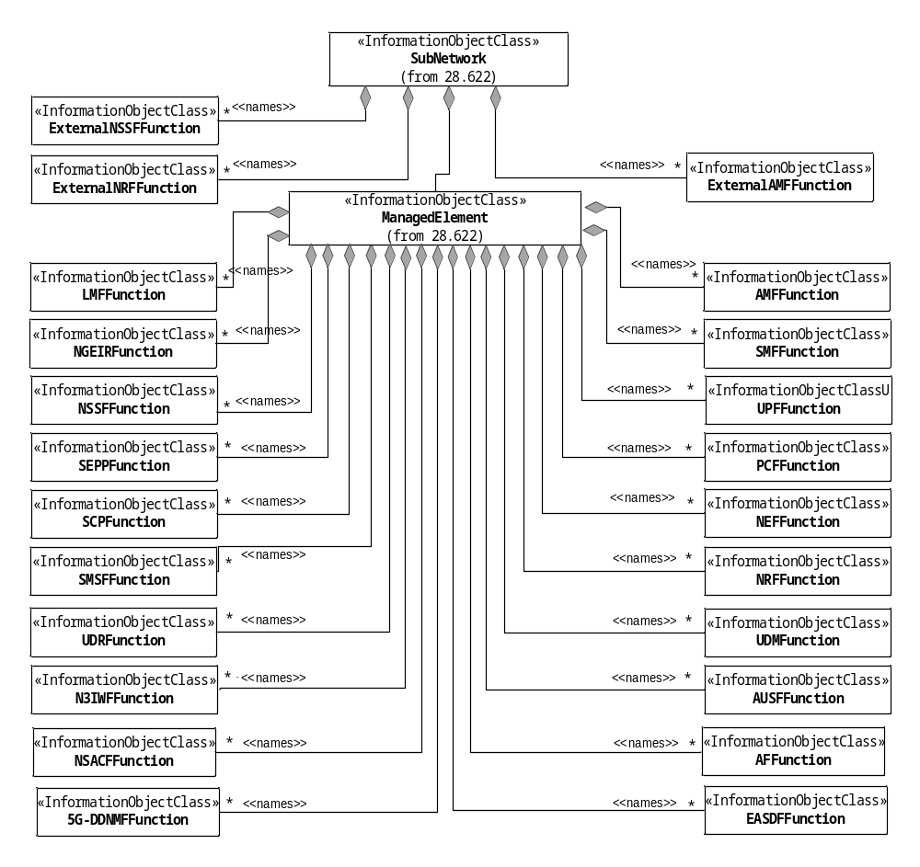
Figure 5.2.1.1-1: 5GC NRM containment/naming relationship
The Figure 5.2.1.1-2 shows the transport view of AMF NRM.
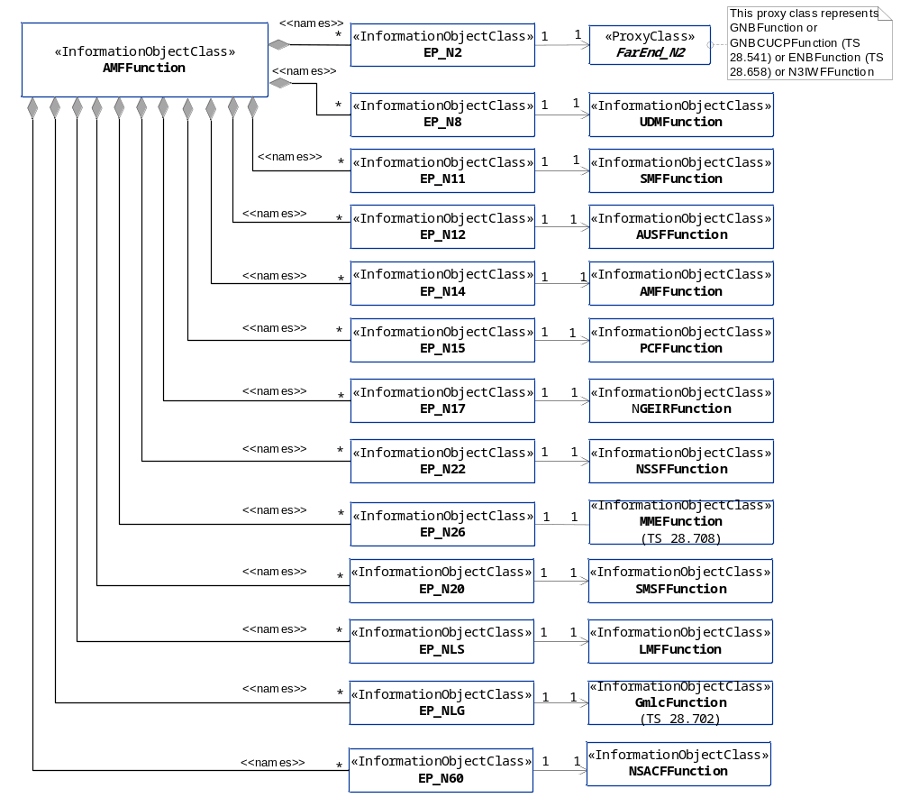
Figure 5.2.1.1-2: Transport view of AMF NRM
The Figure 5.2.1.1-3 shows the transport view of SMF NRM.
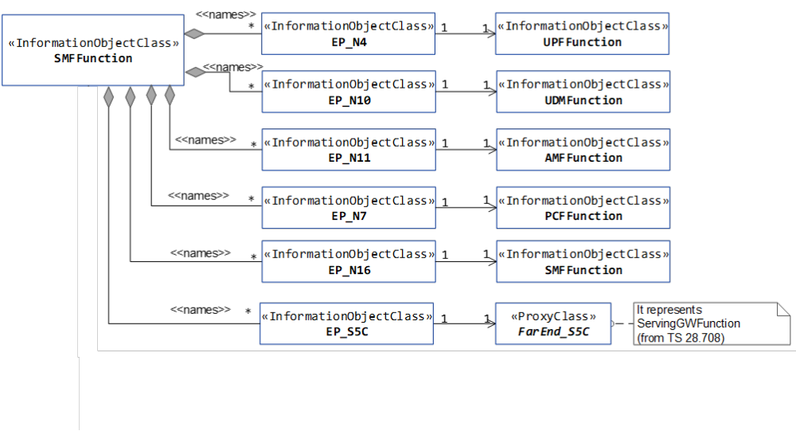
Figure 5.2.1.1-3: Transport view of SMF NRM
The Figure 5.2.1.1-4 shows the transport view of UPF NRM.
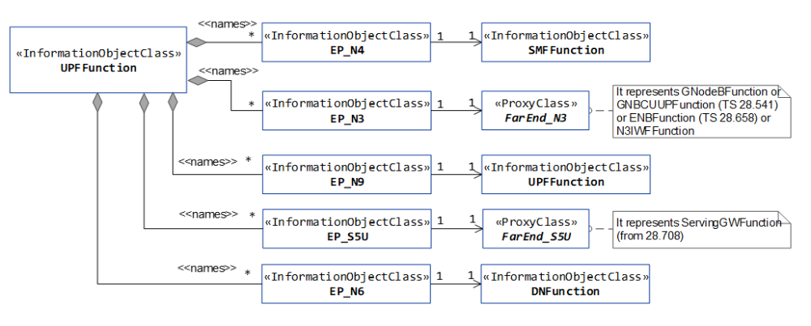
Figure 5.2.1.1-4: Transport view of UPF NRM
The Figure 5.2.1.1-5 shows the transport view of N3IWF NRM.
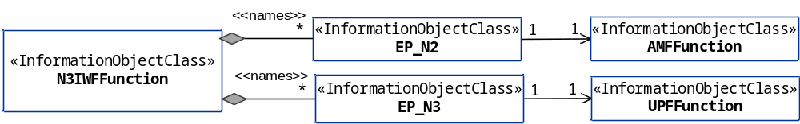
Figure 5.2.1.1-5: Transport view of N3IWF NRM
The Figure 5.2.1.1-6 shows the transport view of PCF NRM.
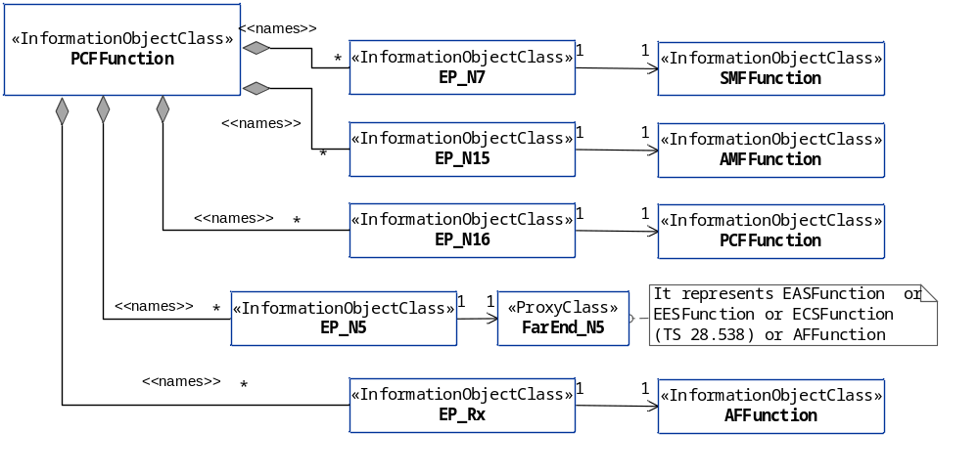
Figure 5.2.1.1-6: Transport view of PCF NRM
The Figure 5.2.1.1-7 shows the transport view of AUSF NRM.
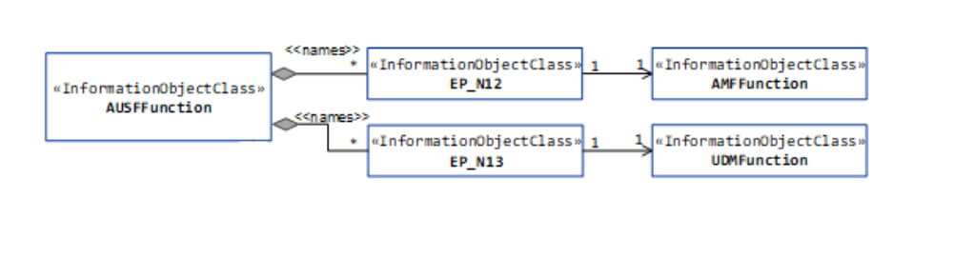
Figure 5.2.1.1-7: Transport view of AUSF NRM
The Figure 5.2.1.1-8 shows the transport view of UDM NRM.
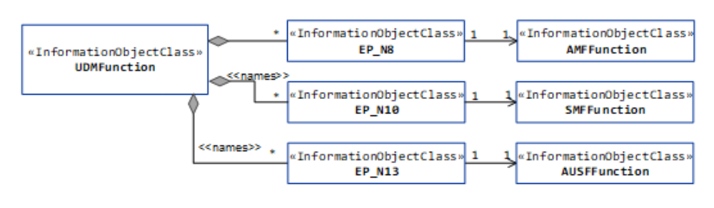
Figure 5.2.1.1-8: Transport view of UDM NRM
The Figure 5.2.1.1-9 shows the transport view of NRF NRM.
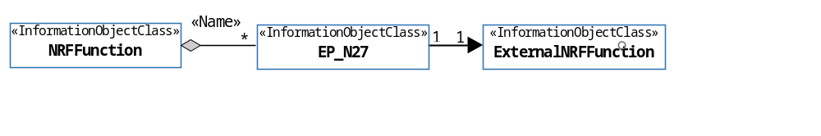
Figure 5.2.1.1-9: Transport view of NRF NRM
The Figure 5.2.1.1-10 shows the transport view of NSSF NRM.
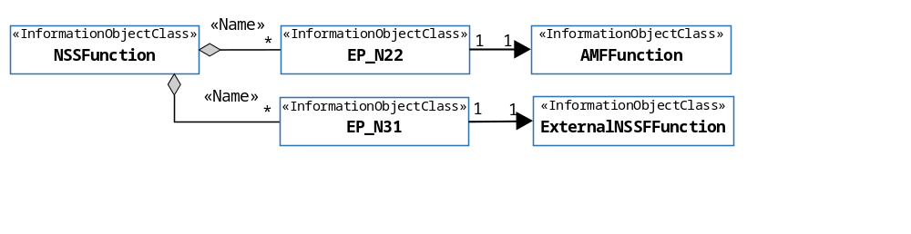
Figure 5.2.1.1-10: Transport view of NSSF NRM
The Figure 5.2.1.1-11 shows the transport view of SMSF NRM.
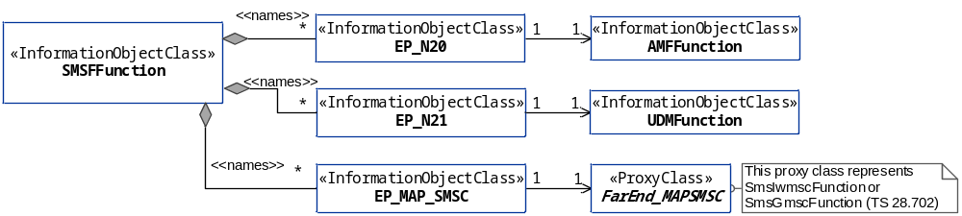
Figure 5.2.1.1-11: Transport view of SMSF NRM
The Figure 5.2.1.1-12 shows the transport view of 5G location service related NRM.
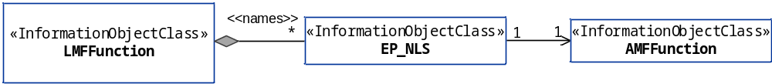
Figure 5.2.1.1-12: Transport view of LMF NRM
The Figure 5.2.1.1-13 shows the transport view of 5G-EIR NRM.
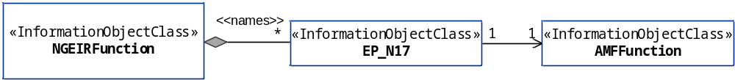
Figure 5.2.1.1-13: Transport view of 5G-EIR NRM
The Figure 5.2.1.1-14 shows the transport view of SEPP NRM.
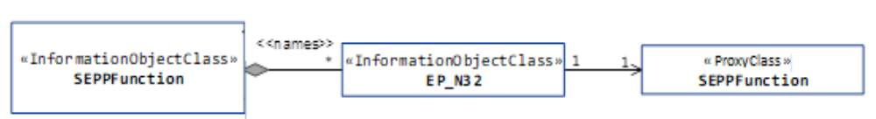
Figure 5.2.1.1-14: Transport view of SEPP NRM
The Figure 5.2.1.1-15 shows the NRM fragment for control of QoS monitoring per QoS flow per UE.
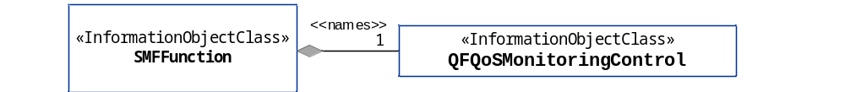
Figure 5.2.1.1-15: NRM fragment for control of QoS monitoring per QoS flow per UE
The Figure 5.2.1.1-16 shows the NRM fragment for control of GTP-U path QoS monitoring.
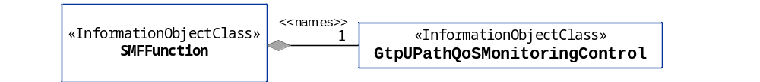
Figure 5.2.1.1-16: NRM fragment for control of GTP-U path QoS monitoring
The Figure 5.2.1.1-17 shows the NRM fragment for pre-configured 5QIs in 5GC.
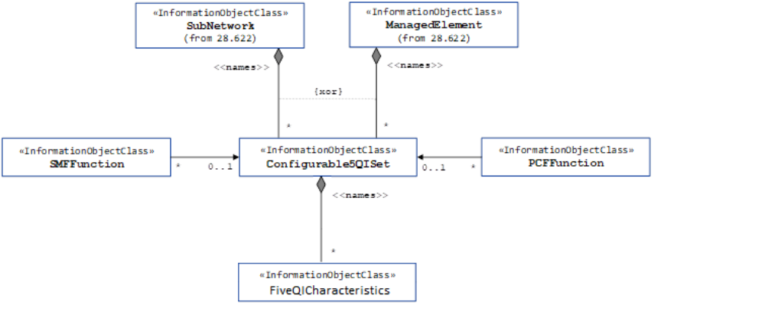
Figure 5.2.1.1-17: NRM fragment for pre-configured 5QIs in 5GC
The Figure 5.2.1.1-18 shows the NRM fragment for 5QI and DSCP mapping.
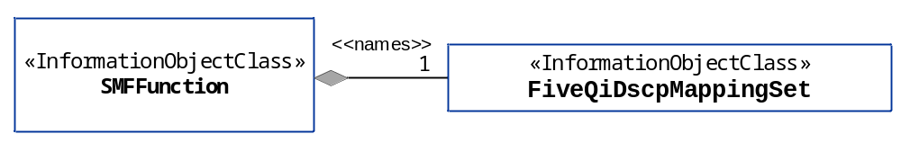
Figure 5.2.1.1-18: NRM fragment for 5QI and DSCP mapping.
The Figure 5.2.1.1-19 shows the NRM fragment for predefined PCC rule.
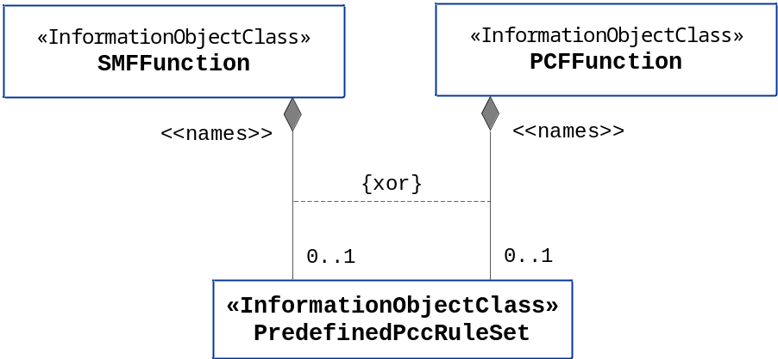
Figure 5.2.1.1-19: NRM fragment for predefined PCC rule
The Figure 5.2.1.1-20 shows the NRM fragment for dynamically assigned 5QIs in 5GC.
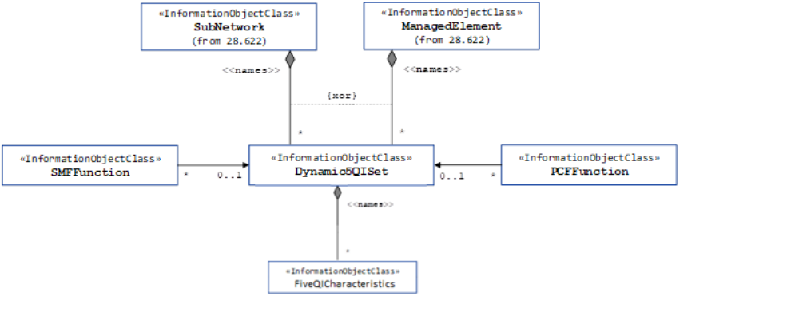
Figure 5.2.1.1-20: NRM fragment for dynamically assigned 5QIs in 5GC

The Figure 5.2.1.1-21 shows the transport view of NSACF NRM.
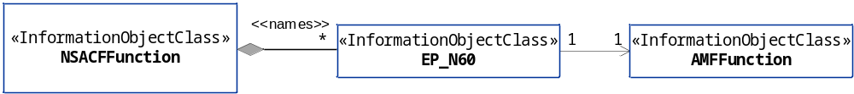
Figure 5.2.1.1-21: Transport view of NSACF NRM
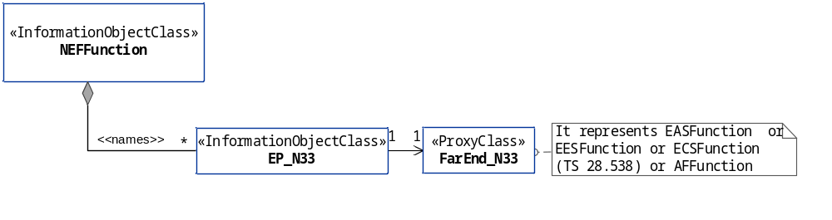
Figure 5.2.1.1-22: Transport view of NEF NRM
The Figure 5.2.1.1-23 shows the transport view of 5G DDNMF NRM.
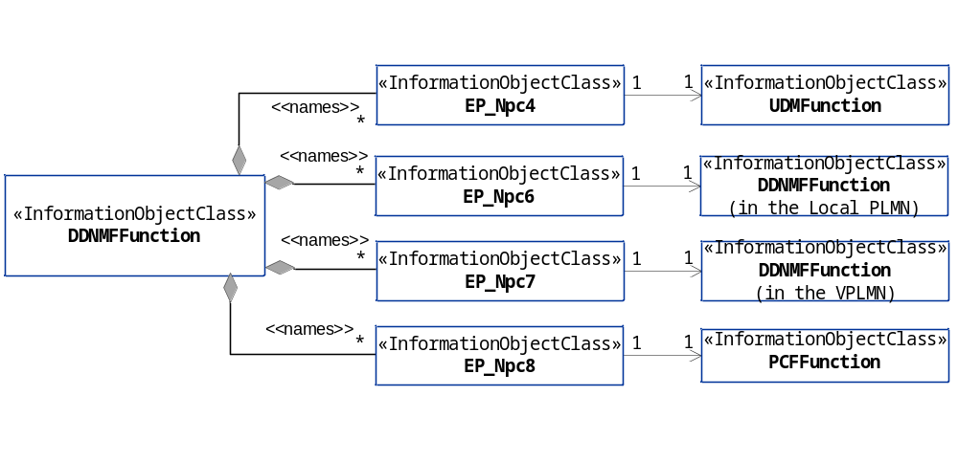
Figure 5.2.1.1-23: Transport view of 5G DDNMF NRM
The Figure 5.2.1.1-24 shows the transport view of 5G EASDF NRM.
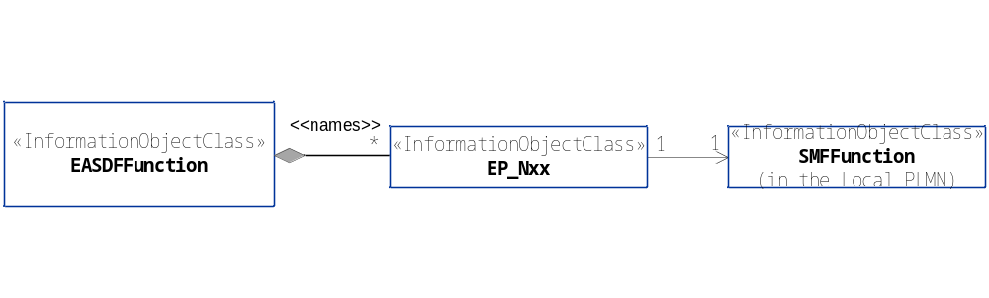
Figure 5.2.1.1-24: Transport view of 5G EASDF NRM

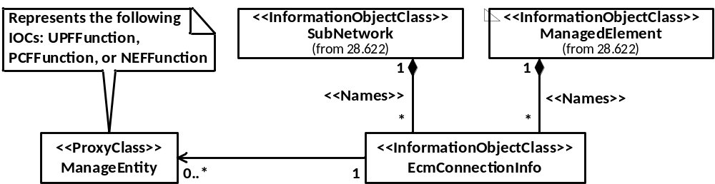
Figure 5.2.1.1-25: EcmConnectionInfo NRM

5.2.1.2 Inheritance
This clause depicts the inheritance relationships that exist between IOCs.
Figure 5.2.1.2-1 shows the inheritance hierarchy from IOC ManagedFunction related to the 5GC NF NRM.
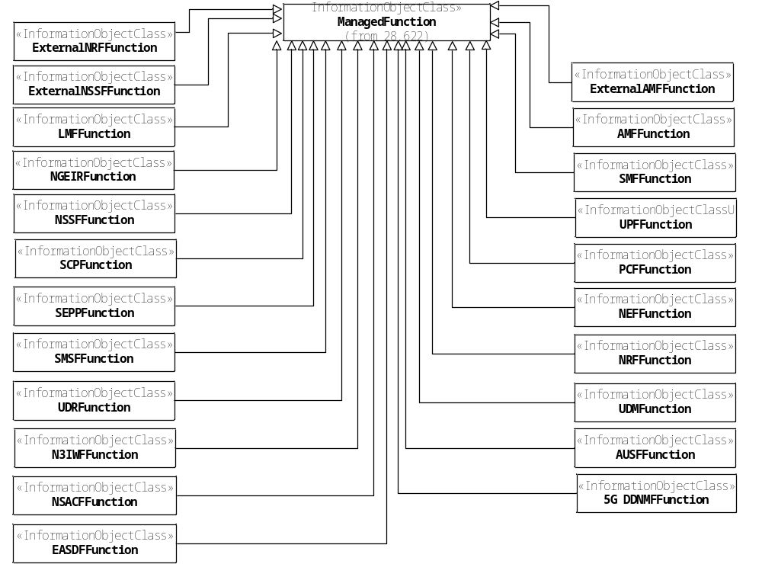
Figure 5.2.1.2-1: Inheritance hierarchy from IOC ManagedFunction related to the 5GC NF NRM
Figure 5.2.1.2-2 shows the inheritance hierarchy from IOC EP_RP related to 5GC NF NRM.
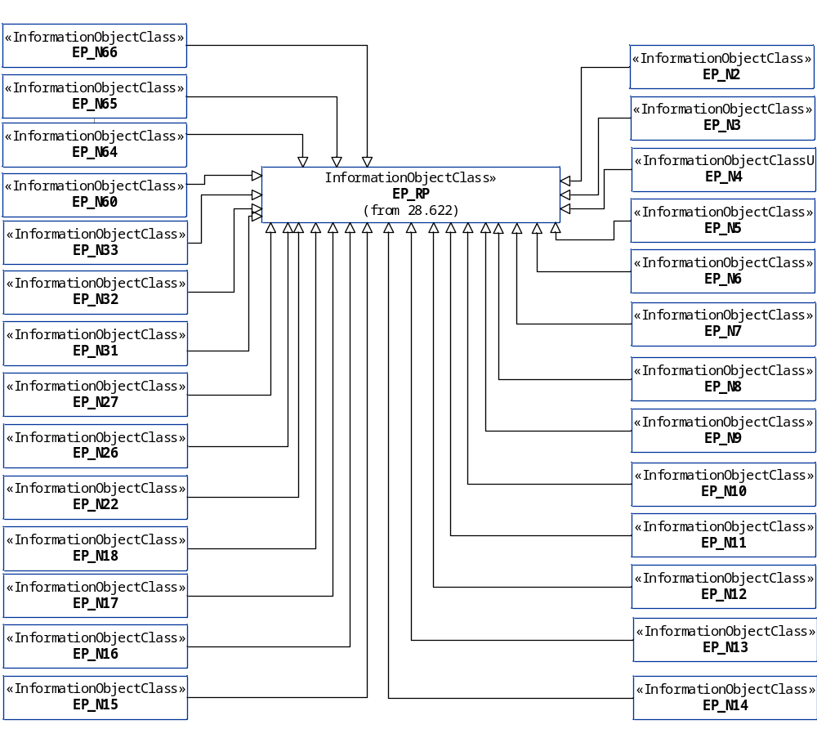
Figure 5.2.1.2-2: Inheritance hierarchy from IOC EP_RP related to the 5GC NF NRM
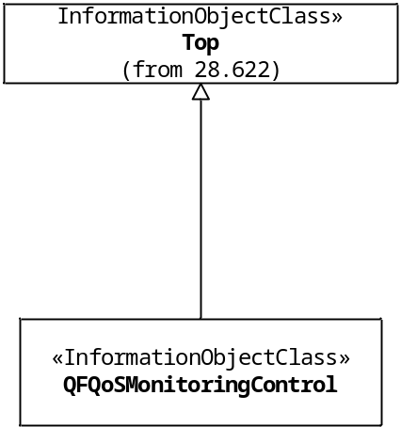
Figure 5.2.1.2-3: Inheritance hierarchy for IOC QFQoSMonitoringControl
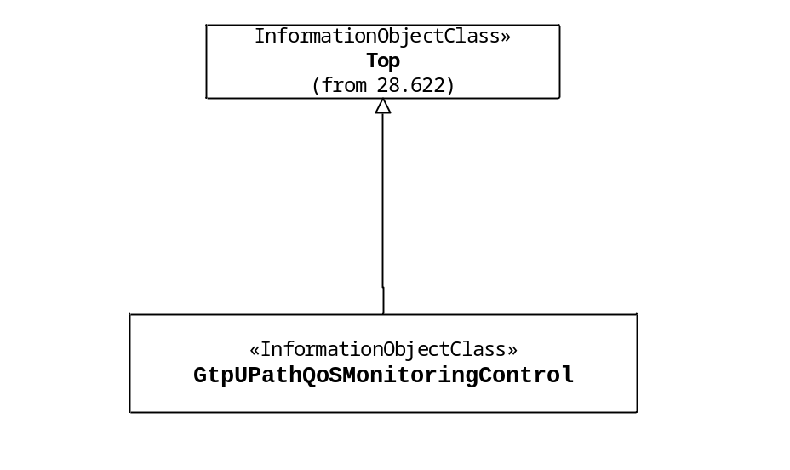
Figure 5.2.1.2-4: Inheritance hierarchy for IOC GtpUPathQoSMonitoringControl
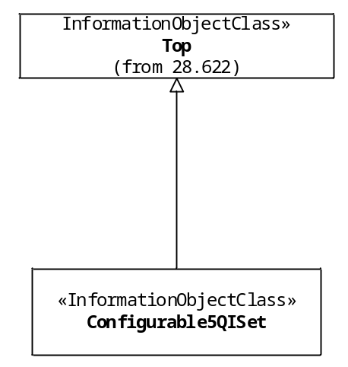
Figure 5.2.1.2-5: Inheritance hierarchy for IOC Configurable5QISet
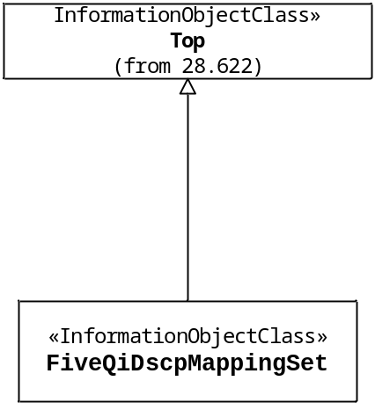
Figure 5.2.1.2-6: Inheritance hierarchy for IOC FiveQiDscpMapping
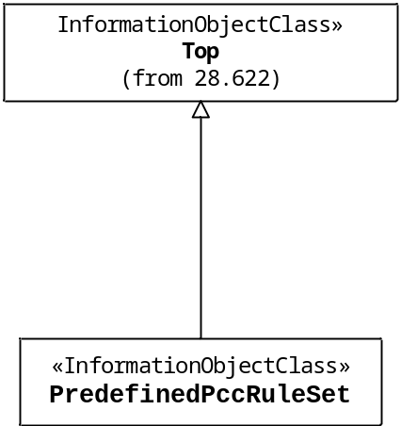
Figure 5.2.1.2-7: Inheritance hierarchy for predefined PCC rule modeling
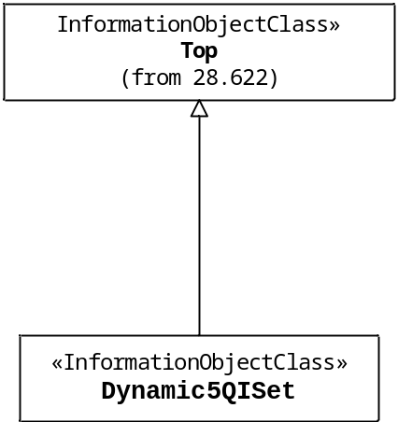
Figure 5.2.1.2-8: Inheritance hierarchy for IOC Dynamic5QISet
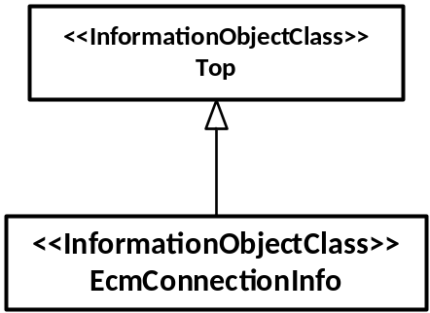
Figure 5.2.1.2-9: Inheritance hierarchy for EcmConnectionInfo

Next Modified Section

5.3.x EcmConnectionInfo

5.3.x.1 Definition
This IOC contains attributes to enable ECSP management system to connect EDN NFs (i.e., EAS, ECS, and EES) to 5GC NFs (i.e., UPF, PCF, NEF, SCEF) (See clause 6.3.2, 6.3.4, 6.4.6 in TS 28.538 [79]).

5.3.x.2 Attributes
The EcmConnectionInfo IOC includes attributes inherited from Top IOC (defined in TS 28.622[30]) and the following attributes:

Attribute name | Support Qualifier | isReadable | isWritable | isInvariant | isNotifyable
eASServiceArea | CM | T | T | F | T
eESServiceArea | CM | T | T | F | T
eDNServiceArea | CM | T | T | F | T
eASIpAddress | CM | T | T | F | T
eESIpAddress | CM | T | T | F | T
eCSIpAddress | CM | T | T | F | T
ednIdentifier | M | T | T | F | T
ecmConnectionType | CM | T | T | F | T
5GCNfConnEcmInfoList | CM | T | T | F | T
uPFConnectionInfo | CM | T | T | F | T

5.3.x.3 Attribute constraints

Name | Definition
eASServiceArea S | Condition: EAS connection to 5GC NF is supported
eASIpAddress S | Condition: EAS connection to 5GC NF is supported
eESServiceArea S | Condition: EES connection to 5GC NF is supported
eESIpAddress S | Condition: EES connection to 5GC NF is supported
eDNServiceArea S | Condition: EAS or ECS connection to 5GC NF is supported
eCSIpAddress S | Condition: ECS connection to 5GC NF is supported
ecmConnectionType S | Condition: EAS connection to 5GC NF is supported
5GCNfConnEcmInfoList S | Condition: EAS, EES, and ECS connections to 5GC NF is supported
uPFConnectionInfo S | Condition: EAS connection to UPF is supported

5.3.x.4 Notifications
The common notifications defined in subclause 5.5 are valid for this IOC, without exceptions or additions

5.3.y 5GCNfConnEcmInfo <<dataType>>

5.3.y.1 Definition
This data type specifies the 5GC NF connection information.

5.3.y.2 Attributes

Attribute name | S | isReadable | isWritable | isInvariant | isNotifyable
5GCNFType | M | T | T | F | T
5GCNFIpAddress | M | T | T | F | T
5GCNFRef | M | T | T | F | T

Editor’s note: Role based attribute of 5GCNfRef inside the dataType needs further work.

5.3.y.3 Attribute constraints
None

5.3.y.4 Notifications
The subclause 4.5 of the <<IOC>> using this <<dataType>> as one of its attributes, shall be applicable.

5.3.w UPFConnInfo <<dataType>>

5.3.v.1 Definition
This data type specifies the UPF connection information.

5.3.v.2 Attributes

Attribute name | S | isReadable | isWritable | isInvariant | isNotifyable
uPFIpAddress | M | T | T | F | T
uPFRef | M | T | T | F | T

5.3.v.3 Attribute constraints
None

5.3.v.4 Notifications
The subclause 4.5 of the <<IOC>> using this <<dataType>> as one of its attributes, shall be applicable.
Next Modified Section

5.4.1 Attribute properties

Attribute Name | Documentation and Allowed Values | Properties
aMFIdentifier | The AMFI is constructed from an AMF Region ID, an AMF Set ID and an AMF Pointer. The AMF Region ID identifies the region, the AMF Set ID uniquely identifies the AMF Set within the AMF Region, and the AMF Pointer uniquely identifies the AMF within the AMF Set. (Ref. 3GPP TS 23.003 [13]) | type: Integer  multiplicity: 1  isOrdered: N/A  isUnique: N/A  defaultValue: None  allowedValues: N/A  isNullable: False
aMFSetId | It represents the AMF Set ID, which is uniquely identifies the AMF Set within the AMF Region.  allowedValues: defined in subclause 2.10.1 of 3GPP TS 23.003 [13]. | type: Integer  multiplicity: 1  isOrdered: N/A  isUnique: N/A  defaultValue: None  allowedValues: N/A  isNullable: False
aMFSetMemberList | It is the list of DNs of AMFFunction instances of the AMFSet.  allowedValues: N/A | type: DN  multiplicity: *  isOrdered: N/A  isUnique: True  defaultValue: None  isNullable: False
aMFRegionId | It represents the AMF Region ID, which identifies the region.  allowedValues: defined in subclause 2.10.1 of 3GPP TS 23.003 [13]. | type: Integer  multiplicity: 1  isOrdered: N/A  isUnique: N/A  defaultValue: None  allowedValues: N/A  isNullable: False
gUAMIdList | List of supported Globally Unique AMF Ids (GUAMIs). | type: GUAMInfo  multiplicity: 1.. *  isOrdered: N/A  isUnique: N/A  defaultValue: None  allowedValues: N/A  isNullable: False
backupInfoAmfFailure | List of GUAMIs for which the AMF acts as a backup for AMF failure. | type: GUAMInfo  multiplicity: 1.. *  isOrdered: N/A  isUnique: N/A  defaultValue: None  allowedValues: N/A  isNullable: False
backupInfoAmfRemoval | List of GUAMIs for which the AMF acts as a backup for planned AMF removal. | type: GUAMInfo  multiplicity: 1.. *  isOrdered: N/A  isUnique: N/A  defaultValue: None  allowedValues: N/A  isNullable: False
localAddress | This parameter specifies the localAddress including IP address and VLAN ID used for initialization of the underlying transport.  First string is IP address, IP address can be an IPv4 address (See RFC 791 [37]) or an IPv6 address (See RFC 2373 [38]).  Second string is VLAN Id (See IEEE 802.1Q [39]). | type: String  multiplicity: 2  isOrdered: True  isUnique: N/A  defaultValue: None  isNullable: False
remoteAddress | Remote address including IP address used for initialization of the underlying transport.  IP address can be an IPv4 address (See RFC 791 [37]) or an IPv6 address (See RFC 2373 [38]). | type: String  multiplicity: 1  isOrdered: N/A  isUnique: N/A  defaultValue: None  isNullable: False
nfProfileList | It is a set of NFProfile(s) to be registered in the NRF instance. NFProfile is defined in 3GPP TS 29.510 [23]. | type: <<dataType>>  multiplicity: *  isOrdered: N/A  isUnique: N/A  defaultValue: None  allowedValues: N/A  isNullable: False
cNSIIdList | It is a set of NSI ID. NSI ID is an identifier for identifying the Core Network part of a Network Slice instance when multiple Network Slice instances of the same Network Slice are deployed, and there is a need to differentiate between them in the 5GC. See NSI ID definition in clause 3.1 of TS 23.501 [2] and subclause 6.1.6.2.7 of 3GPP TS 29.531 [24]. | type: String  multiplicity: *  isOrdered: N/A  isUnique: N/A  defaultValue: None  allowedValues: N/A  isNullable: False
sNSSAIList | See subclause 4.4.1.
pLMNInfoList | It defines the PLMN(s) of a Network Function. | type: PLMNInfo  multiplicity: 1.. *  isOrdered: N/A  isUnique: N/A  defaultValue: None  allowedValues: N/A  isNullable: False
sBIFQDN | It is used to indicate the FQDN of the registered NF instance in service-based interface, for example, NF instance FQDN structure is:  nftype<nfnum>.slicetype<sliceid>.mnc<MNC>.mcc<MCC>.3gppnetwork.org | type: String  multiplicity: 1  isOrdered: N/A  isUnique: N/A  defaultValue: None  allowedValues: N/A  isNullable: False
interPlmnFQDN | If the NF needs to be discoverable by other NFs in a different PLMN, then an FQDN that is used for inter-PLMN routing as specified in 3GPP TS 23.003 [13] shall be registered with the NRF. | type: String  multiplicity: 0..1  isOrdered: N/A  isUnique: N/A  defaultValue: None  allowedValues: N/A  isNullable: False
sBIServiceList | It is used to indicate the all supported NF services registered on service-based interface. | type: String  multiplicity: *  isOrdered: N/A  isUnique: N/A  defaultValue: None  allowedValues: N/A  isNullable: False
nRTACList | It is the list of Tracking Area Codes (either legacy TAC or extended TAC).  allowedValues:  Legacy TAC and Extended TAC are defined in clause 9.3.3.10 of TS 38.413 [5]. | type: Integer  multiplicity: 1..*  isOrdered: N/A  isUnique: N/A  defaultValue: None  allowedValues: N/A  isNullable: False
taiList | The list of TAIs. | type: TAI  multiplicity: 1..*  isOrdered: N/A  isUnique: N/A  defaultValue: None  allowedValues: N/A  isNullable: False
taiRangeList | The range of TAIs. | type: TAIRange  multiplicity: 1..*  isOrdered: N/A  isUnique: N/A  defaultValue: None  allowedValues: N/A  isNullable: False
nRTACRangeList | The range of TACs. | type: nrTACRange  multiplicity: 1..*  isOrdered: N/A  isUnique: N/A  defaultValue: None  allowedValues: N/A  isNullable: False
nRTACstart | First value identifying the start of a TAC range, to be used when the range of TAC's can be represented as a hexadecimal range (e.g., TAC ranges). 3-octet string identifying a tracking area code, each character in the string shall take a value of "0" to "9" or "A" to "F" and shall represent 4 bits. The most significant character representing the 4 most significant bits of the TAC shall appear first in the string, and the character representing the 4 least significant bit of the TAC shall appear last in the string.  Pattern: "^([A-Fa-f0-9]{4}|[A-Fa-f0-9]{6})$" | type: String  multiplicity: 0..1  isOrdered: N/A  isUnique: N/A  defaultValue: None  allowedValues: N/A  isNullable: False
nRTACend | Last value identifying the end of a TAC range, to be used when the range of TAC's can be represented as a hexadecimal range (e.g. TAC ranges). 3-octet string identifying a tracking area code, each character in the string shall take a value of "0" to "9" or "A" to "F" and shall represent 4 bits. The most significant character representing the 4 most significant bits of the TAC shall appear first in the string, and the character representing the 4 least significant bit of the TAC shall appear last in the string.  Pattern: "^([A-Fa-f0-9]{4}|[A-Fa-f0-9]{6})$" | type: String  multiplicity: 0..1  isOrdered: N/A  isUnique: N/A  defaultValue: None  allowedValues: N/A  isNullable: False
nRTACpattern | Pattern (regular expression according to the ECMA-262 dialect [x0]) representing the set of TAC's belonging to this range. A TAC value is considered part of the range if and only if the TAC string fully matches the regular expression. | type: String  multiplicity: 0..1  isOrdered: N/A  isUnique: N/A  defaultValue: None  allowedValues: N/A  isNullable: False
supportedBMOList | It is used to indicate the list of supported BMOs (Bridge Managed Objects) required for integration with TSN system. | type: String  multiplicity: *  isOrdered: N/A  isUnique: N/A  defaultValue: None  allowedValues: N/A  isNullable: False
managedNFProfile | This parameter defines profile for managed NF (See TS 23.501 [2]).  allowedValues: N/A | type: ManagedNFProfile  multiplicity: 1  isOrdered: N/A  isUnique: N/A  defaultValue: None  allowedValues: N/A  isNullable: False
nfInstanceID | This parameter defines unique identity of the NF Instance. The format of the NF Instance ID shall be a Universally Unique Identifier (UUID) version 4, as described in IETF RFC 4122 [44]  allowedValues: N/A | type: String  multiplicity: 1  isOrdered: F  isUnique: N/A  defaultValue: None  isNullable: False
nfType | This parameter defines type of Network Function  allowedValues: See TS 23.501[2] for NF types | type: ENUM  multiplicity: 1..*  isOrdered: N/A  isUnique: N/A  defaultValue: None  isNullable: False
heartBeatTimer | Time between two consecutive heart-beat messages from an NF Instance to the NRF defined in seconds. | type: Integer  multiplicity: 1  isOrdered: N/A  isUnique: N/A  defaultValue: 0  isNullable: False
fqdn | This parameter defines FQDN of the Network Function (See TS 23.003 [13])  allowedValues: N/A | type: String  multiplicity: 1  isOrdered: F  isUnique: N/A  defaultValue: None  isNullable: False
ipAddress | This parameter defines IP Address of the Network Function. It can be IPv4 address (See RFC 791 [37]) or IPv6 address (See RFC 2373 [38]).  allowedValues: N/A | type: String  multiplicity: 1  isOrdered: F  isUnique: N/A  defaultValue: None  isNullable: False
authzInfo | This parameter defines NF Specific Service authorization information. It shall include the NF type (s) and NF realms/origins allowed to consume NF Service(s) of NF Service Producer (See TS 23.501[2]).  allowedValues: N/A | type: String  multiplicity: 1  isOrdered: F  isUnique: N/A  defaultValue: None  isNullable: True
allowedPLMNs | PLMNs allowed to access the NF instance.  If not provided, any PLMN is allowed to access the NF. | type: PLMNId  multiplicity: 1..*  isOrdered: F  isUnique: N/A  defaultValue: None  isNullable: True
allowedSNPNs | SNPNs allowed to access the NF instance.  The absence of this attribute in the NF profile indicates that no SNPN, other than the SNPN(s) registered in the snpnList attribute of the NF Profile, is allowed to access the service instance. | type: SNPNInfo  multiplicity: 1..*  isOrdered: F  isUnique: N/A  defaultValue: None  isNullable: True
mCC | This is the Mobile Country Code (MCC) of the PLMN identifier. See TS 23.003 [3] subclause 2.2 and 12.1.  allowedValues: a bounded string of 3 characters representing 3 digits. | type: String  multiplicity: 1  isOrdered: N/A  isUnique: N/A  defaultValue: None  isNullable: False
mNC | This is the Mobile Network Code (MNC) of the PLMN identifier. See TS 23.003 [3] subclause 2.2 and 12.1.  allowedValues: A bounded string of 2 or 3 characters representing 2 or 3 digits. | type: String  multiplicity: 1  isOrdered: N/A  isUnique: N/A  defaultValue: None  isNullable: False
nId | Network Identity; Shall be present if PlmnIdNid identifies an SNPN (see clauses 5.30.2.3, 5.30.2.9, 6.3.4, and 6.3.8 in 3GPP TS 23.501 [2]). | type: String  multiplicity: 1  isOrdered: N/A  isUnique: N/A  defaultValue: None  isNullable: False
allowedNfTypes | Type of the NFs allowed to access the NF instance.  If not provided, any NF type is allowed to access the NF.  allowedValues: See TS 23.501[2] for NF types | type: ENUM  multiplicity: 1..*  isOrdered: F  isUnique: N/A  defaultValue: None  isNullable: True
allowedNfDomains | Pattern (regular expression according to the ECMA-262 dialect [72]) representing the NF domain names within the PLMN of the NRF allowed to access the NF instance.  If not provided, any NF domain is allowed to access the NF. | type: String  multiplicity: 1..*  isOrdered: F  isUnique: N/A  defaultValue: None  isNullable: True
allowedNSSAIs | S-NSSAI of the allowed slices to access the NF instance.  If not provided, any slice is allowed to access the NF. | type: S-NSSAI  multiplicity: 1..*  isOrdered: F  isUnique: N/A  defaultValue: None  isNullable: True
locality | The parameter defines information about the location of the NF instance (e.g. geographic location, data center) defined by operator (See TS 29.510[23]).  allowedValues: N/A | type: String  multiplicity: 1  isOrdered: F  isUnique: N/A  defaultValue: None  isNullable: True
capacity | This parameter defines static capacity information in the range of 0-65535, expressed as a weight relative to other NF instances of the same type; if capacity is also present in the nfServiceList parameters, those will have precedence over this value (See TS 29.510[23])  allowedValues: 0-65535 | type: Integer  multiplicity: 1  isOrdered: N/A  isUnique: N/A  defaultValue: None  allowedValues: N/A  isNullable: False
recoveryTime | Timestamp when the NF was (re)started. The NRF shall notify NFs subscribed to receiving notifications of changes of the NF profile, if the NF recoveryTime is changed. | type: DateTime  multiplicity: 1  isOrdered: N/A  isUnique: N/A  defaultValue: None  allowedValues: N/A  isNullable: True
nfServicePersistence | This parameter indicates whether the different service instances of a same NF Service in the NF instance, supporting a same API version, are capable to persist their resource state in shared storage and therefore these resources are available after a new NF service instance supporting the same API version is selected by a NF Service Consumer (see TS 29.510 [23]). | type: Boolean  multiplicity: 1  isOrdered: N/A  isUnique: N/A  defaultValue: None  allowedValues: N/A  isNullable: True
nfSetIdList | A NF Set Identifier is a globally unique identifier of a set of equivalent and interchangeable CP NFs from a given network that provide distribution, redundancy and scalability (see clause 5.21.3 of 3GPP TS 23.501 [2]).  An NF Set Identifier shall be constructed from the MCC, MNC, NID (for SNPN), NF type and a Set ID. A NF Set Identifier shall be formatted as the following string:  set<Set ID>.<nftype>set.5gc.mnc<MNC>.mcc<MCC> for a NF Set in a PLMN, or  set<Set ID>.<nftype>set.5gc.nid<NID>.mnc<MNC>.mcc<MCC> for a NF Set in a SNPN.  At most one NF Set ID shall be indicated per PLMN-ID or SNPN of the NF. | type: String  multiplicity: 1..*  isOrdered: N/A  isUnique: N/A  defaultValue: None  allowedValues: N/A  isNullable: False
nfProfileChangesSupportInd | This parameter indicates if the NF Service Consumer supports or does not support receiving NF Profile Changes. It may be present in the NFRegister or NFUpdate (NF Profile Complete Replacement) request and shall be absent in the response (see Annex B 3GPP TS 29.510 [23]). | type: Boolean  multiplicity: 1  isOrdered: N/A  isUnique: N/A  defaultValue: None  allowedValues: N/A  isNullable: True
defaultNotificationSubscriptions | Notification endpoints for different notification types.  This attribute may contain multiple default subscriptions for a same notification type; in that case, those default subscriptions are used as alternative notification endpoints. | type: DefaultNotificationSubscription  multiplicity: 1..*  isOrdered: N/A  isUnique: True  defaultValue: None  allowedValues: N/A  isNullable: False
notificationType | This parameter indicates the types of notifications used in Default Notification URIs in the NF Profile of an NF Instance.  allowedValues:  "N1_MESSAGES",  "N2_INFORMATION",  "LOCATION_NOTIFICATION",  ”DATA_REMOVAL_NOTIFICATION”,  "DATA_CHANGE_NOTIFICATION",  "LOCATION_UPDATE_NOTIFICATION",  "NSSAA_REAUTH_NOTIFICATION",  "NSSAA_REVOC_NOTIFICATION" | type: ENUM  multiplicity: 1  isOrdered: N/A  isUnique: N/A  defaultValue: None  allowedValues: N/A  isNullable: False
callbackURI | This attribute contains a default notification endpoint to be used by a NF Service Producer towards an NF Service Consumer that has not registered explicitly a callback URI in the NF Service Producer (e.g. as a result of an implicit subscription). | type: String  multiplicity: 1  isOrdered: N/A  isUnique: N/A  defaultValue: None  allowedValues: N/A  isNullable: False
n1MessageClass | This attribute (if it is present) identifies that class of N1 messages shall be notified as per TS 29.518 [80]. | type: Boolean  multiplicity: 1  isOrdered: N/A  isUnique: N/A  defaultValue: None  allowedValues: N/A  isNullable: True
n2InformationClass | This attribute (if it is present) identifies that class of N2 messages shall be notified as per TS 29.518 [80]. | type: Boolean  multiplicity: 1  isOrdered: N/A  isUnique: N/A  defaultValue: None  allowedValues: N/A  isNullable: True
versions | This attribute identifies the API versions (e.g. "v1") supported for the default notification type. | type: String  multiplicity: 1..*  isOrdered: N/A  isUnique: N/A  defaultValue: None  allowedValues: N/A  isNullable: False
binding | This attribute shall contain the value of the Binding Indication for the default subscription notification (i.e. the value part of "3gpp-Sbi-Binding" header), as specified in clause 6.12.4 of 3GPP TS 29.500 [76]. | type: String  multiplicity: 1  isOrdered: N/A  isUnique: N/A  defaultValue: None  allowedValues: N/A  isNullable: False
servingScope | This parameter indicates the served geographical areas of a NF instance. | type: String  multiplicity: 1..*  isOrdered: N/A  isUnique: N/A  defaultValue: None  allowedValues: N/A  isNullable: False
nfSetRecoveryTimeList | This parameter contains the recovery time of NF Set(s) indicated by the NfSetId, where the NF instance belongs. | type: DateTime  multiplicity: 1.. *  isOrdered: N/A  isUnique: N/A  defaultValue: None  allowedValues: N/A  isNullable: False
serviceSetRecoveryTimeList | This parameter contains the recovery time of NF Service Set(s) configured in the NF instance, which are indicated by the NfServiceSetId. | type: DateTime  multiplicity: 1.. *  isOrdered: N/A  isUnique: True  defaultValue: None  allowedValues: N/A  isNullable: False
scpDomains | This parameter shall carry the list of SCP domains the SCP belongs to, or the SCP domain the NF (other than SCP) or the SEPP belongs to. | type: String  multiplicity: 1.. *  isOrdered: N/A  isUnique: N/A  defaultValue: None  allowedValues: N/A  isNullable: False
vendorId | Vendor ID of the NF instance, according to the IANA-assigned "SMI Network Management Private Enterprise Codes" [77].  allowedValues: 6 decimal digits; if the SMI code has less than 6 digits, it shall be padded with leading digits "0" to complete a 6-digit string value. | type: String  multiplicity: 0..1  isOrdered: N/A  isUnique: N/A  defaultValue: None  allowedValues: N/A  isNullable: False
nFInfo | This parameter includes NF specific data in Managed NF profile  allowedValues: N/A | type: NFInfo  multiplicity: 1  isOrdered: N/A  isUnique: N/A  defaultValue: None  allowedValues: N/A  isNullable: False
hostAddr | This parameter defines host address of a NF  allowedValues: N/A | type: HostAddr  multiplicity: 1  isOrdered: N/A  isUnique: N/A  defaultValue: None  allowedValues: N/A  isNullable: False
priority | This parameter defines Priority (relative to other NFs of the same type) in the range of 0-65535, to be used for NF selection; lower values indicate a higher priority. If priority is also present in the nfServiceList parameters, those will have precedence over this value (See TS 29.510[23]).  allowedValues: 0-65535 | type: Integer  multiplicity: 1  isOrdered: N/A  isUnique: N/A  defaultValue: None  allowedValues: N/A  isNullable: False
supportedDataSetIds | This parameter defines list of supported data sets in the UDR instance (See TS 29.510[23]).  allowedValues: "SUBSCRIPTION", "POLICY", EXPOSURE", "APPLICATION" | type: ENUM  multiplicity: 1..*  isOrdered: N/A  isUnique: False  defaultValue: None  isNullable: False
nFSrvGroupId | This parameter defines identity of the group that is served by the NF instance (See TS 29.510[23]).  allowedValues: N/A | type: String  multiplicity: 1  isOrdered: F  isUnique: N/A  defaultValue: None  isNullable: False
smfServingAreas | This parameter defines the SMF service area(s) the UPF can serve (See TS 29.510[23]).  allowedValues: N/A | type: String  multiplicity: 1..*  isOrdered: F  isUnique: True  defaultValue: None  isNullable: False
isESCoveredBy | This indicates whether the adjacentCell provides no, partial or full coverage for the cell which name-contains the NRCellRelation instance.  Adjacent cells with this attribute equal to "FULL" are recommended to be considered as candidate cells to take over the coverage when the original cell state is about to be changed to energySaving.  All adjacent cells with this attribute value equal to "PARTIAL" are recommended to be considered as entirety of candidate cells to take over the coverage when the original cell state is about to be changed to energySaving.  allowedValues: NO, PARTIAL, FULL | type: ENUM  multiplicity: 1  isOrdered: N/A  isUnique: N/A  defaultValue: None  isNullable: False
commModelList | The attribute specifies a list of commModel which is defined as a datatype (see clause 5.3.69). It can be used by NF and NF services to interact with each other in 5G Core network (see TS 23.501 [2]).  allowedValues: Not applicable | type: commModel  multiplicity: 1..*  isOrdered: N/A  isUnique: N/A  defaultValue: None  isNullable: False
groupId | This parameter identiies a list of target NF services on which the same communication model is applied to.  allowedValues: N/A | type: Integer  multiplicity: 1  isOrdered: N/A  isUnique: False  defaultValue: None  isNullable: False
commModelType | This parameter defines communication model used by a NF to interact with NF service(s) (See TS 23.501 [2]).  allowedValues:”DIRECT_COMMUNICATION_WO_NRF”, “DIRECT_COMMUNICATION_WITH_NRF”, “INDIRECT_COMMUNICATION_WO_DEDICATED_DISCOVERY”, “INDIRECT_COMMUNICATION_WITH_DEDICATED_DISCOVERY” | type: ENUM  multiplicity: 1  isOrdered: N/A  isUnique: N/A  defaultValue: None  allowedValues: N/A  isNullable: False
targetNFServiceList | This parameter lists target NF services sharing same communication model and configuration.  allowedValues: N/A | type: DN  multiplicity: 1..*  isOrdered: F  isUnique: N/A  defaultValue: None  isNullable: False
commModelConfiguration | This parameter defines configuration parameters for specific communication model for a group of NF Services.  allowedValues: N/A | type: String  multiplicity: 1  isOrdered: N/A  isUnique: N/A  defaultValue: None  allowedValues: N/A  isNullable: False
supportedFuncList | This parameter lists functionalities supported by a SCP. Refer to TS 23.501 [2]. | type: SupportedFunction  multiplicity: 1..*  isOrdered: N/A  isUnique: False  defaultValue: None  isNullable: False
address | This parameter defines address of a SCP instance, it can be IP address (either IPv4 address (See RFC 791 [37]) or IPv6 address (See RFC 2373 [38])) or FQDN (See TS 23.003 [13]). | type: String  multiplicity: 1  isOrdered: N/A  isUnique: N/A  defaultValue: None  allowedValues: N/A  isNullable: False
function | This parameter defines name of a functionality supported by a SCP. | type: String  multiplicity: 1  isOrdered: F  isUnique: N/A  defaultValue: None  isNullable: False
policy | This parameter defines configuration policies of a functionality supported by a SCP. | type: String  multiplicity: 1  isOrdered: N/A  isUnique: N/A  defaultValue: None  allowedValues: N/A  isNullable: False
capabilityList | This parameter lists capabilities supported by a NEF. Refer to TS 23.501 [2].  allowedValues: N/A | type: String  multiplicity: 1..*  isOrdered: N/A  isUnique: False  defaultValue: None  isNullable: False
isCAPIFSup | This parameter defines if the NEF support Common API Framework.  allowedValues: TRUE, FALSE | type: Boolean  multiplicity: 1  isOrdered: F  isUnique: N/A  defaultValue: None  isNullable: False
sEPPType | This parameter defines the type of a SEPP entity. Refer to TS 33.501 [52].  allowedValues: “CSEPP”, “PSEPP” | type: ENUM  multiplicity: 1  isOrdered: N/A  isUnique: False  defaultValue: None  isNullable: False
sEPPId | This parameter is identifier of a SEPP, it is unique inside a PLMN.  allowedValues: N/A | type: Integer  multiplicity: 1  isOrdered: N/A  isUnique: N/A  defaultValue: None  allowedValues: N/A  isNullable: False
remotePlmnId | This parameter defines PLMNId of the remote SEPP.  allowedValues: N/A | Type: PLMNId  multiplicity: 1  isOrdered: N/A  isUnique: N/A  defaultValue: None  isNullable: False
remoteSeppAddress | This parameter defines address of the remote SEPP. It can be IP address (either IPv4 address (See RFC 791 [37]) or IPv6 address (See RFC 2373 [38])) or FQDN(See TS 23.003 [13]).  allowedValues: N/A | type: String  multiplicity: 1  isOrdered: F  isUnique: N/A  defaultValue: None  isNullable: False
remoteSeppId | This parameter defines identifier of the remote SEPP. it is unique inside a PLMN.  allowedValues: N/A | type: Integer  multiplicity: 1  isOrdered: N/A  isUnique: N/A  defaultValue: None  allowedValues: N/A  isNullable: False
n32cParas | This attribute is used to configure parameters to establish security link between two SEPPs.  allowedValues: N/A | type: String  multiplicity: 1  isOrdered: F  isUnique: N/A  defaultValue: None  isNullable: False
n32fPolicy | This attribute is used to configure policies to protect the messages exchanged between SEPPs.  allowedValues: N/A | type: String  multiplicity: 1  isOrdered: F  isUnique: N/A  defaultValue: None  isNullable: False
withIPX | This attribute defines if there’s an IPX interconnected between two SEPPs.  allowedValues: TRUE, FALSE | type: Boolean  multiplicity: 1  isOrdered: N/A  isUnique: N/A  defaultValue: None  allowedValues: N/A  isNullable: False
FiveQiDscpMappingList | It provides the list of mapping between 5QIs and DSCP.  allowedValues: N/A | type: FiveQiDscpMapping  multiplicity: *  isOrdered: N/A  isUnique: N/A  defaultValue: None  isNullable: False
fiveQIValues | It indicates a list of 5QI value.  allowedValues: 0 - 255 | type: Integer  multiplicity: *  isOrdered: N/A  isUnique: Yes  defaultValue: None  isNullable: False
dscp | It indicates a DSCP.  allowedValues: 0 – 255 | type: Integer  multiplicity: 1  isOrdered: N/A  isUnique: Yes  defaultValue: None  isNullable: False
configurable5QISetRef | This is the DN of Configurable5QISet.  allowedValues: DN of the Configurable5QISet MOI. | type: String  multiplicity: 0..1  isOrdered: False  isUnique: True  defaultValue: None  isNullable: True
dynamic5QISetRef | This is the DN of Dynamic5QISet MOI.  allowedValues: DN of the Dynamic5QISet MOI. | type: String  multiplicity: 0..1  isOrdered: False  isUnique: True  defaultValue: None  isNullable: True
fiveQIValue | It identifies the 5QI value.  allowedValues: 0 – 255 | type: Integer  multiplicity: 1  isOrdered: N/A  isUnique: Yes  defaultValue: None  isNullable: False
resourceType | It indicates the Resource Type of a 5QI, as specified in TS 23.501 [2].  allowedValues: "GBR", Non-GBR" | type: ENUM  multiplicity: 1  isOrdered: N/A  isUnique: False  defaultValue: None  isNullable: False
priorityLevel | It indicates the Priority Level of a 5QI, as specified in TS 23.501 [2].  allowedValues: 0 - 127 | type: Integer  multiplicity: 1  isOrdered: N/A  isUnique: False  defaultValue: None  isNullable: False
packetDelayBudget | It indicates the Packet Delay Budget (in unit of 0.5ms) of a 5QI, as specified in TS 23.501 [2].  allowedValues: 0 - 1023 | type: Integer  multiplicity: 1  isOrdered: N/A  isUnique: False  defaultValue: None  isNullable: False
packetErrorRate | It indicates the Packet Error Rate of a 5QI, as specified in TS 23.501 [2].  allowedValues: N/A | type: PacketErrorRate  multiplicity: 1  isOrdered: N/A  isUnique: False  defaultValue: None  isNullable: False
averagingWindow | It indicates the Averaging Window (in unit of ms) of a 5QI, as specified in TS 23.501 [2].  allowedValues: 0 - 4095 | type: Integer  multiplicity: 1  isOrdered: N/A  isUnique: False  defaultValue: None  isNullable: False
maximumDataBurstVolume | It indicates the Maximum Data Burst Volume (in unit of Byte) of a 5QI, as specified in TS 23.501 [2].  allowedValues: 0 - 4095 | type: Integer  multiplicity: 1  isOrdered: N/A  isUnique: False  defaultValue: None  isNullable: False
scalar | The Packet Error Rate of a 5QI expressed as Scalar x 10-k where k is the Exponent.  This attriutes indicates the Scalar of this expression.  allowedValues: 0 - 9 | type: Integer  multiplicity: 1  isOrdered: N/A  isUnique: False  defaultValue: None  isNullable: False
exponent | The Packet Error Rate of a 5QI expressed as Scalar x 10-k where k is the Exponent.  This attriutes indicates the Exponent of this expression.  allowedValues: 0 - 9 | type: Integer  multiplicity: 1  isOrdered: N/A  isUnique: False  defaultValue: None  isNullable: False
gtpUPathQoSMonitoringState | It indicates the state of GTP-U path QoS monitoring for URLLC service.  allowedValues: "Enabled", "Disabled". | type: ENUM  multiplicity: 1  isOrdered: N/A  isUnique: N/A  defaultValue: Enabled  isNullable: False
gtpUPathMonitoredSNSSAIs | It specifies the S-NSSAIs for which the GTP-U path QoS monitoring is to be performed.  allowedValues: See 3GPP TS 23.003 [13] | type: S-NSSAI  multiplicity: *  isOrdered: N/A  isUnique: N/A  defaultValue: None  isNullable: False
monitoredDSCPs | It specifies the DSCPs for which the GTP-U path QoS monitoring is to be performed.  allowedValues: See 3GPP TS 29.244 [56] | type: Integer  multiplicity: *  isOrdered: N/A  isUnique: N/A  defaultValue: None  isNullable: False
isEventTriggeredGtpUPathMonitoringSupported | It indicates whether the event triggered GTP-U path QoS monitoring reporting based on thresholds is supported, see 3GPP TS 29.244 [56].  allowedValues: “Yes”, “No”. | type: Boolean  multiplicity: 1  isOrdered: N/A  isUnique: N/A  defaultValue: Yes  isNullable: False
isPeriodicGtpUMonitoringSupported | It indicates whether the periodic GTP-U path QoS monitoring reporting is supported, see 3GPP TS 29.244 [56].  allowedValues: “Yes”, “No”. | type: Boolean  multiplicity: 1  isOrdered: N/A  isUnique: N/A  defaultValue: Yes  isNullable: False
isImmediateGtpUMonitoringSupported | It indicates whether the immediate GTP-U path QoS monitoring reporting is supported, see 3GPP TS 29.244 [56].  allowedValues: “Yes”, “No”. | type: Boolean  multiplicity: 1  isOrdered: N/A  isUnique: N/A  defaultValue: Yes  isNullable: False
gtpUPathDelayThresholds | It specifies the thresholds for reporting the packet delay for the GTO-U path QoS monitoring, if the isEventTriggeredGtpUPathMonitoringSupported attribute of the same MOI is set to “yes”.  The packet delay will be reported to SMF when it exceeds the threshold (in milliseconds).  allowedValues: N/A. | type: GtpUPathDelayThresholdsType  multiplicity: 1  isOrdered: Y  isUnique: N/A  defaultValue: None  isNullable: False
gtpUPathMinimumWaitTime | It specifies the minimum waiting time (in seconds) between two consecutive reports for event triggered GTP-U path QoS monitoring reporting, if the isEventTriggeredGtpUPathMonitoringSupported attribute of the same MOI is set to “yes”.  allowedValues: see 3GPP TS 29.244 [56]. | type: Integer  multiplicity: 1  isOrdered: N/A  isUnique: N/A  defaultValue: None  isNullable: False
gtpUPathMeasurementPeriod | It specifies the period (in seconds) for reporting the packet delay for GTP-U path QoS monitoring, if the isPeriodicGtpUMonitoringSupported attribute of the same MOI is set to “yes”.  allowedValues: see 3GPP TS 29.244 [56]. | type: Integer  multiplicity: 1  isOrdered: N/A  isUnique: N/A  defaultValue: None  isNullable: False
n3AveragePacketDelayThreshold | It specifies the threshold for reporting the average packet delay of a GTP-U path on N3 interface.  allowedValues: see 3GPP TS 29.244 [56]. | type: Integer  multiplicity: 1  isOrdered: N/A  isUnique: N/A  defaultValue: None  isNullable: False
n3MinPacketDelayThreshold | It specifies the threshold for reporting the minimum packet delay of a GTP-U path on N3 interface.  allowedValues: see 3GPP TS 29.244 [56]. | type: Integer  multiplicity: 1  isOrdered: N/A  isUnique: N/A  defaultValue: None  isNullable: False
n3MaxPacketDelayThreshold | It specifies the threshold for reporting the maxinum packet delay of a GTP-U path on N3 interface.  allowedValues: see 3GPP TS 29.244 [56]. | type: Integer  multiplicity: 1  isOrdered: N/A  isUnique: N/A  defaultValue: None  isNullable: False
n9AveragePacketDelayThreshold | It specifies the threshold for reporting the average packet delay of a GTP-U path on N9 interface.  allowedValues: see 3GPP TS 29.244 [56]. | type: Integer  multiplicity: 1  isOrdered: N/A  isUnique: N/A  defaultValue: None  isNullable: False
n9MinPacketDelayThreshold | It specifies the threshold for reporting the minimum packet delay of a GTP-U path on N9 interface.  allowedValues: see 3GPP TS 29.244 [56]. | type: Integer  multiplicity: 1  isOrdered: N/A  isUnique: N/A  defaultValue: None  isNullable: False
n9MaxPacketDelayThreshold | It specifies the threshold for reporting the maxinum packet delay of a GTP-U path on N9 interface.  allowedValues: see 3GPP TS 29.244 [56]. | type: Integer  multiplicity: 1  isOrdered: N/A  isUnique: N/A  defaultValue: None  isNullable: False
qFQoSMonitoringState | It indicates the state of QoS monitoring per QoS flow per UE for URLLC service.  allowedValues: "Enabled", "Disabled". | type: ENUM  multiplicity: 1  isOrdered: N/A  isUnique: N/A  defaultValue: Enabled  isNullable: False
qFMonitoredSNSSAIs | It specifies the S-NSSAIs for which the QoS monitoring per QoS flow per UE is to be performed.  allowedValues: See 3GPP TS 23.003 [13] | type: S-NSSAI  multiplicity: *  isOrdered: N/A  isUnique: N/A  defaultValue: None  isNullable: False
qFMonitored5QIs | It specifies the 5QIs for which the QoS monitoring per QoS flow per UE is to be performed.  allowedValues: See 3GPP TS 23.501[2] | type: Integer  multiplicity: *  isOrdered: N/A  isUnique: N/A  defaultValue: None  isNullable: False
isEventTriggeredQFMonitoringSupported | It indicates whether the event based QoS monitoring reporting per QoS flow per UE is supported, see 3GPP TS 29.244 [56].  allowedValues: “Yes”, “No”. | type: Boolean  multiplicity: 1  isOrdered: N/A  isUnique: N/A  defaultValue: Yes  isNullable: False
isPeriodicQFMonitoringSupported | It indicates whether the periodic QoS monitoring reporting per QoS flow per UE is supported, see 3GPP TS 29.244 [56].  allowedValues: “Yes”, “No”. | type: Boolean  multiplicity: 1  isOrdered: N/A  isUnique: N/A  defaultValue: Yes  isNullable: False
isSessionReleasedQFMonitoringSupported | It indicates whether the session release based QoS monitoring reporting per QoS flow per UE is supported, see 3GPP TS 29.244 [56].  allowedValues: “Yes”, “No”. | type: Boolean  multiplicity: 1  isOrdered: N/A  isUnique: N/A  defaultValue: Yes  isNullable: False
qFPacketDelayThresholds | It specifies the thresholds for reporting the packet delay between PSA and UE for QoS monitoring per QoS flow per UE, if the isEventTriggeredQFMonitoringSupported attribute of the same MOI is set to “yes”.”.  The packet delay will be reported by PSA UPF to SMF when it exceeds the threshold (in milliseconds).  allowedValues: see 3GPP TS 29.244 [56]. | type: QFPacketDelayThresholdsType  multiplicity: 1  isOrdered: N/A  isUnique: N/A  defaultValue: None  isNullable: False
qFMinimumWaitTime | It specifies the minimum waiting time (in seconds) between two consecutive reports for event triggered QoS monitoring reporting per QoS flow per UE, if the isEventTriggeredQFMonitoringSupported attribute of the same MOI is set to “yes”.  allowedValues: see 3GPP TS 29.244 [56]. | type: Integer  multiplicity: 1  isOrdered: N/A  isUnique: N/A  defaultValue: None  isNullable: False
qFMeasurementPeriod | It specifies the period (in seconds) for reporting the packet delay for QoS monitoring per QoS flow per UE, if the isPeriodicQFMonitoringSupported attribute of the same MOI is set to “yes”.  allowedValues: see 3GPP TS 29.244 [56]. | type: Integer  multiplicity: 1  isOrdered: N/A  isUnique: N/A  defaultValue: None  isNullable: False
thresholdDl | It specifies the threshold for reporting the DL packet delay between PSA UPF and UE.  allowedValues: see 3GPP TS 29.244 [56]. | type: Integer  multiplicity: 1  isOrdered: N/A  isUnique: N/A  defaultValue: None  isNullable: False
thresholdUl | It specifies the threshold for reporting the UL packet delay between PSA UPF and UE.  allowedValues: see 3GPP TS 29.244 [56]. | type: Integer  multiplicity: 1  isOrdered: N/A  isUnique: N/A  defaultValue: None  isNullable: False
thresholdRtt | It specifies the threshold for reporting the round-trip packet delay between PSA UPF and UE.  allowedValues: see 3GPP TS 29.244 [56]. | type: Integer  multiplicity: 1  isOrdered: N/A  isUnique: N/A  defaultValue: None  isNullable: False
predefinedPccRules | It specifies the predefined PCC Rules, see TS 25.503 [59].  allowedValues: N/A | type: PccRule  multiplicity: 1..*  isOrdered: N/A  isUnique: N/A  defaultValue: None  isNullable: False
pccRuleId | It identifies the PCC rule.  allowedValues: N/A | type: String  multiplicity: 1  isOrdered: N/A  isUnique: N/A  defaultValue: None  isNullable: False
flowInfoList | It is a list of IP flow packet filter information.  allowedValues: N/A | type: FlowInformation  multiplicity: *  isOrdered: N/A  isUnique: N/A  defaultValue: None  isNullable: False
applicationId | A reference to the application detection filter configured at the UPF.  allowedValues: N/A | type: String  multiplicity: 1  isOrdered: N/A  isUnique: N/A  defaultValue: None  isNullable: False
appDescriptor | It is the ATSSS rule application descriptor.  allowedValues: see TS 29.571 [61]. | type: BitString  multiplicity: 1  isOrdered: N/A  isUnique: N/A  defaultValue: None  isNullable: False
contentVersion | Indicates the content version of the PCC rule.  allowedValues: N/A | type: Integer  multiplicity: 1  isOrdered: N/A  isUnique: N/A  defaultValue: None  isNullable: False
precedence | It indicates the order in which this PCC rule is applied relative to other PCC rules within the same PDU session.  allowedValues: 0..255. | type: Integer  multiplicity: 1  isOrdered: N/A  isUnique: N/A  defaultValue: None  isNullable: False
afSigProtocol | Indicates the protocol used for signalling between the UE and the AF. The default value is "NO_INFORMATION".  allowedValues: “NO_INFORMATION”, “SIP”. | type: ENUM  multiplicity: 1  isOrdered: N/A  isUnique: N/A  defaultValue: “NO_INFORMATION”  isNullable: False
isAppRelocatable | It indicates the application relocation possibility. The default value is "FALSE.  allowedValues: “TRUE”, “FALSE”. | type: Boolean  multiplicity: 1  isOrdered: N/A  isUnique: N/A  defaultValue: None  isNullable: False
isUeAddrPreserved | It Indicates whether UE IP address should be preserved.  The default value is "FALSE".  allowedValues: “TRUE”, “FALSE”. | type: Boolean  multiplicity: 1  isOrdered: N/A  isUnique: N/A  defaultValue: “FALSE”  isNullable: False
qosData | It contains the QoS control policy data for a PCC rule.  allowedValues: N/A | type: QoSData  multiplicity: *  isOrdered: N/A  isUnique: N/A  defaultValue: None  isNullable: False
altQosParams | It contains the QoS control policy data for the Alternative QoS parameter sets of the service data flow. Only the "qosId" attribute, "5qi" attribute, "maxbrUl" attribute, "maxbrDl" attribute, "gbrUl" attribute and "gbrDl" attribute are applicable within the QosData data type. This data type represents an ordered list, where the lower the index of the array for a given entry, the higher the priority.  allowedValues: N/A | type: QoSData  multiplicity: *  isOrdered: N/A  isUnique: N/A  defaultValue: None  isNullable: False
trafficControlData | It contains the traffic control policy data for a PCC rule.  allowedValues: N/A | type: TrafficControlData  multiplicity: *  isOrdered: N/A  isUnique: N/A  defaultValue: None  isNullable: False
conditionData | It contains the condition data for a PCC rule.  allowedValues: N/A | type: ConditionData  multiplicity: 1  isOrdered: N/A  isUnique: N/A  defaultValue: None  isNullable: False
tscaiInputUl | It contains transports TSCAI input parameters for TSC traffic at the ingress interface of the DS-TT/UE (uplink flow direction).  allowedValues: N/A | type: TscaiInputContainer  multiplicity: 1  isOrdered: N/A  isUnique: N/A  defaultValue: None  isNullable: False
tscaiInputDl | It contains transports TSCAI input parameters for TSC traffic at the ingress of the NW-TT (downlink flow direction).  allowedValues: N/A | type: TscaiInputContainer  multiplicity: 1  isOrdered: N/A  isUnique: N/A  defaultValue: None  isNullable: False
flowDescription | It defines a packet filter for an IP flow.  allowedValues: see TS 29.214 [62]. | type: String  multiplicity: 1  isOrdered: N/A  isUnique: N/A  defaultValue: None  isNullable: False
ethFlowDescription | It defines a packet filter for an Ethernet flow.  allowedValues: see TS 29.514 [62]. | type: EthFlowDescription  multiplicity: 1  isOrdered: N/A  isUnique: N/A  defaultValue: None  isNullable: False
destMacAddr | It specifies the destination MAC address formatted in the hexadecimal notation according to clause 1.1 and clause 2.1 of IETF RFC 7042 [63].  Pattern: '^([0-9a-fA-F]{2})((-[0-9a-fA-F]{2}){5})$'.  allowedValues: N/A. | type: String  multiplicity: 1  isOrdered: N/A  isUnique: N/A  defaultValue: None  isNullable: False
ethType | A two-octet string that represents the Ethertype, as described in IEEE 802.3 [64] and IETF RFC 7042 [63] in hexadecimal representation.  Each character in the string shall take a value of "0" to "9" or "A" to "F" and shall represent 4 bits. The most significant character representing the 4 most significant bits of the ethType shall appear first in the string, and the character representing the 4 least significant bits of the ethType shall appear last in the string.  allowedValues: see IEEE 802.3 [64] and IETF RFC 7042 [63]. | type: String  multiplicity: 1  isOrdered: N/A  isUnique: N/A  defaultValue: None  isNullable: False
fDesc | It contains the flow description for the Uplink or Downlink IP flow. It shall be present when the ethtype is IP.  allowedValues: see flowDescription in TS 29.214 [62]. | type: String  multiplicity: 1  isOrdered: N/A  isUnique: N/A  defaultValue: None  isNullable: False
fDir | It indicates the packet filter direction.  allowedValues: "DOWNLINK", "UPLINK". | type: ENUM  multiplicity: 1  isOrdered: N/A  isUnique: N/A  defaultValue: None  isNullable: False
sourceMacAddr | It specifies the source MAC address formatted in the hexadecimal notation according to clause 1.1 and clause 2.1 of IETF RFC 7042 [63].  Pattern: '^([0-9a-fA-F]{2})((-[0-9a-fA-F]{2}){5})$'.  allowedValues: N/A. | type: String  multiplicity: 1  isOrdered: N/A  isUnique: N/A  defaultValue: None  isNullable: False
vlanTags | It specifies the Customer-VLAN and/or Service-VLAN tags containing the VID, PCP/DEI fields as defined in IEEE 802.1Q [65] and IETF RFC 7042 [63]. The first/lower instance in the array stands for the Customer-VLAN tag and the second/higher instance in the array stands for the Service-VLAN tag.  Each field is encoded as a two-octet string in hexadecimal representation. Each character in the string shall take a value of "0" to "9" or "A" to "F" and shall represent 4 bits. The most significant character representing the PCP/DEI field shall appear first in the string, followed by character representing the 4 most significant bits of the VID field, and the character representing the 4 least significant bits of the VID field shall appear last in the string.  If only Service-VLAN tag is provided, empty string for Customer-VLAN tag shall be provided.  allowedValues: see IEEE 802.1Q [65] and IETF RFC 7042 [63]. | type: String  multiplicity: *  isOrdered: N/A  isUnique: N/A  defaultValue: None  isNullable: False
srcMacAddrEnd | It specifies the source MAC address end. If this attribute is present, the sourceMacAddr attribute specifies the source MAC address start. E.g. srcMacAddrEnd with value 00-10-A4-23-3E-FE and sourceMacAddr with value 00-10-A4-23-3E-02 means all MAC addresses from 00-10-A4-23-3E-02 up to and including 00-10-A4-23-3E-FE.  allowedValues: N/A. | type: String  multiplicity: 1  isOrdered: N/A  isUnique: N/A  defaultValue: None  isNullable: True
destMacAddrEnd | It specifies the destination MAC address end. If this attribute is present, the destMacAddr attribute specifies the destination MAC address start.  allowedValues: N/A. | type: String  multiplicity: 1  isOrdered: N/A  isUnique: N/A  defaultValue: None  isNullable: True
packFiltId | It is the identifier of the packet filter.  allowedValues: N/A. | type: String  multiplicity: 1  isOrdered: N/A  isUnique: N/A  defaultValue: None  isNullable: False
packetFilterUsage | It indicates if the packet shall be sent to the UE.  The default value is "FALSE".  allowedValues: TRUE, FALSE | type: Boolean  multiplicity: 1  isOrdered: N/A  isUnique: N/A  defaultValue: “FALSE”  isNullable: False
tosTrafficClass | It contains the Ipv4 Type-of-Service and mask field or the Ipv6 Traffic-Class field and mask field.  allowedValues: N/A | type: String  multiplicity: 1  isOrdered: N/A  isUnique: N/A  defaultValue: None  isNullable: False
spi | It is the security parameter index of the IPSec packet, see IETF RFC 4301 [66].  allowedValues: see IETF RFC 4301 [66]. | type: String  multiplicity: 1  isOrdered: N/A  isUnique: N/A  defaultValue: None  isNullable: True
flowLabel | It specifies the Ipv6 flow label header field.  AllowedValues: N/A | type: String  multiplicity: 1  isOrdered: N/A  isUnique: N/A  defaultValue: None  isNullable: True
flowDirection | It indicates the direction/directions that a filter is applicable.  AllowedValues: “DOWNLINK”, “UPLINK”, “BIDIRECTIONAL”, “UNSPECIFIED”. | type: ENUM  multiplicity: 1  isOrdered: N/A  isUnique: N/A  defaultValue: None  isNullable: True
qosId | It identifies the QoS control policy data for a PCC rule.  AllowedValues: N/A | type: String  multiplicity: 1  isOrdered: N/A  isUnique: N/A  defaultValue: None  isNullable: False
maxbrUl | It represents the maximum uplink bandwidth formatted as follows:  Pattern: '^\d+(\.\d+)? (bps|Kbps|Mbps|Gbps|Tbps)$', see TS 29.512 [60].  Examples:  "125 Mbps", "0.125 Gbps", "125000 Kbps"  AllowedValues: N/A | type: String  multiplicity: 1  isOrdered: N/A  isUnique: N/A  defaultValue: None  isNullable: True
maxbrDl | It represents the maximum downlink bandwidth formatted as follows:  Pattern: '^\d+(\.\d+)? (bps|Kbps|Mbps|Gbps|Tbps)$', see TS 29.512 [60].  Examples:  "125 Mbps", "0.125 Gbps", "125000 Kbps".  AllowedValues: N/A. | type: String  multiplicity: 1  isOrdered: N/A  isUnique: N/A  defaultValue: None  isNullable: True
gbrUl | It represents the guaranteed uplink bandwidth formatted as follows:  Pattern: '^\d+(\.\d+)? (bps|Kbps|Mbps|Gbps|Tbps)$', see TS 29.512 [60].  Examples:  "125 Mbps", "0.125 Gbps", "125000 Kbps".  AllowedValues: N/A. | type: String  multiplicity: 1  isOrdered: N/A  isUnique: N/A  defaultValue: None  isNullable: True
gbrDl | It represents the guaranteed downlink bandwidth formatted as follows:  Pattern: '^\d+(\.\d+)? (bps|Kbps|Mbps|Gbps|Tbps)$', see TS 29.512 [60].  Examples:  "125 Mbps", "0.125 Gbps", "125000 Kbps".  AllowedValues: N/A. | type: String  multiplicity: 1  isOrdered: N/A  isUnique: N/A  defaultValue: None  isNullable: True
extMaxDataBurstVol | It denotes the largest amount of data that is required to be transferred within a period of 5G-AN PDB, see TS 29.512 [60].  AllowedValues: 4096..2000000. | type: Integer  multiplicity: 1  isOrdered: N/A  isUnique: N/A  defaultValue: None  isNullable: True
arp | It indicates the allocation and retention priority.  AllowedValues: N/A. | type: ARP  multiplicity: 1  isOrdered: N/A  isUnique: N/A  defaultValue: None  isNullable: False
ARP.priorityLevel | It defines the relative importance of a resource request.  AllowedValues: 1..15. | type: Integer  multiplicity: 1  isOrdered: N/A  isUnique: N/A  defaultValue: None  isNullable: False
preemptCap | It defines whether a service data flow may get resources that were already assigned to another service data flow with a lower priority level.  AllowedValues: "NOT_PREEMPT", "MAY_PREEMPT". | type: ENUM  multiplicity: 1  isOrdered: N/A  isUnique: N/A  defaultValue: None  isNullable: False
preemptVuln | It defines whether a service data flow may lose the resources assigned to it in order to admit a service data flow with higher priority level.  AllowedValues: "NOT_PREEMPTABLE", "PREEMPTABLE". | type: ENUM  multiplicity: 1  isOrdered: N/A  isUnique: N/A  defaultValue: None  isNullable: False
qosNotificationControl | It indicates whether notifications are requested from 3GPP NG-RAN when the GFBR can no longer (or again) be guaranteed for a QoS Flow during the lifetime of the QoS Flow. The default value is "FALSE".  AllowedValues: "TRUE", "FALSE". | type: Boolean  multiplicity: 1  isOrdered: N/A  isUnique: N/A  defaultValue: “FALSE”  isNullable: False
reflectiveQos | Indicates whether the QoS information is reflective for the corresponding non-GBR service data flow. The default value is "FALSE".  AllowedValues: "TRUE", "FALSE". | type: Boolean  multiplicity: 1  isOrdered: N/A  isUnique: N/A  defaultValue: “FALSE”  isNullable: False
sharingKeyDl | It indicates, by containing the same value, what PCC rules may share resource in downlink direction.  AllowedValues: N/A. | type: String  multiplicity: 1  isOrdered: N/A  isUnique: N/A  defaultValue: None  isNullable: True
sharingKeyUl | It indicates, by containing the same value, what PCC rules may share resource in uplink direction.  AllowedValues: N/A. | type: String  multiplicity: 1  isOrdered: N/A  isUnique: N/A  defaultValue: None  isNullable: True
maxPacketLossRateDl | It indicates the downlink maximum rate for lost packets that can be tolerated for the service data flow.  AllowedValues: 0..1000. | type: Integer  multiplicity: 1  isOrdered: N/A  isUnique: N/A  defaultValue: None  isNullable: True
maxPacketLossRateUl | It indicates the uplink maximum rate for lost packets that can be tolerated for the service data flow.  AllowedValues: 0..1000. | type: Integer  multiplicity: 1  isOrdered: N/A  isUnique: N/A  defaultValue: None  isNullable: True
tcId | It univocally identifies the traffic control policy data within a PDU session.  AllowedValues: N/A. | type: String  multiplicity: 1  isOrdered: N/A  isUnique: N/A  defaultValue: None  isNullable: False
flowStatus | It represents whether the service data flow(s) are enabled or disabled. The default value is "ENABLED". See TS 29.514 [67].  AllowedValues: “ENABLED-UPLINK”, “ENABLED-DOWNLINK”, “ENABLED”, “DISABLED”, “REMOVED”. | type: ENUM  multiplicity: 1  isOrdered: N/A  isUnique: N/A  defaultValue: “ENABLED”  isNullable: False
redirectInfo | It indicates whether the detected application traffic should be redirected to another controlled address.  AllowedValues: N/A. | type: RedirectInformation  multiplicity: 1  isOrdered: N/A  isUnique: N/A  defaultValue: “ENABLED”  isNullable: False
addRedirectInfo | It contains the additional redirect information indicating whether the detected application traffic should be redirected to another controlled address.  AllowedValues: N/A. | type: RedirectInformation  multiplicity: 1..*  isOrdered: N/A  isUnique: N/A  defaultValue: “ENABLED”  isNullable: False
redirectEnabled | It indicates whether the redirect instruction is enabled.  AllowedValues: "TRUE", "FALSE". | type: Boolean  multiplicity: 1  isOrdered: N/A  isUnique: N/A  defaultValue: None  isNullable: False
redirectAddressType | It indicates the type of redirect address, see TS 29.512 [60].  AllowedValues: " IPV4_ADDR", "IPV6_ADDR", “URL”, “SIP_URI”. | type: ENUM  multiplicity: 1  isOrdered: N/A  isUnique: N/A  defaultValue: None  isNullable: False
redirectServerAddress | It indicates the address of the redirect server.  AllowedValues: N/A. | type: String  multiplicity: 1  isOrdered: N/A  isUnique: N/A  defaultValue: None  isNullable: False
muteNotif | It indicates whether applicat'on's start or stop notification is to be muted. The default value is "FALSE".  AllowedValues: "TRUE", "FALSE". | type: Boolean  multiplicity: 1  isOrdered: N/A  isUnique: N/A  defaultValue: “FALSE”  isNullable: False
trafficSteeringPolIdDl | It references to a pre-configured traffic steering policy for downlink traffic at the SMF, see TS 29.512 [60].  AllowedValues: N/A. | type: String  multiplicity: 1  isOrdered: N/A  isUnique: N/A  defaultValue: None  isNullable: False
trafficSteeringPolIdUl | It references to a pre-configured traffic steering policy for uplink traffic at the SMF, see TS 29.512 [60].  AllowedValues: N/A. | type: String  multiplicity: 1  isOrdered: N/A  isUnique: N/A  defaultValue: None  isNullable: False
routeToLocs | It provides a list of location which the traffic shall be routed to for the AF request.  AllowedValues: N/A. | type: RouteToLocation  multiplicity: 1..*  isOrdered: N/A  isUnique: N/A  defaultValue: None  isNullable: False
traffCorreInd | It indicates the traffic correlation.  AllowedValues: "TRUE", "FALSE". | type: Boolean  multiplicity: 1  isOrdered: N/A  isUnique: N/A  defaultValue: “FALSE”  isNullable: False
dnai | It represents the DNAI (Data network access identifier), see 3GPP TS 23.501 [2].  AllowedValues: N/A. | type: String  multiplicity: 1  isOrdered: N/A  isUnique: N/A  defaultValue: None  isNullable: False
routeInfo | It provides the traffic routing information.  AllowedValues: N/A. | type: RouteInformation  multiplicity: 1  isOrdered: N/A  isUnique: N/A  defaultValue: None  isNullable: False
ipv4Addr | It defines the Ipv4 address of the tunnel end point in the data network, formatted in the "dotted decimal" notation.  Pattern: '^(([0-9]|[1-9][0-9]|1[0-9][0-9]|2[0-4][0-9]|25[0-5])\.){3}([0-9]|[1-9][0-9]|1[0-9][0-9]|2[0-4][0-9]|25[0-5])$'.  AllowedValues: N/A. | type: String  multiplicity: 1  isOrdered: N/A  isUnique: N/A  defaultValue: None  isNullable: False
ipv6Addr | It defines the Ipv6 address of the tunnel end point in the data network.  Pattern: '^((:|(0?|([1-9a-f][0-9a-f]{0,3}))):)((0?|([1-9a-f][0-9a-f]{0,3})):){0,6}(:|(0?|([1-9a-f][0-9a-f]{0,3})))$'  and  Pattern: '^((([^:]+:){7}([^:]+))|((([^:]+:)*[^:]+)?::(([^:]+:)*[^:]+)?))$'.  AllowedValues: N/A. | type: String  multiplicity: 1  isOrdered: N/A  isUnique: N/A  defaultValue: None  isNullable: False
portNumber | It defines the UDP port number of the tunnel end point in the data network, see TS 29.571 [61].  AllowedValues: N/A. | type: Integer  multiplicity: 1  isOrdered: N/A  isUnique: N/A  defaultValue: None  isNullable: False
routeProfId | It identifies the routing profile.  AllowedValues: N/A. | type: String  multiplicity: 1  isOrdered: N/A  isUnique: N/A  defaultValue: None  isNullable: False
upPathChgEvent | It contains the information about the AF subscriptions of the UP path change.  AllowedValues: N/A. | type: UpPathChgEvent  multiplicity: 1  isOrdered: N/A  isUnique: N/A  defaultValue: None  isNullable: False
notificationUri | It provides notification address (Uri) of AF receiving the event notification.  AllowedValues: N/A. | type: String  multiplicity: 1  isOrdered: N/A  isUnique: N/A  defaultValue: None  isNullable: False
notifCorreId | It is used to set the value of Notification Correlation ID in the notification sent by the SMF, see TS 29.512 [60].  AllowedValues: N/A. | type: String  multiplicity: 1  isOrdered: N/A  isUnique: N/A  defaultValue: None  isNullable: False
dnaiChgType | It indicates the type of DNAI change, see TS 29.512 [60].  AllowedValues: “EARLY”, “EARLY_LATE”, “LATE”. | type: ENUM  multiplicity: 1  isOrdered: N/A  isUnique: N/A  defaultValue: None  isNullable: False
afAckInd | It identifies whether the AF acknowledgement of UP path event notification is expected.The default value is "FALSE".  AllowedValues: “TRUE”, “FALSE”. | type: Boolean  multiplicity: 1  isOrdered: N/A  isUnique: N/A  defaultValue: “FALSE”  isNullable: False
steerFun | It indicates the applicable traffic steering functionality, see TS 29.512 [60].  AllowedValues: “MPTCP”, “ATSSS_LL”. | type: ENUM  multiplicity: 1  isOrdered: N/A  isUnique: N/A  defaultValue: None  isNullable: False
steerModeDl | It provides the traffic distribution rule across 3GPP and Non-3GPP accesses to apply for downlink traffic.  AllowedValues: N/A. | type: SteeringMode  multiplicity: 1  isOrdered: N/A  isUnique: N/A  defaultValue: None  isNullable: False
steerModeUl | It provides the traffic distribution rule across 3GPP and Non-3GPP accesses to apply for uplink traffic.  AllowedValues: N/A. | type: SteeringMode  multiplicity: 1  isOrdered: N/A  isUnique: N/A  defaultValue: None  isNullable: False
mulAccCtrl | It indicates whether the service data flow, corresponding to the service data flow template, is allowed or not allowed. The default value is "NOT_ALLOWED".  AllowedValues: "ALLOWED", "NOT_ALLOWED". | type: ENUM  multiplicity: 1  isOrdered: N/A  isUnique: N/A  defaultValue: "NOT_ALLOWED"  isNullable: False
steerModeValue | It indicates the value of the steering mode, see TS 29.512 [60].  AllowedValues: “ACTIVE_STANDBY”, “LOAD_BALANCING”, “SMALLEST_DELAY”, “PRIORITY_BASED”. | type: ENUM  multiplicity: 1  isOrdered: N/A  isUnique: N/A  defaultValue: None  isNullable: False
active | It indicates the active access, see TS 29.571 [61].  AllowedValues: "3GPP_ACCESS", "NON_3GPP_ACCESS". | type: ENUM  multiplicity: 1  isOrdered: N/A  isUnique: N/A  defaultValue: None  isNullable: False
standby | It indicates the Standby access, see TS 29.571 [61].  AllowedValues: "3GPP_ACCESS", "NON_3GPP_ACCESS". | type: ENUM  multiplicity: 1  isOrdered: N/A  isUnique: N/A  defaultValue: None  isNullable: False
threeGLoad | It indicates the traffic load to steer to the 3GPP Access expressed in one percent.  AllowedValues: 0..100. | type: Integer  multiplicity: 1  isOrdered: N/A  isUnique: N/A  defaultValue: None  isNullable: False
prioAcc | It indicates the high priority access, see TS 29.571 [61].  AllowedValues: "3GPP_ACCESS", "NON_3GPP_ACCESS". | type: ENUM  multiplicity: 1  isOrdered: N/A  isUnique: N/A  defaultValue: None  isNullable: False
condId | It uniquely identifies the condition data.  AllowedValues: N/A. | type: String  multiplicity: 1  isOrdered: N/A  isUnique: N/A  defaultValue: None  isNullable: False
activationTime | It indicates the time (in date-time format) when the decision data shall be activated, see TS 29.512 [60] and TS 29.571 [61].  AllowedValues: N/A. | type: DateTime  multiplicity: 1  isOrdered: N/A  isUnique: N/A  defaultValue: None  isNullable: False
deactivationTime | It indicates the time (in date-time format) when the decision data shall be deactivated, see TS 29.512 [60] and TS 29.571 [61].  AllowedValues: N/A. | type: DateTime  multiplicity: 1  isOrdered: N/A  isUnique: N/A  defaultValue: None  isNullable: False
accessType | It provides the condition of access type of the UE when the session AMBR shall be enforced, see TS 29.512 [60].  AllowedValues: "3GPP_ACCESS", "NON_3GPP_ACCESS". | type: ENUM  multiplicity: 1  isOrdered: N/A  isUnique: N/A  defaultValue: None  isNullable: False
ratType | It provides the condition of RAT type of the UE when the session AMBR shall be enforced, see TS 29.512 [60] and TS 29.571 [61].  AllowedValues: "NR", "EUTRA", “WLAN”, “VIRTUAL”, “NBIOT”, “WIRELINE”, “WIRELINE_CABLE”, “WIRELINE_BBF”, “LTE-M”, “NR_U”, “EUTRA_U”, “TRUSTED_N3GA”, “TRUSTED_WLAN”, “UTRA”, “GERA”. | type: ENUM  multiplicity: 1  isOrdered: N/A  isUnique: N/A  defaultValue: None  isNullable: False
periodicity | It identifies the time period between the start of two bursts in reference to the TSN GM.  AllowedValues: see TS 29.571 [61]. | type: integer  multiplicity: 1  isOrdered: N/A  isUnique: N/A  defaultValue: None  isNullable: False
burstArrivalTime | Indicates the arrival time (in date-time format) of the data burst in reference to the TSN GM.  AllowedValues: see TS 29.571 [61]. | type: DateTime  multiplicity: 1  isOrdered: N/A  isUnique: N/A  defaultValue: None  isNullable: False
nsacfInfoSnssaiList | It represents a list of NSACF information per S-NSSAI.  AllowedValues: N/A | type: NsacfInfoSnssai  multiplicity: *  isOrdered: N/A  isUnique: Yes  defaultValue: None  isNullable: True
snssaiInfo | It defines generic information for a S-NSSAI. The information includes global unique identifier of a Network Slice (see [2] for definition of Network Slice) and adminstrativeState of the Network Slice  AllowedValues: N/A. | type: SnssaiInfo  multiplicity: 1  isOrdered: N/A  isUnique: N/A  defaultValue: None  isNullable: False
isSubjectToNsac | It defines if the Network Slice subjects to network slice admission control. The value is set to False if the maxNumberofUEs attribute in corresponding SliceProfile is absent.  AllowedValues: True, False | type: Boolean  multiplicity: 1  isOrdered: N/A  isUnique: N/A  defaultValue: False  isNullable: False
NsacfInfoSnssai.maxNumberofUEs | It defines the maximum number of UEs which are allowed to be served by the Network Slice that is subject to network slice admission control. This number could be derived from maxNumberofUEs defined in corresponding SliceProfile.  AllowedValues: 0 - 65535 | type: Integer  multiplicity: 1  isOrdered: N/A  isUnique: N/A  defaultValue: 0  isNullable: False
eACMode | It represents if early admission control (EAC) mode is activated.  AllowedValues: Active, Inactive | type: ENUM  multiplicity: 1  isOrdered: N/A  isUnique: N/A  defaultValue: Inactive  isNullable: False
activeEacThreshhold | It defines threshold in percentage value of the number of the UEs registered with the network slice to the maximum number of UEs allowed to register with the network slice. The eACMode is set to active when the number of the UEs registered with the network slice is above this threshold.  AllowedValues: 0 - 100 | type: Integer  multiplicity: 1  isOrdered: N/A  isUnique: N/A  defaultValue: 0  isNullable: False
deactiveEacThreshhold | It defines threshold in percentage value of the number of the UEs registered with the network slice to the maximum number of UEs allowed to register with the network slice. The eACMode is set to inactive when the number of the UEs registered with the network slice is below this threshold.  AllowedValues: 0 - 100  Note: If this attribute is absent, activeEacThreshhold is used to trigger deactivation of eACMode. | type: Integer  multiplicity: 1  isOrdered: N/A  isUnique: N/A  defaultValue: 100  isNullable: True
numberofUEs | It represents the number of the UEs registered with the network slice. This attribute is updated by NSACF.  AllowedValues: 0 - 65535 | type: Integer  multiplicity: 1  isOrdered: N/A  isUnique: N/A  defaultValue: None  isNullable: False
uEIdList | It represents the UEs registered with the network slice. This attribute is updated by NSACF.  AllowedValues: N/A | type: String  multiplicity: *  isOrdered: N/A  isUnique: Yes  defaultValue: None  isNullable: True
networkSliceInfoList | The attribute specifies a list of NetworkSliceInfo which is defined as a datatype (see clause 5.3.95). It can be used by the NWDAF to facilitate the data collection from OAM.  allowedValues: N/A | type: NetworkSliceInfo  multiplicity: 1..*  isOrdered: N/A  isUnique: N/A  defaultValue: None  isNullable: False
networkSliceRef | This holds a DN of the NetworkSlice managed object relating to the NetworkSlice instance differentiated by sNSSAI and optional cNSIId. | type: DN  multiplicity: 1  isOrdered: N/A  isUnique: N/A  defaultValue: None  isNullable: False
sNSSAI | It represents the S-NSSAI the NetworkSlice managed object is supporting. The S-NSSAI is defined in TS 23.003 [13].  allowedValues: See TS 23.003 [13] | type: S-NSSAI  multiplicity: 1  isOrdered: N/A  isUnique: N/A  defaultValue: None  allowedValues: N/A  isNullable: False
cNSIId | It represents NSI ID which is an identifier for identifying the Core Network part of a Network Slice instance when multiple Network Slice instances of the same Network Slice are deployed, and there is a need to differentiate between them in the 5GC. See NSI ID definition in clause 3.1 of TS 23.501 [2] and subclause 6.1.6.2.7 of TS 29.531 [24]. | type: String  multiplicity: *  isOrdered: N/A  isUnique: N/A  defaultValue: None  allowedValues: N/A  isNullable: False
eCSAddrConfigInfo | It represents one or more FQDN(s) and/or IP address(es) of Edge Configuration Server(s), and of an ECS Provider ID. | type: String  multiplicity: 1..*  isOrdered: N/A  isUnique: TrueN/A  defaultValue: None  allowedValues: N/A  isNullable: False
aMFSet.aMFRegionRef | This is the DN of AMFRegion instance of the AMFSet. This holds a DN of AMFRegion instance for which the AMFSet instance belongs to.  allowedValues: N/A | type: DN  multiplicity: 1  isOrdered: N/A  isUnique: N/A  defaultValue: None  isNullable: True
aMFSetRef | This is the DN of AMFSet.  allowedValues: N/A | type: DN  multiplicity: 1  isOrdered: N/A  isUnique: N/A  defaultValue: None  isNullable: True
aMFRegion.aMFSetListRef | This holds a list of DN of AMFSet instances in the same AMFRegion instance.  allowedValues: N/A | type: DN  multiplicity: *  isOrdered: N/A  isUnique: True  defaultValue: None  isNullable: True
ServerAddr | This attribute indicates the DNS server address for the PDU Session (see clause 6.2.2.2 in TS 23.548 [78])  allowedValues: Not applicable. | Type: String  multiplicity: 1  isOrdered: N/A  isUnique: N/A  defaultValue: None  isNullable: False
NsacfInfoSnssai.maxNumberofPDUSessions | It defines the maximum number of concurrent PDU sessions supported by the network slic. This number could be derived from maxNumberofPDUSessions defined in corresponding SliceProfile. | type: Integer  multiplicity: 1  isOrdered: N/A  isUnique: N/A  defaultValue: None  allowedValues:N/A  isNullable: False
eASServiceArea | This parameter defines the EAS service area (see clause 7.3.3.6 in TS 23.558 [x]).  allowedValues: N/A | type: ServingLocation  multiplicity: 1  isOrdered: N/A  isUnique: NA  defaultValue: None  isNullable: False
eESServiceArea | This parameter defines the EES service area (see clause 7.3.3.5 in TS 23.558 [x]).  allowedValues: N/A | type: ServingLocation  multiplicity: 1  isOrdered: N/A  isUnique: NA  defaultValue: None  isNullable: False
eDNServiceArea | This parameter defines the EDN service area (see clause 7.3.3.4 in TS 23.558 [x]).  allowedValues: N/A | type: ServingLocation  multiplicity: 1  isOrdered: N/A  isUnique: NA  defaultValue: None  isNullable: False
5GCNfConnEcmInfoList | The attribute specifies a list of 5GCNfConnInfo which is defined as a datatype (see clause 5.3.y). It is used to provide 5GC NFs, such as PCF, NEF, SCEF, that are connected EDN NFs, such as EAS, EES, and ECS.  allowedValues: N/A | type: 5GCNfConnEcmInfo  multiplicity: 1..*  isOrdered: False  isUnique: N/A  defaultValue: None  isNullable: False
5GCNFType | It indicates the type of a NF instance.  AllowedValues: “PCF”, “NEF”, “SCEF”. | type: ENUM  multiplicity: 1  isOrdered: N/A  isUnique: N/A  defaultValue: None  isNullable: True
5GCNFIpAddress | This parameter defines address of a NF instance, It can be IP address (either IPv4 address (See RFC 791 [37]) or IPv6 address (See RFC 2373 [38])) or FQDN (See TS 23.003 [13]).  allowedValues: N/A | type: String  multiplicity: 1  isOrdered: N/A  isUnique: N/A  defaultValue: None  isNullable: False
5GCNFRef | This attribute holds the DN of a NF instance.  allowedValues: N/A | type: DN  multiplicity: 1  isOrdered: N/A  isUnique: N/A  defaultValue: None  isNullable: True
ednIdentifier | The identifier of the edge data network (See TS 23.558 [x]).  allowedValues: N/A | type: string  multiplicity: 1  isOrdered: N/A  isUnique: N/A  defaultValue: None  isNullable: False
eASIpAddress | This parameter defines address of an EAS instance. It can be IP address (either IPv4 address (See RFC 791 [37]) or IPv6 address (See RFC 2373 [38]).  allowedValues: N/A | type: String  multiplicity: 1  isOrdered: N/A  isUnique: N/A  defaultValue: None  isNullable: False
eESIpAddress | This parameter defines address of an EES instance. It can be IP address (either IPv4 address (See RFC 791 [37]) or IPv6 address (See RFC 2373 [38])).  allowedValues: N/A | type: String  multiplicity: 1  isOrdered: N/A  isUnique: NA  defaultValue: None  isNullable: False
eCSIpAddress | This parameter defines address of an ECS instance. It can be IP address (either IPv4 address (See RFC 791 [37]) or IPv6 address (See RFC 2373 [38])).  allowedValues: N/A | type: String  multiplicity: 1  isOrdered: N/A  isUnique: NA  defaultValue: None  isNullable: False
uPFConnectionInfo | The attribute is defined as a datatype UPFConnInfo (see clause 5.3.w). It is used to provide the UPF IP address and UPF DN.  allowedValues: N/A | type: UPFConnInfo  multiplicity: 1  isOrdered: N/A  isUnique: N/A  defaultValue: None  isNullable: False
uPFRef | This attribute holds the DN of an UPF instance.  allowedValues: N/A | type: DN  multiplicity: 1  isOrdered: N/A  isUnique: N/A  defaultValue: None  isNullable: True
UpfIpAddress | This parameter defines address of an UPF instance, It can be IP address (either IPv4 address (See RFC 791 [37]) or IPv6 address (See RFC 2373 [38])) or FQDN (See TS 23.003 [13]).  allowedValues: N/A | type: String  multiplicity: 1  isOrdered: N/A  isUnique: N/A  defaultValue: None  isNullable: True
ecmConnectionType | It indicates the type of ECM connection (i.e., user plane connection via UPF, control plane connection via PCF or NEF.  AllowedValues: “USERPLANE”, “CONTROLPLANE”, “BOTH”. | type: ENUM  multiplicity: 1  isOrdered: N/A  isUnique: NA  defaultValue: None  isNullable: True

End of Modified Sections

