3GPP TSG-SA5 Meeting #141-e S5-221430

e-meeting, 17 - 26 January 2022

Source: Ericsson

Title: Update procedure for product on-boarding

Document for: Approval
Agenda Item: 6.5.2

1 Decision/action requested
In this box give a very clear / short /concise statement of what is wanted.

2 References
(Reference - in list form - should be made to previous related SA5/3GPP/etc. documents.)
(For changes against a draft TS/TR, a pseudo CR - a.k.a. pCR - will be provided using this Tdoc template. In this case, the number, name and version of the draft TS/TR used as base must be provided and the version must be the latest available version of the draft TS/TR.)
<Examples of references, please delete when you have inserted your actual references:
[1] 3GPP TS 32.500 SON Concepts and Requirements
[2] 3GPP TS 99.999 This example has a very long name, because then we can see how thi References paragraph will handle paragraphs spanning more than one line.
[3] 3GPP TS 99.999 Title of the document
[4] S5-991234, CR 32.999 v10.1.1, Inverting architecture of SON
[5] S5-100001, Agenda, 3GPP SA5#69 Comment>

3 Rationale
The procedure for product onboarding needs some clarifications as some of the terminology is not clear.

4 Detailed proposal

1st Change

2 References
The following documents contain provisions which, through reference in this text, constitute provisions of the present document.
- References are either specific (identified by date of publication, edition number, version number, etc.) or non-specific.
- For a specific reference, subsequent revisions do not apply.
- For a non-specific reference, the latest version applies. In the case of a reference to a 3GPP document (including a GSM document), a non-specific reference implicitly refers to the latest version of that document in the same Release as the present document.
[1] 3GPP TR 21.905: "Vocabulary for 3GPP Specifications".
[2] TM Forum TMF622 Product Order API REST Specification
[3] TM Forum TMF641 Service Ordering API
[4] TM Forum TMF652 Resource Order Management API
[5] 3GPP TS 28.531: "Management and orchestration; Concepts, use cases and requirements"
[6] 3GPP TS 28.202: "Charging management; Network slice management charging in the 5G System (5GS); Stage 2"
[7] 3GPP TR23.700-99 “Study on Network Slice Capability Exposure for Application Layer Enablement (NSCALE)”

[8] 3GPP TS23.434 “Service Enabler Architecture Layer for Verticals (SEAL); Functional architecture and information flows.”
[9] 3GPP TS 28.541: "Management and orchestration; 5G Network Resource Model (NRM); Stage 2 and stage 3"
[x] 3GPP TS 28.537: "Management and orchestration; Management and orchestration; Management capabilities"
[y] TM Forum TMF633 Service Catalogue Management API
[z] TM Forum TMF620 Product Catalogue Management API

2nd Change

4.1.4.5 Procedure for product onboarding
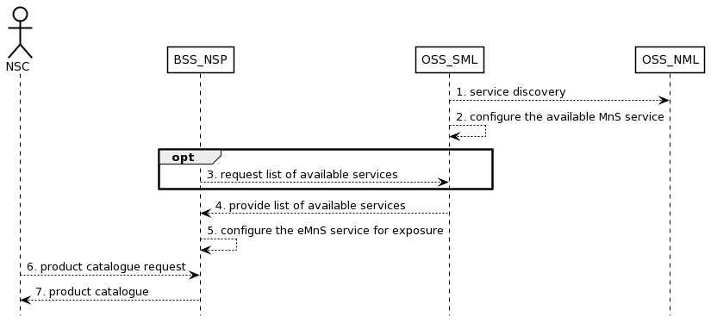
Figure 4.1.4.5.1 Procedure related to product onboarding
- OSS_SML obtains 3GPP management services in the network through management service discovery;
- OSS_SML governs the rules and policies of MnS and configures the available MnS (e.g. eMnS) to BSS_NSP. For example, if the RAN NE is dedicated to external customers, the performance monitoring service of a RAN NE should be exposed. Otherwise, it should not be exposed;
- Optional, the BSS_NSP may send information to request the list of available services from OSS_SML;
- OSS_SML provides the list of available services to BSS_NSP;
- BSS_NSP configures (groups or package the services into a product) the services from OSS_SML such that they can be exposed to NSC;
- NSC should request the product catalog from BSS_NSP.
- BSS_NSP provides product catalog to NSC.
Editor’s Note: “EGMF can have the functionality of eMnS data Whether registration to an external discovery system is FFS.”

3rd Change

7.z Potential solution for product onboarding
This clause describes a solution for the procedure described in clause 4.1.4.5. For each step in the procedure Table 7.z.1 identifies the following:
- if an interface is Internal to an operator, i.e.internal to the NSP or External between a NSC and NSP, or None in case the step is an internal process and there is no interface requirement,
- which operation or notification is used by that step, and
- which specification describes the interface (stage 2 and stage 3).

Step | Description in step | Interface | Reference | Description in reference
1 | service discovery | Internal | 3GPP TS 28.537[x] | FFS
2 |  | None | - | -
3 | request list of available services | Internal | TM Forum TMF633[y] | Service Catalogue
4 | provide list of available services | Internal | TM Forum TMF633[y] | Service Catalogue
5 |  | None | - | -
6 | product catalogue request | External | TM Forum TMF620[z] | Product Catalogue
7 | product catalogue | External | TM Forum TMF620[z] | Product Catalogue
Table 7.z.1 Solution for product onboarding

^{rth} Change

A.5 UML code
@startuml
@startuml
skinparam sequence {
ArrowColor Black
ActorBorderColor Black
ActorBackgroundColor White
ParticipantBorderColor Black
ParticipantBackgroundColor White
LifeLineBorderColor Black
BackGroundColor <<BSS_Prov>> Black
}
skinparam NoteBackgroundColor White
skinparam NoteBorderColor Black
skinparam shadowing false
hide footbox

actor NSC
participant BSS_NSP
participant OSS_SML
participant OSS_NML

OSS_SML--> OSS_NML: 1. service discovery
OSS_SML---> OSS_SML: 2. configure the available MnS service
opt
BSS_NSP -->OSS_SML: 3. request list of available services
end
OSS_SML---> BSS_NSP: 4. provide list of available services
BSS_NSP --> BSS_NSP: 5. configure the eMnS service for exposure
NSC --> BSS_NSP: 6. product catalogue request
BSS_NSP --> NSC: 7. product catalogue
@enduml

End of Changes

