3GPP TSG-SA5 Meeting #141-e S5-221424

e-meeting, 17 -26 January 2022

Source: Ericsson

Title: eMnS service

Document for: Approval
Agenda Item: 6.5.2

1 Decision/action requested
Approve the proposal.

3 Definitions of terms, symbols and abbreviations

3.1 Terms
For the purposes of the present document, the terms given in 3GPP TR 21.905 [1] and the following apply. A term defined in the present document takes precedence over the definition of the same term, if any, in 3GPP TR 21.905 [1].
Exposed Management Service A service that is exposing system management data according to a business contract.
eMnS consumer See clause 4.1.2.2.
eMnS producer See clause 4.1.2.3.

3.2 Symbols
For the purposes of the present document, the following symbols apply:
<symbol> <Explanation>

3.3 Abbreviations
For the purposes of the present document, the abbreviations given in 3GPP TR 21.905 [1] and the following apply. An abbreviation defined in the present document takes precedence over the definition of the same abbreviation, if any, in 3GPP TR 21.905 [1].
BSS Business Support System
CSP Communication Service Provider
eMnS Exposed Management Service
NOP Network OPerator

4 Concepts and background

4.1 Concepts related to network management capability exposure

4.1.1 Exposed Management Services
Exposed MnS (eMnS) represents the MnS that can be exposed by MnS producer to the external MnS consumer. eMnS may rely on a dedicated MnF (e.g. EGMF defined in 3GPP or function defined in other standard like TMF) that manages the exposure aspects.
The access check for each eMnS consumer is regulated with a business contract and is specific to each eMnS consumer.
The terminology in the contract is eMnS consumer specific. This means that the terminology must be translated to 3GPP system terminology for each eMnS consumer, for instance:
- The actions wanted from the eMnS consumer to be translated to 3GPP management actions.
- The performance information from the 3GPP management system to be aggregated according to the contract and to be translated to eMnS consumer terminology.
Furthermore, what an eMnS consumer may discover in an eMnS discovery service is regulated in a business contract, and is therefore eMnS consumer specific.

4.1.2 Exposure of Management Services
Exposure of management services supports the case that an external MnS consumer which is outside 3GPP management system can indirectly access management capability offered by MnS producer within 3GPP management system. Even though the eMnS complies with the same Technical Specification as a MnS, the actual operational behaviour and managed data may be constrained by the network slice provider.

4.1.3 Exposure interface via BSS

4.1.3.1 General
Exposure of service data to companies that are external to the operator are regulated by contracts. Different customers may have access to different management capabilities. It may differ on what attributes/policies/intents are allowed to be changed, which value ranges changes are allowed, and which performance metrics are allowed to be exposed.
The network slice data with the ServiceProfile is located in the Network Management Layer.
Even if the external interface always goes via BSS, there are different scenarios for how a customer, e.g. vertical, can influence the ServiceProfile.
The capabilities required by a Vertical have to be the same on the interface between NOP Network Management Layer and CSP Service manager. The external interface is external to the administrative domain of the operator, while the internal interface is inside the administrative domain of the operator.

4.1.4 Exposure interface via OSS

4.1.4.1 General
Exposure of service data to companies that are external to the operator are regulated by contracts. The exposure usually goes through BSS, as explained in clause 4.1.1.2. However, based on specific contract, the customer may interact with the Operator without going through BSS. There are different scenarios for how a customer having such contract interacts with Operator for the network slice management capability exposure.

4.1.4.2 Exposure scenarios
Scenario 1: The NOP and NSP belong to the same Operator. The OSS/SML and OSS/NML are connected via internal interface. The external customer has an external interface with the NSP based on the contract between the external customer and NSP.
NOTE 1: External customer may have connection with NSP BSS for the product-level interaction. If not, the OSS/SML may have embedded BSS functionalities for the product-level interaction.
NOTE 2: The Company-B BSS connects to the BSS part of external customer and the Company-B OSS/SML connect to the OSS/SML part of external customer.
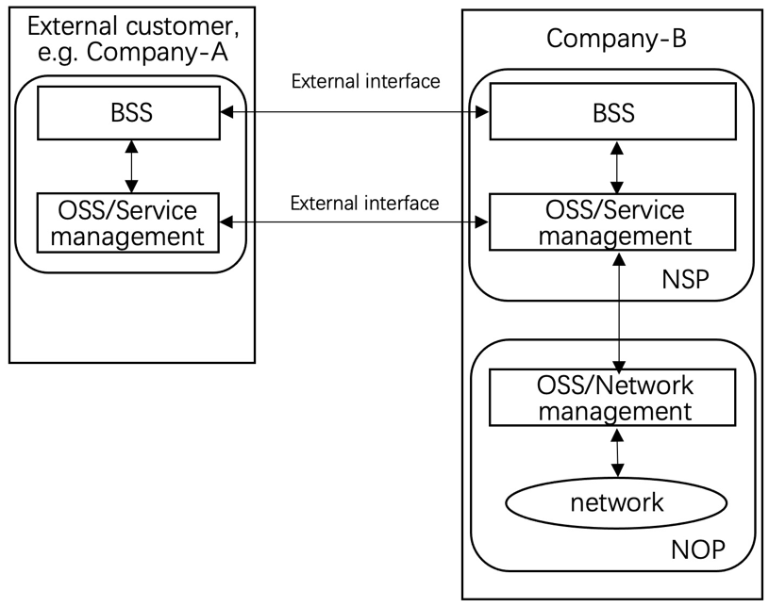
Figure 4.1.4.2-1 NSP OSS/SML to customer being an external interface

Scenario 2: The NOP may interface to an external NSP that has a contract with NOP for the exposure directly via OSS. The NOP’s OSS/SML have a direct machine to machine interface with the NSP’s OSS/SML. The external customer has an external interface with the NSP OSS/SML based on the contract between external customer and NSP.
NOTE 3: External customer may have connection with NSP BSS for the product-level interaction. If not, the NSP OSS/SML may have an embedded BSS functionalities for the product-level interaction.
NOTE 4: If the external customer can get access to the OSS directly, it must maintain a copy of a part of the operator’s MIB. if the customer wants to e.g. receive alarms or performance measurements or KPIs related to the network slice the customer has ordered to the NSP, these alarms / perf. meas / KPIs need to relate to some MOIs known at customer side. All these MOIs shall be part of a containment tree in the copy of the Operators’ MIB maintained by the customer.
Editor’s Note: Whether and how does the external customer obtain the copy of a part of the operator’s MIB is FFS.
NOTE 5: The Company-B BSS connects to the BSS part of external customer and the Company-B OSS/SML connect to the OSS/SML part of external customer.
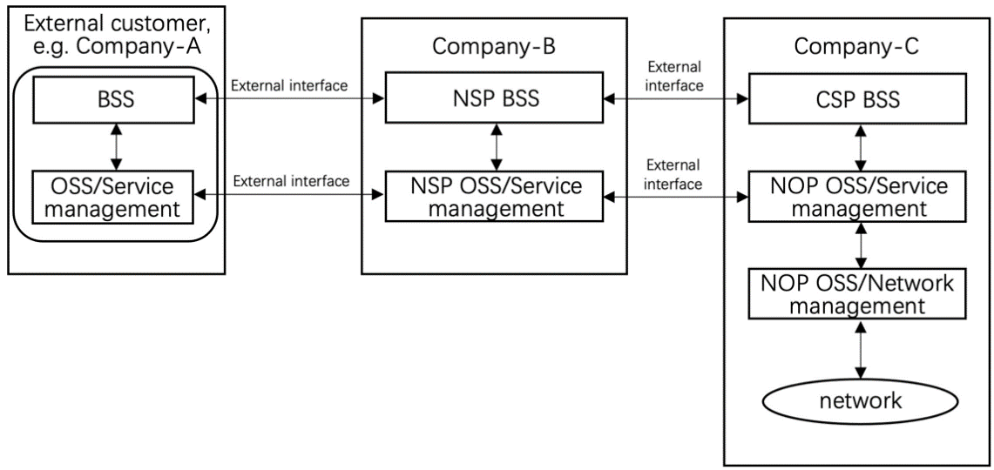
Figure 4.1.4.2-2 NOP OSS/SML to NSP OSS/SML interface being an external interface
Scenario 3: The NOP OSS/SML may interface to an external NSP OSS/SML based on the contract between the two parties. The "External NSP OSS/SML" has internal interface with NSP BSS. The NSP might have a machine to machine interface towards their customer (e.g. a vertical) via their BSS.
NOTE 6: External customer may have connection with BSS for the product-based interaction. If not, the NSP OSS/SML may have embedded BSS functionalities for the product-based interaction.
NOTE 7: If the external customer can get access to the OSS directly, it must maintain a copy of a part of the operator’s MIB. if the customer wants to e.g. receive alarms or performance measurements or KPIs related to the network slice the customer has ordered to the NSP, these alarms / perf. meas / KPIs need to relate to some MOIs known at customer side. All these MOIs shall be part of a containment tree in the copy of the Operators’ MIB maintained by the customer.
Editor’s Note: Whether and how does the external customer obtain the copy of a part of the operator’s MIB is FFS.
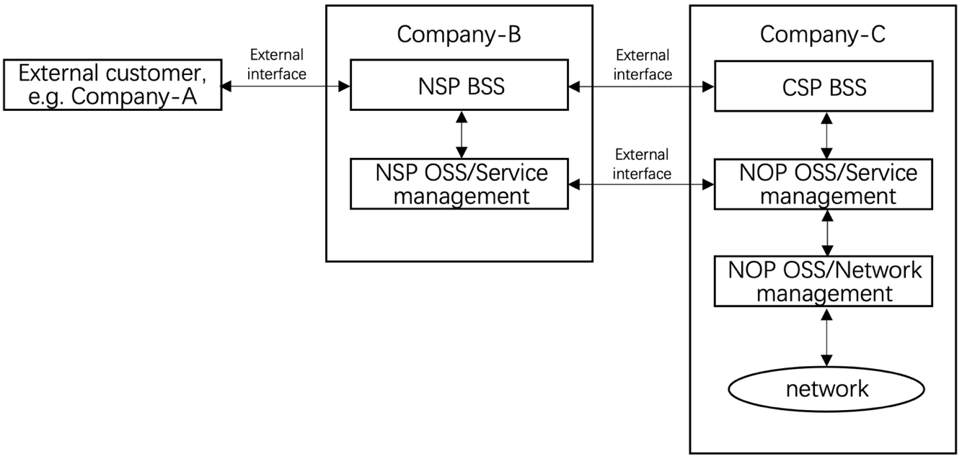
Figure 4.1.4.2-3 NOP OSS/SML to NSP OSS/SML being an external interface, NSP BSS to customer being an external interface

4.1.2 Roles related to network management capability exposure

4.1.2.1 Exposed MnS
The roles related to network management capability exposure are the Exposed MnS consumer and Exposed MnS producer with the interface for the Exposed MnS (eMnS). The roles and interface are shown in Figure 4.1.2.1.1
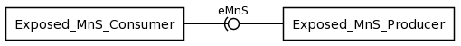
Figure 4.1.2.1.1 Roles related to network management capability exposure

4.1.2.2 Exposed MnS consumer
The logical entity accessing management capability offered by an Exposed MnS producer is called an Exposed MnS consumer. An eMnS consumer is equivalent to an MnS consumer with the difference that it is outside the trust domain of the CSP or NOP. An eMnS consumer is owned by an external customer (e.g. vertical such as Industry, Internet Company, etc) which may take the role of a CSC or NSC. The external customer usually has specific service requirements on a 5G network.

4.1.2.3 Exposed MnS producer
The logical entity offering management capability that can be accessed by an Exposed MnS consumer is called Exposed MnS producer. An eMnS producer is owned by a service provider which may take the role of a CSP or NSP.

4.1.3 Types of interface for the exposure of network slice

4.1.3.1 Introduction
Different types of interfaces may be used during the whole lifecycle of network slice, including ordering, provisioning, operation phases. These interfaces can be categorized as:
- Inter-organization interfaces (represented East-West):
- Between the organizational entity playing the Network Slice Customer (NSC) role, named Company V here, and the organizational entity playing the Network Slice Provider (NSP) role, named Company A here:
- Interface Type-A to:
- create a product (network slice) order,
- retrieve information concerning a product (network slice) order,
- update a product (network slice) order,
- delete a product (network slice) order;
Candidate APIs for Interface Type-A include, but are not limited to, TMF API 622 (Product ordering).
Interface Type-A is not in the scope of 3GPP.
- Between the organizational entity playing the Network Slice Provider (NSP) role, named Company A here, and the two organizational entities playing the Communication Service Provider (CSP) role, acting as ‘partners’ and named Company X and Company Y respectively here
- Interface Type-X to:
- create a product order,
- retrieve information concerning a product order,
- update a product order,
- delete a product order;
Candidate APIs for Interface Type-X include, but are not limited to, TMF API 622 (Product ordering).
Interface Type-X is not in the scope of 3GPP.

- Intra-organization interfaces (represented North-South), internal to the organizational entity playing the Network Slice Provider (NSP) role:
- Between its BSS and its OSS/SML
- Interface Type-1 to:
- create a service order,
- retrieve information concerning a service order,
- update a service order,
- delete a service order;
Candidate APIs for Interface Type-1 include, but are not limited to, TMF API 641 (Service ordering).
Interface Type-1 is not in the scope of 3GPP.
- Between its OSS/SML and its OSS/NML
- Interface Type-2 to:
- create a network slice / network slice subnet,
- retrieve information concerning a network slice / network slice subnet,
- update a network slice / network slice subnet,
- delete a network slice / network slice subnet,
- collect PM and FM data concerning a network slice / network slice subnet;
Candidate APIs for Interface Type-2 include, 3GPP TS 28.531, TS 28.532, TS 28.545, TS 28.550.
Interface Type-2 is in the scope of 3GPP/SA5.

The following clauses describe a non-exhaustive set of use cases.
In case of additional use cases, new types of interfaces may be needed.

4.1.3.2 Use case No.1: simple case
In this use case, Company-V (as the NSC) chooses a product from Company-A product offerings and sends a request to Company-A to order the product which is a network slice via Interface Type-A.
As Company-A can satisfy Company-V’s requirements by itself, it doesn’t have to count on partners.
In this use case, Interface Type-A, Type-1 and Type-2 are involved.
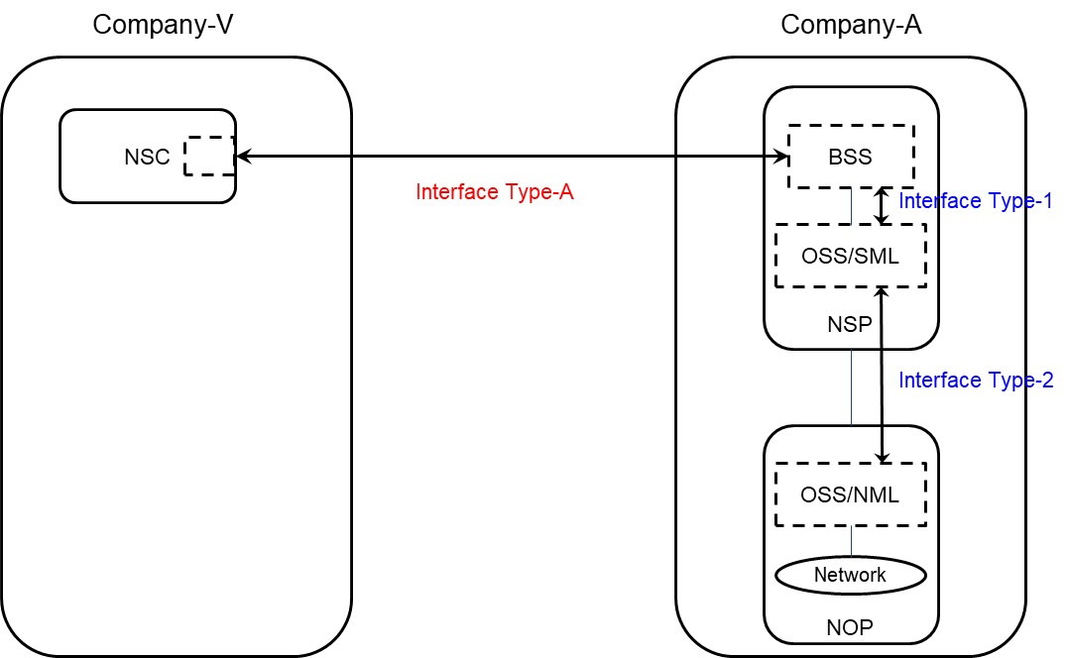
Figure 4.1.3.2.1 Use case No.1: simple case

4.1.3.3 Use case No.2: partners involved
In this use case, Company-V (as the NSC) chooses a product from Company-A product offerings and sends a request to Company-A to order the product which is a network slice via Interface Type-A.
As Company-A can’t satisfy Company-V’s requirements by itself, it has to count on partners (Company-X and Company-Y), e.g. to provide RAN coverage in their respective countries.
In this use case, Interface Type-A, Type-1, Type-2 and Type-X are involved.

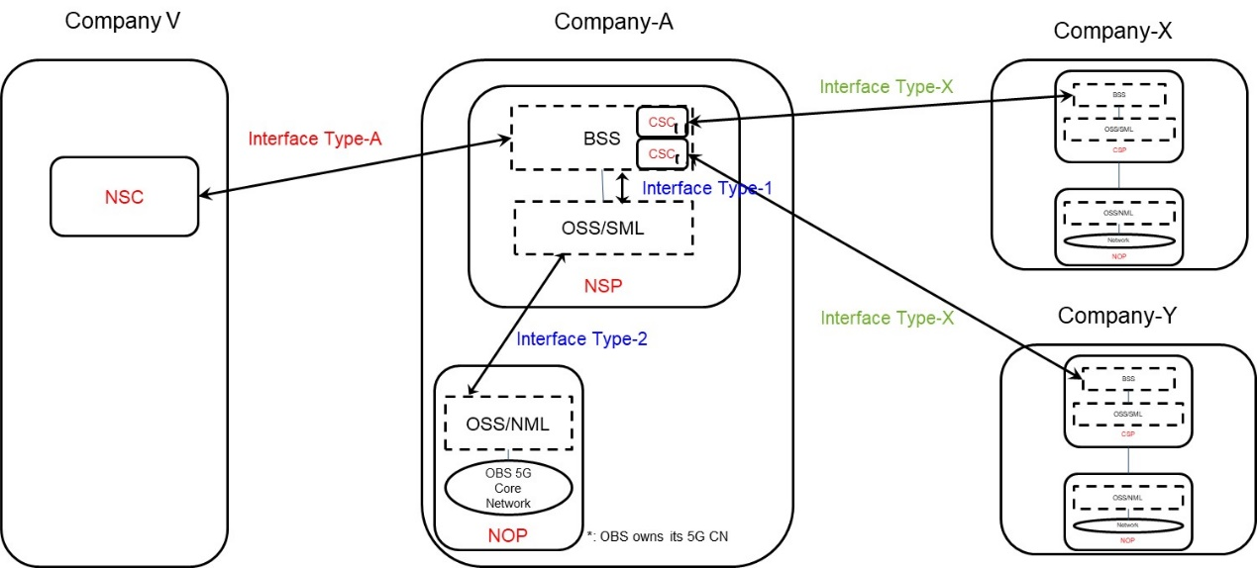
Figure 4.1.3.3.1 Use case No.2: partners involved

4.1.4 Procedures related to consumption of exposed network management capabilities

4.1.4.1 Introduction
When an NSP receives an order from an NSC for a network slice enabled product, the order is decomposed by the NSP’s BSS. Depending if the NSP employs services from 3rd party CSP’s different procedures may apply for the same order. The different procedures applicable to the same order may be invoked asynchronously and treated as independent procedures, however it may not result in loss of traceability between the original order and the orders that are created as result of decomposition. The following procedures have been identified:
- Procedure invoking internal service order after receiving product order from NSC
- Procedure invoking external product order after receiving product order from NSC
- Procedure invoking external service order after receiving product order from NSC

4.1.4.2 Procedure invoking internal service order after receiving product order from NSC
The procedure for invoking a service order internal to the NSP after receiving a product order from an NSC is shown in 4.1.4.2.1. The interface through which the NSC can order a product from the NSP is on BSS level. The steps as shown in Figure 4.1.4.2.1 are described in the subsequent paragraphs.
Editor’s Note: The specific operations in the TM Forum specification referenced by the following procedure are FFS.

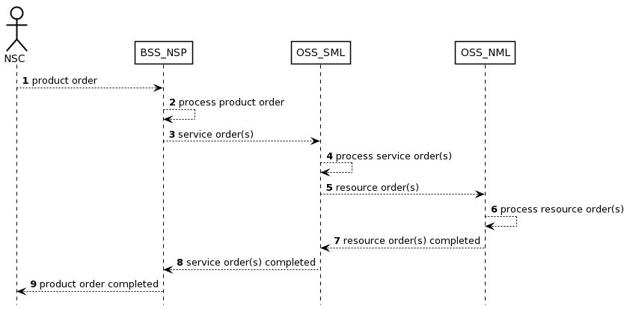
Figure 4.1.4.2.1 Procedure invoking internal service order after receiving product order from NSC
1) The NSP receives a product order from the NSC through the interface to BSS. The interface used towards the BSS is specified by TM Forum specifications [2].
2) The BSS processes the product order and when applicable converts it to appropriate service order(s) for the OSS Service Management Layer. This is internal to BSS and there are no interface requirements.
3) The OSS Service Management Layer receives a service order from the BSS. The interface used is specified by TM Forum specifications [3].
4) The MnS producer on the OSS Service Management Layer processes the service order and when applicable converts it to appropriate request(s) for the OSS Network Management Layer as requests for management and orchestration of resources. This is internal to the MnS producer on the OSS Service Management Layer and there are no interface requirements.
5) The OSS Network Management Layer receives a request from the MnS producer on the OSS Service Management Layer. An interface that may be used is specified by 3GPP TS 28.531 [5] and TS 28.541 [9].
6) The MnS producer on OSS Network Management Layer processes the request and when applicable converts it to appropriate request(s) for the network. An interface that may be used is specified by 3GPP TS 28.531 [5] and TS 28.541 [9].
7) The MnS producer on OSS Network Management Layer notifies the MnS producer on the OSS Service Management Layer that the resource order(s) have been completed. An interface that may be used is specified by 3GPP TS 28.531 [5] and TS 28.541 [9].
8) The MnS producer on OSS Service Management Layer notifies the BSS that the service order has been completed. The interface used is specified by TM Forum specifications [3]
9) The BSS notifies the NSC that the product order has been completed. The NSC may start using the services included in the product order. The interface used the interface towards the BSS is specified by TM Forum specifications [2].
Editor’s Note: The complete set of operations and interfaces are FFS.

4.1.4.3 Procedure invoking external product order after receiving product order from NSC
The procedure for invoking a product order external to the NSP after receiving a product order from an NSC is shown in 4.1.4.3.1. The interface through which the NSC can order a product from the NSP is on BSS level. The steps as shown in Figure 4.1.4.3.1 are described in the subsequent paragraphs.
Editor’s Note: The specific operations in the TM Forum specification referenced by the following procedure are FFS.
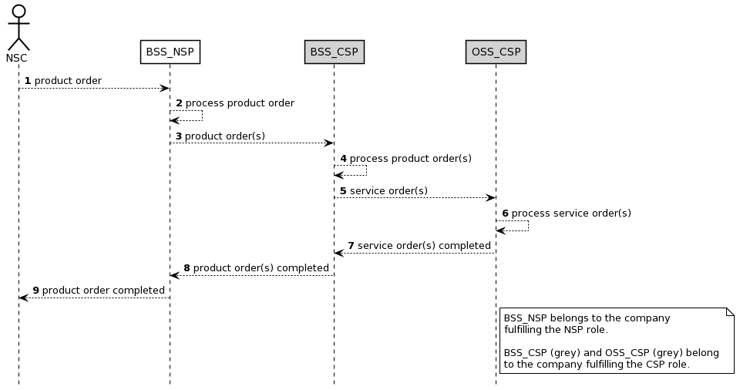
Figure 4.1.4.3.1 Procedure invoking external product order after receiving product order from NSC
1) The NSP receives a product order from the NSC through the interface to BSS. The interface used is specified by TM Forum specifications [2].
2) The NSP BSS processes the product order and when applicable converts it to appropriate product order(s) towards a 3rd party CSP BSS. This is internal to BSS and there are no interface requirements.
NOTE: When the BSS_NSP receives a product order the BSS_NSP splits the product order into service orders. A service order that can be fulfilled by the NSP will be processed by the NSP_OSS_SML (see also Figure 4.1.4.2.1) while a service order that cannot be fulfilled by NSP will be ordered from the CSP through a product order.
3) The CSP BSS receives a product order from the NSP BSS consumer. The interface used is specified by TM Forum specifications [2]
4) The CSP BSS processes the product order and when applicable converts it to appropriate service order(s) for the CSP OSS. This is internal to the BSS and there are no interface requirements.
5) The CSP OSS producer receives a service order from the CSP BSS. The interface used is specified by TM Forum specifications [3]
6) The CSP OSS producer processes the service order until the service order is completed.
7) The CSP OSS notifies the CSP BSS that the service order has been completed. The interface used is specified by TM Forum [3].
8) The CSP BSS notifies the NSP BSS that the product order has been completed. The interface used is specified by TM Forum [2].
9) The BSS notifies the NSC that the product order has been completed. The NSC may start using the services included in the product order.
Editor’s Note: The complete set of operations and interfaces are FFS.

4.1.4.4 Procedure invoking external service order after receiving product order from NSC
The procedure for invoking a service order external to the NSP after receiving a product order from an NSC is shown in 4.1.4.4.1. The interface through which the NSC can order a product from the NSP is on BSS level. The steps as shown in Figure 4.1.4.4.1 are described in the subsequent paragraphs.
Editor’s Note: The specific operations in the TM Forum specification referenced by the following procedure are FFS.

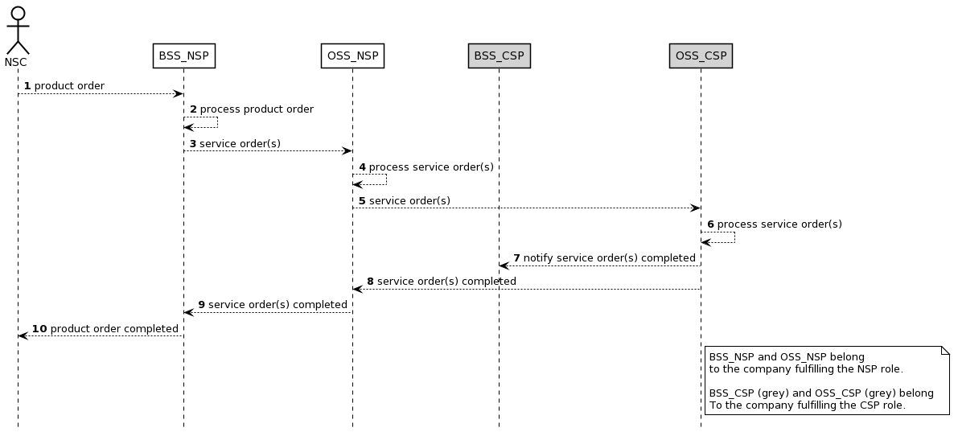
Figure 4.1.4.4.1 Procedure invoking external service order after receiving product order from NSC
1) The NSP receives a product order from the NSC through the interface to BSS. The interface used is specified by TM Forum specifications [2].
2) The NSP BSS processes the product order and when applicable converts it to appropriate service order(s) for the OSS producer. This is internal to BSS producer and there are no interface requirements.
3) The NSP OSS producer receives a service order from the NSP BSS. The interface used is specified by TM Forum specifications [3]
4) The OSS producer processes the service order and when applicable converts it to appropriate service order(s) for a 3rd party CSP OSS. This is internal to the OSS producer and there are no interface requirements.
5) The CSP OSS producer receives a service order from the NSP OSS producer. The interface used is specified by TM Forum specifications [3]
6) The CSP OSS producer processes the service order until the service order is completed. This is internal to the OSS producer and there are no interface requirements
7) The CSP OSS notifies the CSP BSS that the service order has been completed. The interface used is specified by 3GPP [6].
8) The CSP OSS notifies the NSP OSS producer (may occur at the same time as or before step 7) that the service order has been completed. The interface used is specified by 3GPP [3].
9) The NSP BSS notifies the NSC that the product order has been completed. The NSC may start using the services included in the product order.
Editor’s Note: The complete set of operations and interfaces are FFS.

4.1.4.5 Procedure for product onboarding
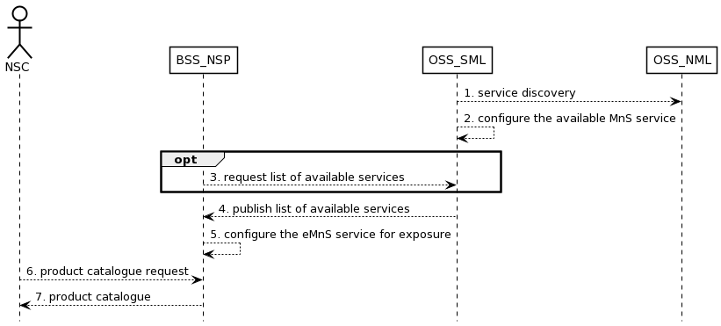
Figure 4.1.4.5.1 Procedure related to product onboarding
- OSS_SML obtains 3GPP management services in the network through service discovery;
- OSS_SML governs the rules and policies of MnS service and configures the available MnS service(e.g. eMnS service) to BSS_NSP. For example, if the RAN NE is dedicated to external customers, the performance monitoring service of RAN NE should be exposed. Otherwise, it should not be exposed;
- Optional, the BSS_NSP may send information to request for the list of available services;
- OSS_SML publishes the list of available services to BSS_NSP;
- BSS_NSP configures the eMnS service to be exposed to NSC;
- NSC should request the product catalog from BSS_NSP.
- BSS_NSP provides product catalog to NSC.
Editor’s Note: “EGMF can have the functionality of eMnS data Whether registration to an external discovery system is FFS.”

4.1.5 Other exposure scenarios
Scenario 1: Consumption of exposed MnS by applications
The operator has other non-management entities such as the middleware or application servers (AS) defined by 3GPP SA6 that could consume management services as shown in Figure 4.1.1.3.2-1. In such a case the BSS may or may not be directly involved. An example of an external application could be a V2X application server may use the management system to provision V2X slices in a certain geography (AS2 or AS3 in Figure). An example for an internal application could be the operators eMBB application server discovering a newly supported coverage area and provisioning the operator eMBB network slice instance in that area (AS1 in Figure). AS1 and AS2 access the 3GPP management system from an operator internal enabler server (see TR23.700-99), another enabler server could be located in the vertical premises and therefore external to the operator. In TR23.700-99 both such options are considered. In this scenario the operator MnSs are directly access by internal or external entities (subject to prior agreements) without going through the BSS. In addition to application servers and application enabler server, any internal of external authorized application function may also access exposed MnS.
In Figure 4.1.5-1 AS1 and AS2 may or may not be aware that they use exposed MnSs from the operator. The respective enabler servers could hide this internal implementation. Bother enabler servers may access exposed MnS subject to respective authorization. However, it is likely that the application enabler server A and AF1 have direct access to management services without a BSS, whereas the application enabler server B and AF2 would need some sort of involvement of the BSS.
Figure 4.1.5.1 Exposure to application server within and outside operator network
Editor’s Note: AF1 and AF2 are for FFS
End of Changes

