**3GPP TSG-SA5 Meeting #141-e *S5-221423***

**e-meeting, 17 - 26 January 2022**

**Source: Ericsson**

**Title: Add solution for product and service order procedures to clause 7**

**Document for: Approval**

**Agenda Item: 6.5.2**

# 1 Decision/action requested

***In this box give a very clear / short /concise statement of what is wanted.***

# 2 References

Not applicable

# 3 Rationale

The procedures described in clause 4.1.4 includes information about operations and references toboth 3GPP and TM Forum specifications. As discussed last meeting there is a question as noted in the Editor’s Note that the operations for the steps in the procedures are being studied. This contribution proposes to address the Editor’s note and to make the procedure solution agnostic. Therefore the following changes are included in this contribution:

- Remove reference to 3GPP and TM Forum as these are describe a solution.

- Add the information on operations and interfaces for each step to clause 7 Solutions.

# 4 Detailed proposal

***1st Change***

### 4.1.4 Procedures related to consumption of exposed network management capabilities

#### 4.1.4.1 Introduction

When an NSP receives an order from an NSC for a network slice enabled product, the order is decomposed by the NSP’s BSS. Depending if the NSP employs services from 3rd party CSP’s different procedures may apply for the same order. The different procedures applicable to the same order may be invoked asynchronously and treated as independent procedures, however it may not result in loss of traceability between the original order and the orders that are created as result of decomposition. The following procedures have been identified:

- Procedure invoking internal service order after receiving product order from NSC

- Procedure invoking external product order after receiving product order from NSC

- Procedure invoking external service order after receiving product order from NSC

#### 4.1.4.2 Procedure invoking internal service order after receiving product order from NSC

The procedure for invoking a service order internal to the NSP after receiving a product order from an NSC is shown in 4.1.4.2.1. The interface through which the NSC can order a product from the NSP is on BSS level. The steps as shown in Figure 4.1.4.2.1 are described in the subsequent paragraphs.

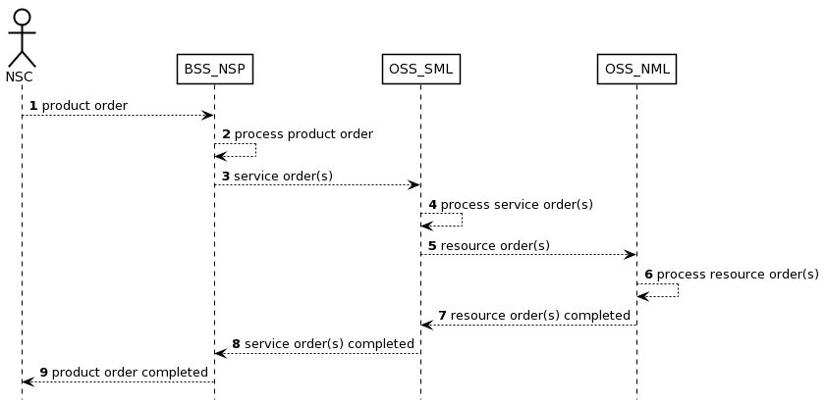

Figure 4.1.4.2.1 Procedure invoking internal service order after receiving product order from NSC

1) The NSP receives a product order from the NSC through the interface to BSS. The interface between the NSC and BSS of the NSP is used.

2) The BSS processes the product order and when applicable converts it to appropriate service order(s) for the OSS Service Management Layer. This is internal to BSS and there are no interface requirements.

3) The OSS Service Management Layer receives a service order from the BSS. The interface between the BSS of the NSP and the OSS_SML of the NSP is used.

4) The OSS Service Management Layer processes the service order and when applicable converts it to appropriate request(s) for the OSS Network Management Layer as requests for management and orchestration of resources. This is internal to the OSS Service Management Layer and there are no interface requirements.

5) The OSS Network Management Layer receives a request from the OSS Service Management Layer. An interface between the OSS Service Management Layer and OSS Network Management Layer may be used.

6) The OSS Network Management Layer processes the request and when applicable converts it to appropriate request(s) for the network. An interface between the OSS Network Management Layer and Network Layer (not shown) may be used.

7) The OSS Network Management Layer notifies the OSS Service Management Layer that the resource order(s) have been completed. An interface between the OSS Service Management Layer and the Netowrk Layer may be used.

8) The OSS Service Management Layer notifies the BSS that the service order has been completed. The interface between the OSS Service Management Layer and the BSS is used.

9) The BSS notifies the NSC that the product order has been completed. The NSC may start using the services included in the product order. The interface between the NSC and the BSS is used

#### 4.1.4.3 Procedure invoking external product order after receiving product order from NSC

The procedure for invoking a product order external to the NSP after receiving a product order from an NSC is shown in 4.1.4.3.1. The interface through which the NSC can order a product from the NSP is on BSS level. The steps as shown in Figure 4.1.4.3.1 are described in the subsequent paragraphs.

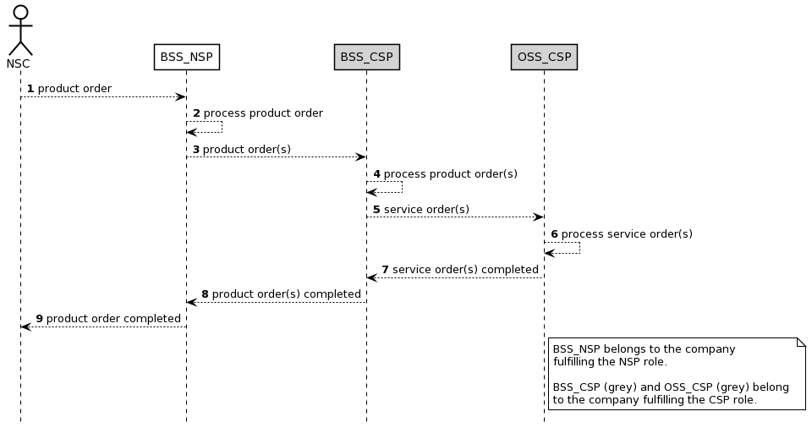

Figure 4.1.4.3.1 Procedure invoking external product order after receiving product order from NSC

1) The NSP receives a product order from the NSC through the interface to BSS. The interface between the NSC and BSS of the NSP is used.

2) The NSP BSS processes the product order and when applicable converts it to appropriate product order(s) towards a 3rd party CSP BSS. This is internal to BSS and there are no interface requirements.

NOTE: When the BSS_NSP receives a product order the BSS_NSP splits the product order into service orders. A service order that can be fulfilled by the NSP will be processed by the NSP_OSS_SML (see also Figure 4.1.4.2.1) while a service order that cannot be fulfilled by NSP will be ordered from the CSP through a product order.

3) The CSP BSS receives a product order from the NSP BSS. The interface between the BSS of the CSP and the BSS of the NSP is used

4) The CSP BSS processes the product order and when applicable converts it to appropriate service order(s) for the CSP OSS. This is internal to the BSS and there are no interface requirements.

5) The CSP OSS receives a service order from the CSP BSS. The interface between the BSS and the OSS both belonging to the CSP is used.

6) The CSP OSS processes the service order until the service order is completed.

7) The CSP OSS notifies the CSP BSS that the service order has been completed. The interface between the OSS and the BSS both belonging to the CSP is used.

8) The CSP BSS notifies the NSP BSS that the product order has been completed. The interface between the BSS of the CSP and the OSS of an NSP is used.

9) The BSS notifies the NSC that the product order has been completed. The NSC may start using the services included in the product order.

#### 4.1.4.4 Procedure invoking external service order after receiving product order from NSC

The procedure for invoking a service order external to the NSP after receiving a product order from an NSC is shown in 4.1.4.4.1. The interface through which the NSC can order a product from the NSP is on BSS level. The steps as shown in Figure 4.1.4.4.1 are described in the subsequent paragraphs.

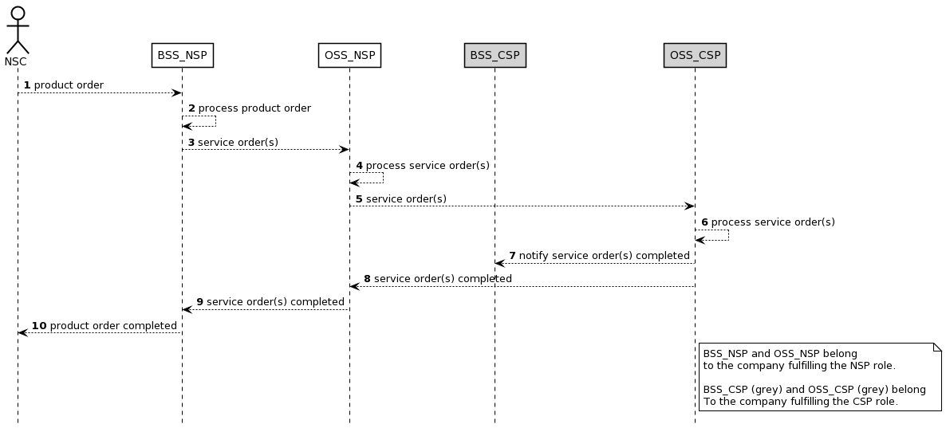

Figure 4.1.4.4.1 Procedure invoking external service order after receiving product order from NSC

1) The NSP receives a product order from the NSC through the interface to BSS. The interface between the NSC and BSS of the NSP is used.

2) The NSP BSS processes the product order and when applicable converts it to appropriate service order(s) for the OSS producer. This is internal to BSS producer and there are no interface requirements.

3) The NSP OSS receives a service order from the NSP BSS. The interface between the OSS and the BSS, both belonging to the same NSP, is used.

4) The OSS processes the service order and when applicable converts it to appropriate service order(s) for a 3rd party CSP OSS. This is internal to the OSS producer and there are no interface requirements.

5) The CSP OSS receives a service order from the NSP OSS producer. The interface between the OSS of the CSP and the OSS of the NSP is used.

6) The CSP OSS processes the service order until the service order is completed. This is internal to the OSS producer and there are no interface requirements

7) The CSP OSS notifies the CSP BSS that the service order has been completed. The interface between the OSS and the BSS, both belonging to the same CSP, is used.

8) The CSP OSS notifies the NSP OSS producer (may occur at the same time as or before step 7) that the service order has been completed. The interface between the OSS of the CSP and the OSS of the NSP is used.

9) The NSP BSS notifies the NSC that the product order has been completed. The NSC may start using the services included in the product order.

4.1.4.5 Procedure for product onboarding

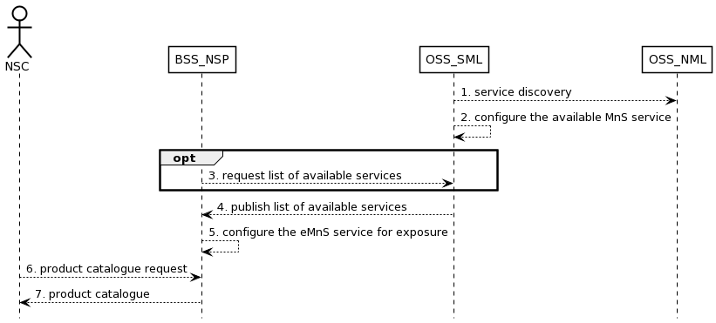

Figure 4.1.4.5.1 Procedure related to product onboarding

1. OSS_SML obtains 3GPP management services in the network through service discovery;
2. OSS_SML governs the rules and policies of MnS service and configures the available MnS service(e.g. eMnS service) to BSS_NSP. For example, if the RAN NE is dedicated to external customers, the performance monitoring service of RAN NE should be exposed. Otherwise, it should not be exposed;
3. Optional, the BSS_NSP may send information to request for the list of available services;
4. OSS_SML publishes the list of available services to BSS_NSP;
5. BSS_NSP configures the eMnS service to be exposed to NSC;
6. NSC should request the product catalog from BSS_NSP.
7. BSS_NSP provides product catalog to NSC.

Editor’s Note: “EGMF can have the functionality of eMnS data Whether registration to an external discovery system is FFS.”

***2nd Change***

# 7 Possible solutions for network management capability exposure

## 7.w Solution for internal service order after receiving product order

This clause describes a solution for the procedure described in clause 4.1.4.2. For each step in the procedure Table 7.w.1 identifies the following:

- if an interface is Internal to an operator, i.e.internal to a CSP or internal to an NSP, or External between a CSP and an NSP, or None in case the step is an internal process and there is no interface requirement,

- which operation or notification is used by that step, and

- which specification describes the interface (stage 2 and stage 3).

|  |  |  |  |  |
| --- | --- | --- | --- | --- |
| **Step** | **Description in step** | **Interface** | **Reference** | **Description in reference** |
| 1 | product order | External | TM Forum TMF622 [2] | Product Order |
| 2 |  | None | - | - |
| 3 | service order | External | TM Forum TMF641 [3] | Service Order |
| 4 |  | None | - | - |
| 5 | resource order | Internal | TM Forum TMF652 [4] | Resource Order |
| 6 |  | Internal | 3GPP TS 28.531 [x], clause 6.5.1- | AllocateNsi |
| 7 | resource order completed | Internal | TM Forum TMF652 [4] | Service Order State Change Event |
| 8 | service order completed | External | TM Forum TMF641 [3] | Product Order State Change Event |
| 9 | product order completed | External | TM Forum TMF622 [2] | Product Order State Change Event |

Table 7.w.1 Solution for internal service order after receiving product order

## 7.x Solution for external product order after receiving product order

This clause describes a solution for the procedure described in clause 4.1.4.3. For each step in the procedure Table 7.x.1 identifies the following:

- if an interface is Internal to an operator, i.e.internal to a CSP or internal to an NSP, or External between a CSP and an NSP, or None in case the step is an internal process and there is no interface requirement,

- which operation or notification is used by that step, and

- which specification describes the interface (stage 2 and stage 3).

|  |  |  |  |  |
| --- | --- | --- | --- | --- |
| **Step** | **Description in step** | **Interface** | **Reference** | **Description in reference** |
| 1 | product order | External | TM Forum TMF622 [2] | Product Order |
| 2 |  | None | - | - |
| 3 | product order | External | TM Forum TMF622 [2] | Product Order |
| 4 |  | None | - | - |
| 5 | service order | Internal | TM Forum TMF641 [3] | Service Order |
| 6 |  | None | - | - |
| 7 | service order completed | Internal | TM Forum TMF641 [3] | Service Order State Change Event |
| 8 | product order completed | External | TM Forum TMF622 [2] | Product Order State Change Event |
| 9 | product order completed | External | TM Forum TMF622 [2] | Product Order State Change Event |

Table 7.x.1 Solution for external product order after receiving product order

## 7.y Solution for external service order after receiving product order

This clause describes a solution for the procedure described in clause 4.1.4.4. For each step in the procedure Table 7.y.1 identifies the following:

- if an interface is Internal to an operator, i.e.internal to a CSP or internal to an NSP, or External between a CSP and an NSP, or None in case the step is an internal process and there is no interface requirement,

- which operation or notification is used by that step, and

- which specification describes the interface (stage 2 and stage 3).

|  |  |  |  |  |
| --- | --- | --- | --- | --- |
| **Step** | **Description in step** | **Interface** | **Reference** | **Description in reference** |
| 1 | product order | External | TM Forum TMF622 [2] | Product Order |
| 2 |  | None | - | - |
| 3 | service order | Internal | TM Forum TMF641 [3] | Service Order |
| 4 |  | None | - | - |
| 5 | service order | External | TM Forum TMF641 [3] | Service Order |
| 6 |  | None | - | - |
| 7 | notify service order completed | Internal | 3GPP TS 28.202 [6] | Service Order Completed Notification |
| 8 | service order completed | External | TM Forum TMF641 [3] | Service Order State Change Event |
| 9 | service order completed | External | TM Forum TMF641 [3] | Service Order State Change Event |

Table 7.y.1 Solution for external product order after receiving product order