**3GPP TSG-SA5 Meeting #141-eS5-221386**

**e-meeting, 17 - 26 January 2022**

**Source: Ericsson, Deutsche Telekom**

**Title: Discussion paper on cleaning up eCosla stage 2 description**

**Document for: Discussion**

**Agenda Item: 6.4.10**

# 1 Decision/action requested

***The group is asked to endorse the detailed proposal in section 4.***

# 2 References

[1] [3GPP TS 28.535](https://portal.3gpp.org/desktopmodules/Specifications/SpecificationDetails.aspx?specificationId=3693): "Management and orchestration; Management services for communication service assurance; Requirements"

[2] [3GPP TS 28.536](https://portal.3gpp.org/desktopmodules/Specifications/SpecificationDetails.aspx?specificationId=3701): "Management and orchestration; Management services for communication service assurance; Stage 2 and stage 3"

[3] [3GPP TS 28.533](https://portal.3gpp.org/desktopmodules/Specifications/SpecificationDetails.aspx?specificationId=3416): "Management and orchestration; Architecture framework"

[4] [SP-200196](https://www.3gpp.org/ftp/tsg_sa/TSG_SA/TSGS_87E_Electronic/Docs/SP-200196.zip): "New WID on Enhanced Closed loop SLS assurance"

[5] [SP 200465](https://www.3gpp.org/ftp/tsg_sa/TSG_SA/TSGS_88E_Electronic/Docs/SP-200465.zip): "Management data collection control and discovery"

[6] [SP_210136](https://www.3gpp.org/ftp/tsg_sa/TSG_SA/TSGs_91E_Electronic/Docs/SP-210136.zip): "Study on Enhancement of service-based management architecture"

[7] [SP 210132](https://www.3gpp.org/ftp/tsg_sa/TSG_SA/TSGs_91E_Electronic/Docs/SP-210132.zip) "Enhancements of Management Data Analytics Service"

# 3 Rationale

With the development of the stage 2 specification for Cosla Rel-17 many changes have been implemented and due to the many changes, the descriptions of classes, data types and attributes could be improved to make them more useable.

The most current agreements on stage 2 are documented in clause 4.1.2 of TS 28.536 [v17.1.0.](https://www.3gpp.org/ftp/Specs/archive/28_series/28.536/28536-h10.zip) in draftCR [S5-216596](https://www.3gpp.org/ftp/tsg_sa/WG5_TM/TSGS5_140e/Docs/S5-216596.zip). The table of content for clause 4.1.2 is as follows:

4.1.2 Model

4.1.2.1 Imported and associated information entities

4.1.2.1.1 Imported information entities and local labels

4.1.2.1.2 Associated information entities and local labels

4.1.2.2 Class diagram

4.1.2.2.1 Relationships

4.1.2.2.2 Inheritance

4.1.2.3 Class definitions

4.1.2.3.1 AssuranceClosedControlLoop

4.1.2.3.2 AssuranceGoal

4.1.2.3.3 Void

4.1.2.3.4 Void

4.1.2.3.5 AssuranceTarget <<dataType>>

4.1.2.3.5 AssuranceScope <<dataType>>

4.1.2.3.l AssuranceGoalStatus <<dataType>>

4.1.2.3.m AssuranceTargetStatus <<dataType>>

4.1.2.3.x AssuranceReport <<IOC>>

4.1.2.4 Attribute definitions

4.1.2.4.1 Attribute properties

4.1.2.4.2 Constraints

4.1.2.4.3 Notifications

4.1.2.5 Common notifications

4.1.2.5.1 Alarm notifications

4.1.2.5.2 Configuration notifications

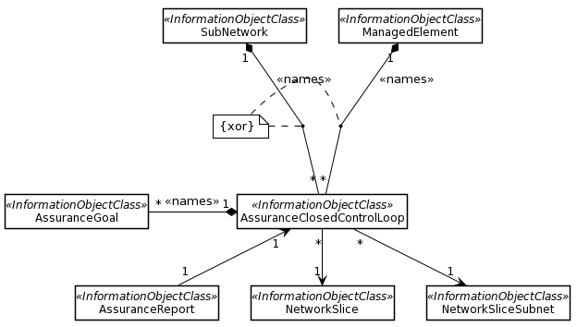

Figure 3.1 The eCOSLA NRM fragment as in draftCR S5-221596

The following updates to clause 4.1.2 have been identified:

**Update 1**

**Issue**: The AssuranceReport is an IOC but it has not been contained and can therefore not be addressed by an MnS consumer. There are two options for providing AssuranceReport (AR) per ACCL or per AG. The proposed solution is to report per ACCL and provide the necessary relationships with AssuranceReport. As the AssuranceReport contain the AssuranceGoalStatus and references the AssruanceGoal the AssuranceGola needs to reference the AssuranceGoalStatus. The AssuranceGoalStatus is changed from dataType to IOC to be able to be referenced from AssuranceGoal.

**Solution:** it is proposed to name contain the AssuranceReport under AssuranceGoal.

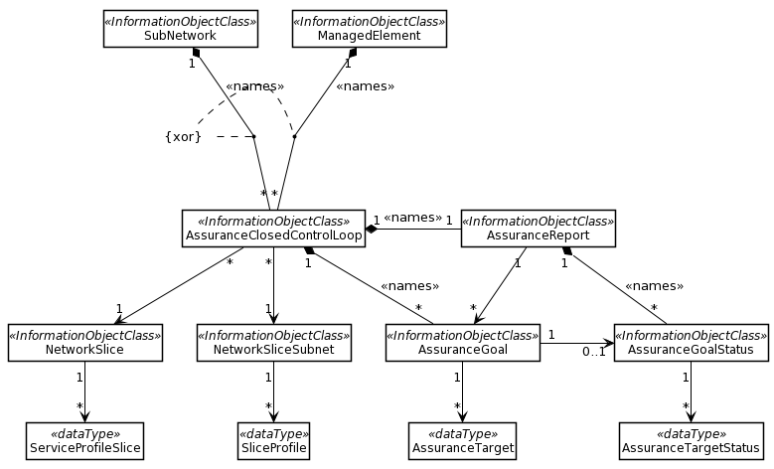

Figure 3.2 The proposed eCOSLA NRM fragment

**Update 2**

1. **Issue:** Description of Assurance report needs revision. If AssuranceReport is contained by AssuranceGoal the reference and description in attribute properties table is not needed. Add containment relationship between AssuranceReport and AssuranceGoalStatus, add reference from AssuranceGoal to AssruanGoalStatus, show the datatype in the UML diagram, Update inheritache diagram
2. **Solution: Remove reference to closed control loop and add containment relationship between AssuranceReport and AssuranceGoalStatus, add reference from AssuranceGoal to AssuanceGoalStatus (changed from dataType to IOC to support this), show the datatype in the UML diagram, Update inheritache diagram**

**Update 3**

**Issue:** The introductory text in clause 4.1.2.2.1 is incomplete according to the methodology TS 32.160 [x]

**Solution:** updated to introductory text according to TS 32.160 [x]

**Update 4**

**Issue:** The formatting of clause 4.1.2.3.1/2/3/4/5 is Justified, it should be Align Right. Also, the word NetworkSLice should be NetworkSlice.

**Solution*:*** update formatting, and fix NetworkSlice to NetworkSlice

**Update 5**

**Issue:** Something funny with the formatting of heading 4.1.2.3.2 AssuranceGoal

**Solution*:*** Fix formatting

**Update 6**

**Issue:** Description of Assurance goal: “corresponding observed or predicted goal fulfilment” should be corresponding observed and/or predicted goal fulfilment. Last paragraph before the Note needs revision

**Solution*:*** Propose revision

**Update 7**

**Issue:** Description of Assurance goal status needs revision. Note also typo in “fuilfilment”.

**Solution*:*** Propose revision,

**Update 8**

**Issue:** The list of configuration notifications in clause 4.1.2.5.2 is incomplete, more notifications are specified in TS 28.532 that may be used.

**Solution:** Add missing notification “notifyMOIChanges” from TS 28.532 to table in clause 4.1.2.5.2

## 3.1 UML code for Figure 3.2

@startuml

skinparam backgroundColor white

skinparam classBackgroundColor white

skinparam classBorderColor black

skinparam Shadowing false

skinparam noteBackgroundColor white

skinparam noteBorderColor white

skinparam arrowColor black

hide circle

hide members

hide fields

class SubNetwork <<InformationObjectClass>>

class ManagedElement <<InformationObjectClass>>

class AssuranceClosedControlLoop <<InformationObjectClass>>

class AssuranceGoal <<InformationObjectClass>>

class AssuranceReport <<InformationObjectClass>>

class AssuranceTarget <<dataType>>

class AssuranceTargetStatus <<dataType>>

class AssuranceGoalStatus <<InformationObjectClass>>

class NetworkSlice <<InformationObjectClass>>

class NetworkSliceSubnet <<InformationObjectClass>>

class ServiceProfileSlice <<dataType>>

class SliceProfile <<dataType>>

SubNetwork "1" *-- "*" AssuranceClosedControlLoop: <<names>>

ManagedElement "1" *-- "*" AssuranceClosedControlLoop: <<names>>

AssuranceClosedControlLoop "1" *-- "*" AssuranceGoal: <<names>>

AssuranceClosedControlLoop "1" *-right- "1" AssuranceReport: <<names>>

AssuranceReport "1" --> "*" AssuranceGoal

AssuranceClosedControlLoop "*" --> "1" NetworkSlice

AssuranceClosedControlLoop "*" --> "1" NetworkSliceSubnet

NetworkSlice "1" --> "*" ServiceProfileSlice

NetworkSliceSubnet "1" --> "*" SliceProfile

AssuranceGoal "1" --> "*" AssuranceTarget

AssuranceGoalStatus "1" --> "*" AssuranceTargetStatus

AssuranceReport "1" *-- "*" AssuranceGoalStatus: <<names>>

AssuranceGoal "1" -right-> "0..1" AssuranceGoalStatus: "<font color=white > blank"

note "{xor}" as Note1

Note1 .. (SubNetwork, AssuranceClosedControlLoop)

Note1 .. (ManagedElement, AssuranceClosedControlLoop)

@enduml

# 4 Detailed proposal

The group is asked to endorse the proposals described in the rational.